

# **User Guide**

**Version: 0.1**

***Design and developed by***

Contents

Version Control 3

1. Introduction of DigiWorks 4

2. Using DigiWorks 5

2.1 Overview 5

2.2 Profiles and dashboards 6

2.2.1 Customizing your dashboard 6

2.2.2 Updating Profile 9

2.2.3 Changing Password 15

2.3 Sites 17

2.3.1 Overview 17

2.3.2 Features 25

2.4 Content 25

2.4.1 Overview 25

2.4.2 Manage content 44

2.4.3 Files and folders 96

2.4.4 Folder rules 97

2.5 Tasks and workflows 97

2.5.1. Starting a Workflow 97

2.5.2. Viewing Workflows You Started 97

2.5.3. Canceling an Active Workflow 97

2.5.4. Viewing Tasks Assigned to You 97

2.5.5. Managing Tasks 97

2.5.6. Signing the Document via the task 97

2.5.7. Analytics 97

2.6 Search 97

2.6.1. Global Search 97

2.6.2. Using the Advance Search 97

2.6.3. AI Search 97

2.7 AI Tools 97

2.7.1. Ask AI 97

2.7.2. Detect PII 97

2.7.3. Generate Tags 97

2.7.4. Summarize It 97

2.7.5. Translate It 97

2.8 Roles and permissions 97

2.8.1. Dashboards Permissions 97

2.8.2. Content Permissions 97

2.8.3. Member Permissions 97

2.8.4. Power Users 97

2.9 Reports 97

2.9.1 Workflow reports 97

2.4.5 Document reports 97

# Version Control

**DOCUMENT INFORMATION**

|  |  |  |
| --- | --- | --- |
| Prepared By: | Ruth Natalie Cristine | |
| Date Prepared: | 26th February 2025 | |
| Reviewed By: |  | Date: |

**VERSION HISTORY**

|  |  |  |  |
| --- | --- | --- | --- |
| **Date** | **Version** | **Author** | **Description** |
| 26th February 2025 | v0.1 | Ruth Natalie Cristine | Initial Draft |
| 18th March 2025 | v0.1 | Ruth Natalie Cristine | Added section 1., 2.1 Overview, 2.2 Profiles and dashboards, and 2.3 Sites |
| 24th March 2025 | v0.1 | Nursyahirah Hafidz | Reviewed document and added section 2.4.3 Manage Content, 2.7 AI Tools, and 2.9 Reports. |
| 11th April 2025 | v0.1 | Ruth Natalie Cristine | Added section 2.4 Content, 2.5 Task and Workflows, 2.6 Search, 2.8 Roles and Permissions, 2.9 Reports. |
|  |  |  |  |
|  |  |  |  |
|  |  |  |  |
|  |  |  |  |
|  |  |  |  |

# Introduction of DigiWorks

DigiWorks represents the next generation of Alfresco Share and the Activiti App, leveraging generative AI to revolutionize how you manage information and processes. By enhancing the Alfresco ADF app, DigiWorks provides a more intuitive and efficient experience for document management, knowledge management, case management, and workflow/BPM.

**DigiWorks** **Key Capabilities:**

1. **Document and Records Management**

DigiWorks offers a streamlined document and records management experience. Its user-friendly design, intelligent search, and direct-action access from search results make information retrieval and workflow management remarkably efficient.

1. **Workflows and Case Management**

Empower your business users with DigiWorks, a modern replacement for the Activiti App in Alfresco Process Services. Its intuitive design allows for easy task management and workflow initiation, putting control back in the hands of the user.

1. **Analytics and Reports**

DigiWorks' Reports and Analytics module makes data analysis easy and customizable. Start with ready-to-use reports for insights into document/records management and user productivity, and then tailor your analysis with the drag-and-drop report designer for custom reports and dashboards. Powerful drill-down capabilities enhance exploration.

1. **Modern UI / UX alternative to Alfresco Share**

Elevate your Alfresco platform with DigiWorks, a modern UI/UX solution that replaces Alfresco Share and the Activiti App. Unlock increased productivity and user adoption with its intuitive interface and integrated Generative AI. DigiWorks is designed for Alfresco 23.x and beyond, enabling seamless Document, Records, Knowledge, Workflow, BPM, Case Management, and GenAI functionality.

1. **Based on Alfresco ADF**

Built on Alfresco's Application Development Framework (ADF) and Angular components, DigiWorks adheres to industry best practices and standards. This ensures a clear upgrade path, long-term support, and a stable roadmap for our customers.

1. **Multi-lingual and Responsive**

DigiWorks multi-lingual and responsive design ensures broad accessibility and an enhanced user experience across diverse devices. Featuring support for over 20 languages, including major European, Asian, and Middle Eastern languages, it caters to a global audience.

# Using DigiWorks

## Overview

In today's rapidly evolving digital landscape, organizations are constantly seeking innovative solutions to streamline their operations and enhance user productivity. Recognizing the limitations of legacy interfaces within the Alfresco platform, DigiWorks presents a transformative approach, offering a GenAI-powered digital workspace that reimagines the user experience.

By replacing the outdated Alfresco Share and Activiti App UI with a modern, intuitive design, DigiWorks empowers users across a spectrum of critical business functions, including Document Management, Records Management, Knowledge Management, Case Management, and Workflow/BPM. This comprehensive platform leverages the power of Generative AI to create a seamless and intelligent environment, where information retrieval, task execution, and process management are significantly simplified.

The integration of GenAI capabilities enables users to effortlessly navigate complex workflows, access relevant information with unprecedented speed, and automate repetitive tasks, thereby freeing up valuable time for strategic initiatives. DigiWorks' commitment to user-centric design ensures that managing business processes is not only more efficient but also remarkably smoother, fostering a more productive and engaged workforce. By bridging the gap between legacy systems and cutting-edge technology, DigiWorks provides a future-proof solution that enables organizations to unlock the full potential of their Alfresco platform and drive sustainable growth.

## Profiles and dashboards

Users may personalize their dashboard and profile settings independently, ensuring that these customizations are visible only to the individual user. To maintain professional standards and facilitate effective collaboration, users are encouraged to ensure the accuracy of profile details that are shared with colleagues.

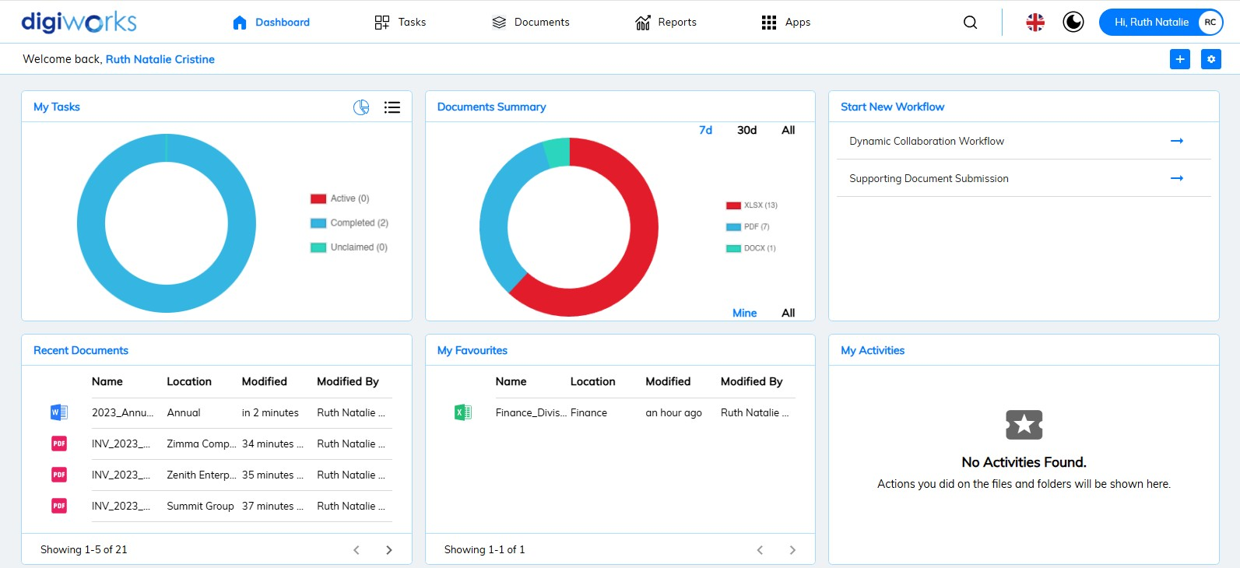

1. **Dashboard** – A short cut to My Task, Document Summary, Start New Workflow, Recent Documents, My Favourites and My Activities.
2. **My Task** – Display user’s tasks in Pie Chart or List of Active; Completed; and Unclaimed Task.
3. **Document Summary** – Display a pie chart showing the number of file types to which the user has access permissions on the site.
4. **Start New Workflow** – A short cut to initiate the workflow
5. **Recent Documents** – Display recently interacted documents.
6. **My Favourites** – Display favourited documents or folders.
7. **My Activities** – Display the files and folders that the user created or modified.

### Customizing your dashboard



1. Start customizing your dashboard by clicking  ,

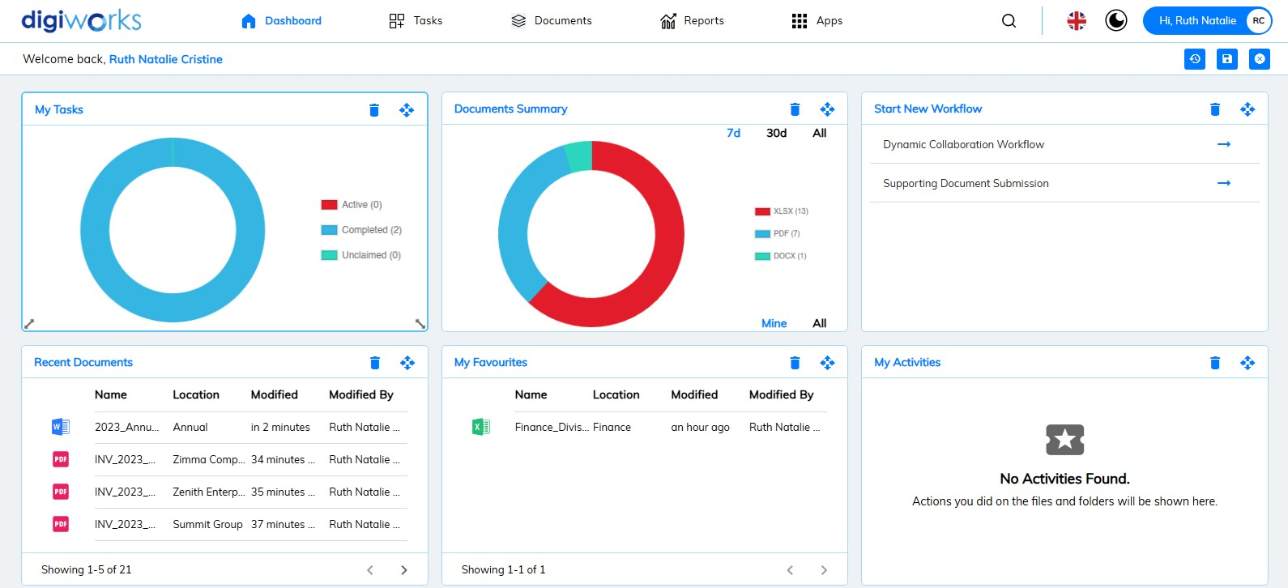

1. Customizable functions offered for the user dashboard are:

*  : To remove the widget from the dashboard.
* : To drag the widget to specific location.
* : To resize the widget.

1. Click on Save to save the changes

* : To restore back to default set up
* : To cancel any changes.

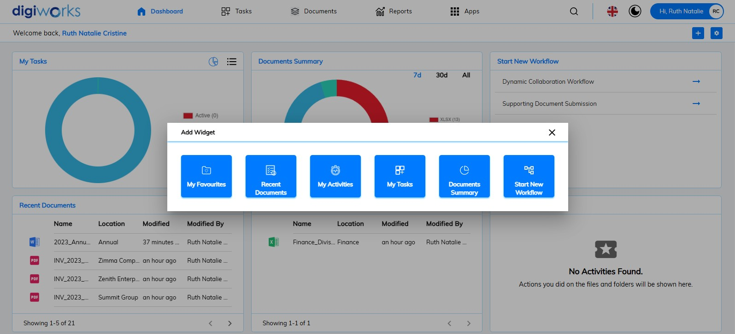

1. To add widget, click and pop up of widget will appear.
2. Select widget to add into the dashboard

### Updating Profile

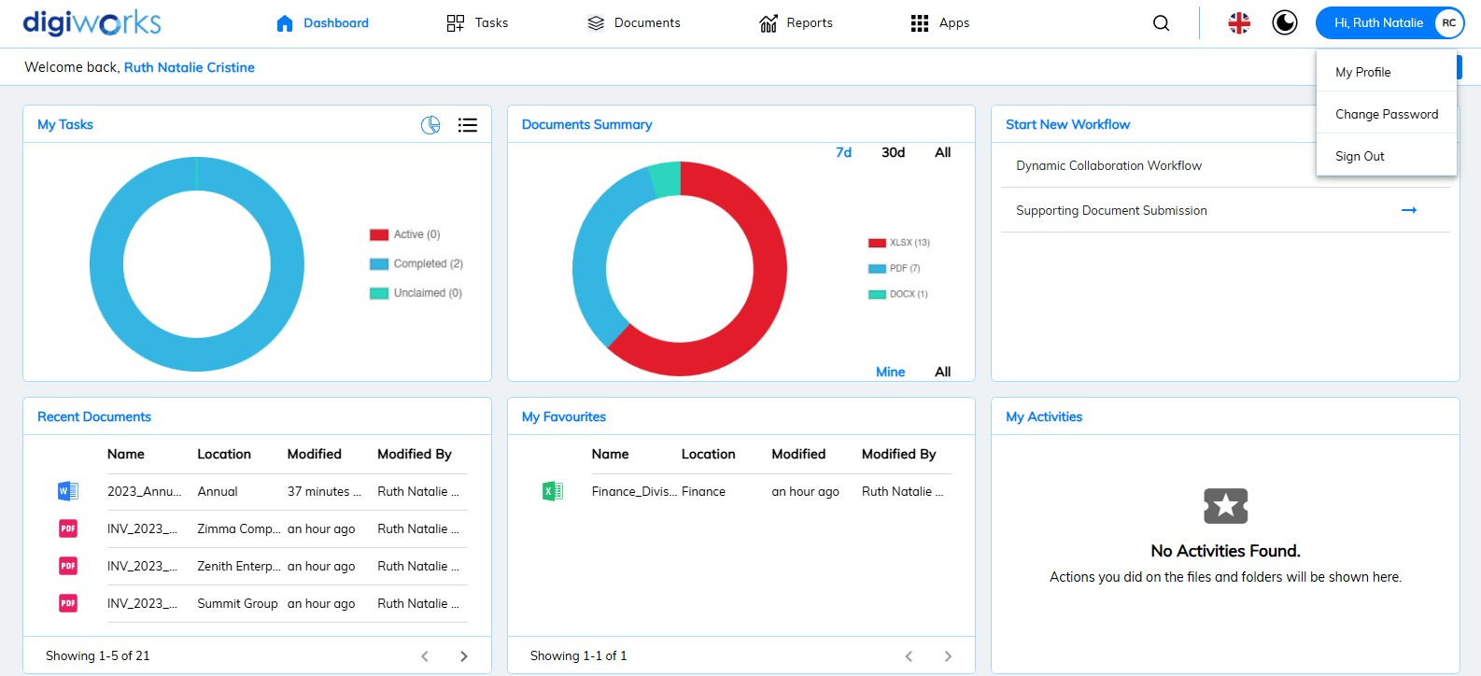

1. Click the User Name (located in the upper right-hand corner)
2. Select My Profile.

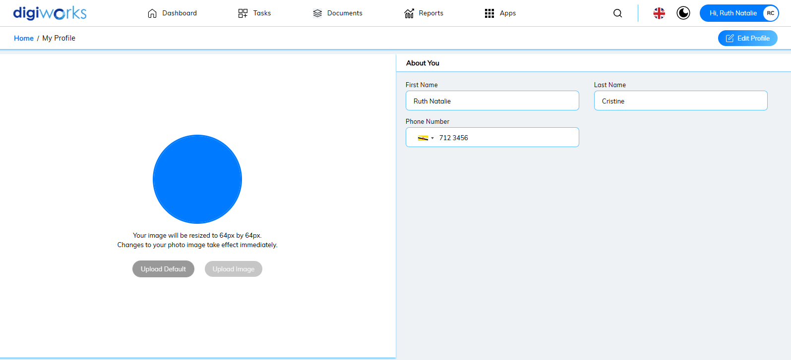

1. Select Edit Profile.
2. User can change editable information under the About You section.

 Notes:

* All information added can only be seen by the owner of the account. ​
* The user’s first and last name cannot be changed however phone number can be updated.

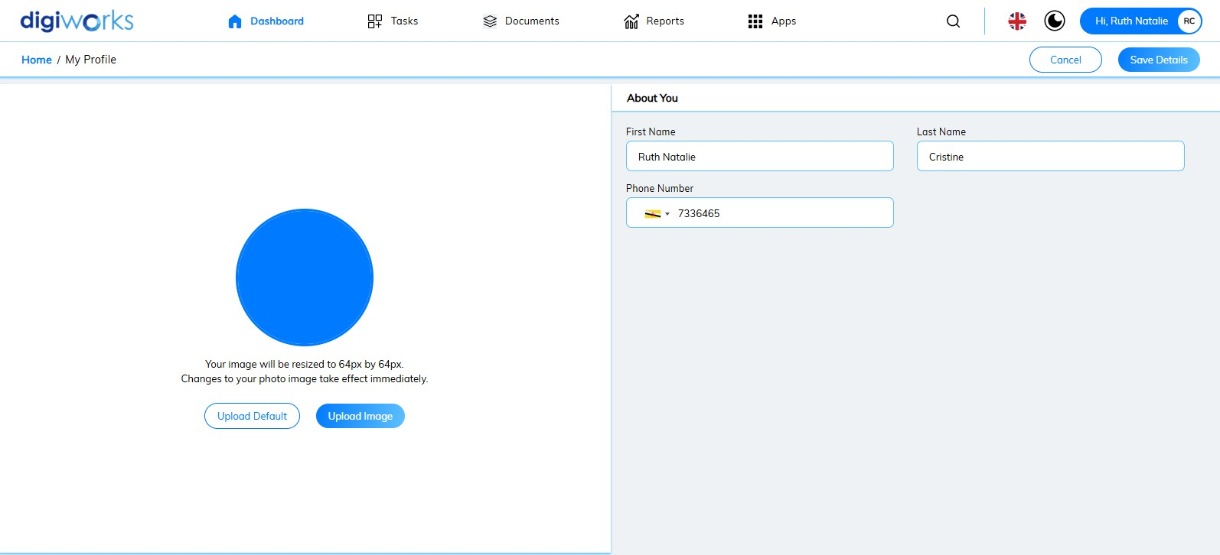

1. Once edited, click Save Details.

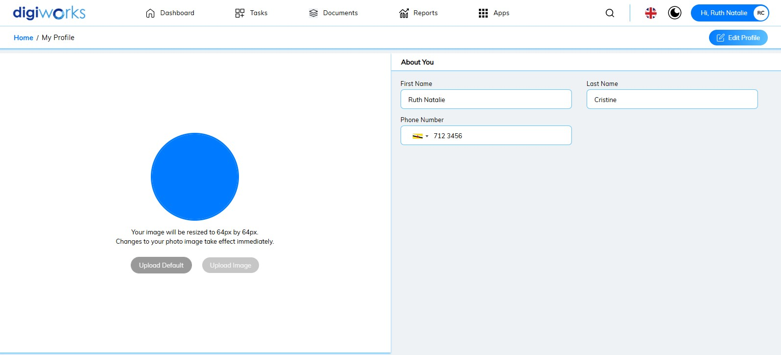

User also can **change the profile** photo by:

1. On the Profile Page, select Edit Profile.



1. Click Upload Image to change user’s profile picture

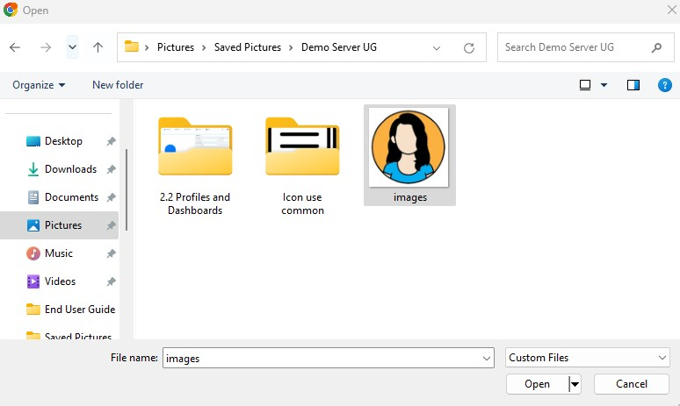

1. Select preferred image from user PC or laptop and click Open.

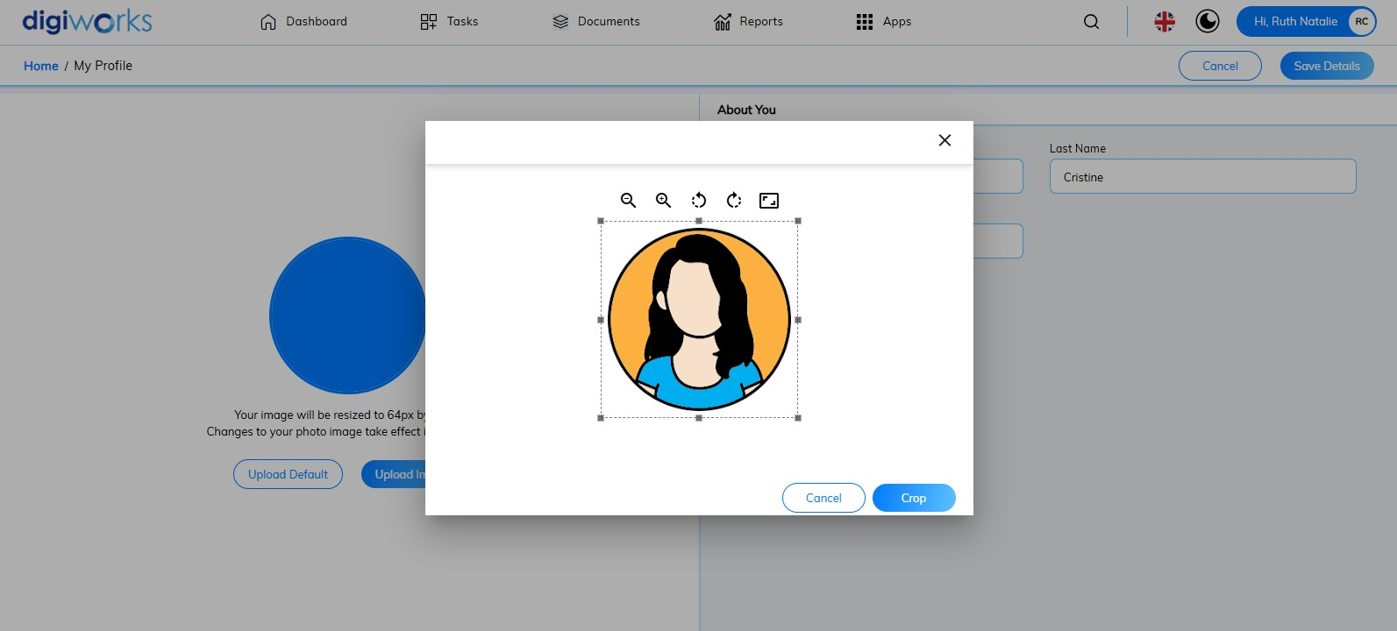

1. A pop-up will be displayed.

 Note:

* User can adjust the image using available features: zoom out, zoom in, rotate left, rotate right, and reset to aspect ration after cropping.

1. Click on Crop to upload image.

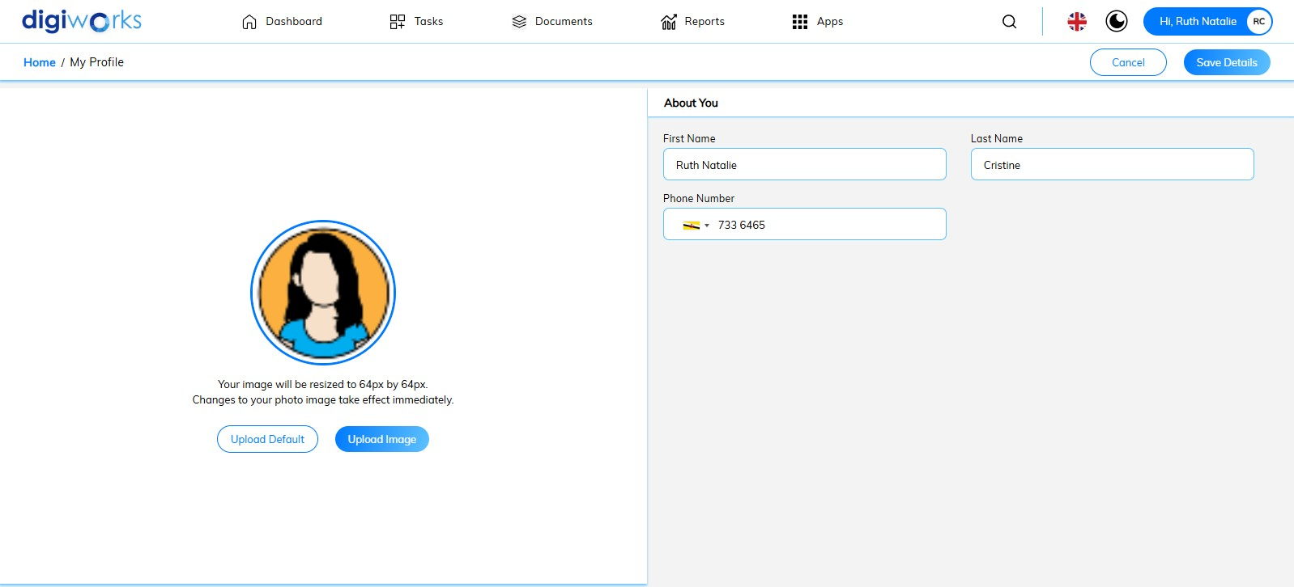

1. Click Save Details once necessary changes have been made.
2. User also can Upload Default to reset profile picture to default.

### Changing Password



1. Click your User Name (located in the upper right-hand corner).
2. Select Change Password from the dropdown menu.

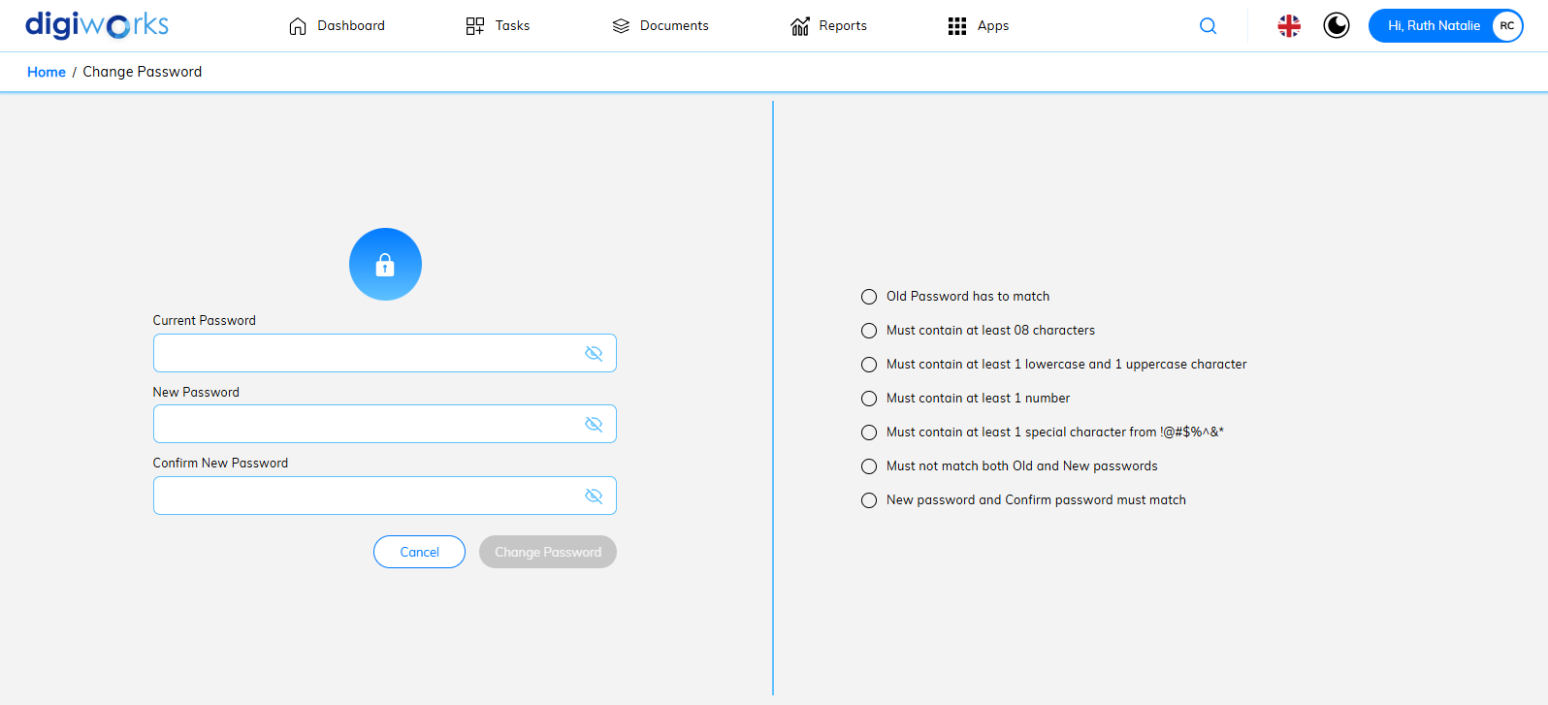

1. Enter your Current Password.
2. Click the to reveal the password.
3. Enter your New Password ensuring it meets the password criteria displayed on the right-hand side.
4. Enter the new password again to confirm.

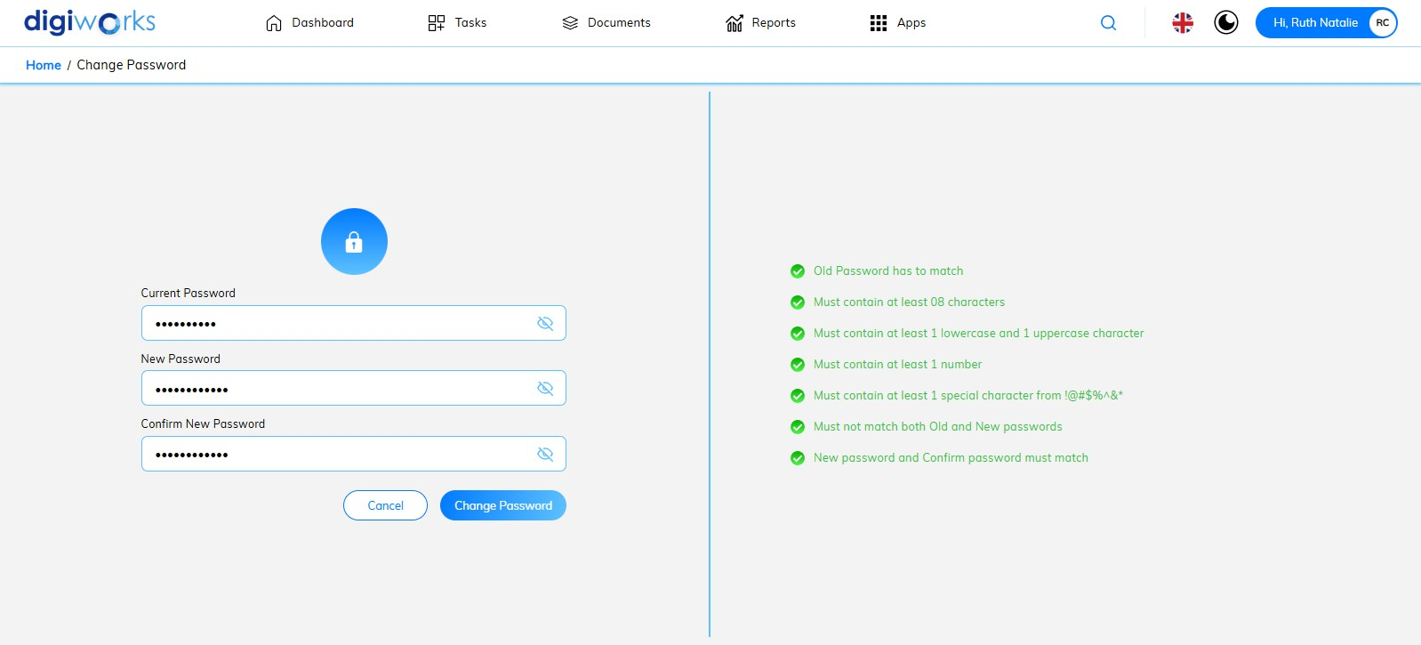

1. Click Change Password to finalize the change,
2. or Cancel to abort the action.

## Sites

### Overview

A site serves as a designated collaborative workspace, facilitating content sharing and interaction among site members. Site creation is restricted to administrative personnel. Upon creation, the initiating administrator is automatically assigned the role of Site Manager. Subsequent to site establishment, additional or alternative Site Managers may be designated as required.

Site visibility is governed by a defined access control mechanism, offering three distinct settings: **public, moderated,** and **private**. These settings determine the site's discoverability and the procedures for user membership. **A public site** is accessible to all users, while **moderated** and **private sites** restrict access and implement specific membership protocols. Comprehensive details regarding the implications of each visibility setting are outlined in the subsequent sections of this document.

#### Create New File Plan

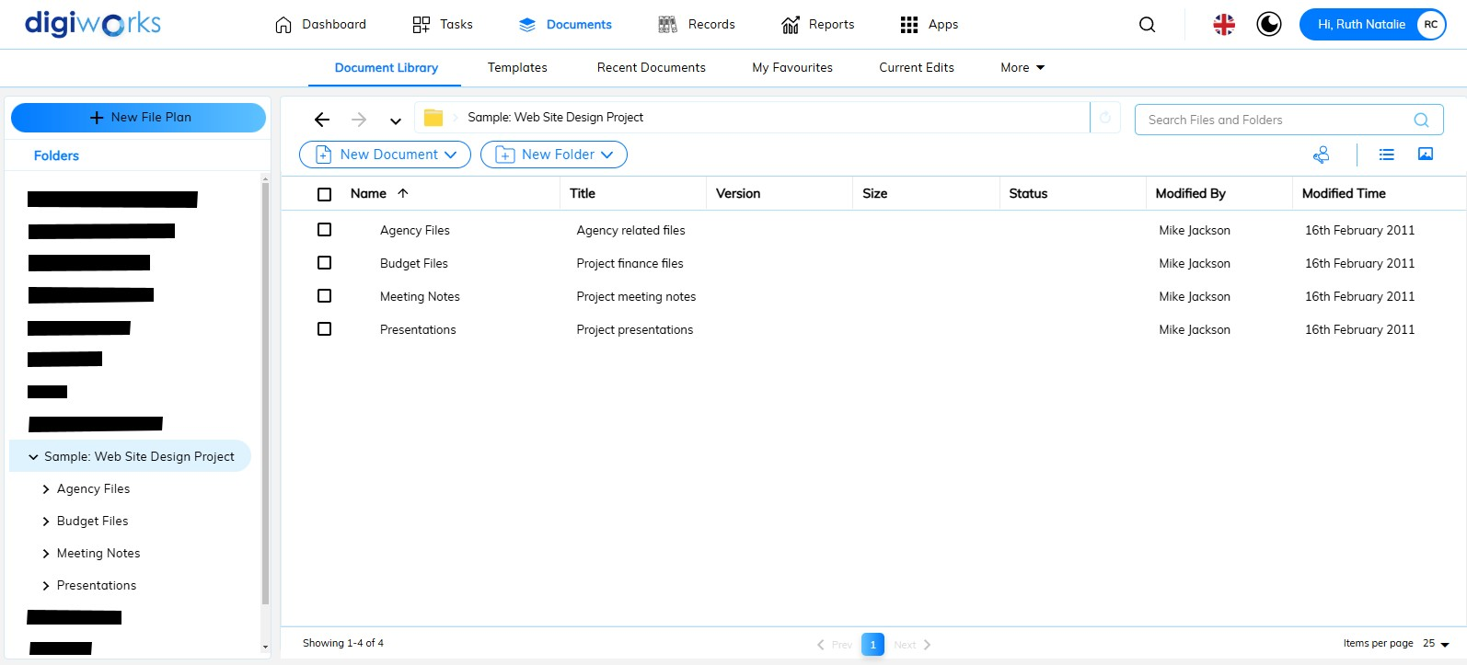

1. Click on the Document Tab.
2. Click the Document Library.
3. Click on button to create a new site.

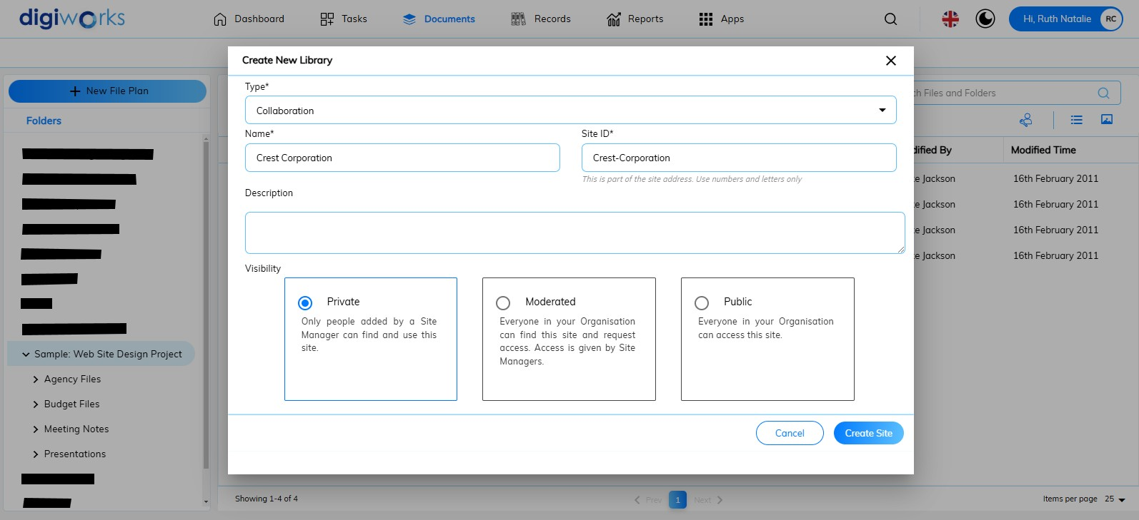

1. The Create New Library pop-up window will appear.
2. Select Collaboration in the Type field.
3. Enter the Site Name in the Name field.
4. The Description field is optional.
5. Choose the site visibility:

|  |  |
| --- | --- |
| **Site visibility** | **Description** |
| Public Site | All users can view the content but only site members can work with the content.  Any user can join the site. |
| Moderate Site | All users can access the site but only site members can see and work with the content.  Users must ask to join the site. |
| Private Site | Only site members can access the site.  Users must be added to the site by a site manager. |

1. Click the Create Site button
2. Alternatively, click Cancel to abort the action.

#### Accessing Existing Sites

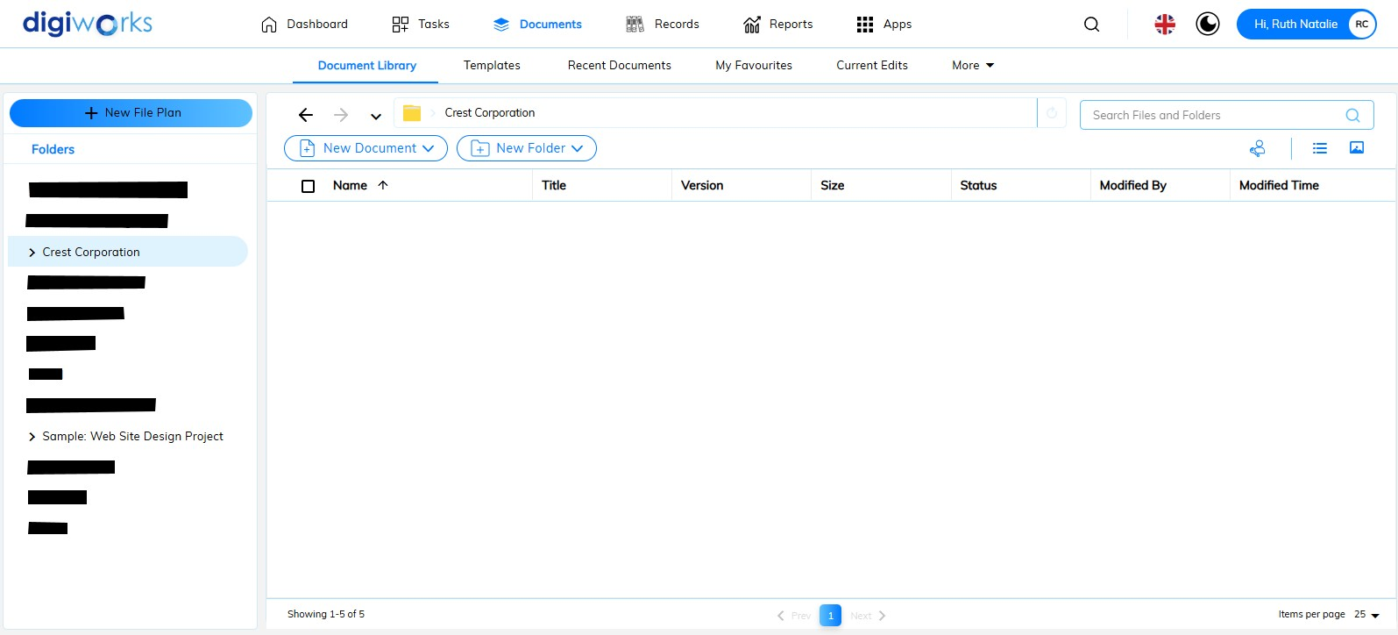

1. In the left panel, under the Folders header, you will see a list of sites to which you have access.
2. Select the site to which you have access or the site you just created in the Create New File Plan process.

#### Managing Site Members

**Grant Site Access to User**



1. Click on to manage permission in the selected site.

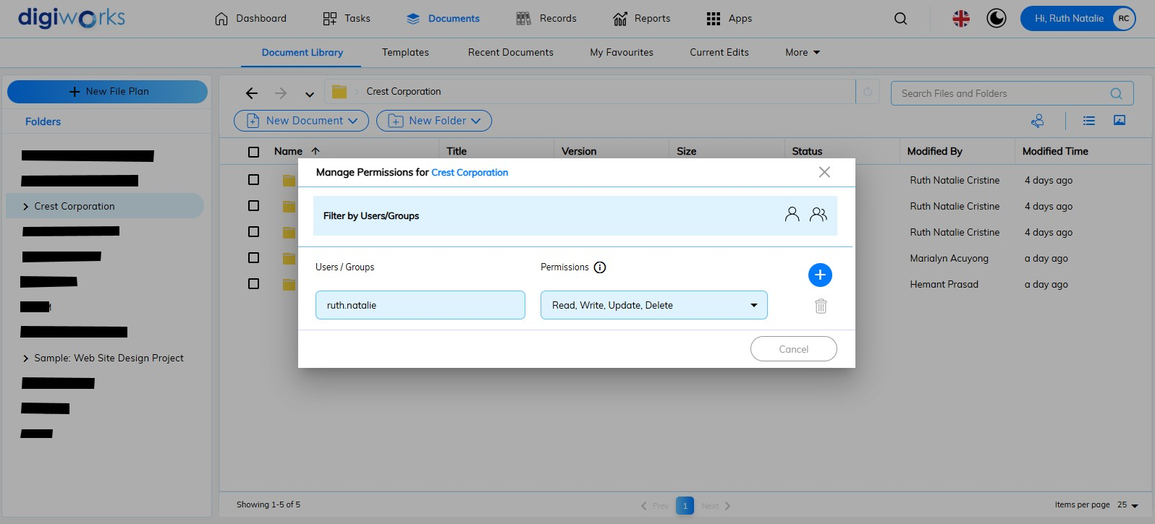

1. Pop up window Manage Permission for Crest Corporation Site will show.
2. Click to add User/Groups to the site.

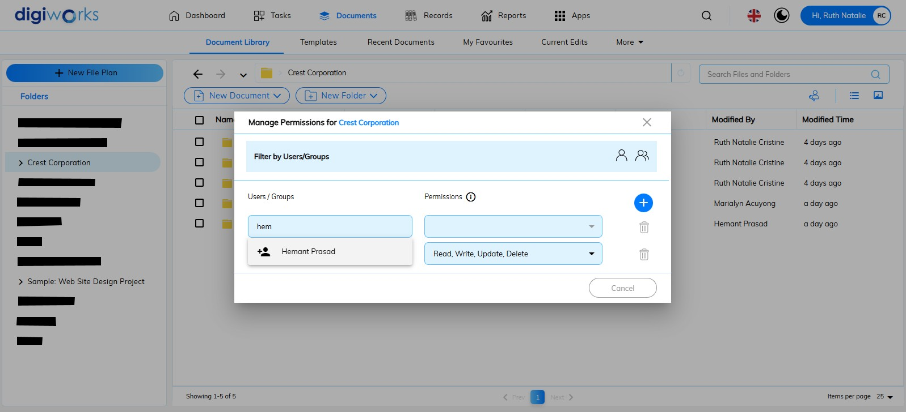

1. Enter the User or Group name in the User/Groups field.

 **Note:**

* This autosuggests field provides User and Group name suggestions. Selecting a name will automatically complete the username.

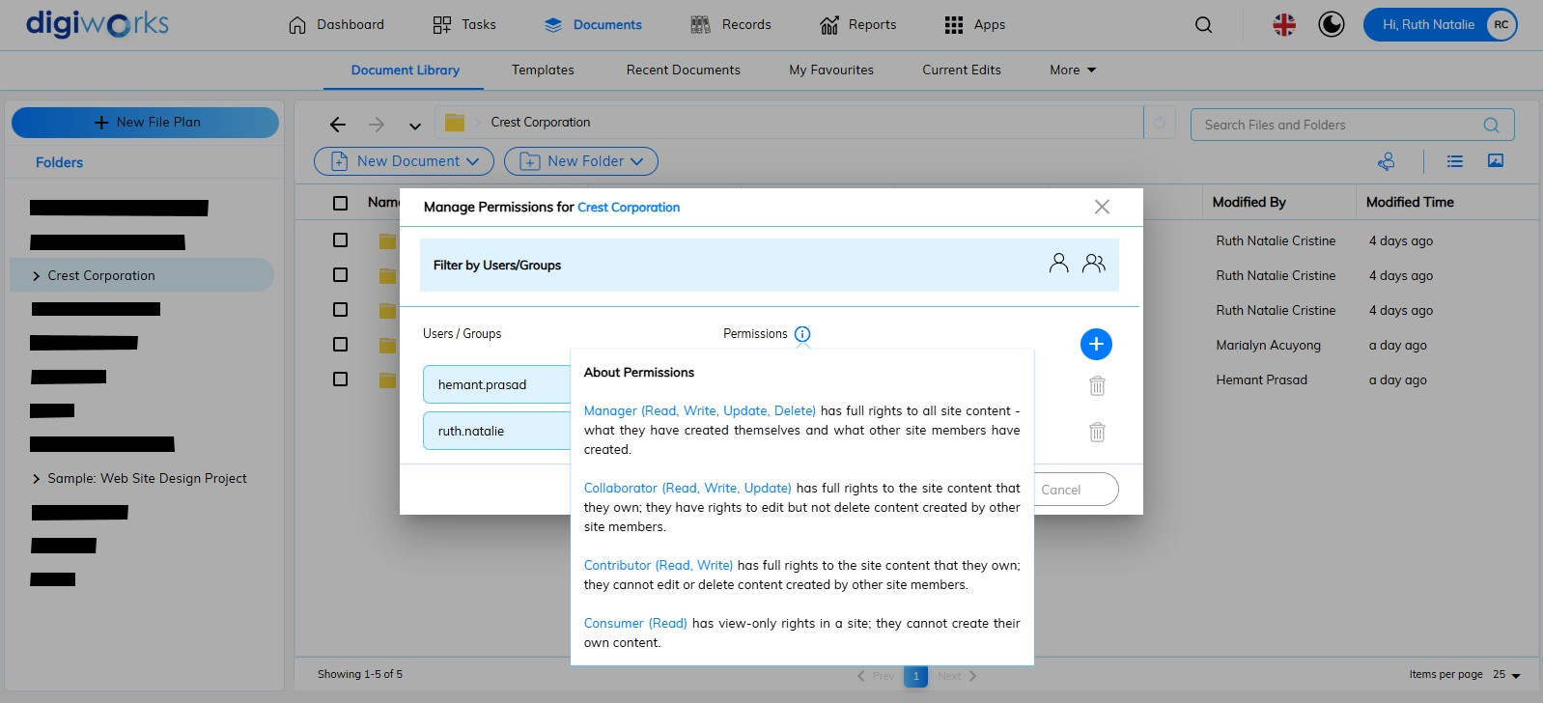

1. Click on to see the permission

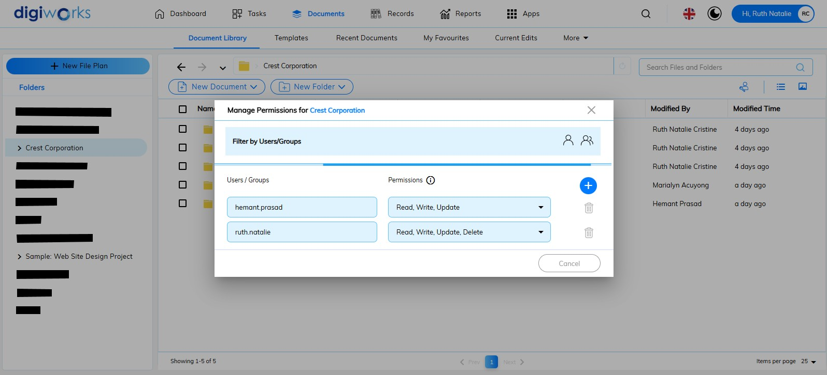

1. Give the permission to the entered username

**Remove User from Site**

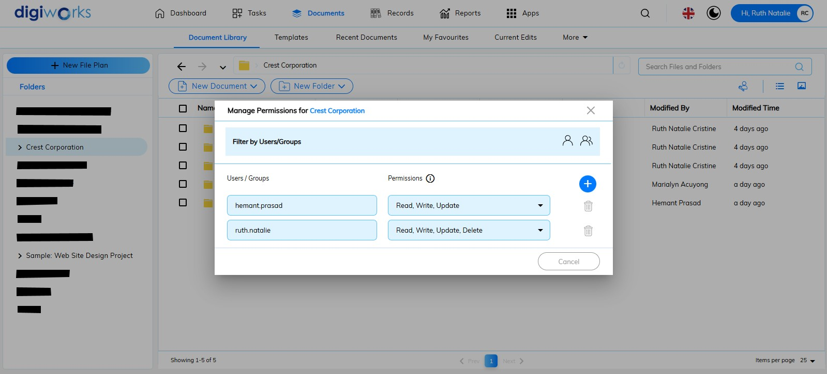

1. Click to remove the user from the site.

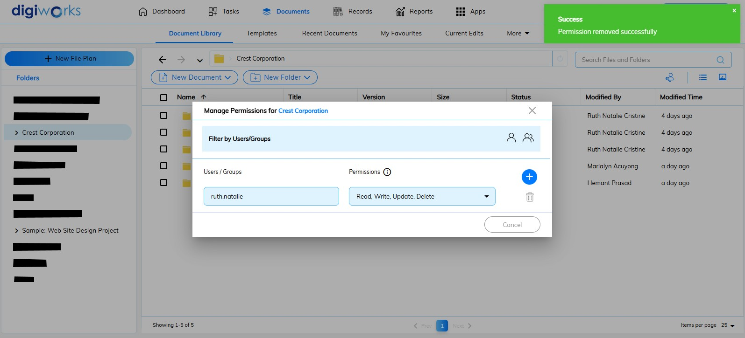

1. A success message will appear.

### Features

## Content

### Overview

The site document library serves as the central repository for storing and managing digital assets, including documents, images, and video files, within a collaborative site environment. Users with appropriate permissions may upload content for sharing and collaborative editing with other site members. Access and modification rights are determined by individual user permission settings.

Activity within the document library is aggregated and displayed in the Site Content dashlet, providing a concise overview of recently added and updated content. This feature facilitates efficient monitoring of content changes within the site.

In addition to the site document library, users may also store and manage content within the My Files and Shared Files areas. Detailed information regarding the functionality and access protocols for these alternative storage locations is available in the respective sections of this document.

#### Document Library

This section provides access to the central repository for storing and managing documents, folders, and other files within the site. It is the primary location for collaborative content.

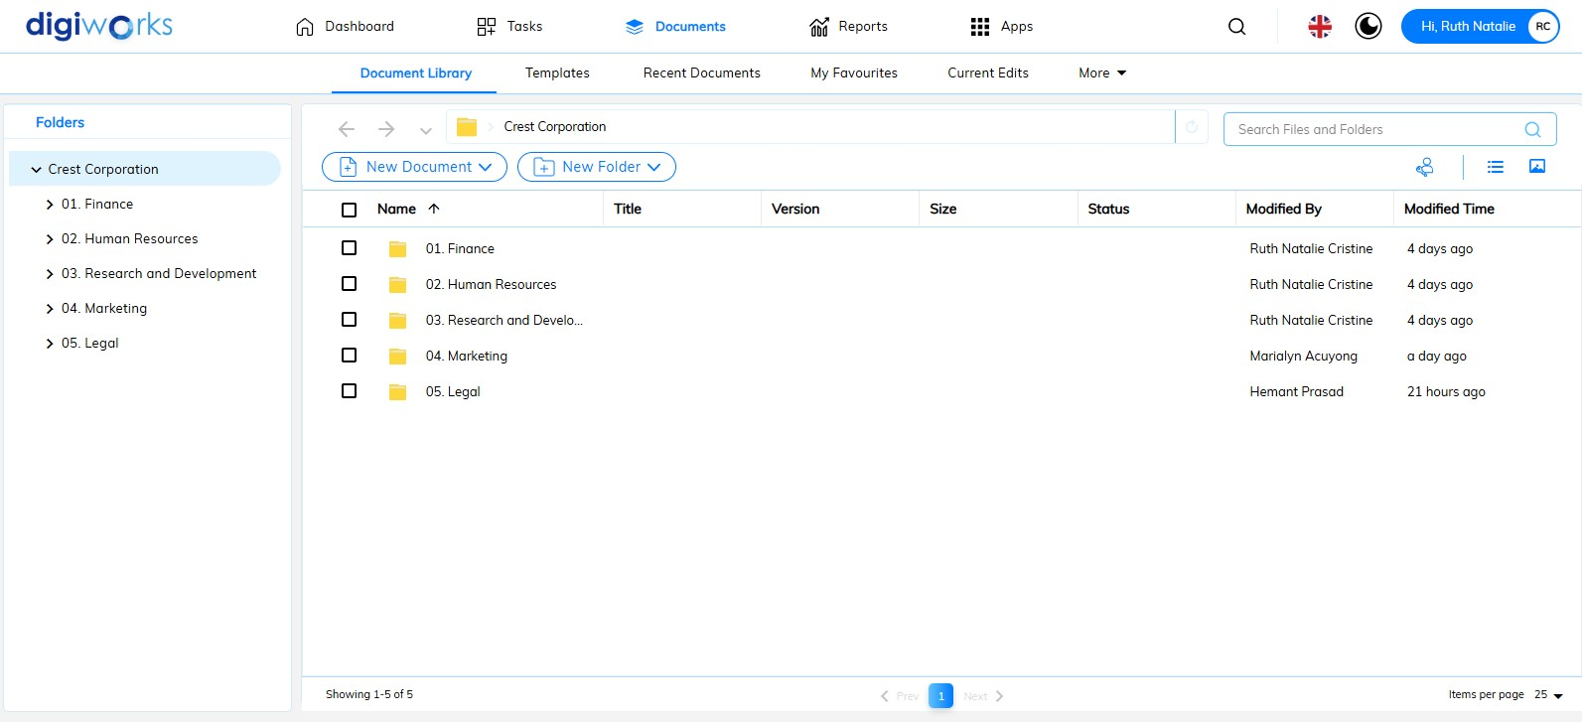

1. Click on the Document Tab
2. Click the Document Library to access the library
3. At the header to change the criteria used to sort the items and click the  to toggle between ascending and descending sort order.

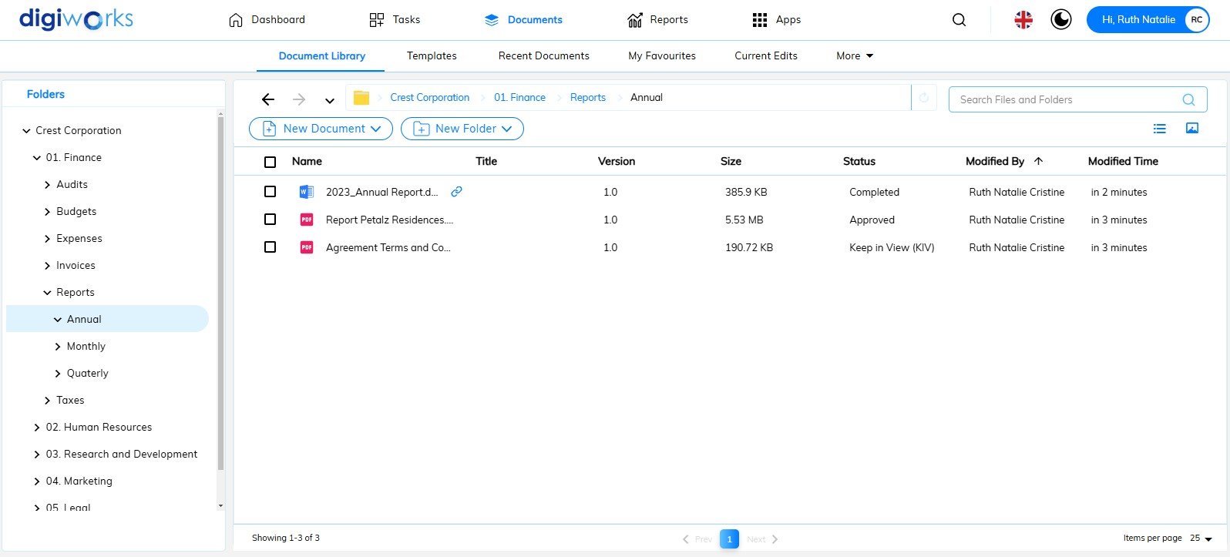

1. Navigate to a deeper level within the folder structure to view additional documents.
2. The following information is displayed in the header beneath the document library:
3. **Name:** This displays the filename assigned to the document or folder.
4. **Title:** This displays the title given to the document or folder, which may be more descriptive than the filename.
5. **Version:** This indicates the version number of the document, reflecting any updates or revisions.
6. **Size:** This shows the file size of the document or folder
7. **Modified By:** This identifies the user who last modified the document or folder.
8. **Modified Time:** This displays the date and time of the most recent modification.

#### Exploring the Library

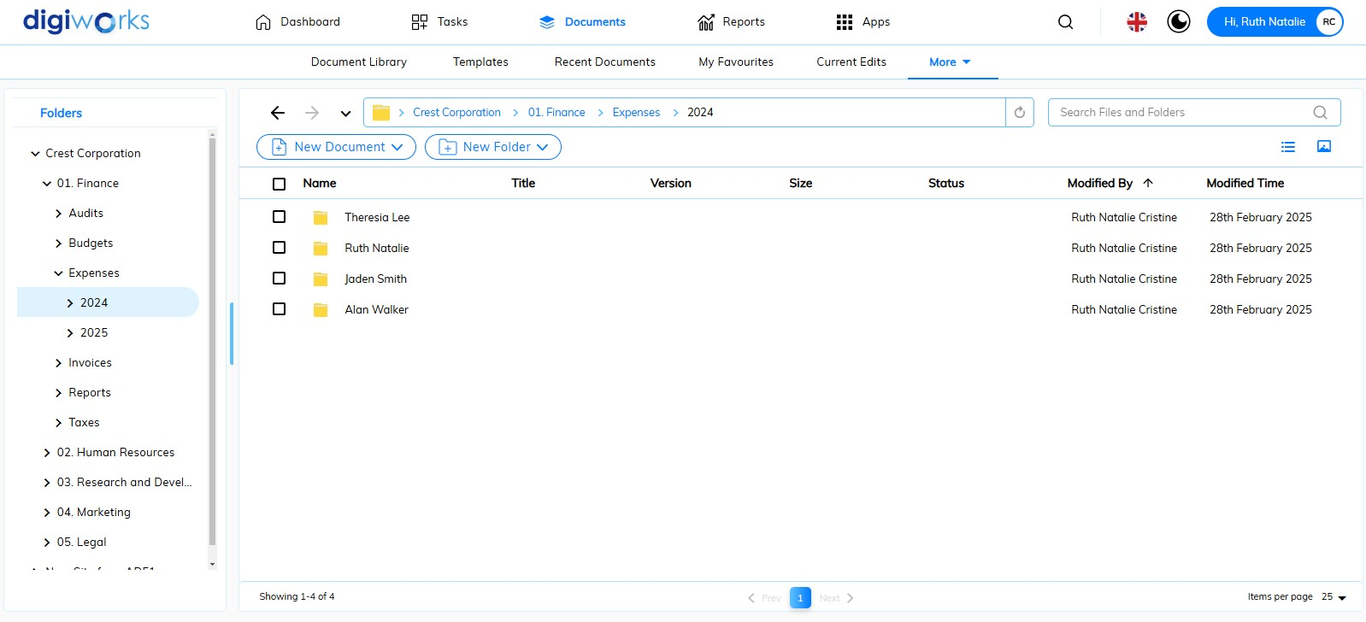

1. Click on the Document Tab
2. There are two ways to view the folder structure:
3. The Document Library section displays the folder structure in a tree view. The symbol indicates that a library folder contains subfolders. Click on a folder name to collapse it.
4. Under the Folders header, there are tree view indicates the folder structure. The symbol indicates that a library contained folder(s) and/or document(s). Click on the symbol to expand or collapse it.

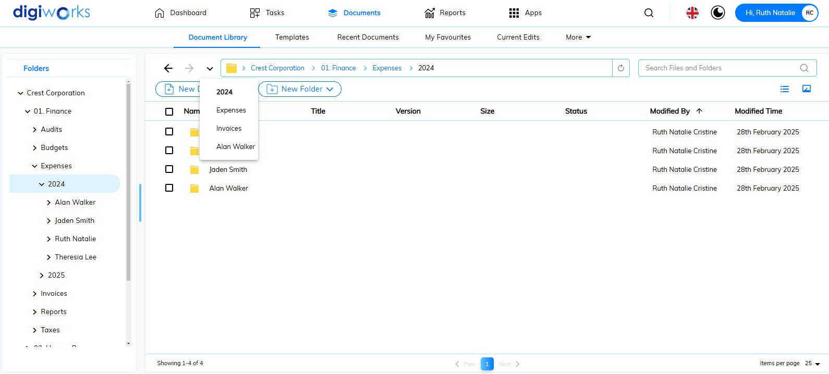

1. To view the recent location, click 
2. Click a recent location option to return to the previous location.

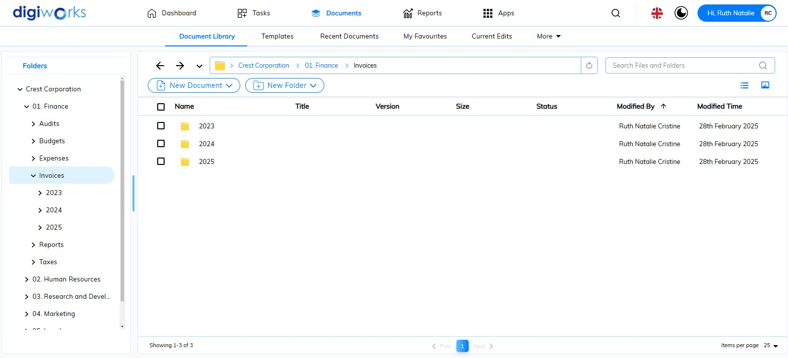

1. To navigate one folder level up, click
2. To navigate one folder level down, click
3. To refresh the folder view, click 

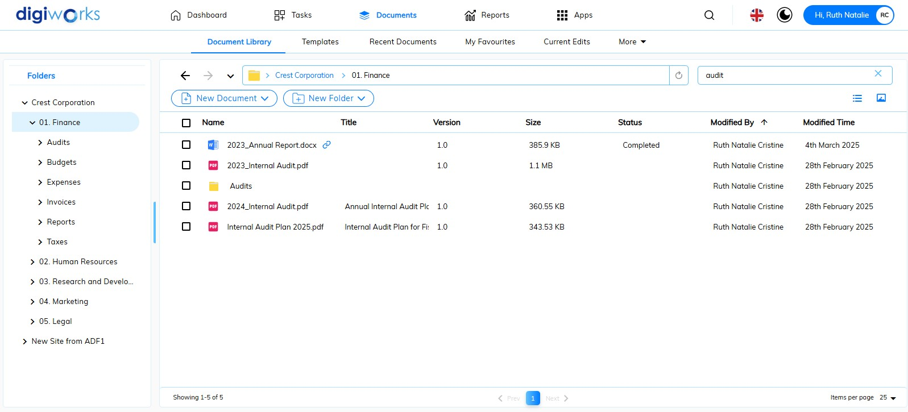

1. To search for folders and/or files within the selected folder, enter a keyword of at least three characters in the search box 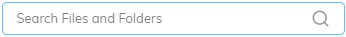.
2. The search results will automatically appear.

#### Library View Options

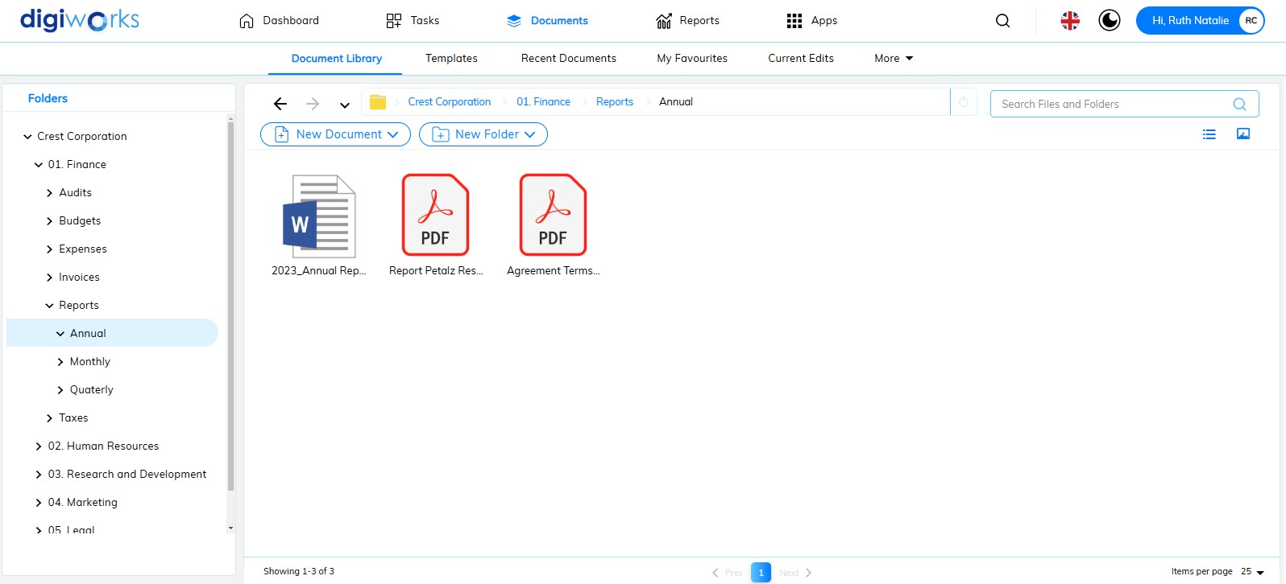

1. The default folder arrangement is List View. Users can switch to Thumbnail View by clicking .
2. To go back to List View or default view, click .
3. By default, 25 items are displayed per page. Click to access additional display options, including 50 and 100 items per page.
4. To navigate to the next page, click .
5. To navigate to the previous page, click .
6. This  displays the number of pages with the blue highlighted number indicating the current page.
7. This displays the total number of items in the current folder.

#### Content outside the Document Library

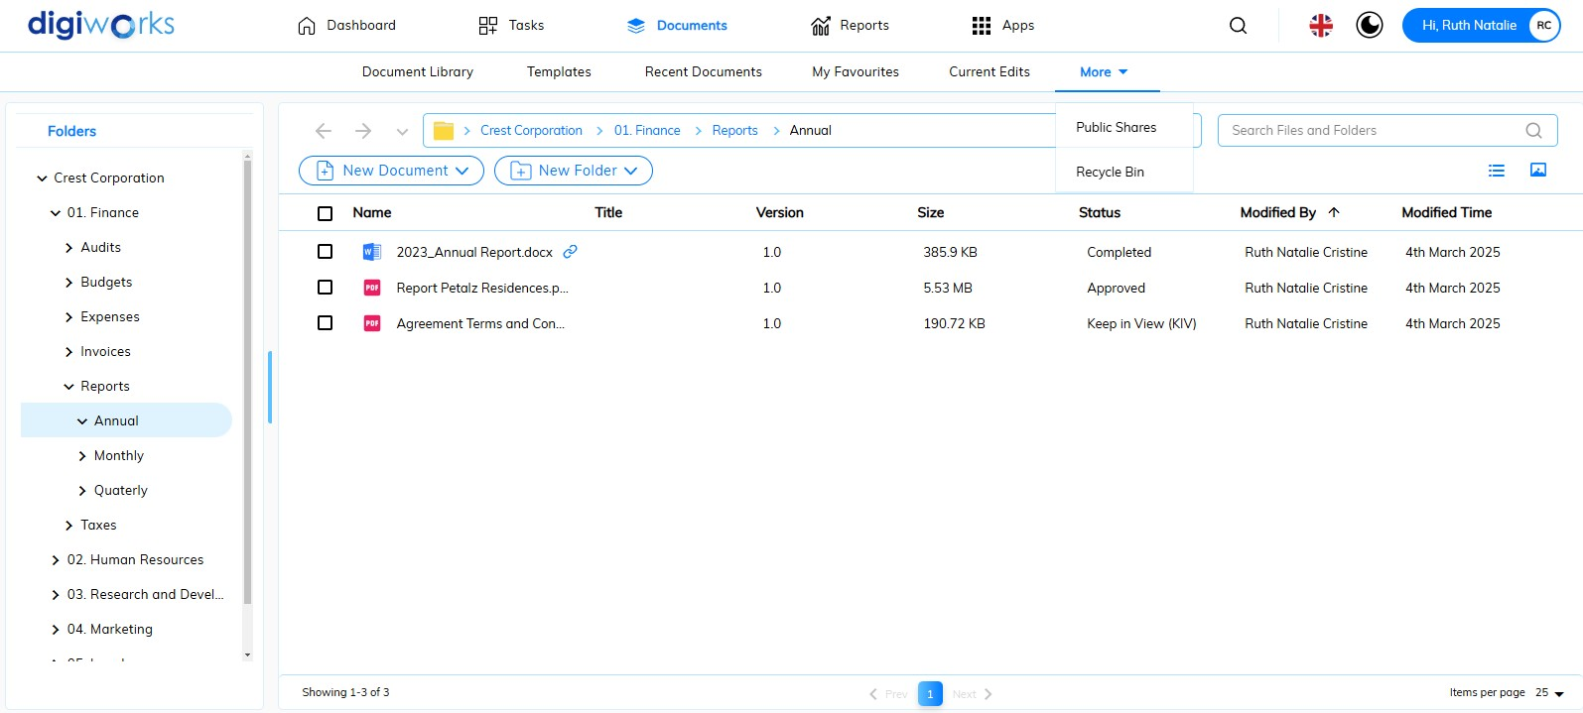

* 1. Click on the Document Tab
  2. Under the Document Tab, the following headers are displayed:

1. **Document Library**: This section provides access to the central repository for storing and managing documents, folders, and other files within the site. It is the primary location for collaborative content.
2. **Templates**: This area contains pre-formatted document templates that users can utilize to create new documents, ensuring consistency and efficiency.
3. **Recent Documents**: This displays a list of documents that the user has recently accessed or modified, allowing for quick retrieval of frequently used files.
4. **My Favourites**: This section allows users to bookmark or save frequently accessed documents for easy access.
5. **Current Edits**: his displays documents that are currently being edited by the user, providing a quick way to resume work in progress.
6. **More: Public Shares**: This section provides access to documents or folders that have been shared publicly, allowing access to users outside of the site's immediate membership.
7. **More: Recycle Bin**: This section stores deleted documents and folders, allowing for recovery of accidentally deleted items.

##### Templates

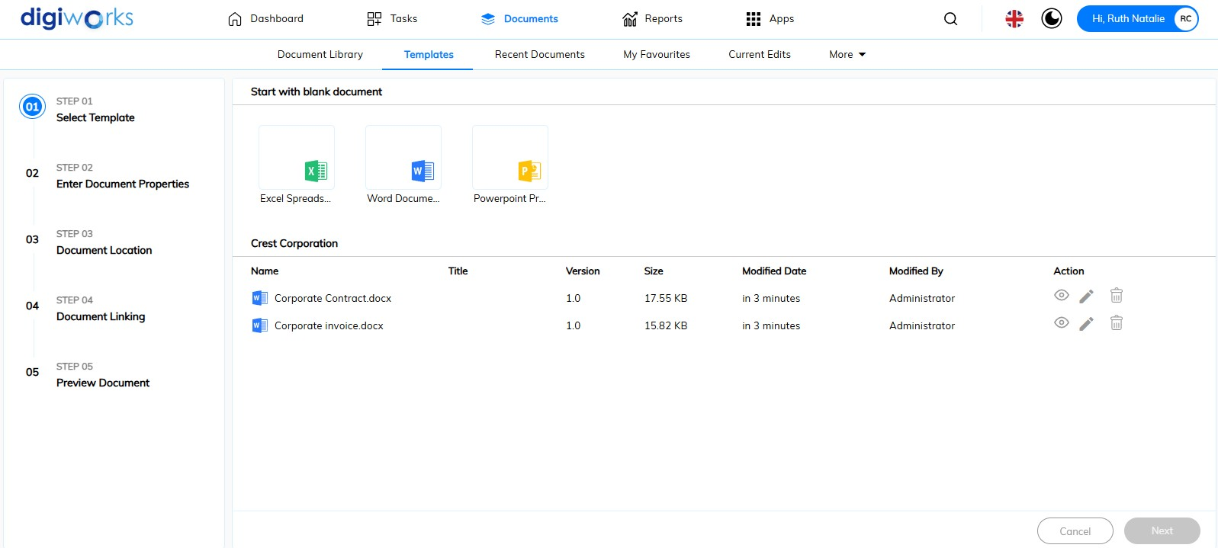

1. Click on the Document Tab.
2. Click on the Templates header.
3. **Step 01**: Select Template.

There are two ways to create a document from a template:

1. Start with a blank document. Choose Excel, Word, or PowerPoint as the blank document type.
2. Start with a pre-defined template. Choose the desired template.
   * + To *preview* the template, click 
     + To *edit* the template, click . The selected template will then be downloaded for offline editing.
     + To *delete* the template, click . A confirmation pop-up message will appear. Click 'Yes' to delete or 'No' to cancel.
3. **Step 02**: Enter Document Properties.

There are two separate scenario depends on which template you chose from Point #3:

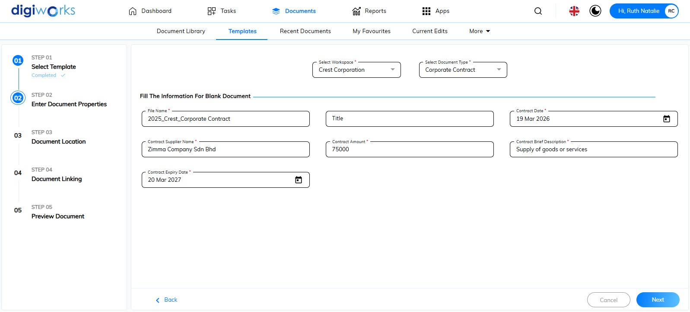

1. If you selected 'Start with a blank document', you will need to select the Workspace and Document Type. Then, fill in the metadata. Click to proceed to next step.

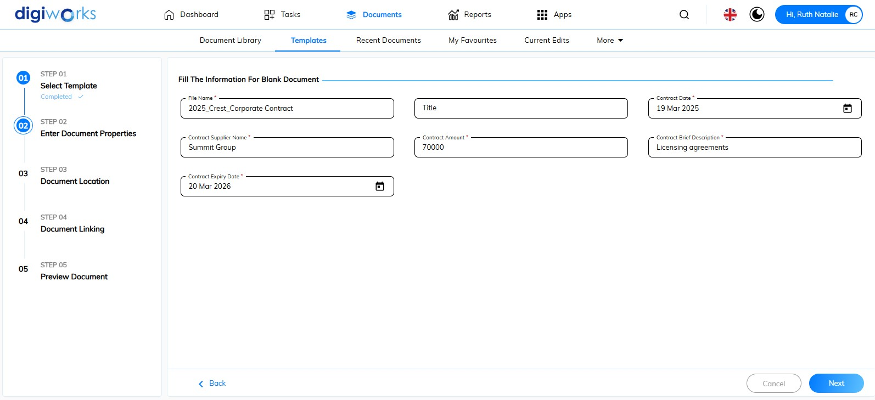

1. If you selected ‘Start with a pre-defined template’, you can proceed directly to filling in the metadata. Click to proceed to next step.
2. **Step 03**: Document Location.

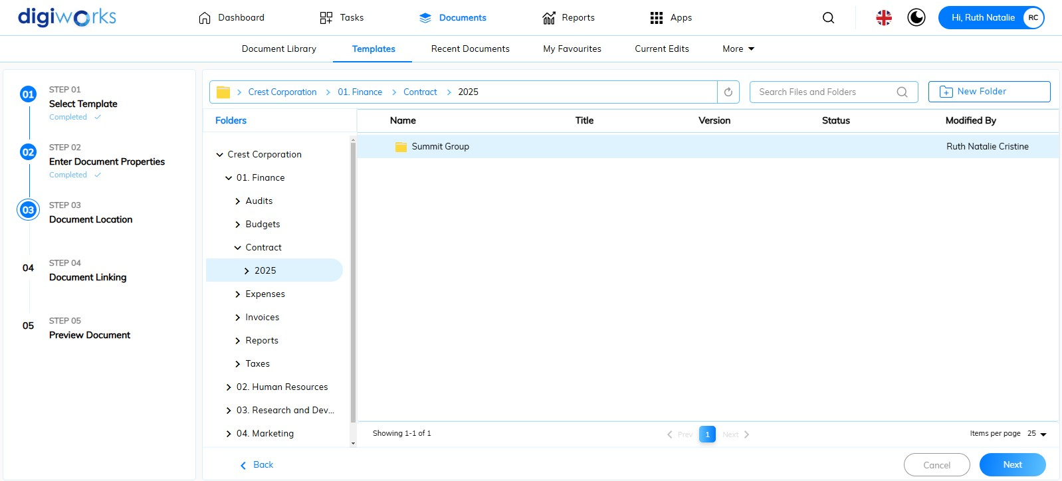

1. Choose the document location, navigate to the subfolder or create new folder.
2. Click 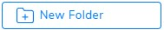to create new folder in the selected location.
3. Follow the steps in 2.4.2.2. Adding Folders.
4. Click to proceed to next step.
5. **Step 04**: Document Linking (optional).

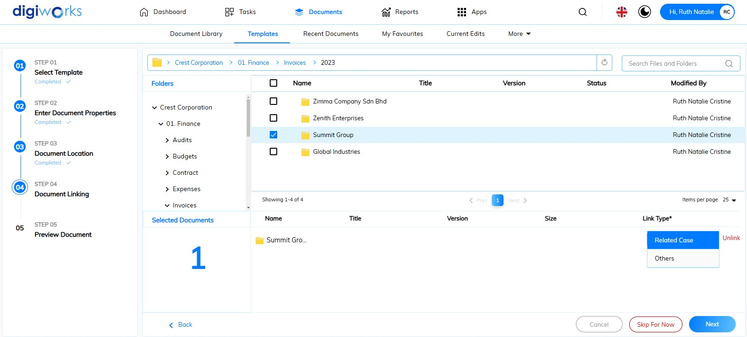

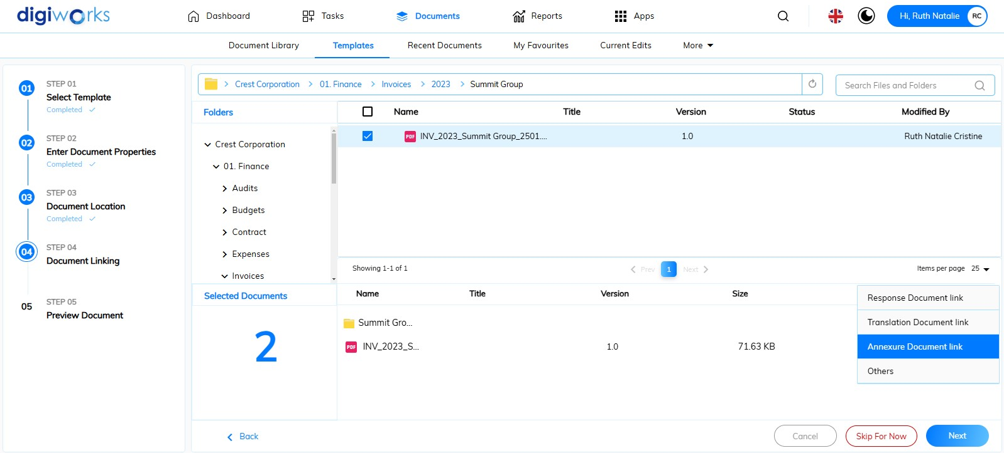

1. Template linking requires selection of a folder or document. Folder linking provides the options 'Related Case' and 'Others', and document linking provides 'Response Document Link', 'Translation Document Link', 'Annexure Document Link', and 'Others'.
2. Click to proceed to next step.
3. **Step 05**: Preview Document.

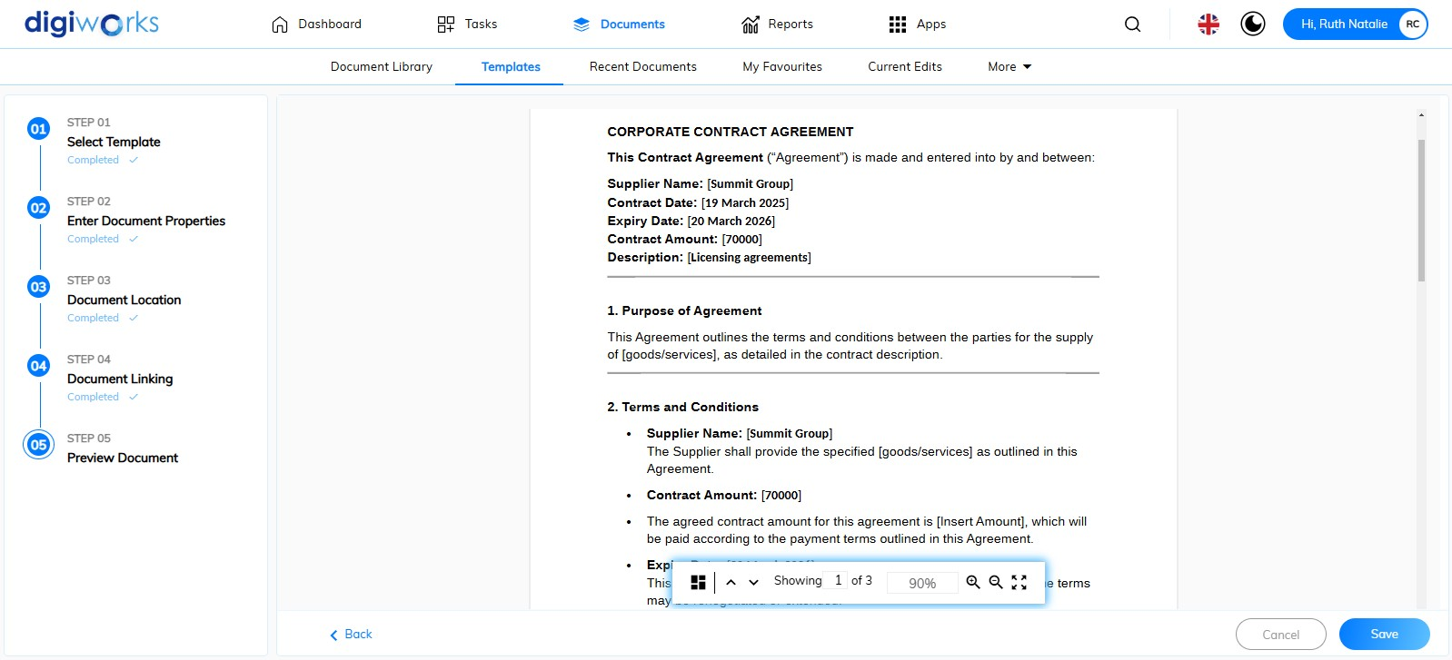

1. Click to save the document **or** click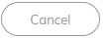to discard the template. If the Cancel button is selected, a confirmation pop-up message will appear. Click 'Yes' to discard or 'No' to cancel the action.
2. A pop-up message will appear confirming successful saving to the designated location.

##### Recent Documents

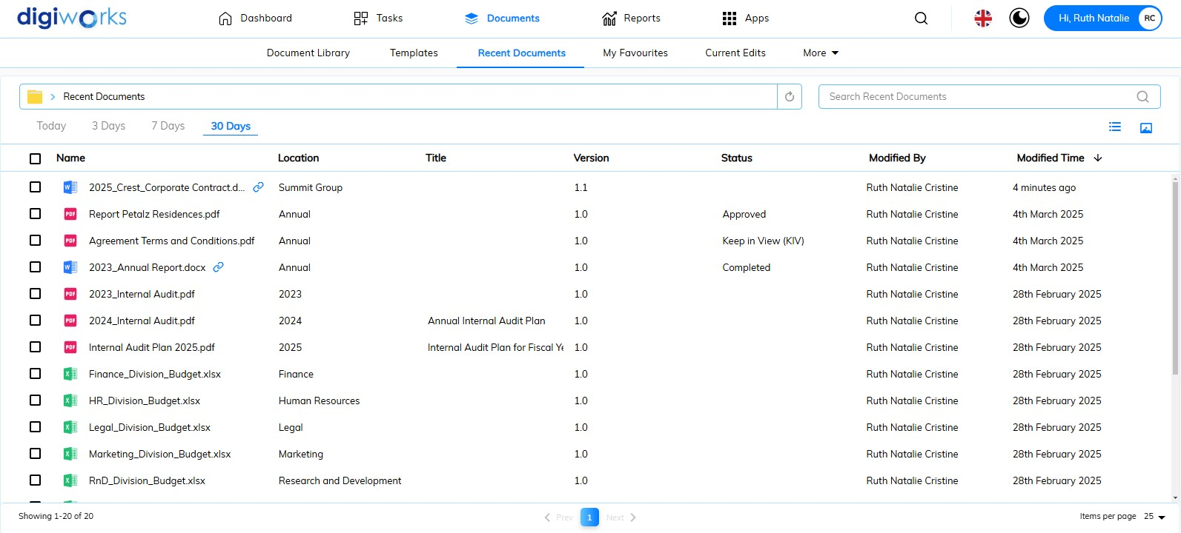

1. Click on the Document Tab.
2. Click on the Recent Documents header.
3. Recent documents are displayed based on pre-defined time durations, such as Today, Last 3 Days, Last 7 Days, and Last 30 Days.
4. Enter at least three characters in the  to search recent documents.

##### My Favourites

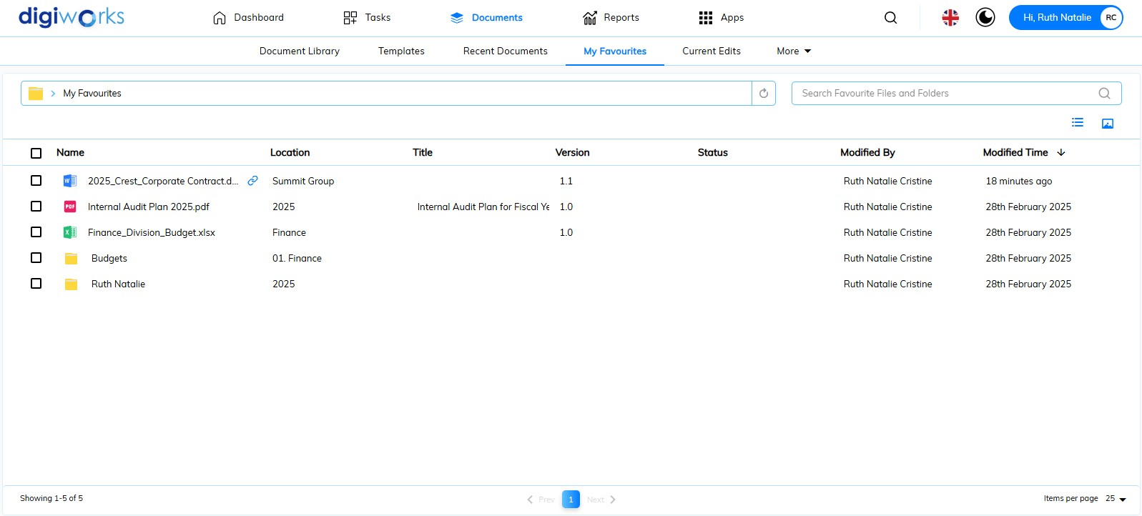

1. Click on the Document Tab.
2. Click on the My Favourites header.
3. Enter at least three characters in the  to search recent documents.

##### Current Edits

Currently is displaying bugs

##### Public Shares

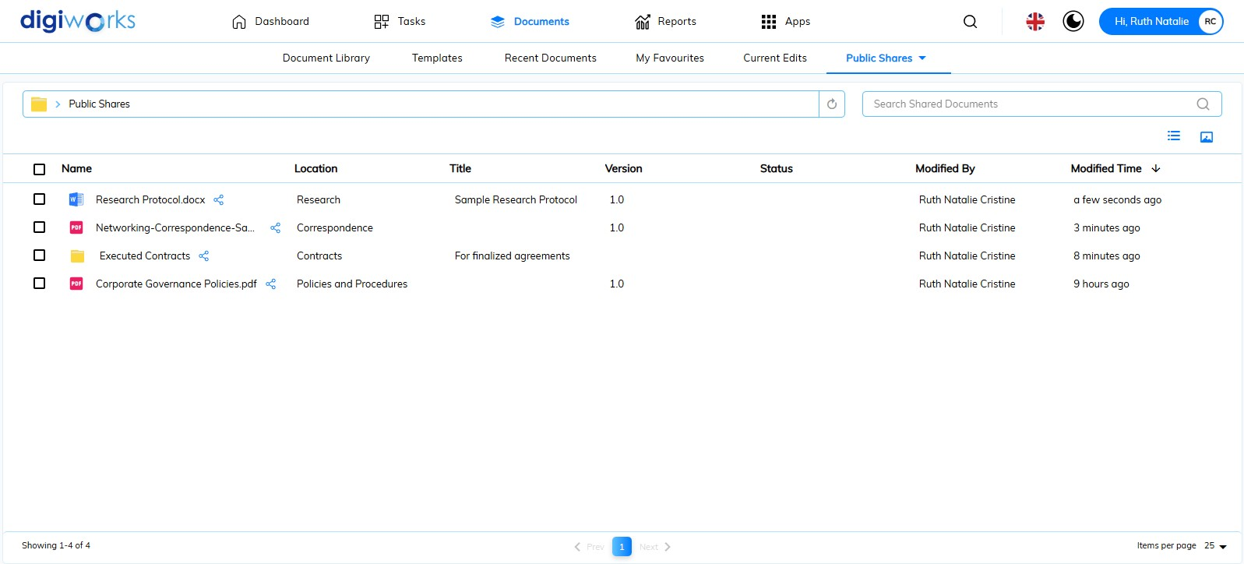

1. Click on the Document Tab.
2. Click on .
3. Select Public Shares from the dropdown options.
4. Enter at least three characters in the  to search recent documents.

##### Recycle Bin

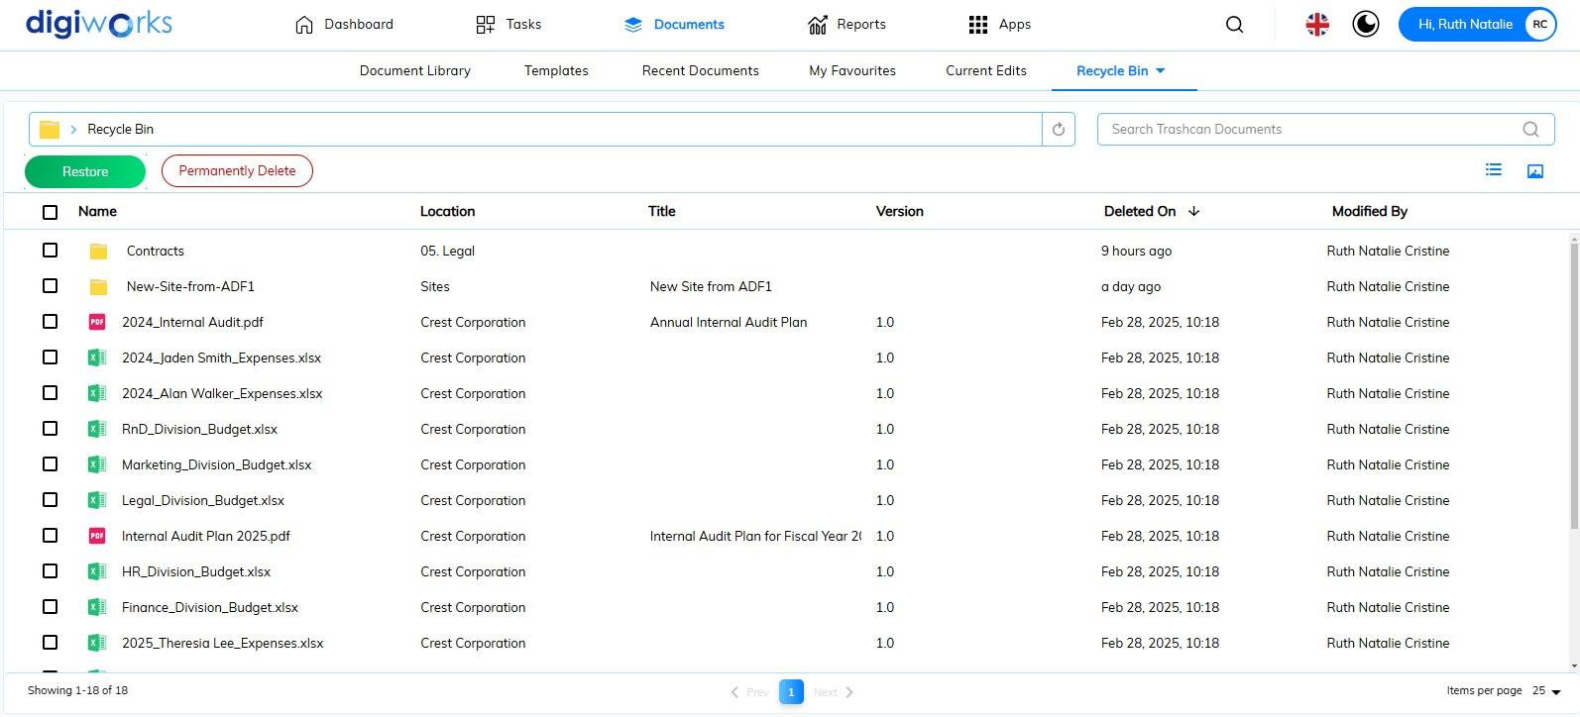

1. Click on the Document Tab.
2. Click on .
3. Select Recycle Bin from the dropdown options.
4. Enter at least three characters in the  to search recent documents.
5. Select the file or folder and click the  button to restore it to the document library.
6. Select the file or folder and click the 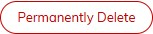 button to restore it to the document library.

### Manage content

Content can be added, viewed and organized easily in DigiWorks.

#### Adding Folders

You can add folders from outside DigiWorks and create new folders within a site.

There are three ways to add folders:

* Click Create in the Document Library
* Drag and drop folders from your computer
* Create folders from templates

##### Create New Folder

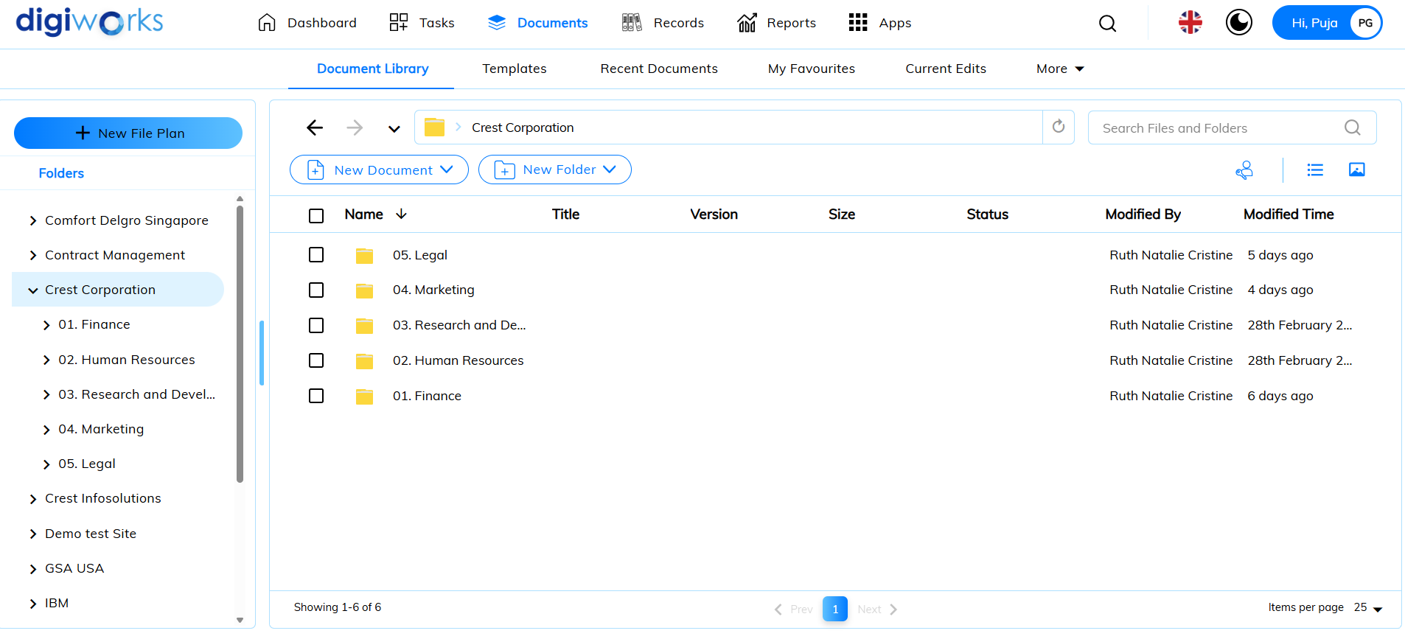

1. Click on the Document tab.
2. Click on Document Library.
3. Click on 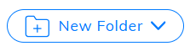and select Create New.

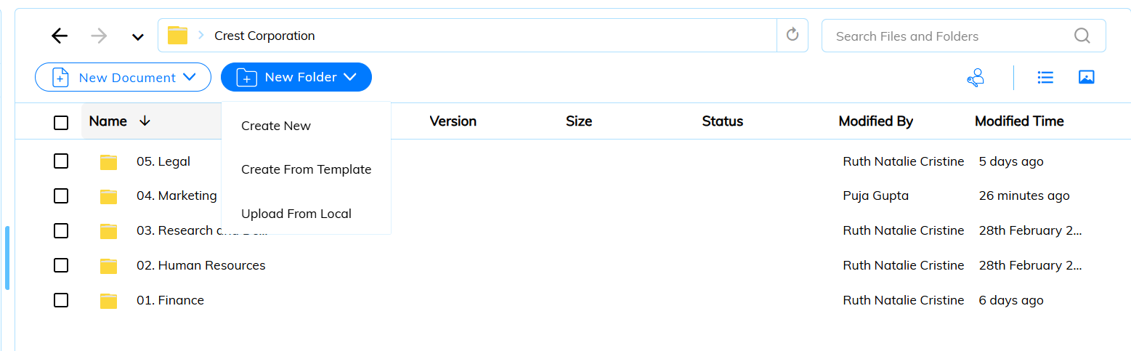

1. Create New Folder pop-up window will appear.
2. Fill in the necessary fields and click Next.

 Notes:

* The folder name does not support the following special characters: * " < > \ / . ? : and |. When the name contains a disallowed character the Save button is disabled.
* The folder name can include a period as long as it is not the last character.

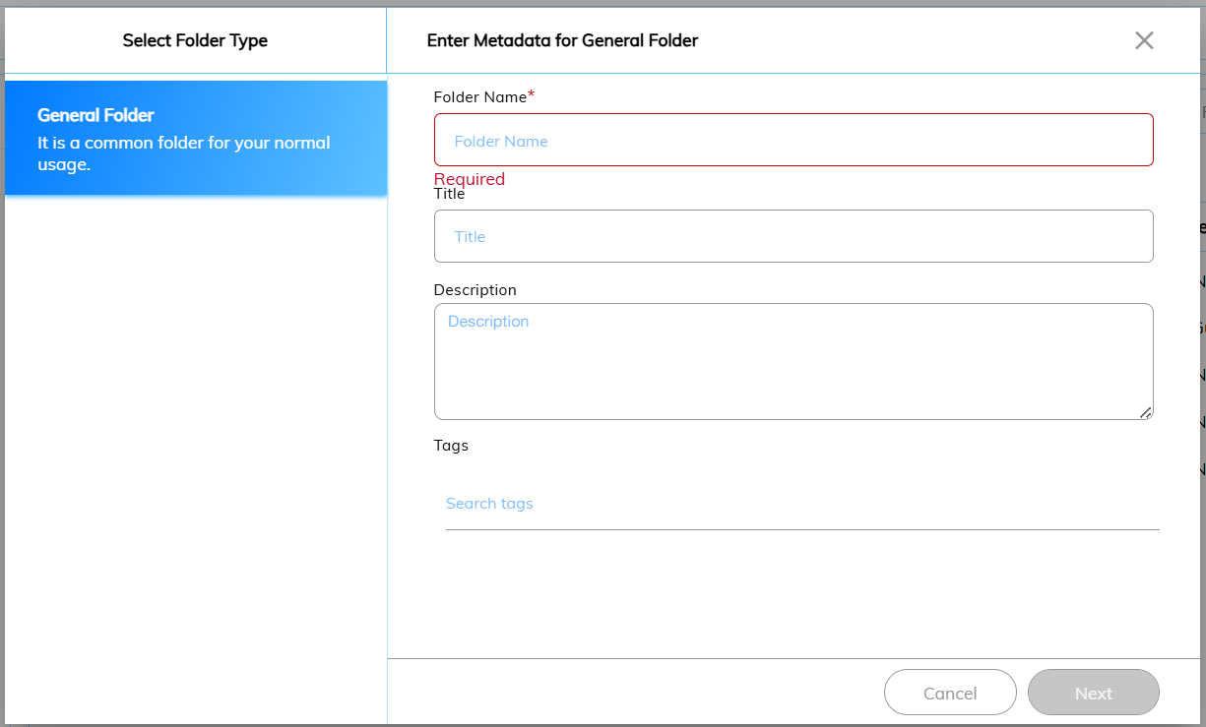

1. Assign permissions pop-up window will appear.
2. Set the permissions accordingly and click Create.

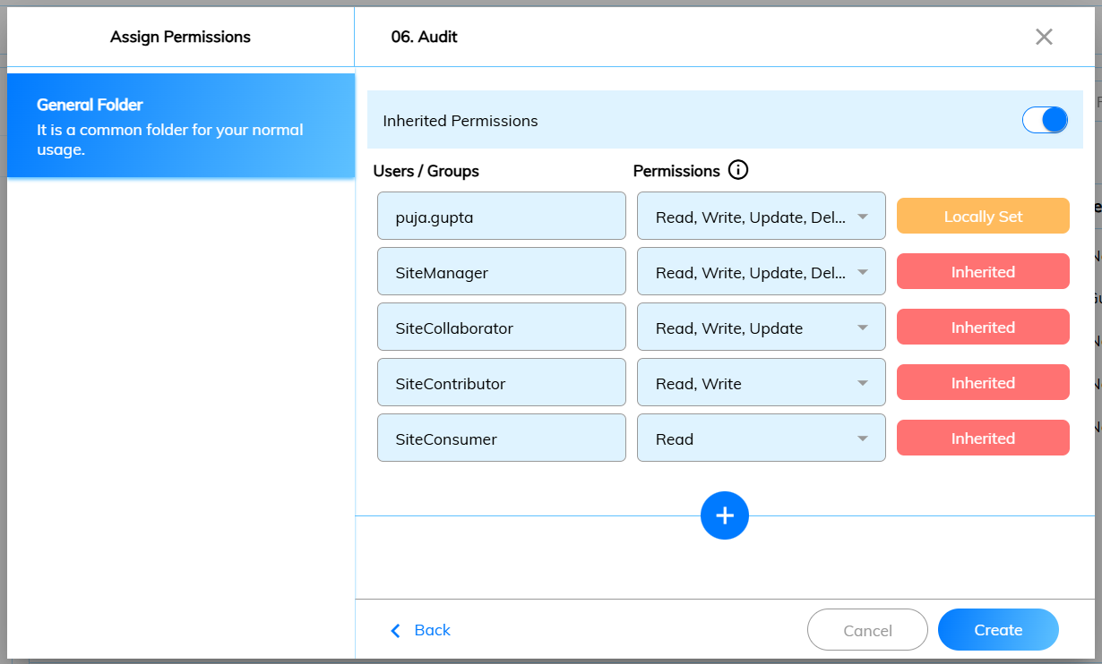

1. Success message will appear, and folder created successfully.

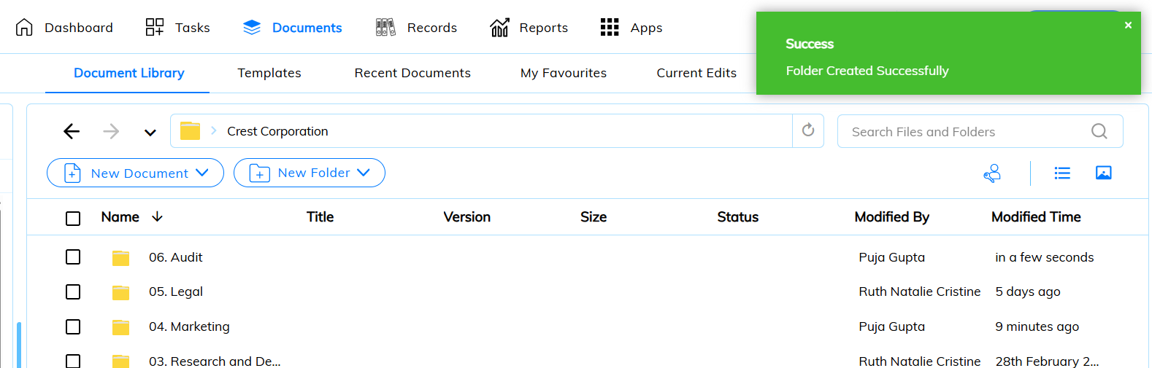

##### Create From Template



1. Click on Documents tab.
2. Click on Document Library.
3. Click on  and select Create From Template.
4. Template browser pop-up window will appear.
5. Navigate to the desired path and click Next.

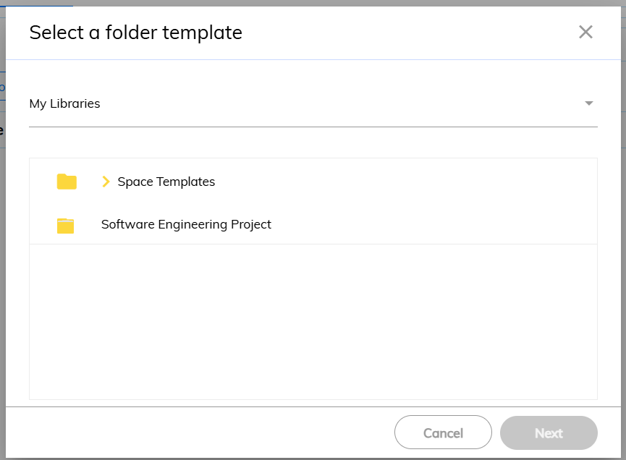

1. Create new folder pop-up window will appear.

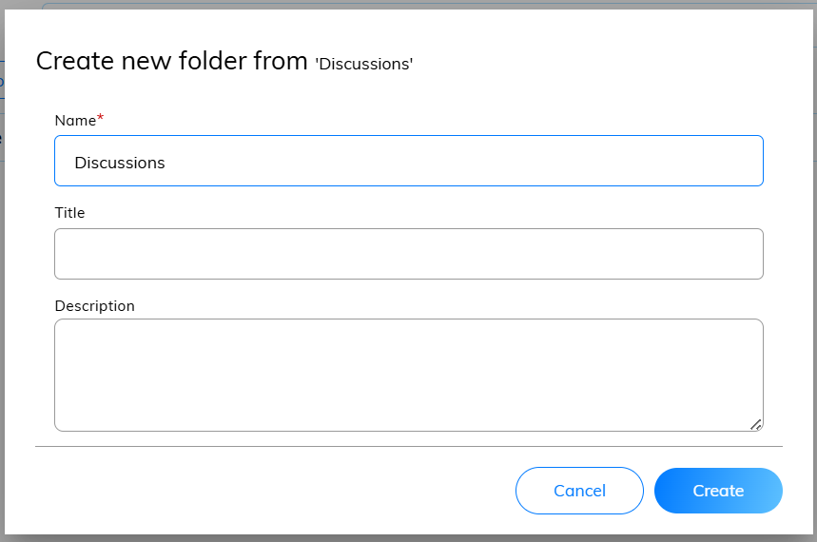

1. Success message will appear.
2. Folder will be created successfully.

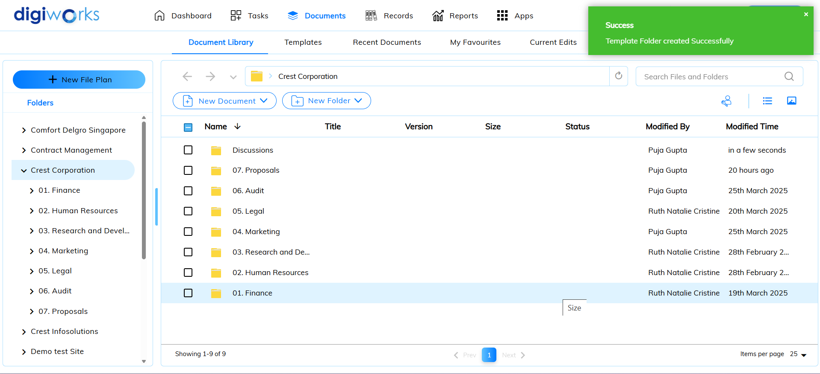

##### Upload from Local



1. Click on the Document tab.
2. Click on Document Library.
3. Click on and select Upload from Local.



1. Folder browser pop-up window will appear.
2. Choose the desired folder and click Upload.

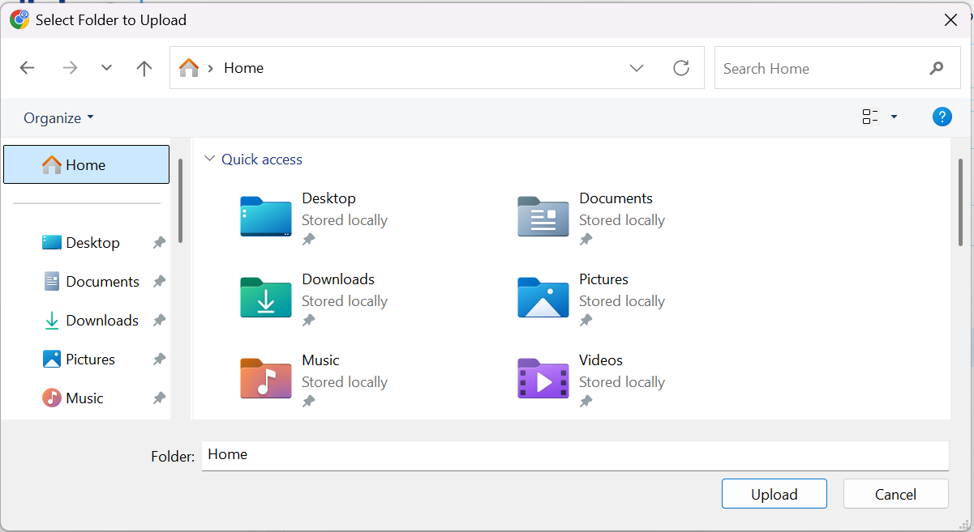

1. Confirmation pop-up message appear and click Upload.

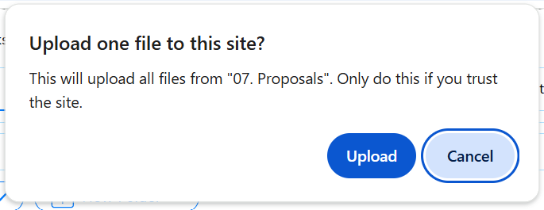

1. Enter file properties pop-up window will appear.
2. Click on  and select document type.

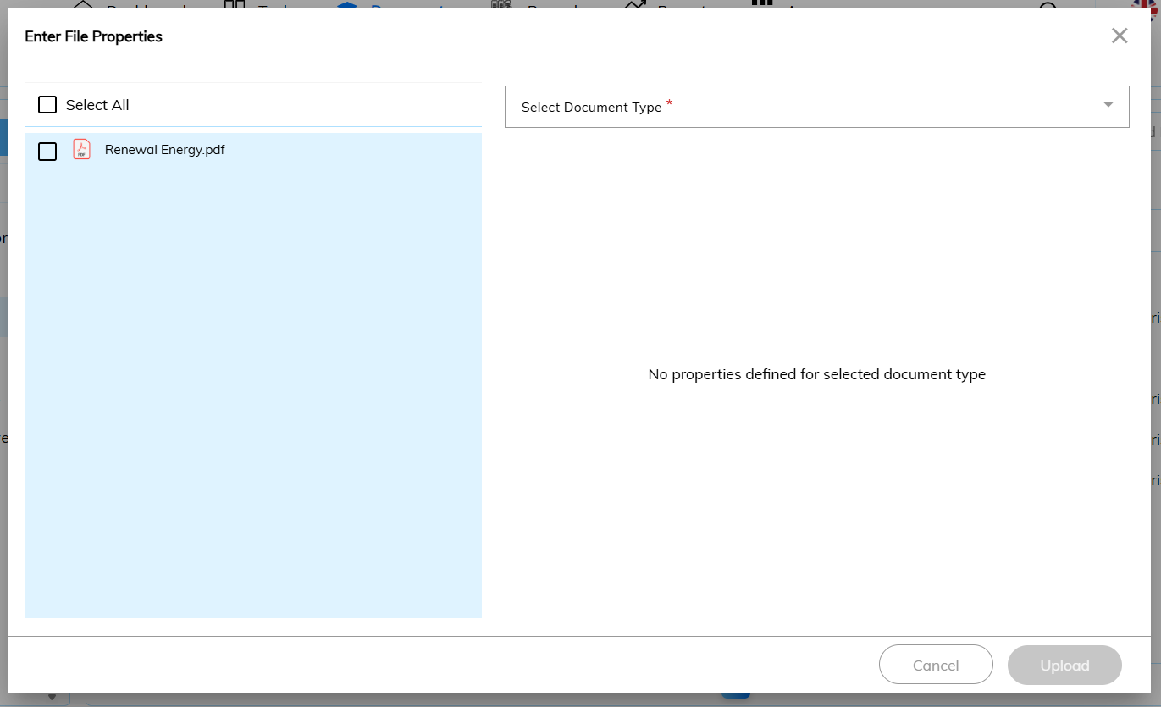

1. There are three (3) types of Document Type: -

|  |  |
| --- | --- |
| **Document Type** | **Description** |
| Default | User may input title and description. |
| Corporate Contract | User may input Contract Date, Contract Supplier Name, Contract Amount, Contract Brief Description and Contract Expiry Date. |
| Corporate Invoice | User may input Invoice Amount, Invoice Number, Description, Invoice Supplier Name and Invoice Date. |

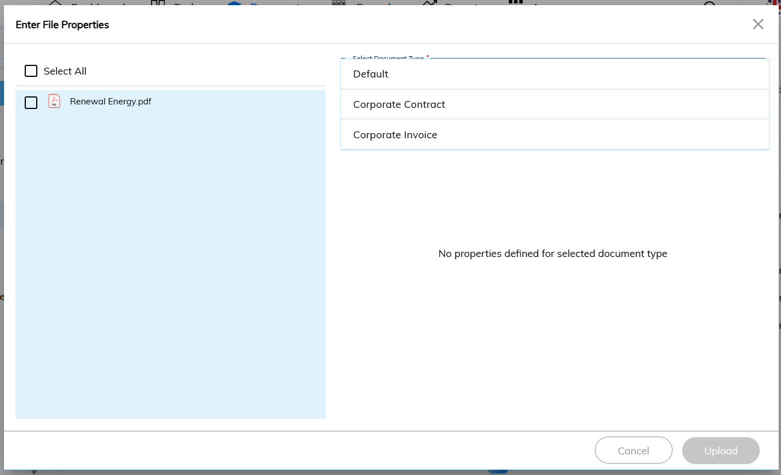

1. Choose a document type and fill in the necessary fields.
2. Tick on the files uploaded and click Upload.
3. Success message will appear and file will be added.

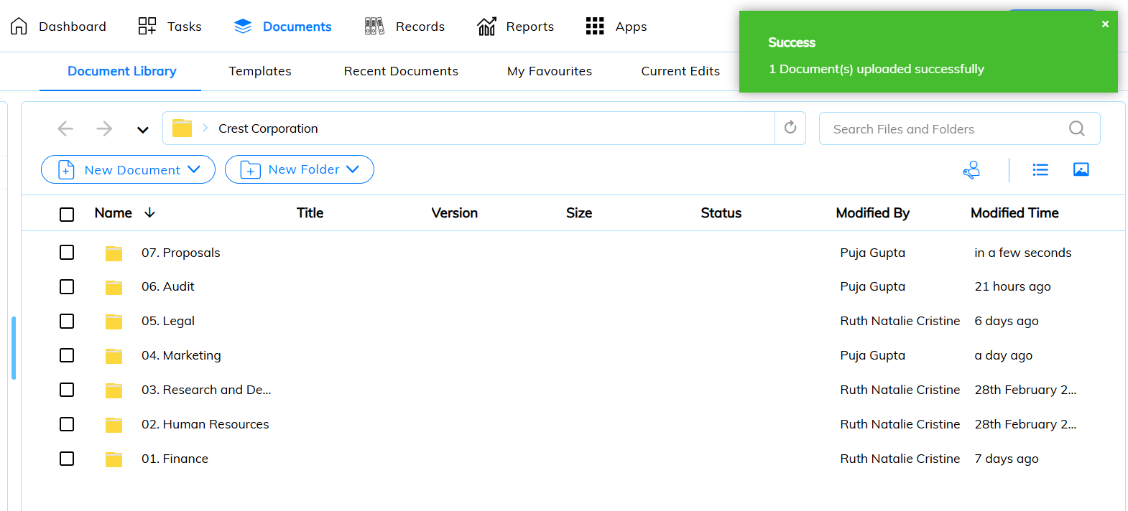

#### Adding Files

##### Upload from PC/Laptop



1. Click on the Document tab.
2. Click on Document Library.
3. Navigate to the designated folder. Click on 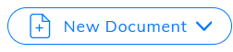and click on Upload From PC/Laptop.

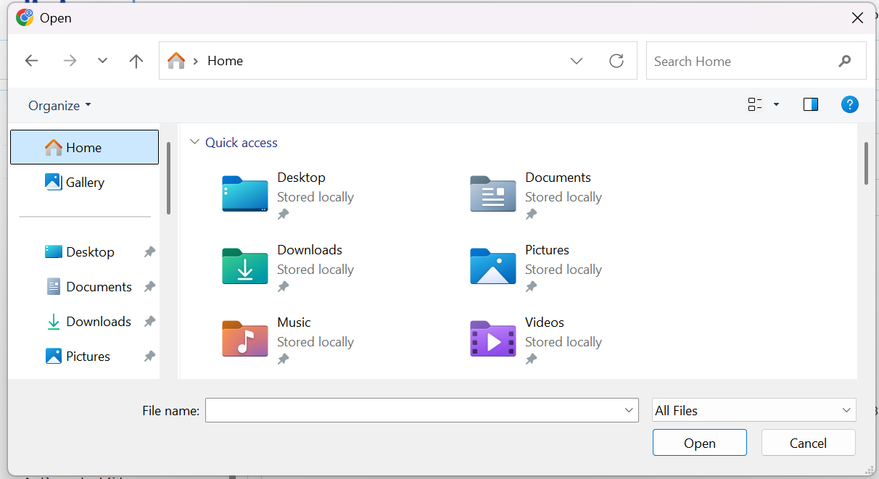

1. The file browser pop-up window will appear.
2. Choose the desired file and click Open.

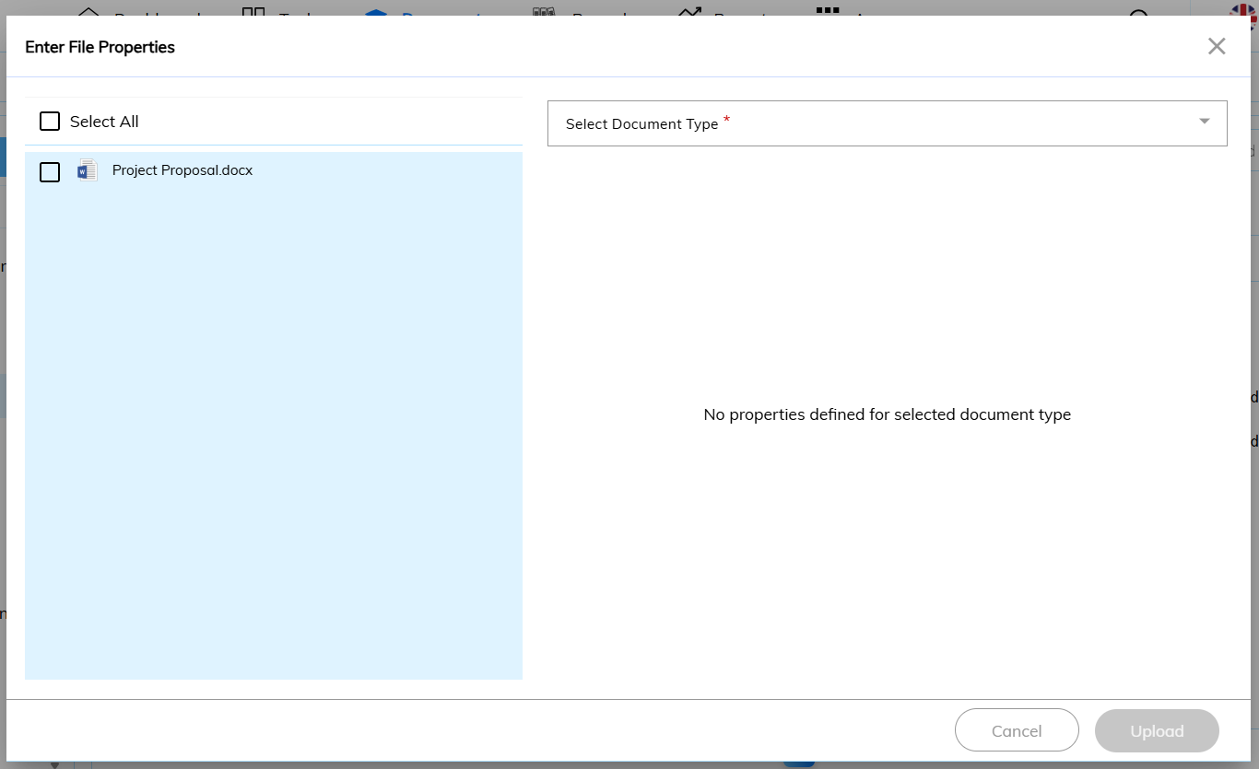

1. Enter file properties pop-up window will appear.
2. Click on  and select document type.

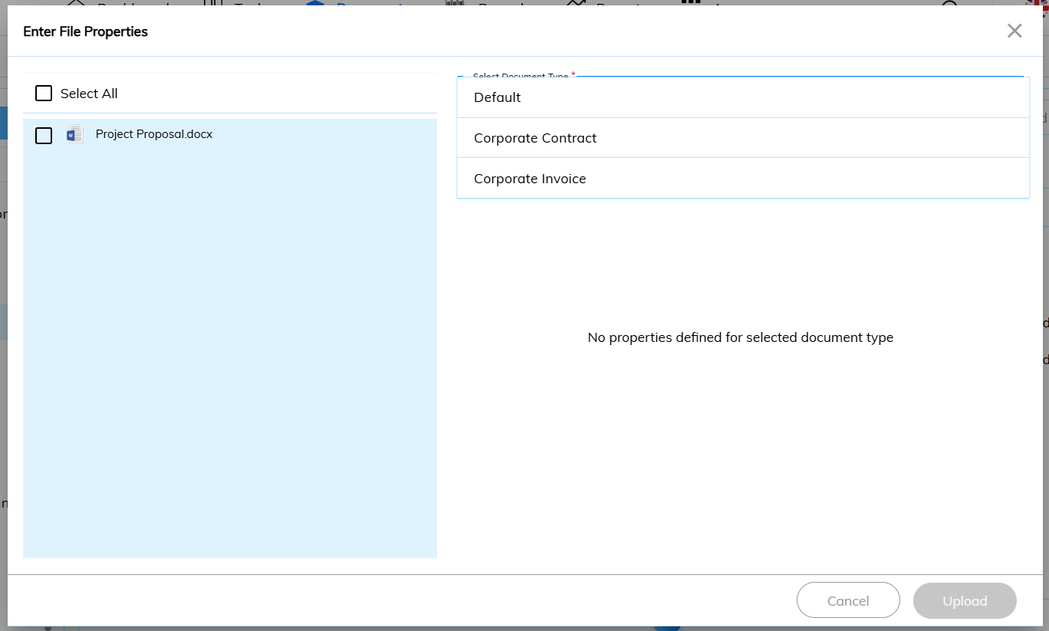

1. There are three (3) types of Document Type: -

|  |  |
| --- | --- |
| **Document Type** | **Description** |
| Default | User may input title and description. |
| Corporate Contract | User may input Contract Date, Contract Supplier Name, Contract Amount, Contract Brief Description and Contract Expiry Date. |
| Corporate Invoice | User may input Invoice Amount, Invoice Number, Description, Invoice Supplier Name and Invoice Date. |

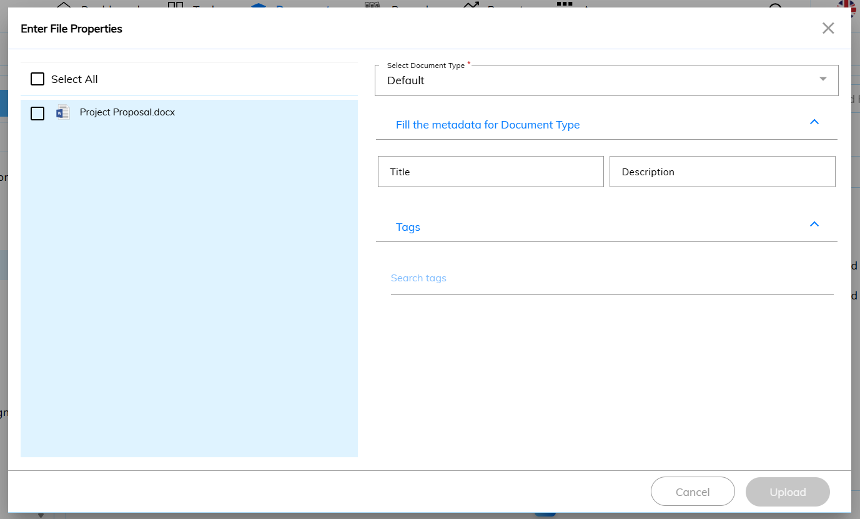

1. Choose a document type and fill in the necessary fields.
2. Tick on 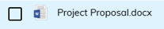and click Upload.
3. Success message will appear and file will be added.

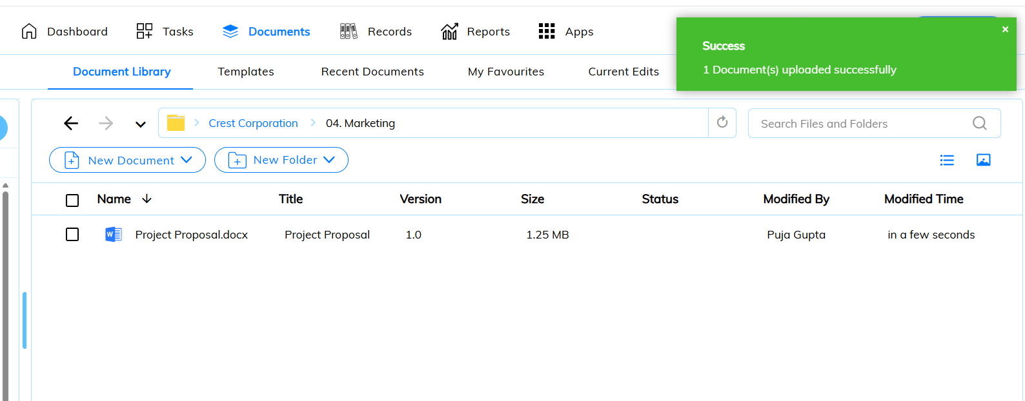

##### Select Template



1. Click on Document tab.
2. Click on Document Library.
3. Navigate to the designated folder. Click on and click Select Template.
4. User can choose to Start with Blank Document or choose the available templates.
5. Click Next once confirmed.

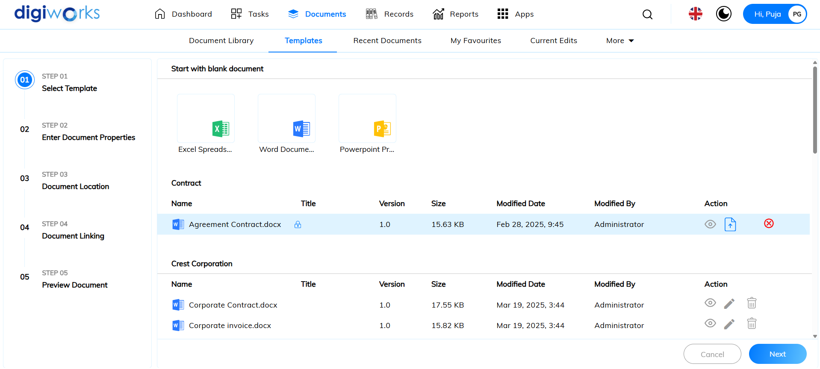

1. Enter document properties and click Next.

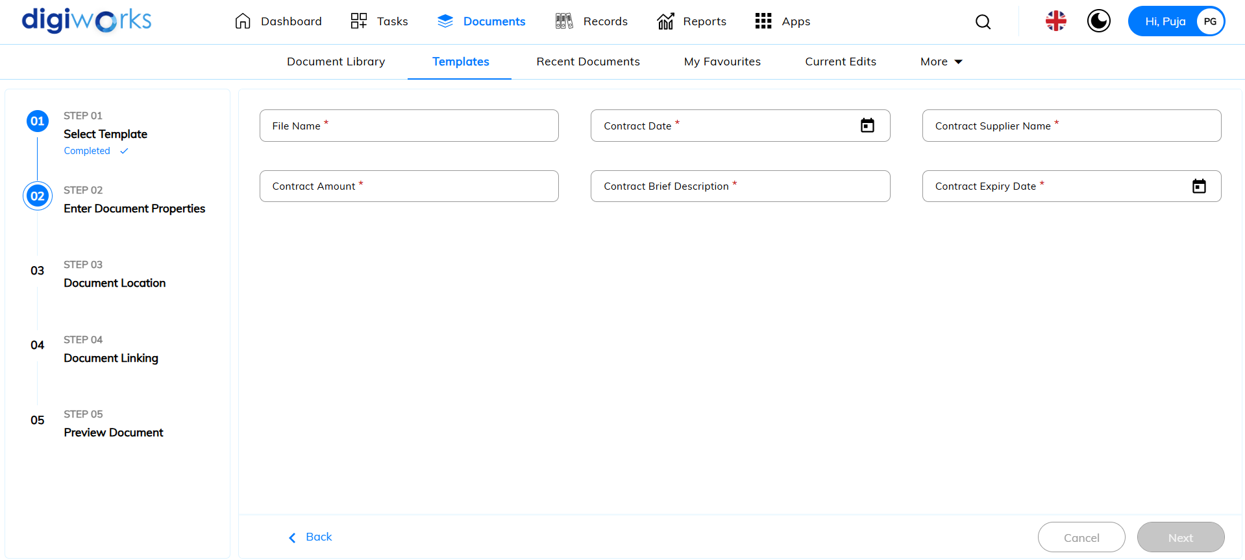

1. Select document location and click Next.

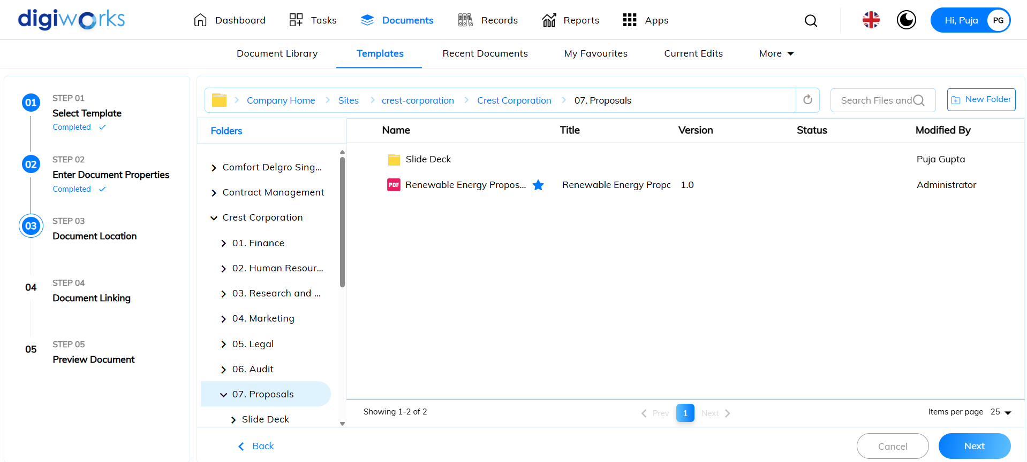

1. Select document to link or user can opt to skip by clicking Skip For Now.

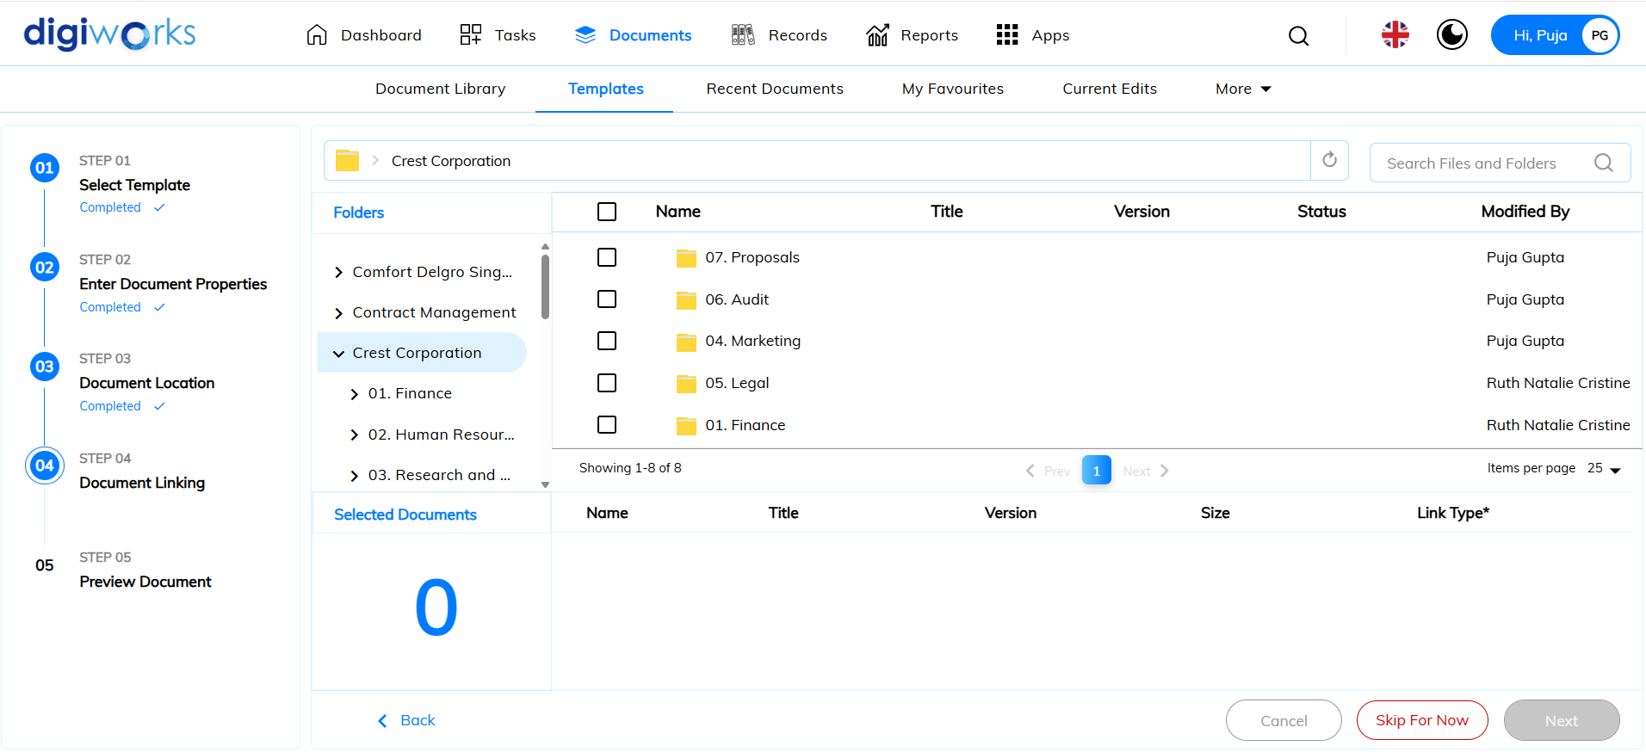

1. Preview Document and click Save.

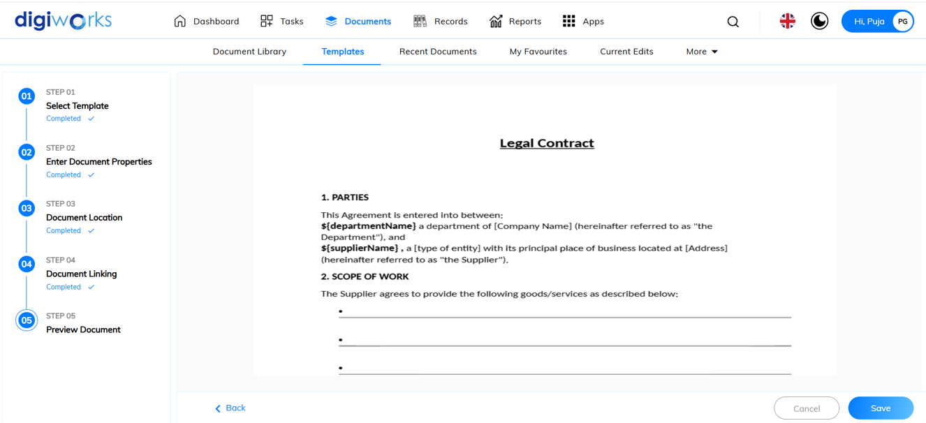

1. Success message will appear.
2. Document has been saved successfully.

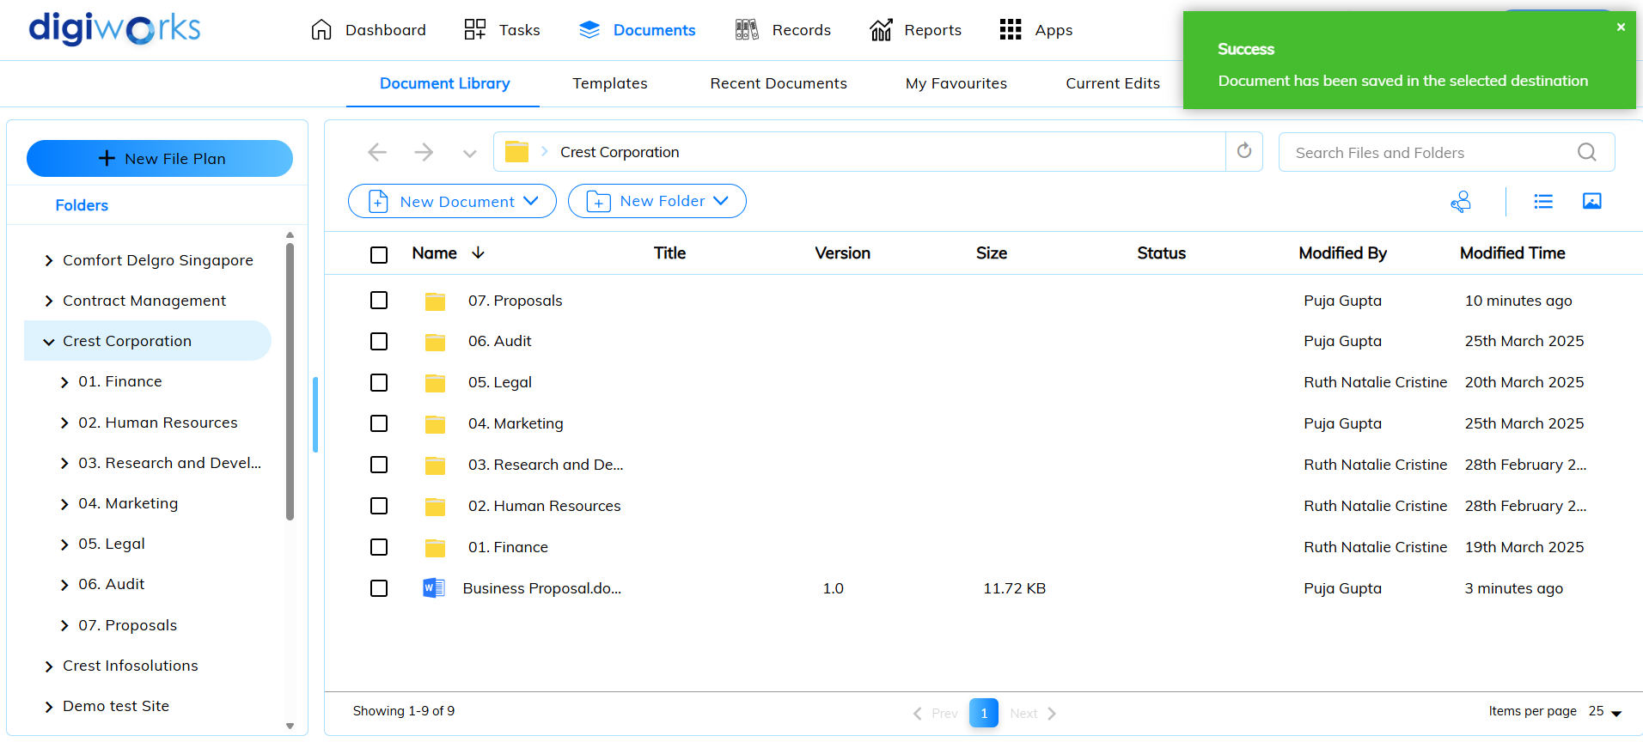

#### Viewing Content

##### Preview

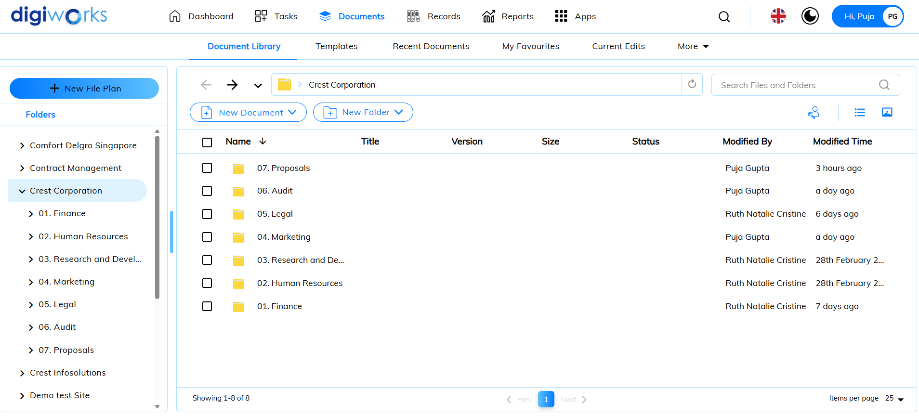

1. Click on Documents tab.
2. Click on Document Library.
3. Select the desired file to view and click on / double click on the file.

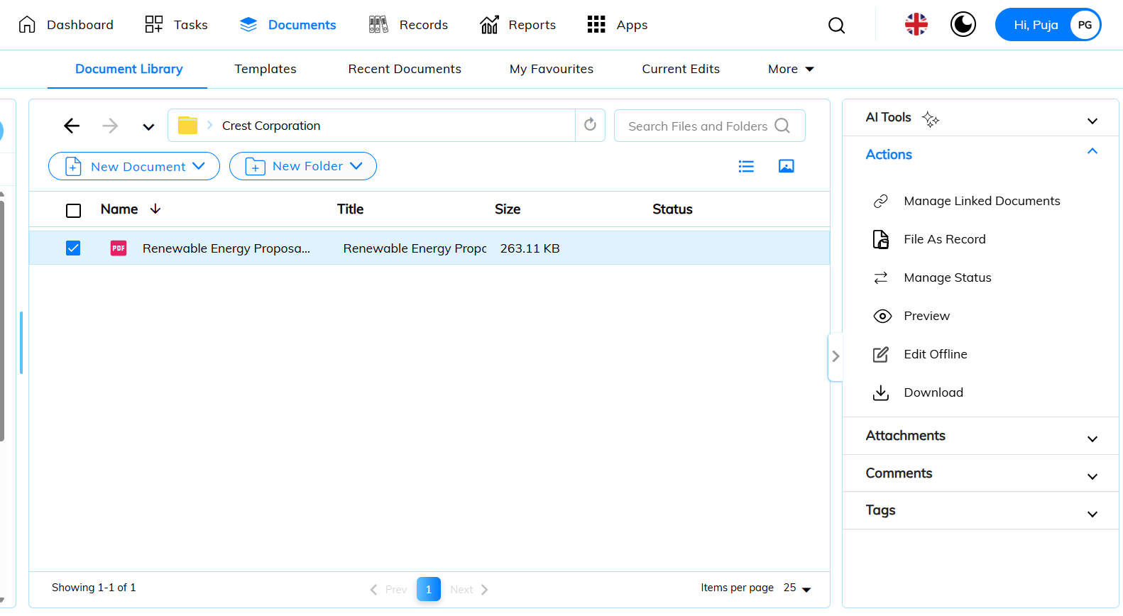

1. Preview page will appear.

 Notes:

* The zoom level and current page number are saved for the next time you preview this item.
* You can download the file in its original format or as a PDF.

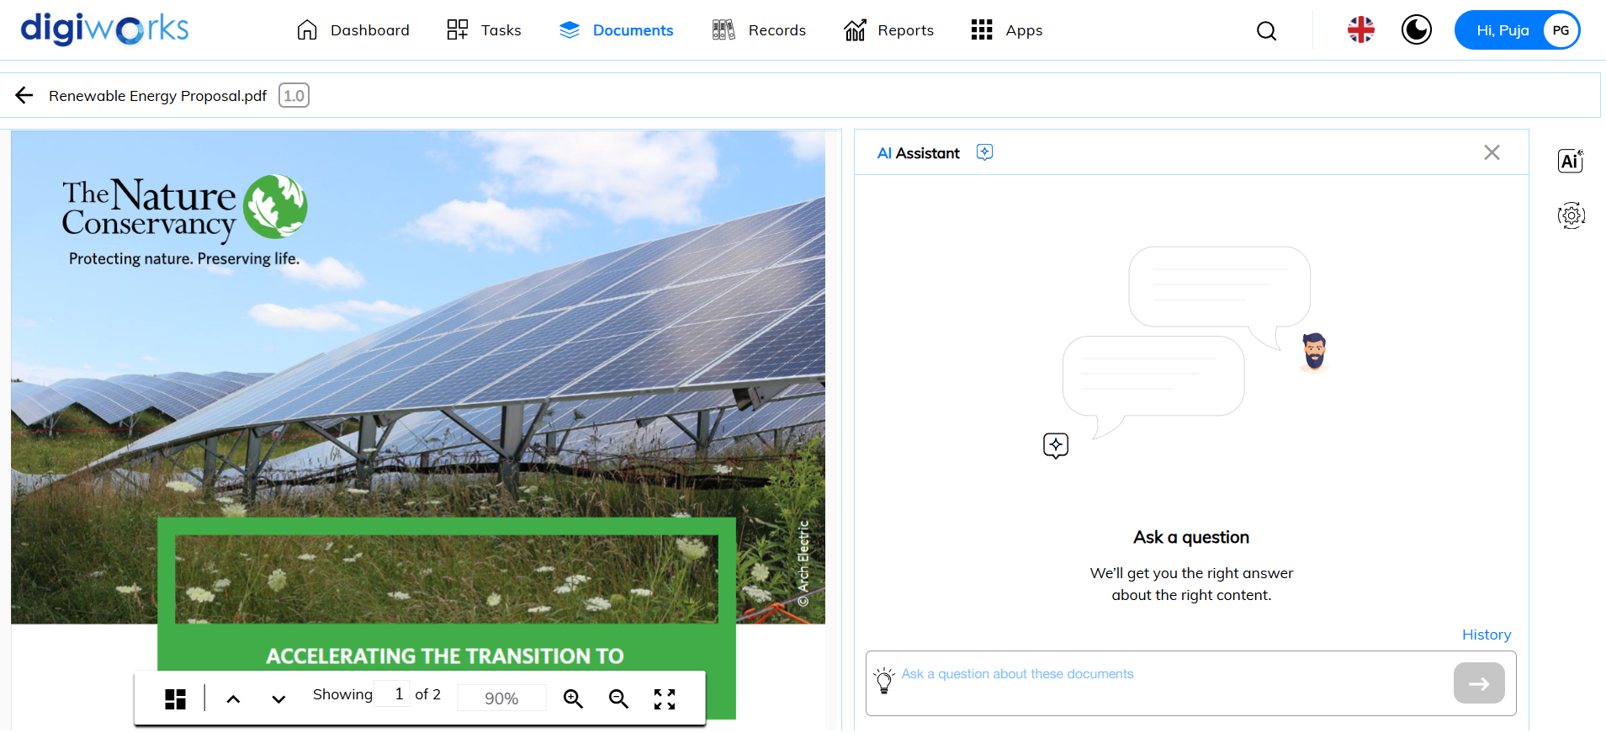

##### Comments

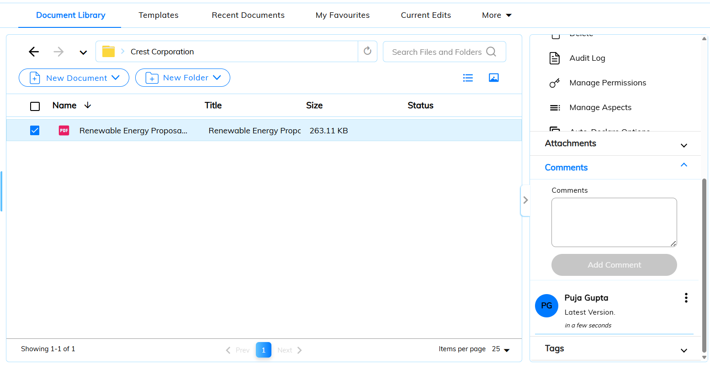

1. In Document Library, click on the desired file.
2. On the right panel, click on Comments.
3. Comments will appear.

 Notes:

* You can’t add a comment if you have Consumer permission levels for the site.
* The comment list displays the 10 most recent comments.

#### Organizing Content

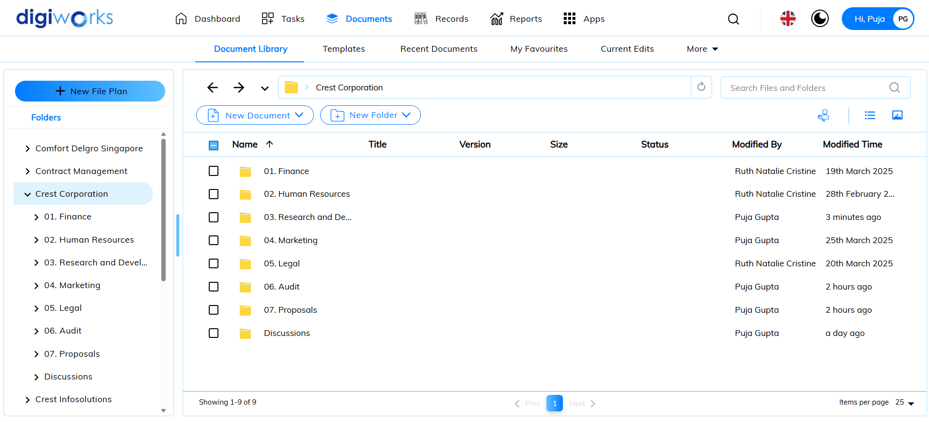

1. Click on Documents tab.
2. Click on Document Library.
3. Navigate to the desired folder and select a file.
4. Click on Manage Versions.

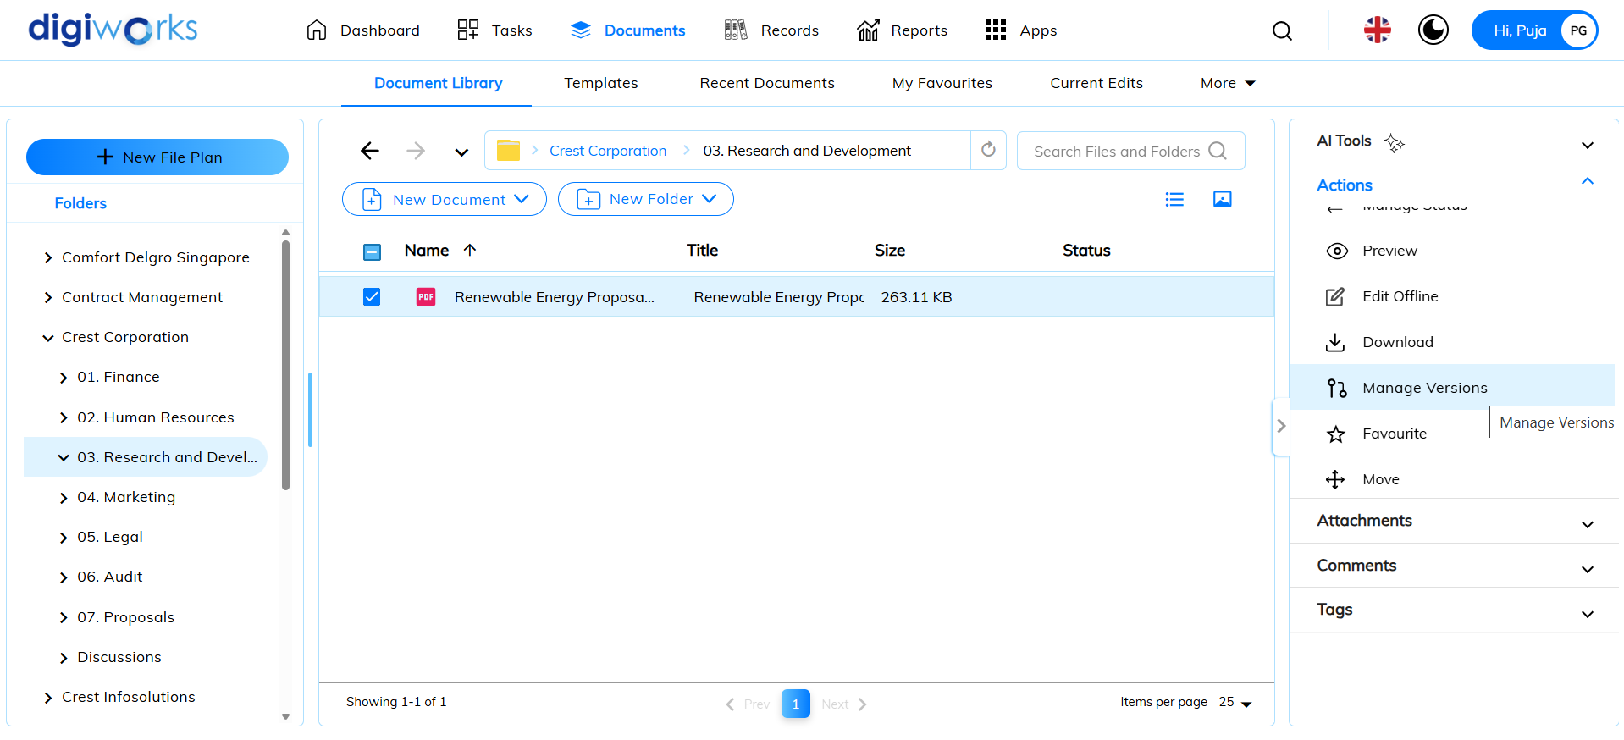

1. Manage version pop-up window will appear.
2. There will be two version options: “Minor Version” and “Major version”.

* Minor Version: Version will be updated to 1.x
* Major Version: Version will updated to 2.x

1. Click on Upload New Version.

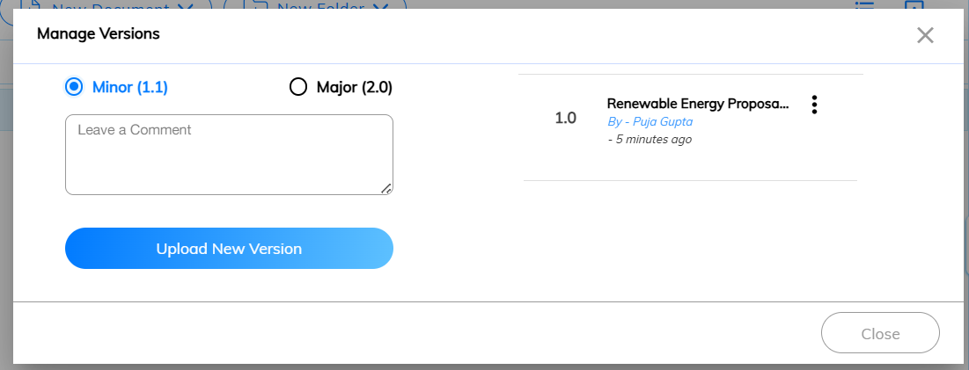

1. File browser pop-up window will appear.
2. Select the desired document and click on Open.

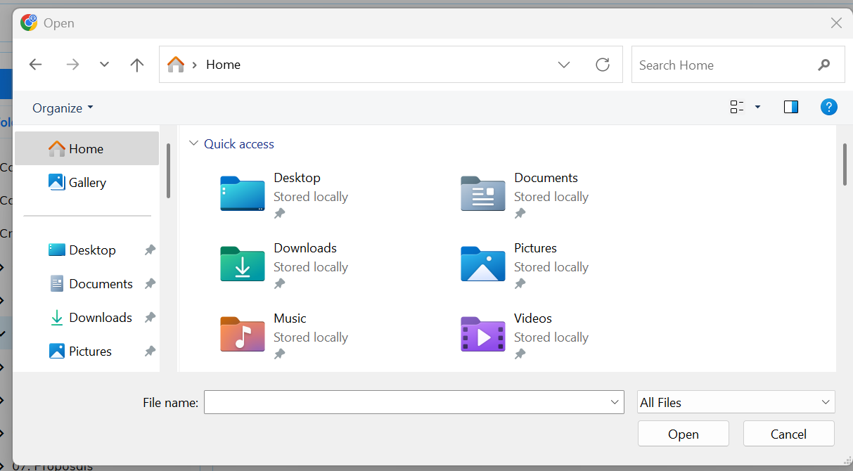

1. Success message will appear.
2. New version will be updated successfully.

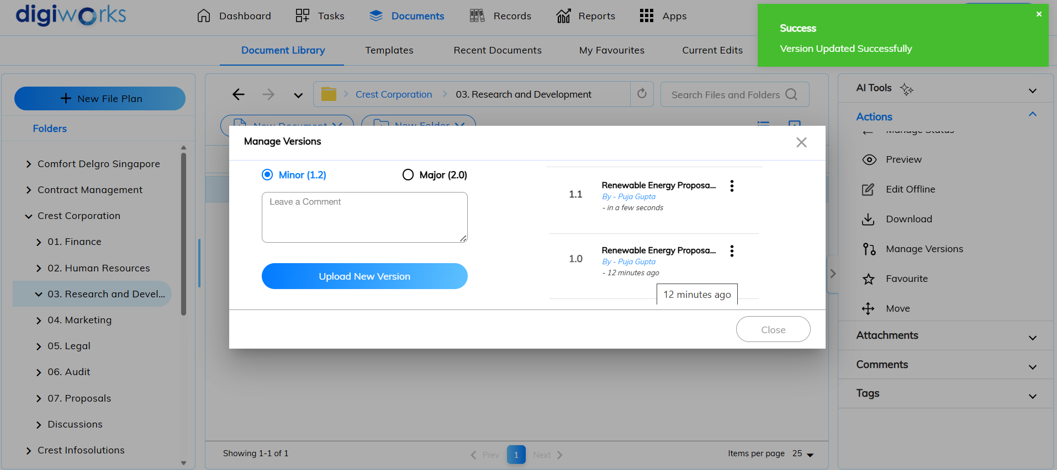

#### Moving Content

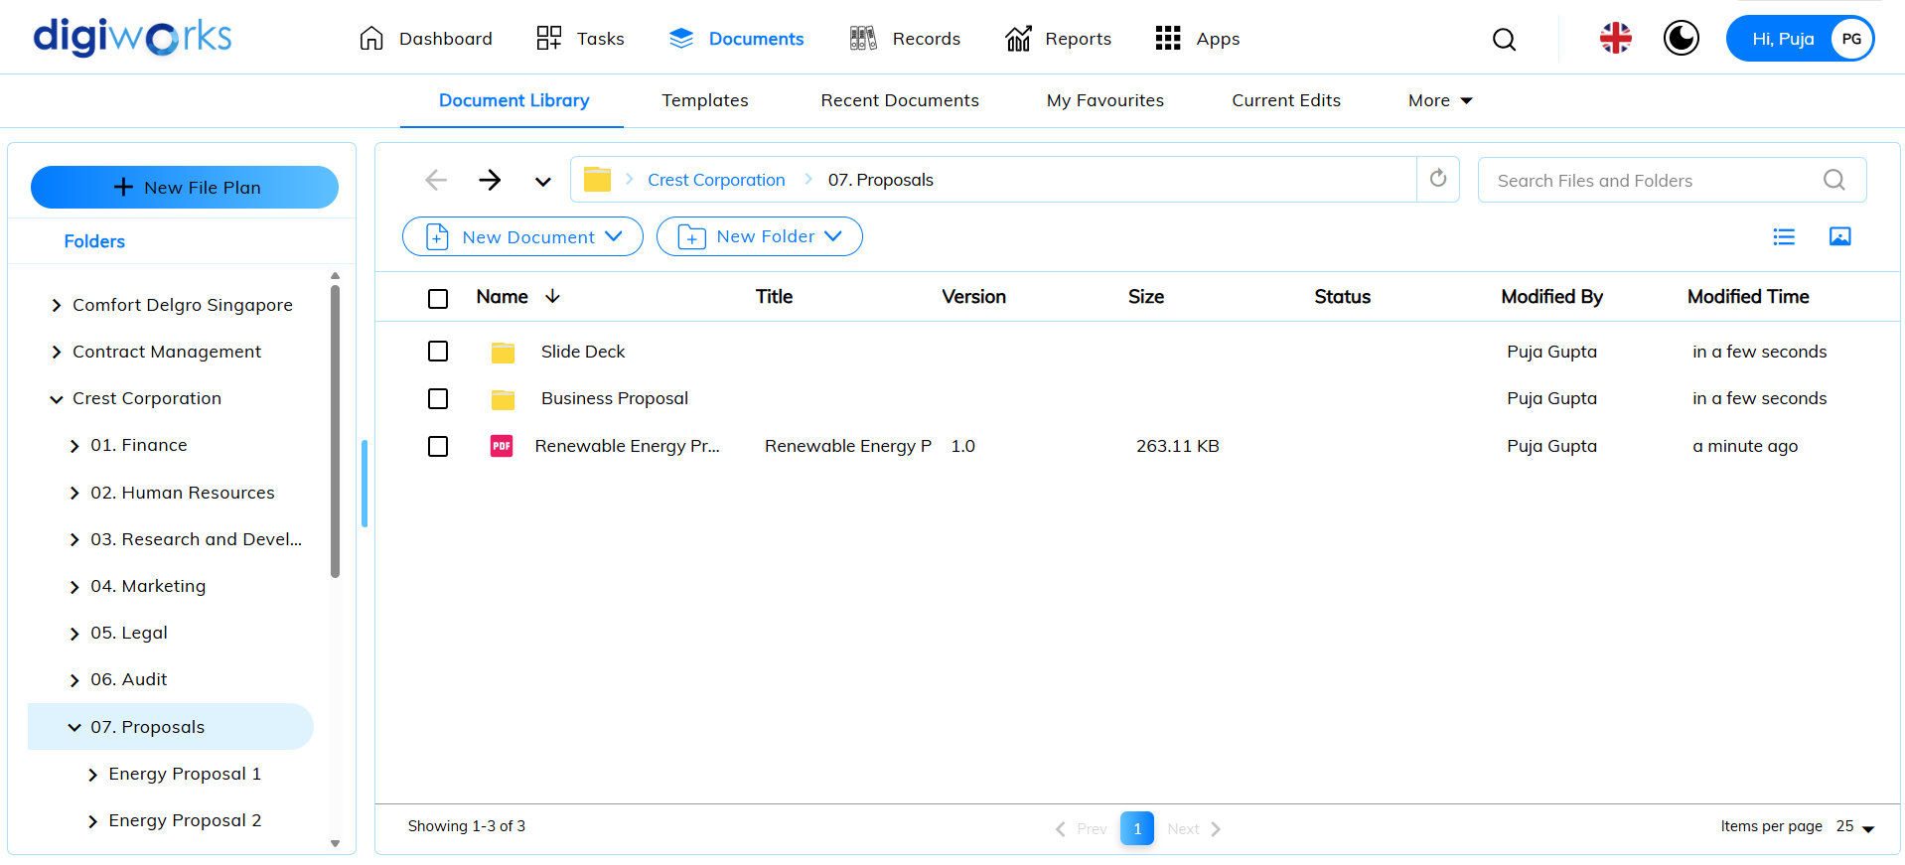

1. Click on Documents tab.
2. Click on Document Library.
3. Select the desire file/folder to move and click on 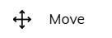.

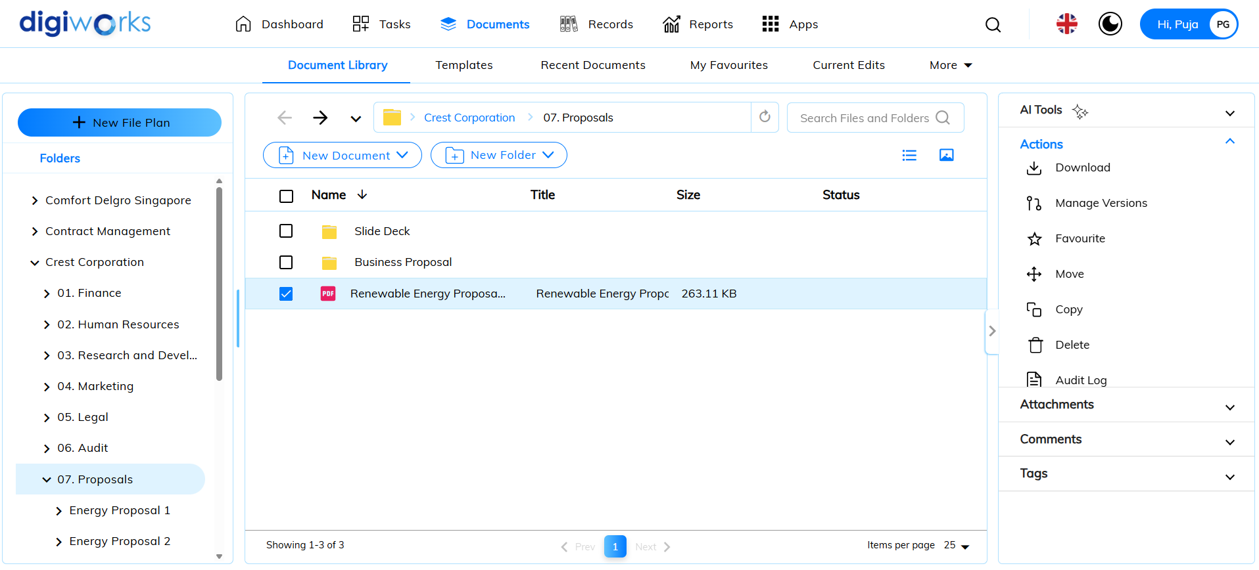

1. Choose the site and folder where you want to place the content.
2. Click Move.

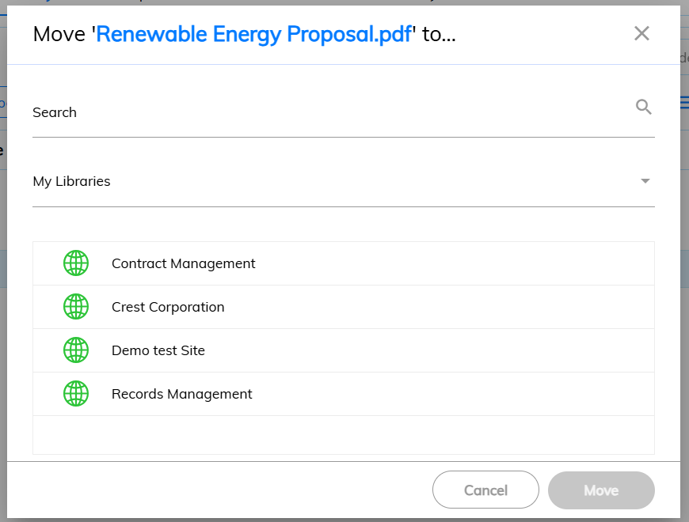

1. Confirmation pop-up window will appear.
2. Click Yes to confirm.

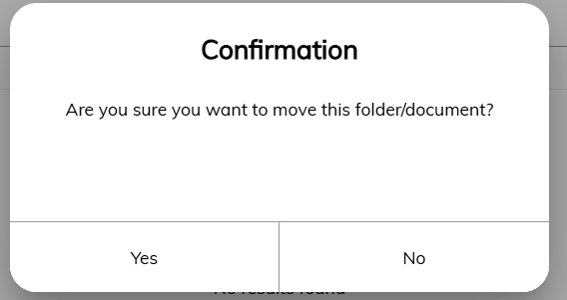

1. Success message will appear.
2. The document has been moved successfully.

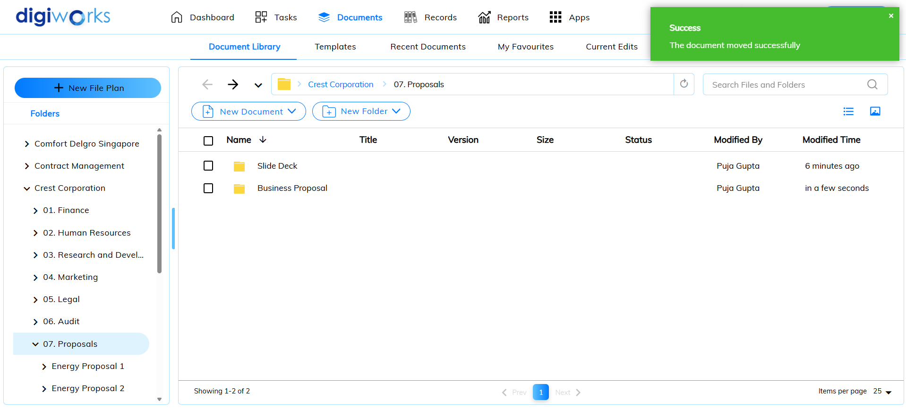

#### Copying Content



1. Click on Documents tab.
2. Click on Document Library.
3. Select the desired file/folder to copy and click on 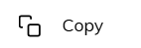.

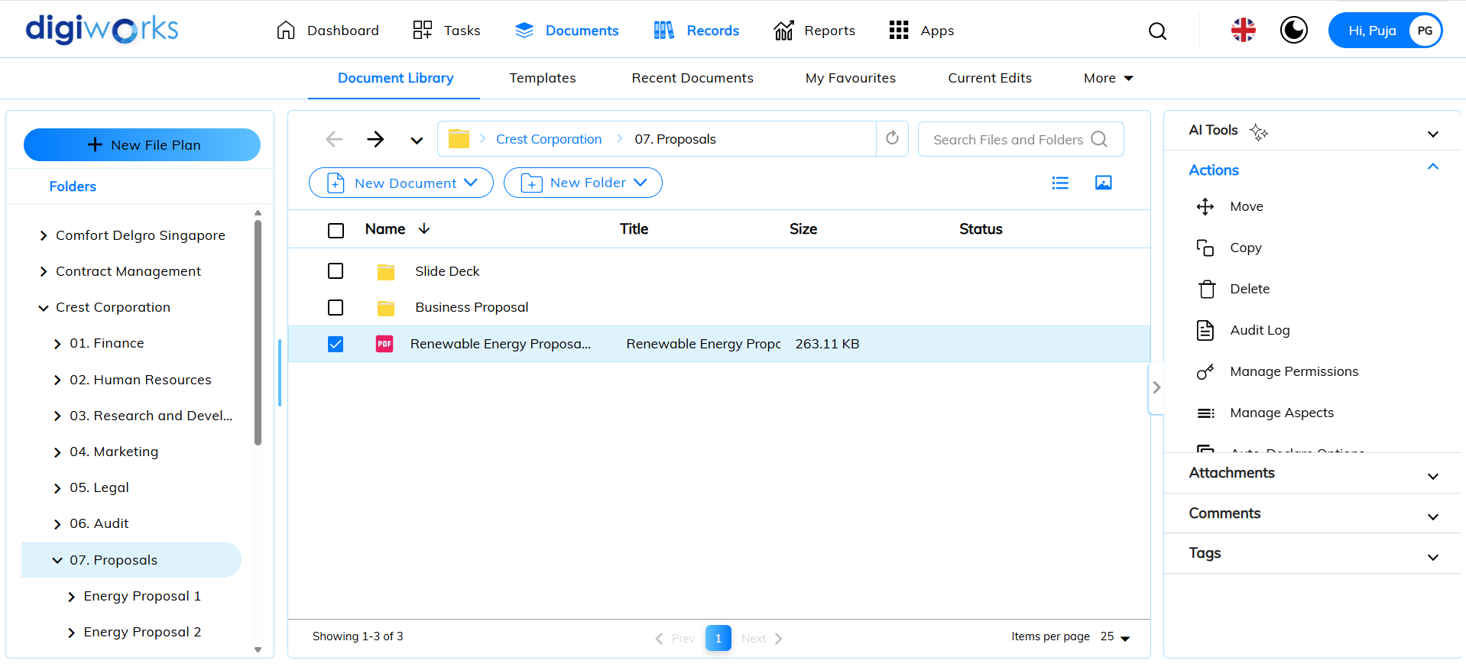

1. Choose the site and folder where you want to place the content.
2. Click Copy.

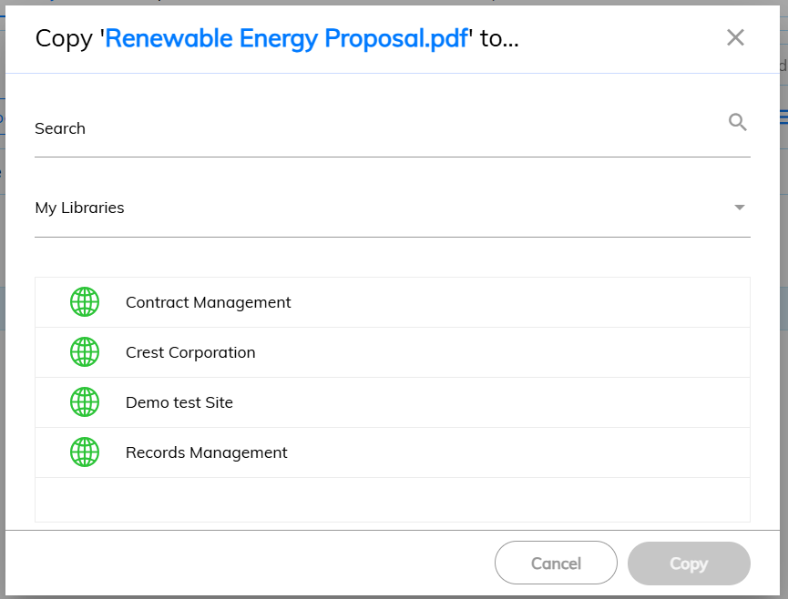

1. Confirmation pop-up window will appear.
2. Click Yes to confirm.

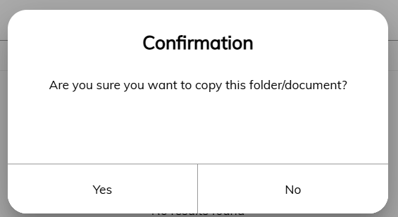

1. Success message will appear.
2. The document has been copied successfully.

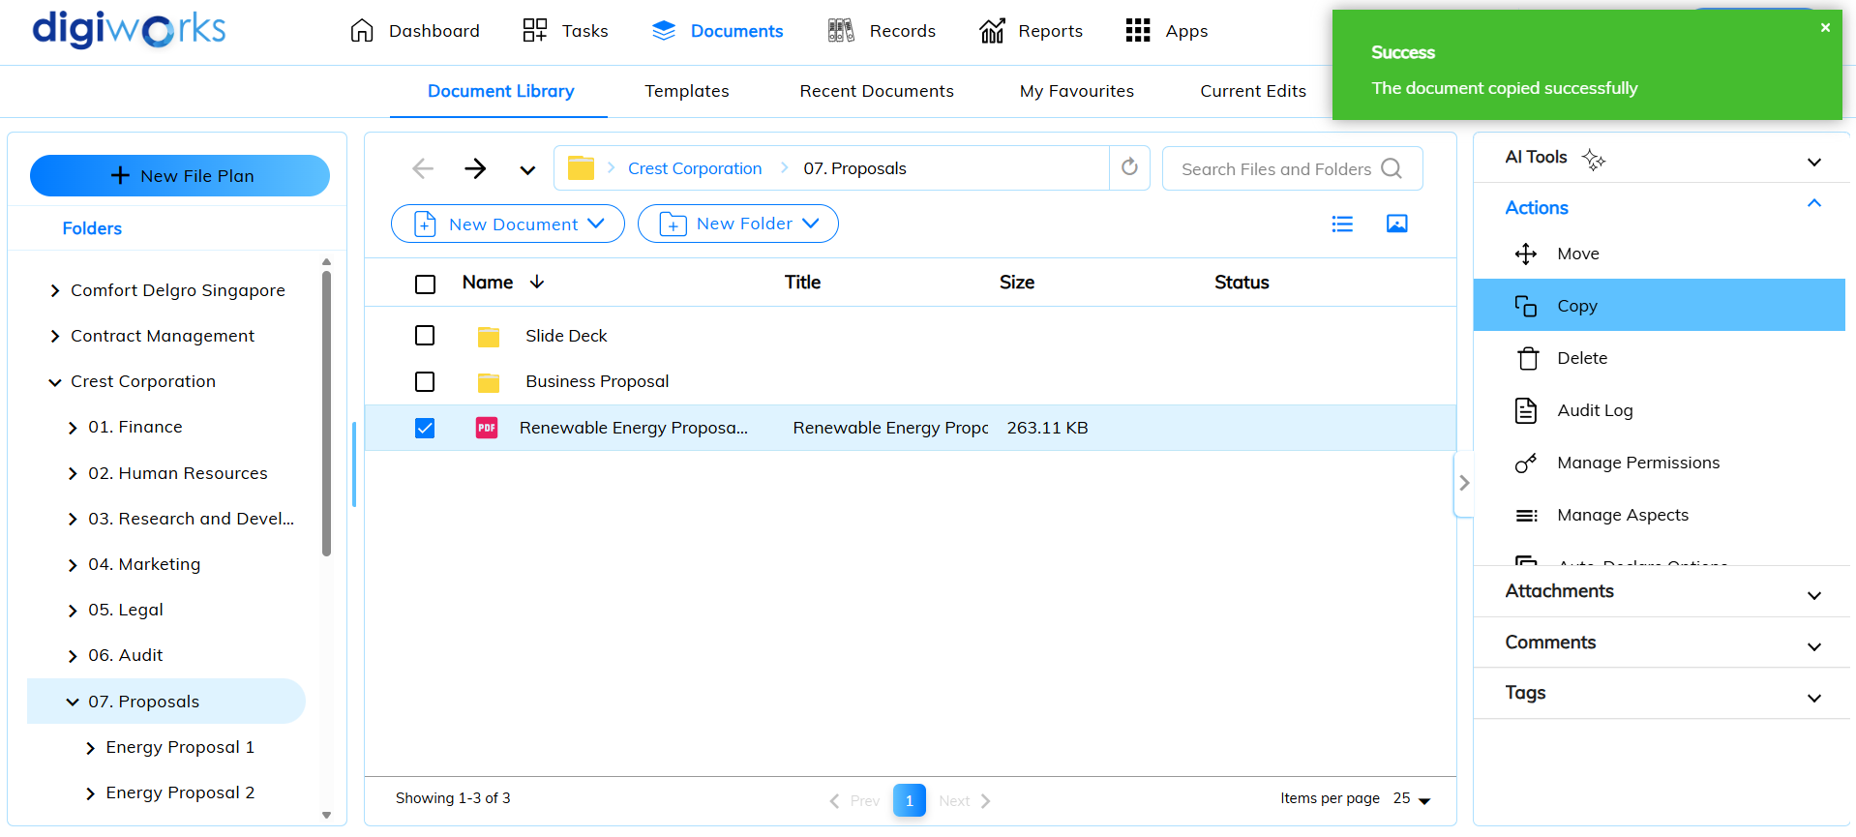

#### Creating Links to Content

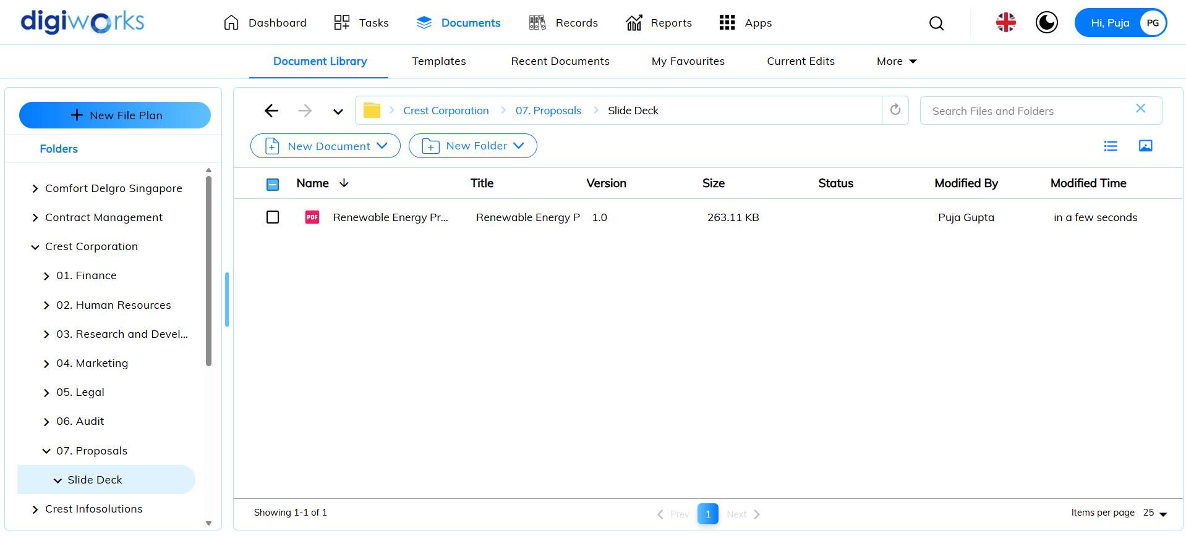

1. Click on Document tab.
2. Click on Document Library.
3. Select the desired file/folder and click on 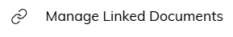.

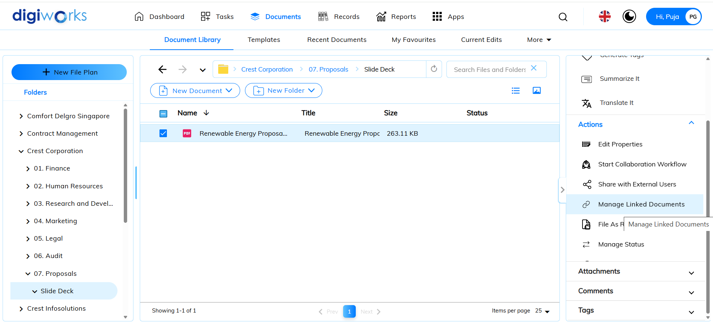

1. On the right panel, click on Link New Document/Folder.

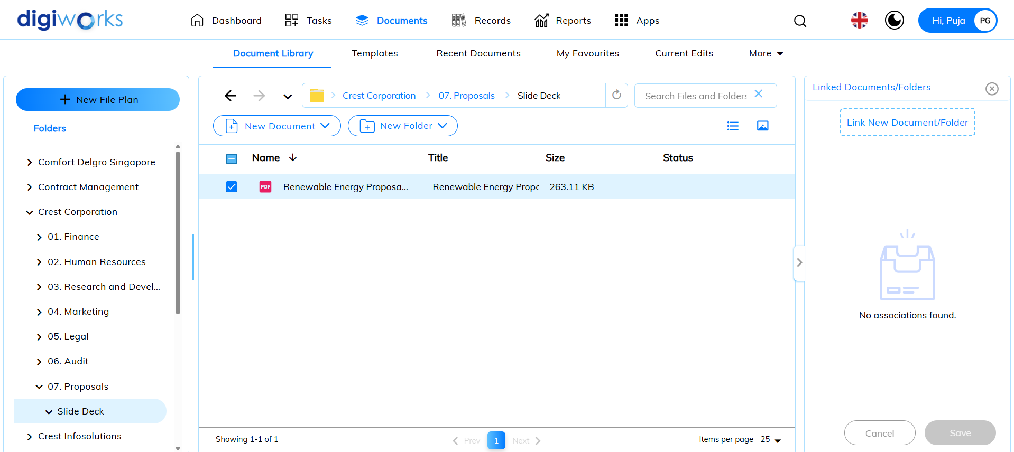

1. File browser pop-up window will appear.
2. Select the desired file/folder to link and click Select.

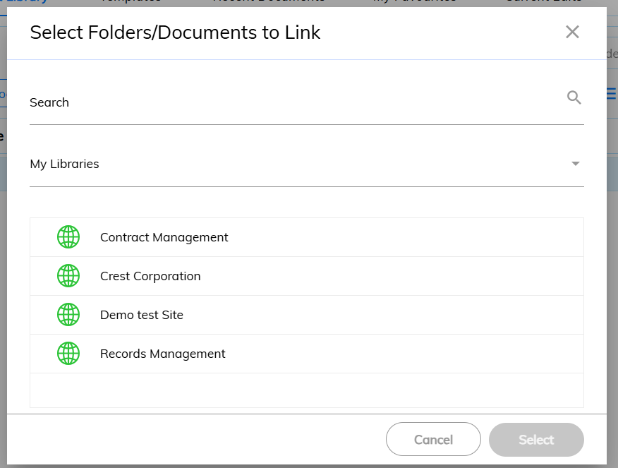

1. Click on Select Link Type.

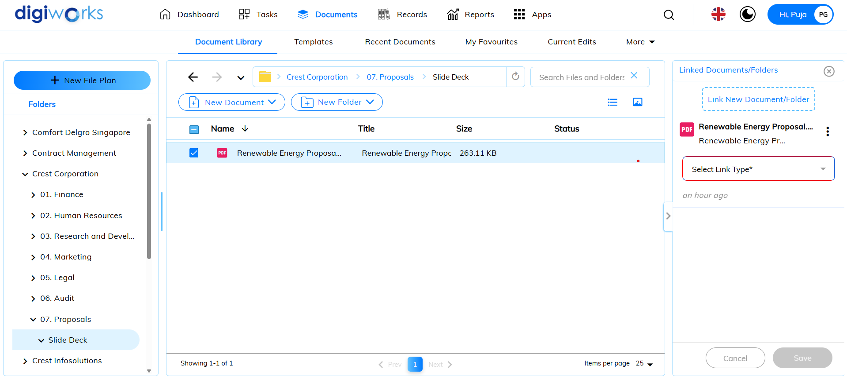

1. Choose the link types accordingly.
2. Click Save.

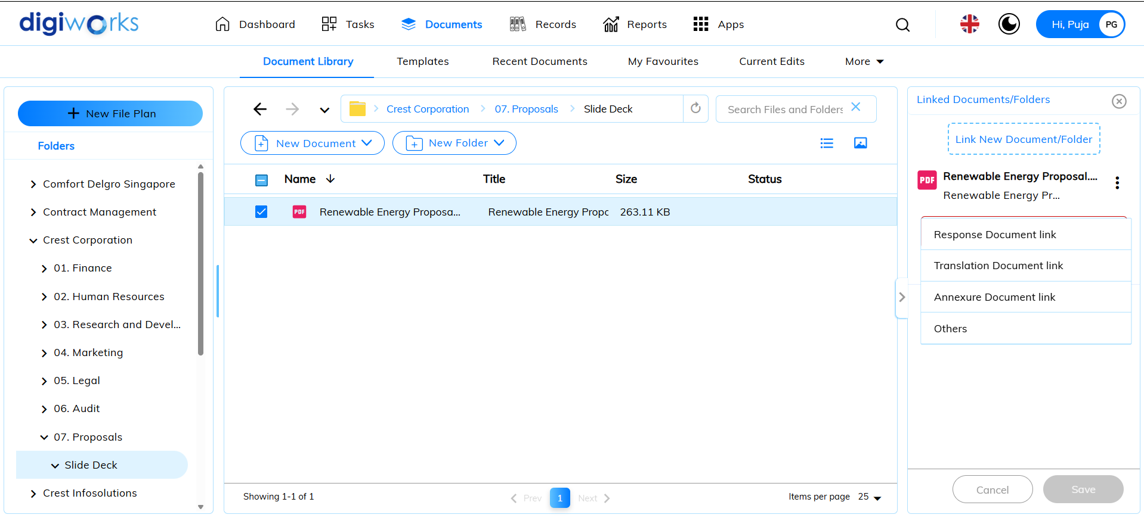

1. Success message will appear.
2. File/folder has been linked successfully.

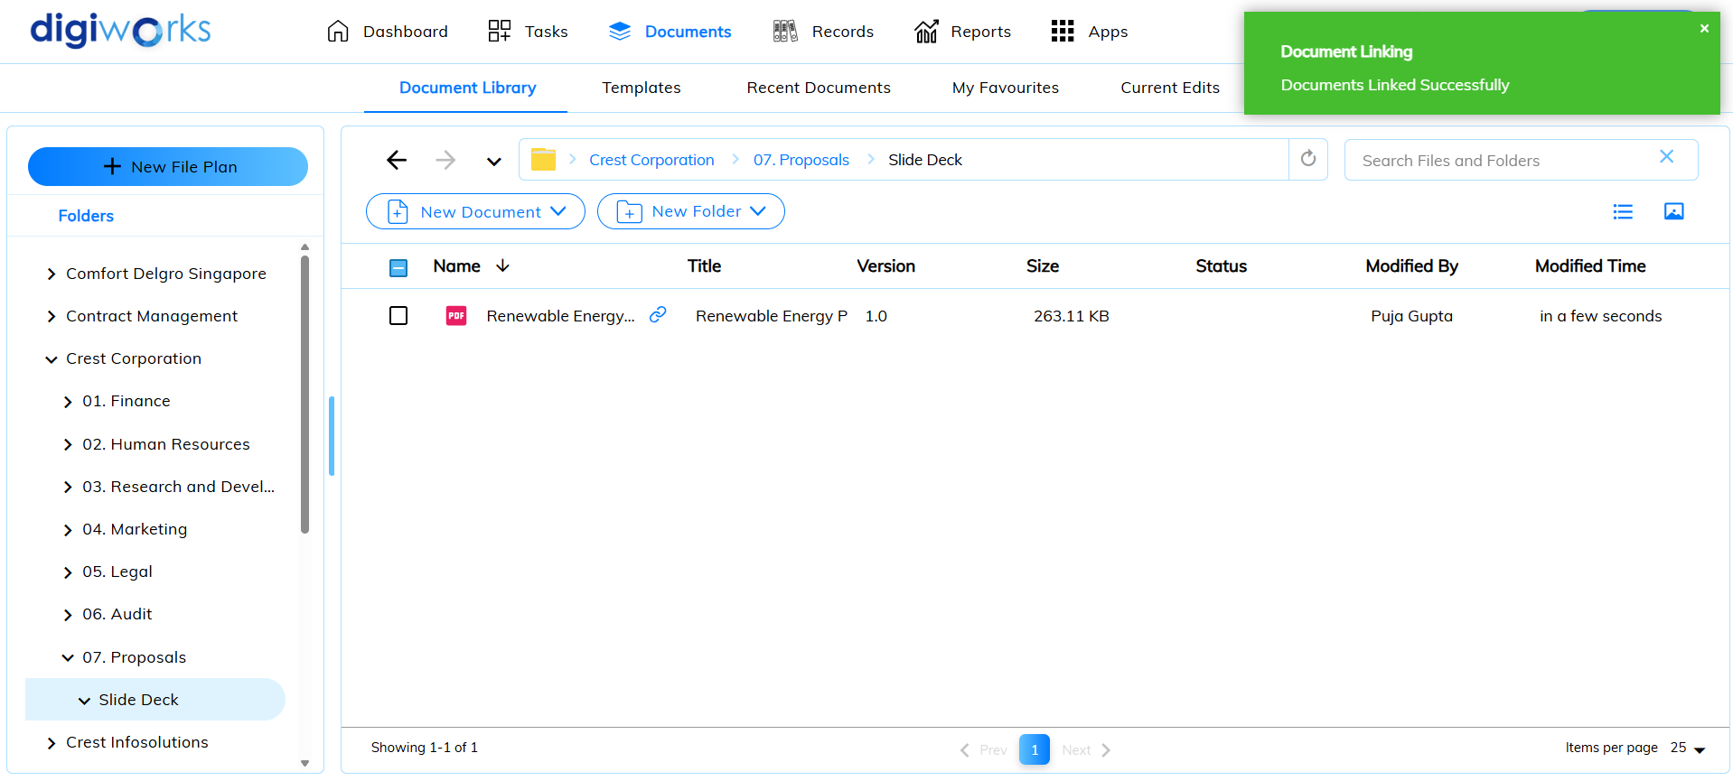

#### Renaming Content



1. Click on Document tab.
2. Click on Document Library.
3. Select the desired file/folder to rename and click on .

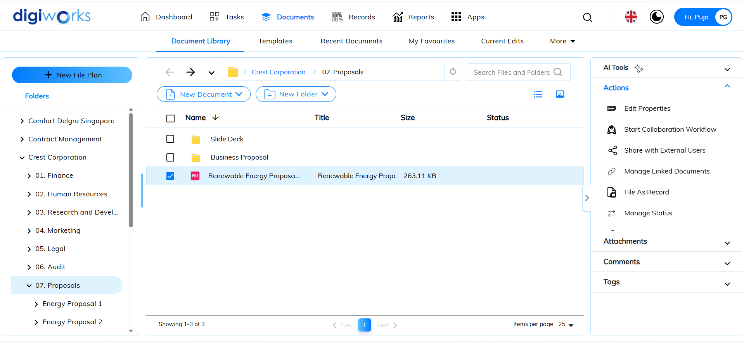

1. For files, edit properties will appear on the right panel.
2. User can rename the file on the right panel and click Save.

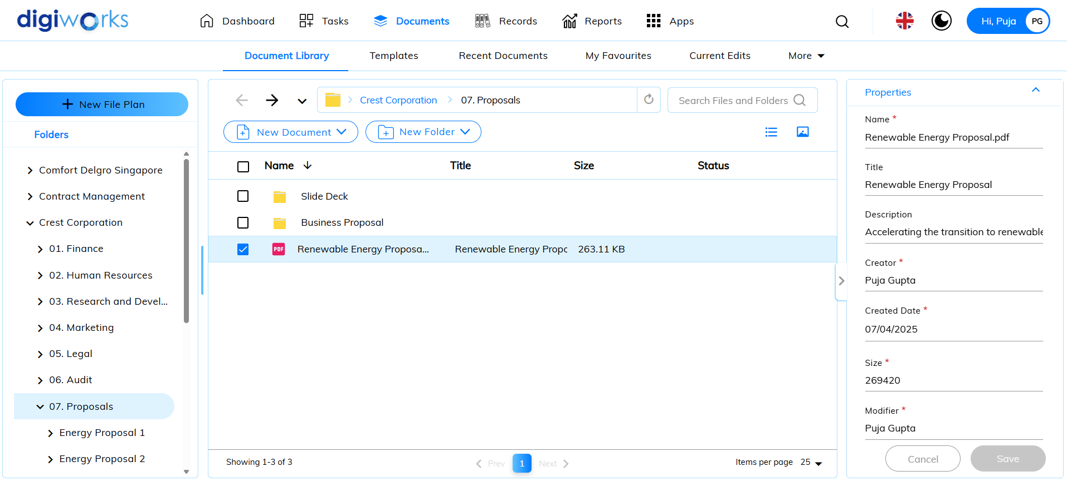

1. For folders, edit properties pop-up window will appear.
2. User can rename the folder and click Update.

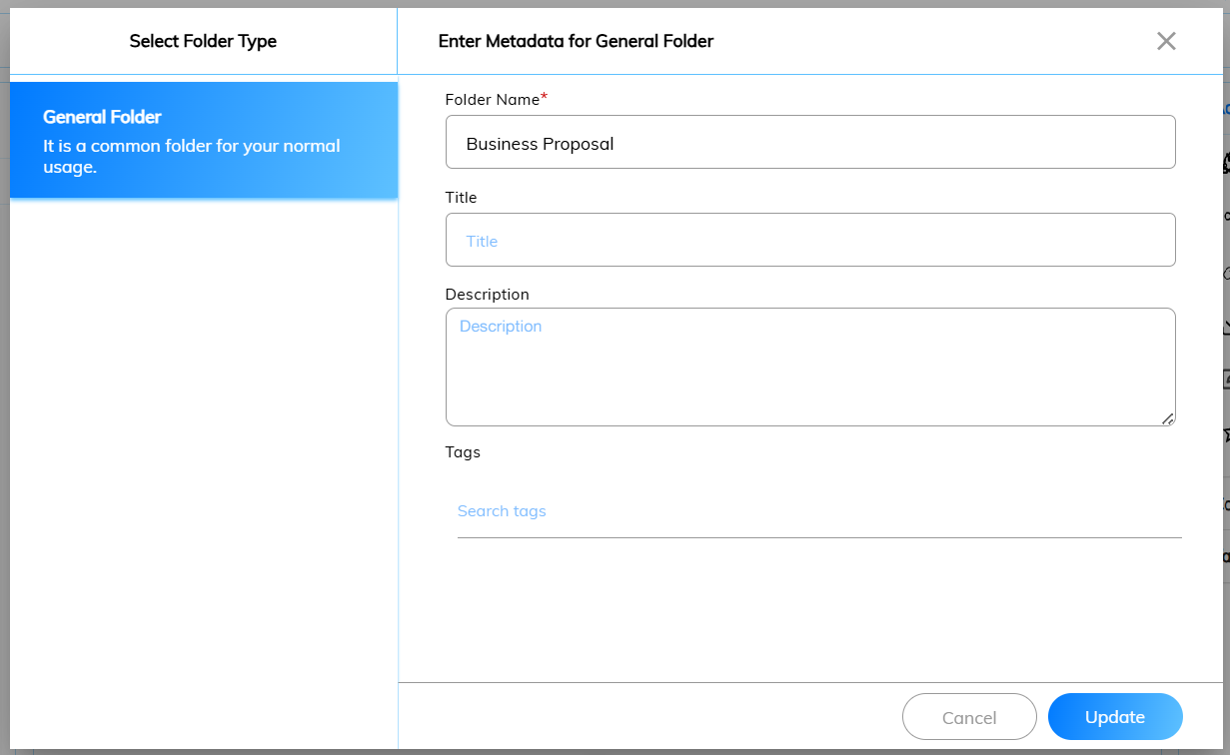

1. Success message will appear.
2. Folder/file has been renamed successfully.

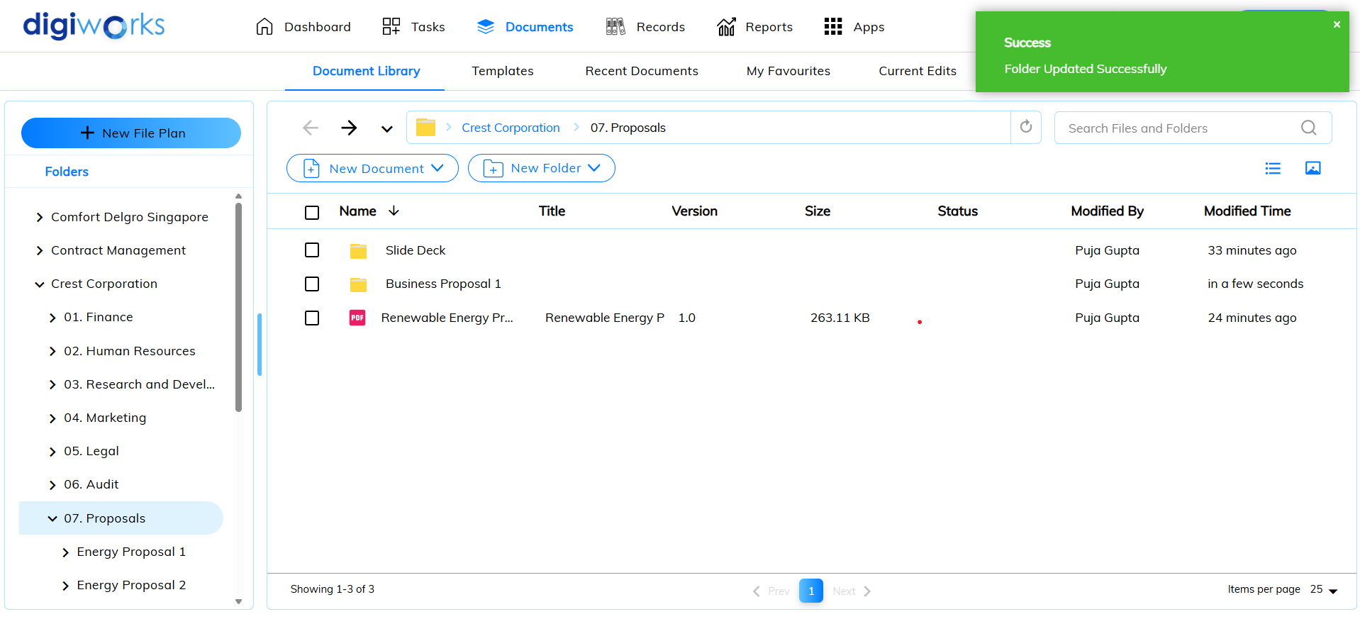

#### Tagging and Categorizing Content

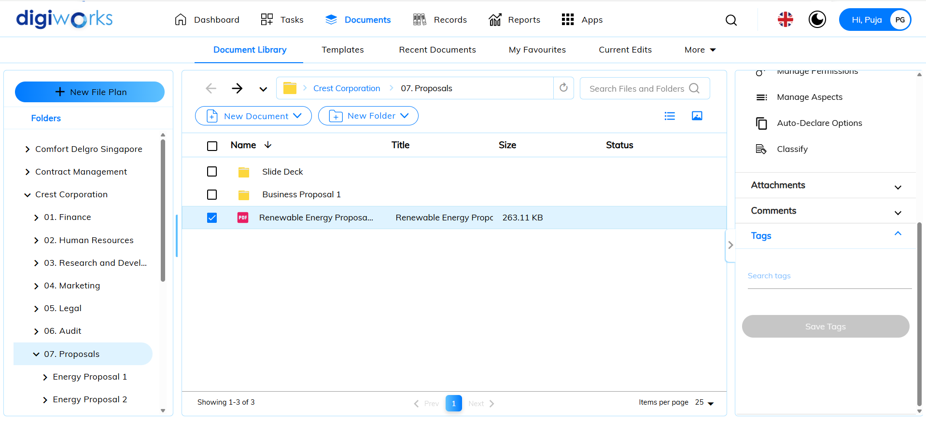

1. Click on Documents tab.
2. Click on Document Library.
3. On the right panel, click on Tags.
4. Choose the desired tag from the list of available tags.
5. Click Save Tags.

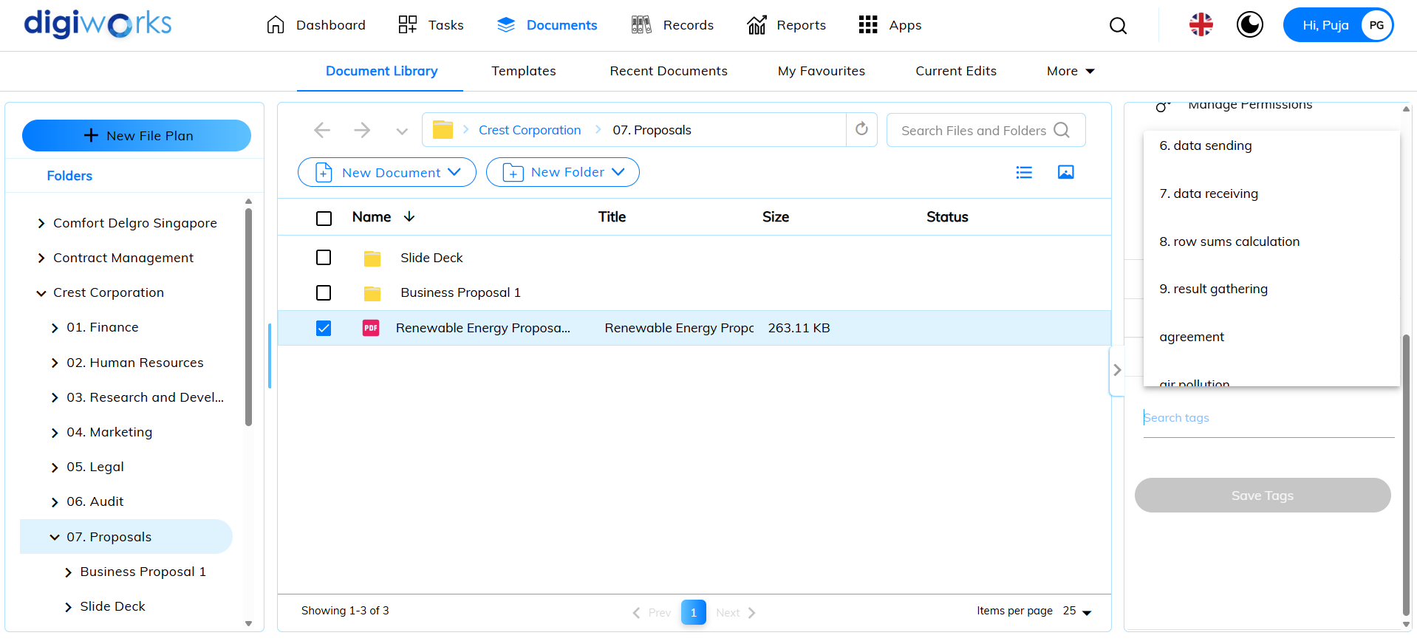

1. Tag will be assigned successfully.

#### Deleting content



1. Click on Documents tab.
2. Click Document Library.
3. Select the desired file/folder to delete and click on 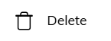.

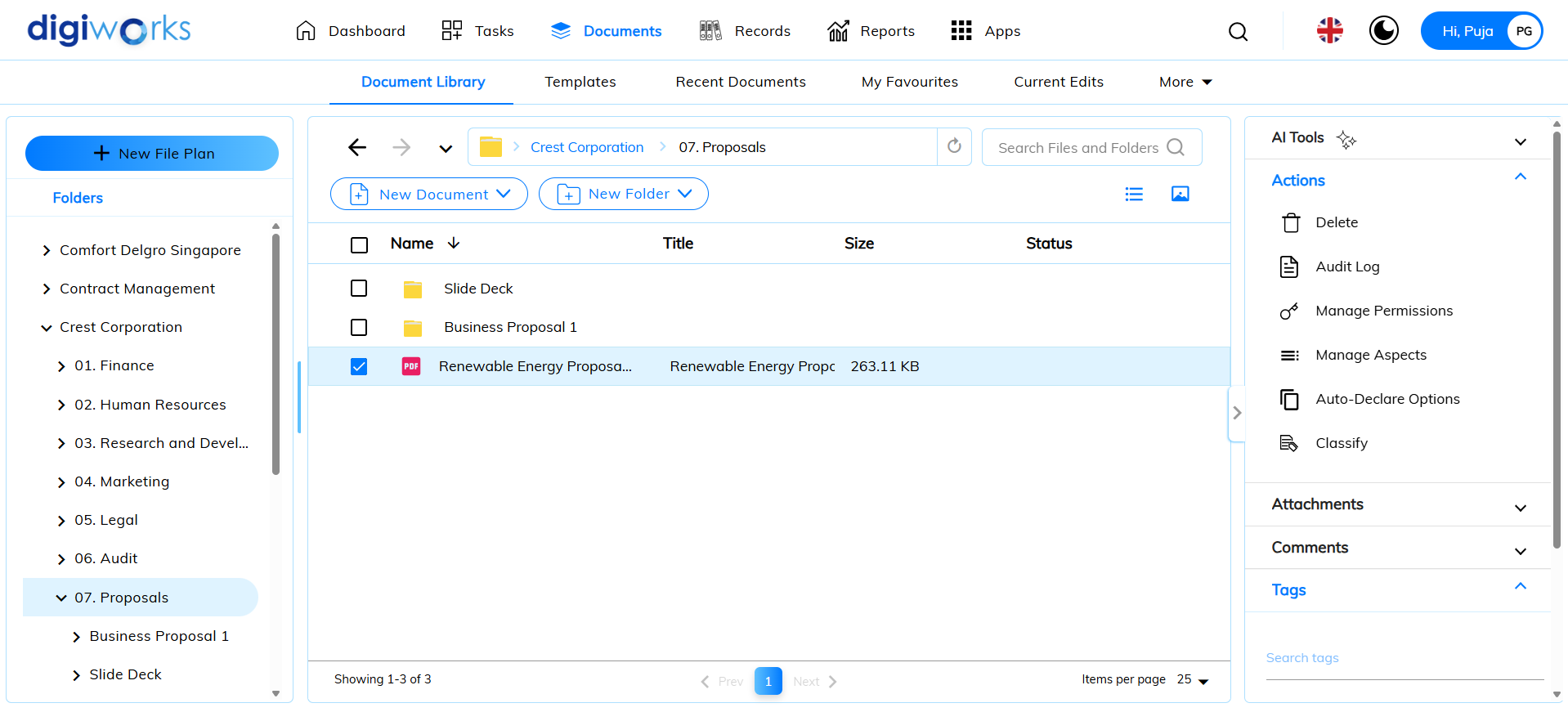

1. Confirmation popup-window will appear.
2. Click Yes to confirm.

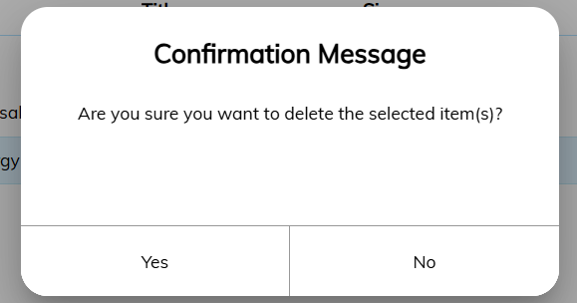

1. Success message will appear.
2. The file/folder has been deleted successfully.

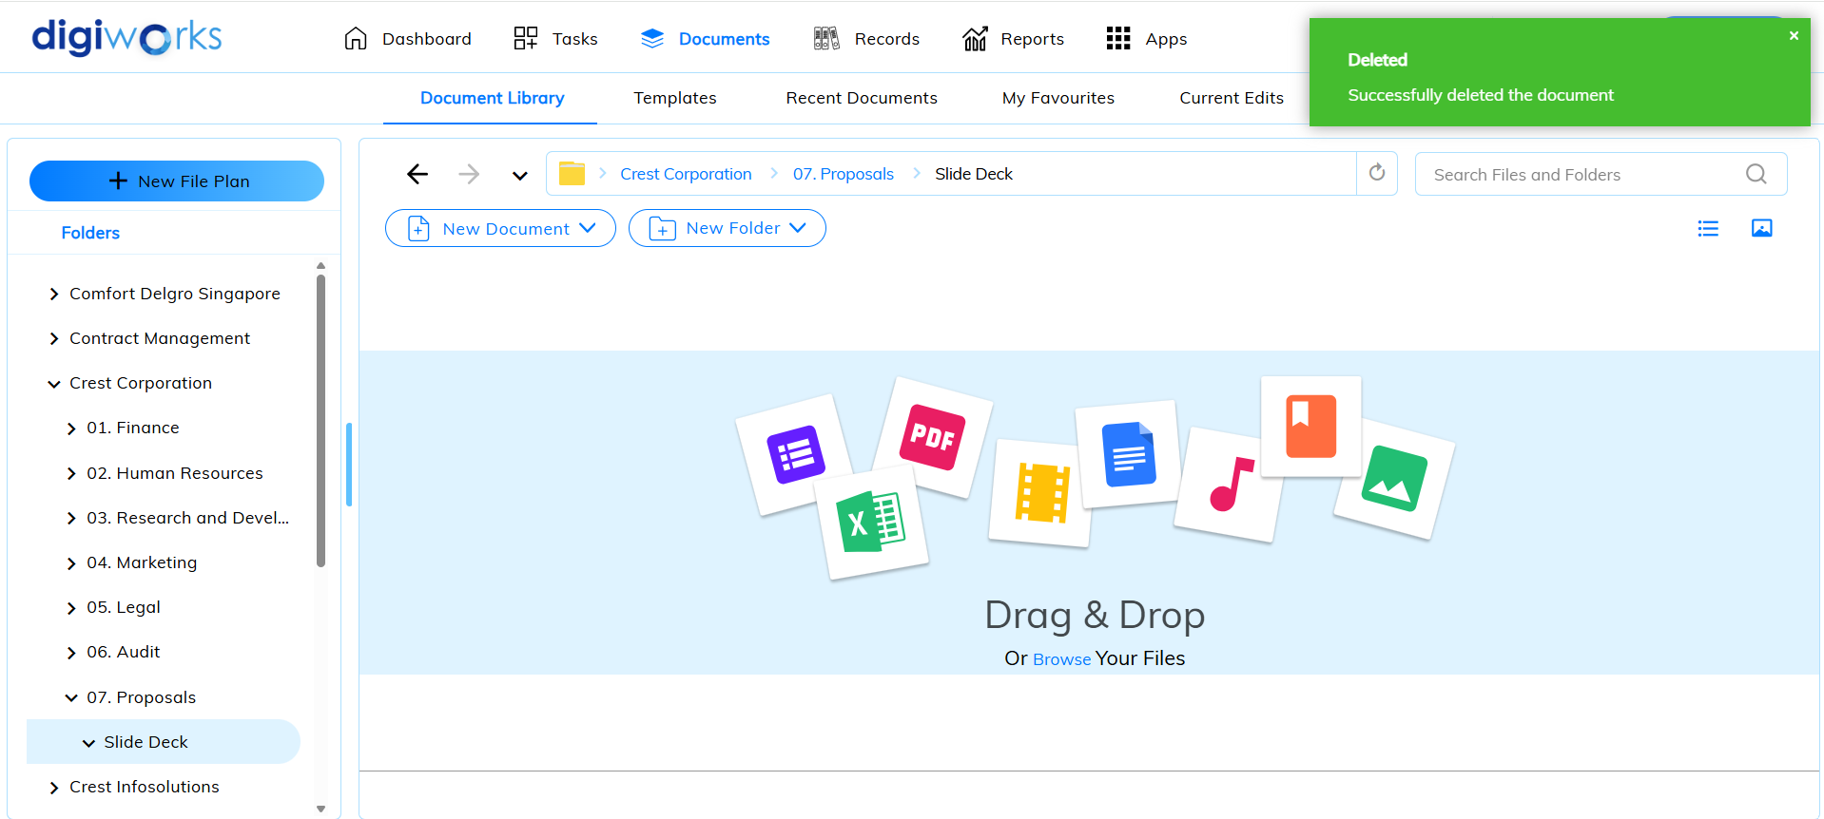

1. To recover deleted content/empty recycle bin, click on  and click Recycle Bin.

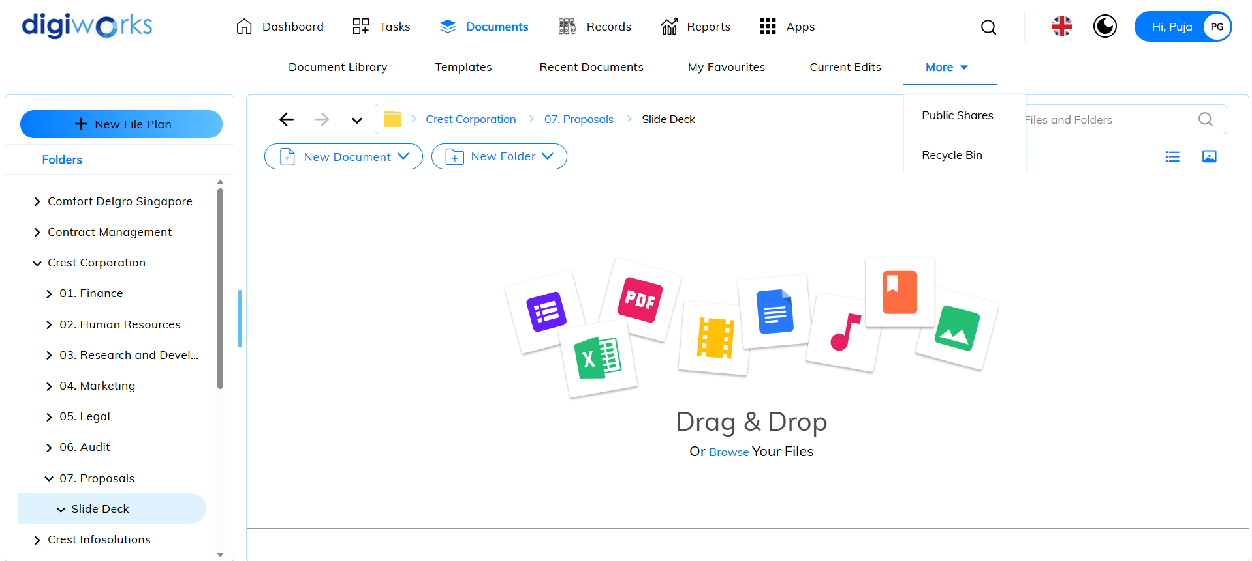

1. There will be two (2) options available:

* Click  to recover deleted content.
* Click 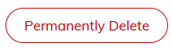 to permanently delete content.

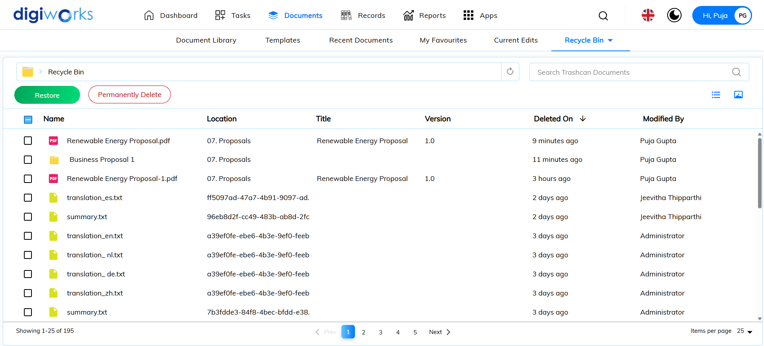

#### Social features for content



1. Click on Documents tab.
2. Click on Document Library.
3. Select the desired file/folder to favourite and click on 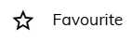.

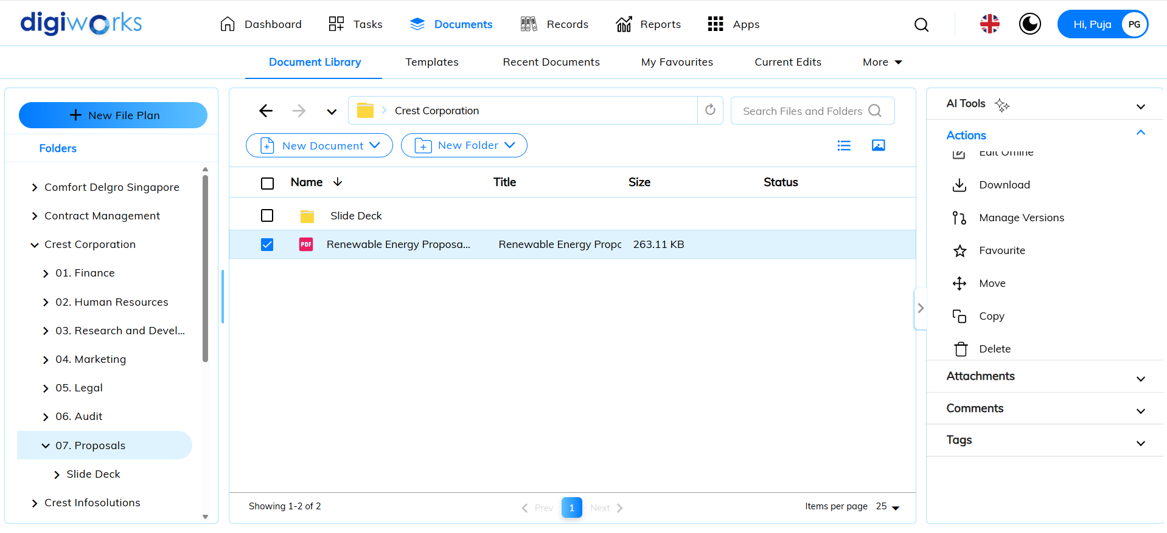

1. A  sign will appear on the right side of the file/folder name.
2. The file/folder has been added to My Favourites.

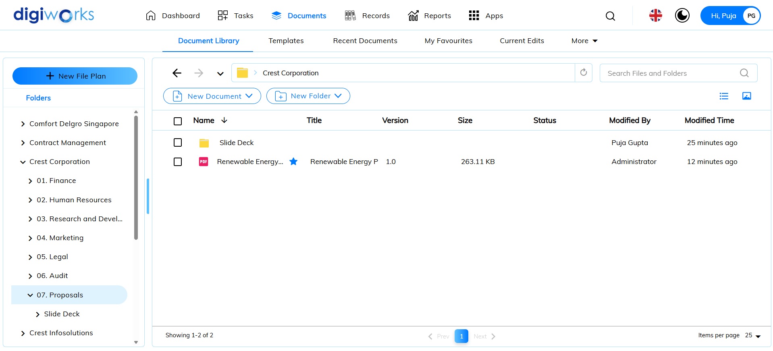

1. To view all favourited file/folder, click on My Favourites.

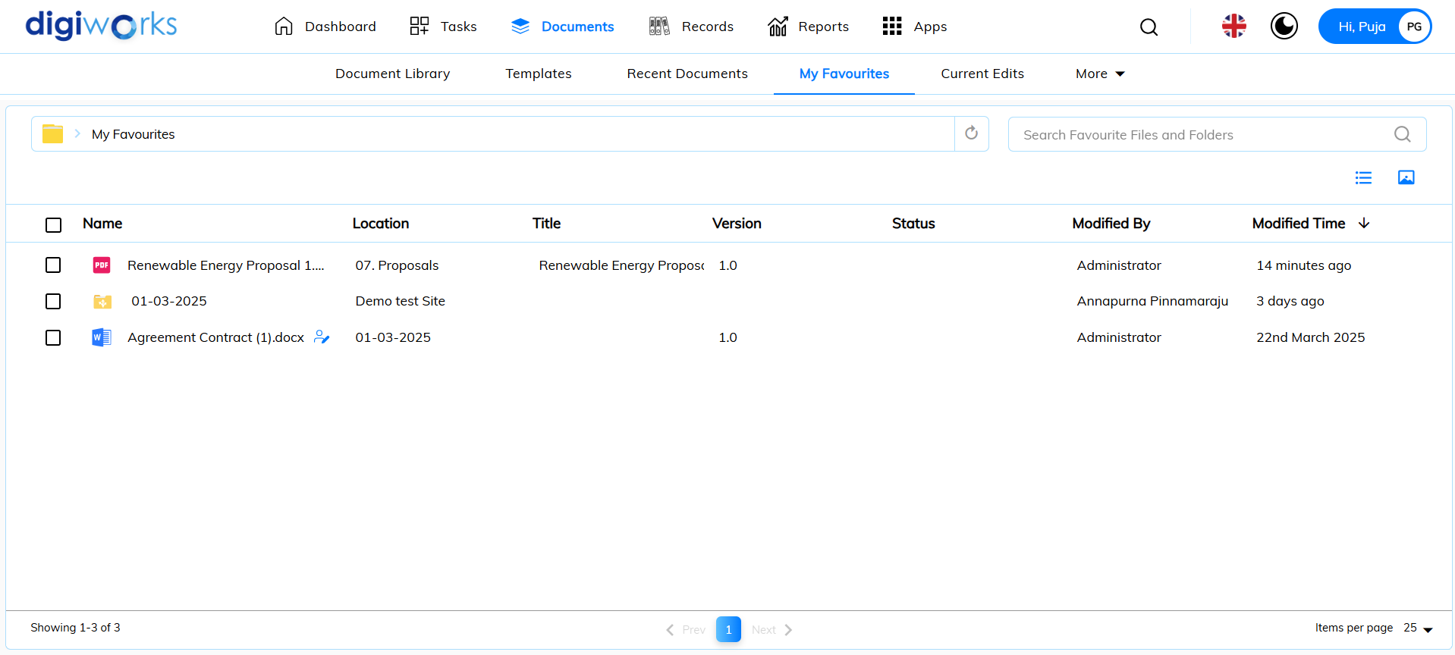

### Files and folders

After files and folders are added to a site, site members can access and interact with them. Members can view, download, edit, and delete files, as well as add new ones.

#### Editing Files

Multiple content editing methods exist, dependent on file type. These options include:

1. **Edit Offline:** Files can be downloaded for local editing. This action locks the file within the library, preventing concurrent edits. Applicable to all file types.
2. **Edit Online:** Files can be edited directly within the corresponding Microsoft Office application. This locks the file during editing. Supported for Microsoft Office 2003 and later files.
3. **Edit in Microsoft 365:** File opens in the browser-based version of the appropriate Microsoft 365 application (e.g., Word Online, Excel Online, PowerPoint Online). During the editing session, the file is locked within the source library to prevent simultaneous modifications by other users. Changes are saved automatically or upon user confirmation, depending on the specific application and configuration. This option is available for supported file formats within the Microsoft 365 suite.
4. **Edit in Google Docs:** Files can be edited via Google Docs. The file is locked during the editing process. Supported for compatible document, presentation, and spreadsheet formats.

##### Editing files Offline

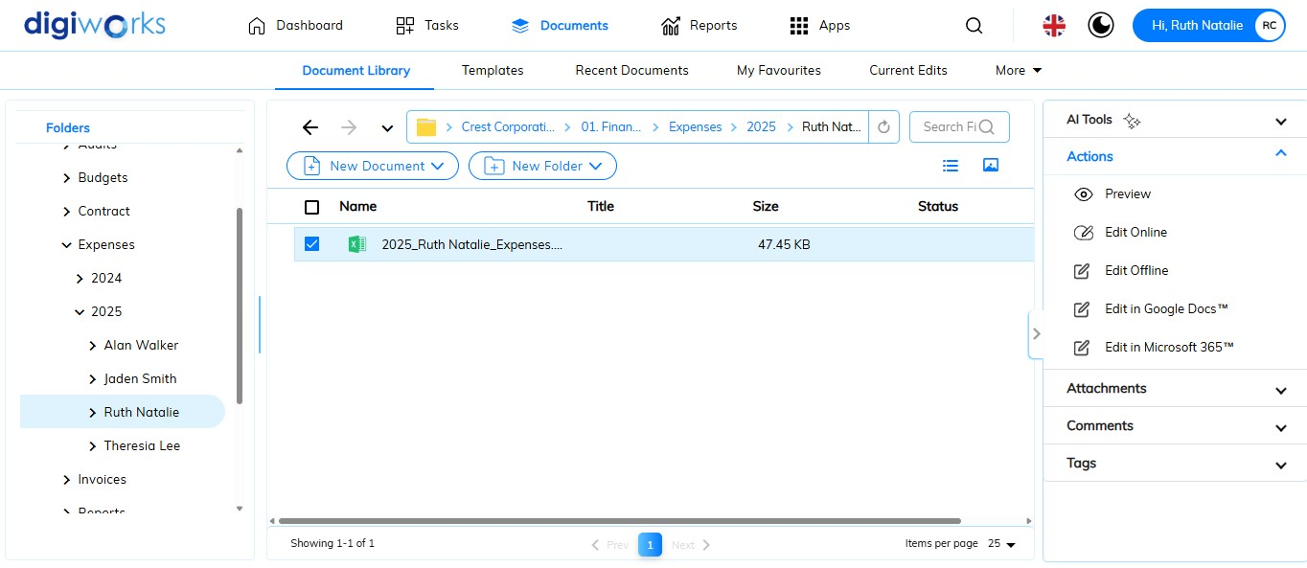

1. Click on the Document Tab.
2. Go to Document Library Tab.
3. Select one of the files for which to edit offline.
4. Click on  button.
5. The document will automatically download, ready for offline editing through a Microsoft Office application.

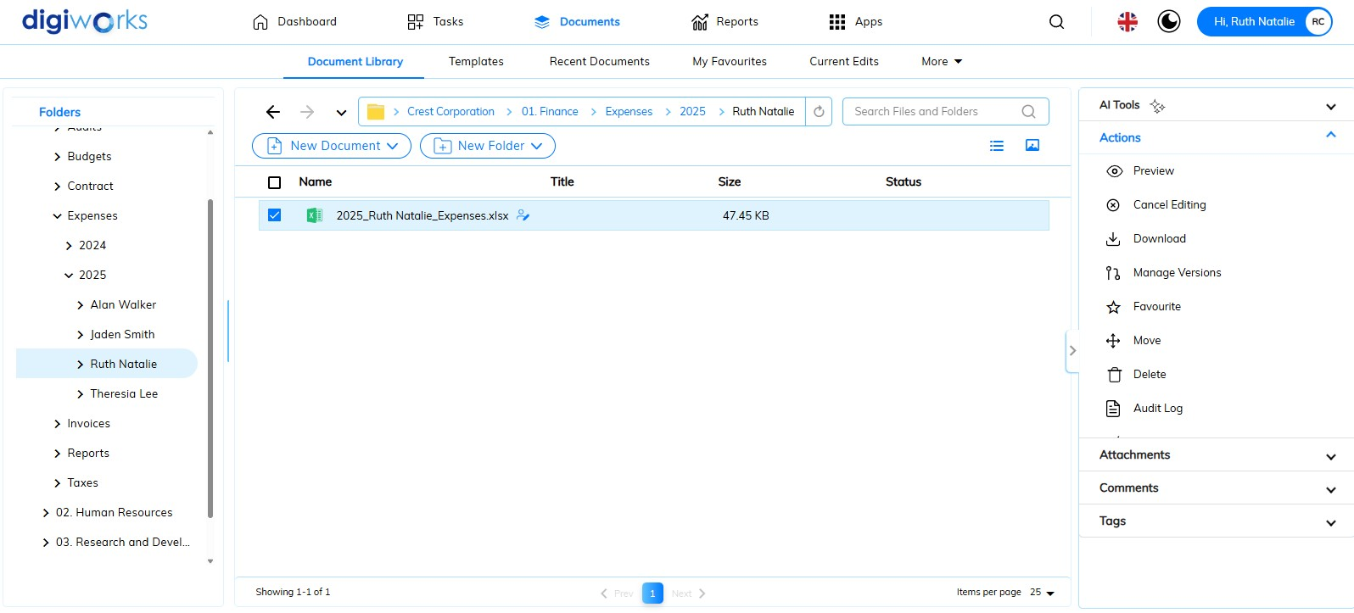

1. Selecting button to unlocks the file and discards modifications.
2. However, to upload new version, click button to upload the edited version to DigiWorks.

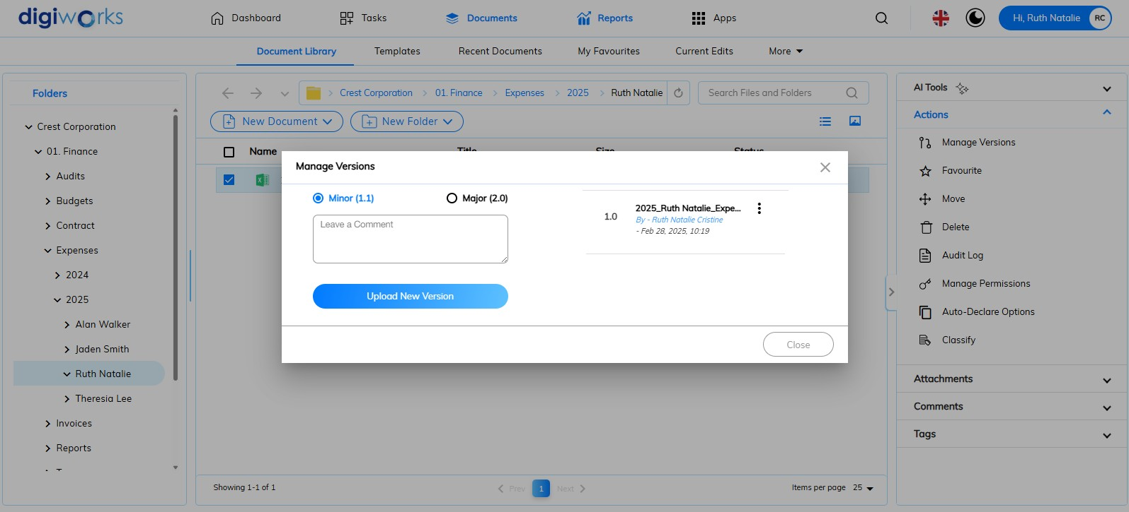

1. Choose either Minor or Major version.
2. Leave the comment of the edited version (optional).
3. Click button.

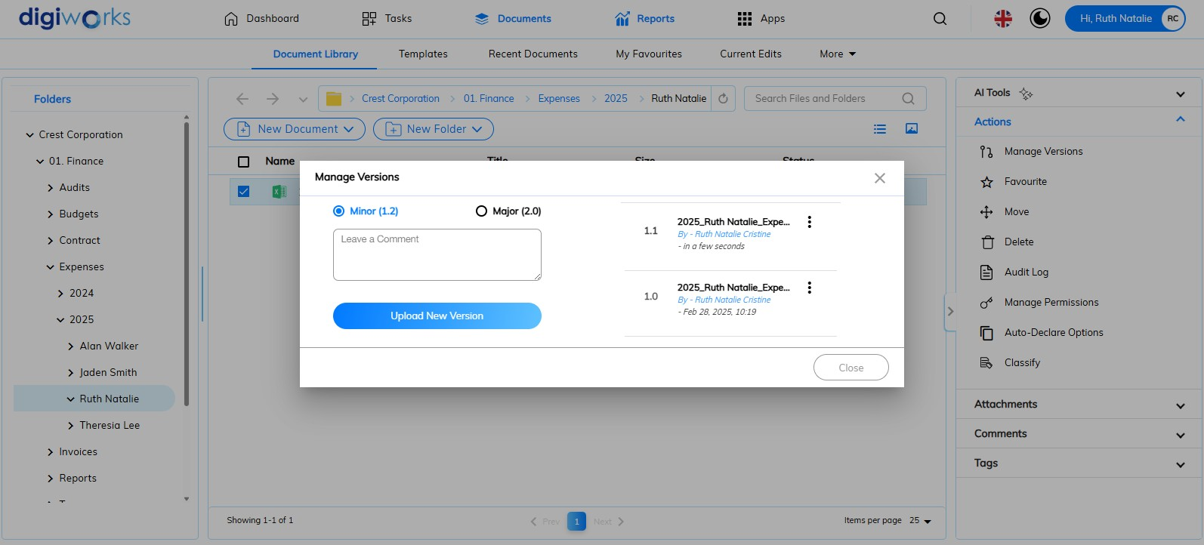

1. The most recently uploaded file will be at the top.

##### Editing Files Online

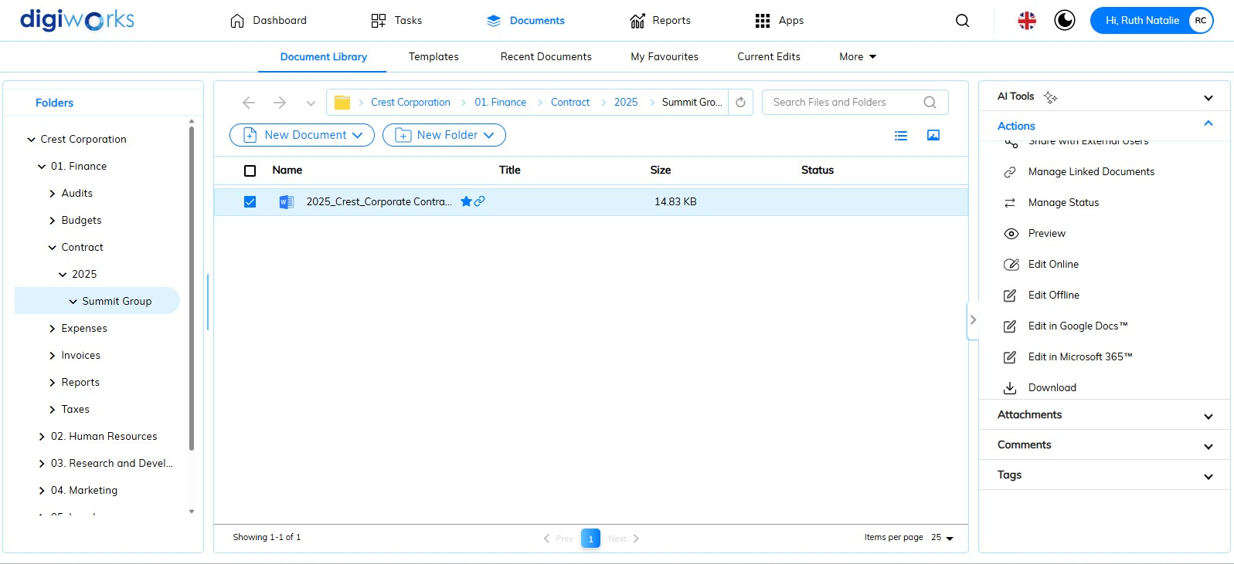

1. Click on the Document Tab.
2. Go to Document Library Tab.
3. Select one of the files for which to edit online.
4. Click on  button.

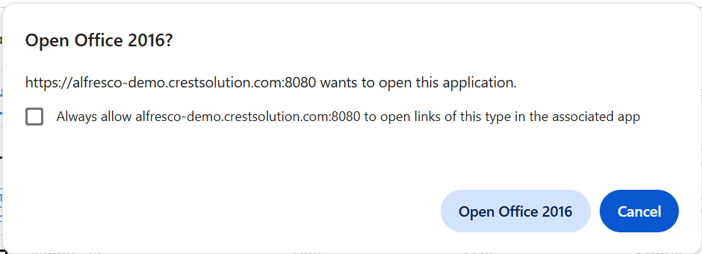

1. Pop up window will show and click Open Office 2016.

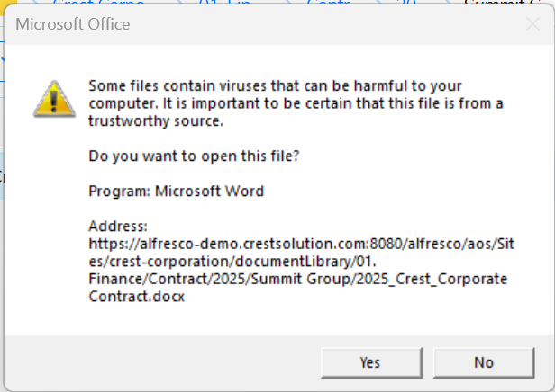

1. The Ms Word application will open and click Yes on pop up window.

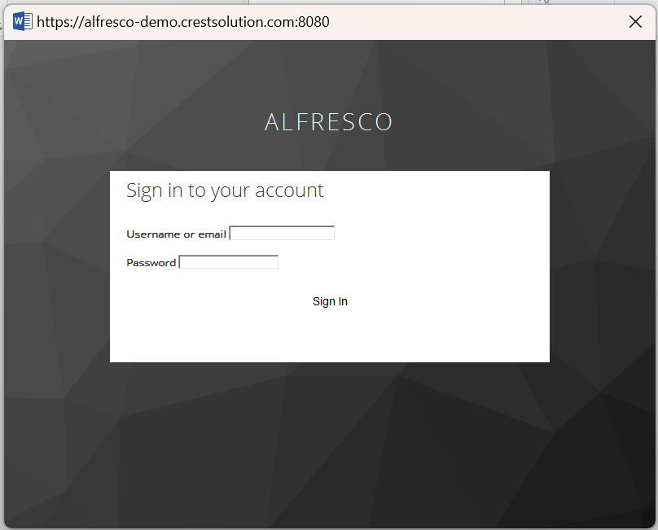

1. Sign in to DigiWorks account, enter the username and password.

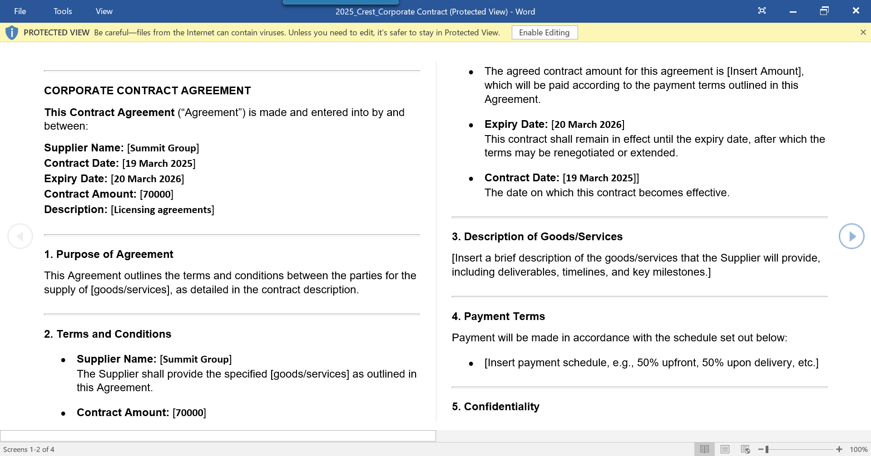

1. The file will open, click Enable Editing.

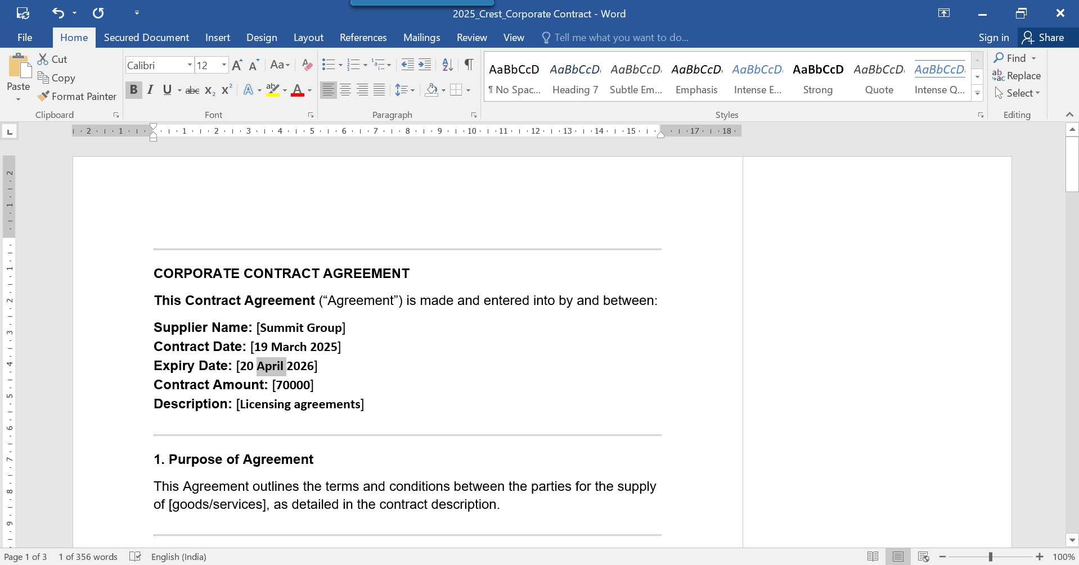

1. The file is ready to edit. The Expiry Date, in this scenario, was changed from 20th March 2026 to 20th April 2026.

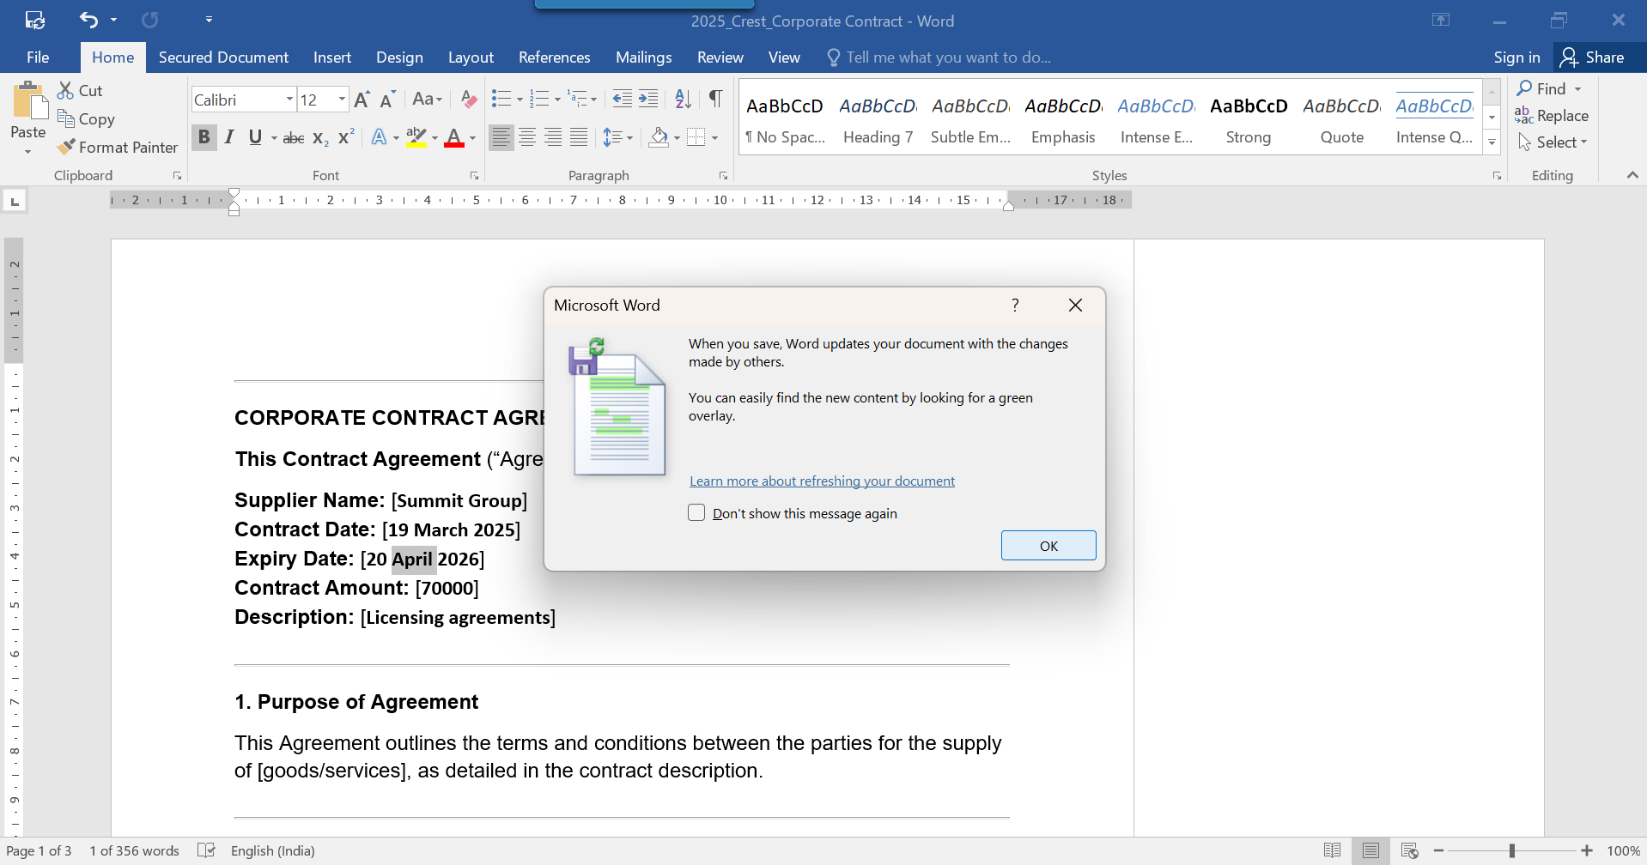

1. Click the Save button, and confirm by clicking OK in the pop-up.
2. Go back to DigiWorks.
3. Locate the previously edited file and click Preview.

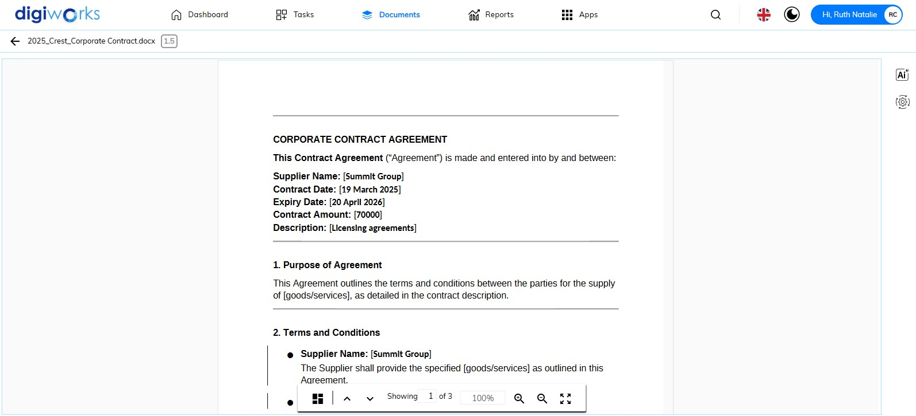

1. The file is successfully saved to DigiWorks.
2. Click button to go back to Document Library.
3. Click button.

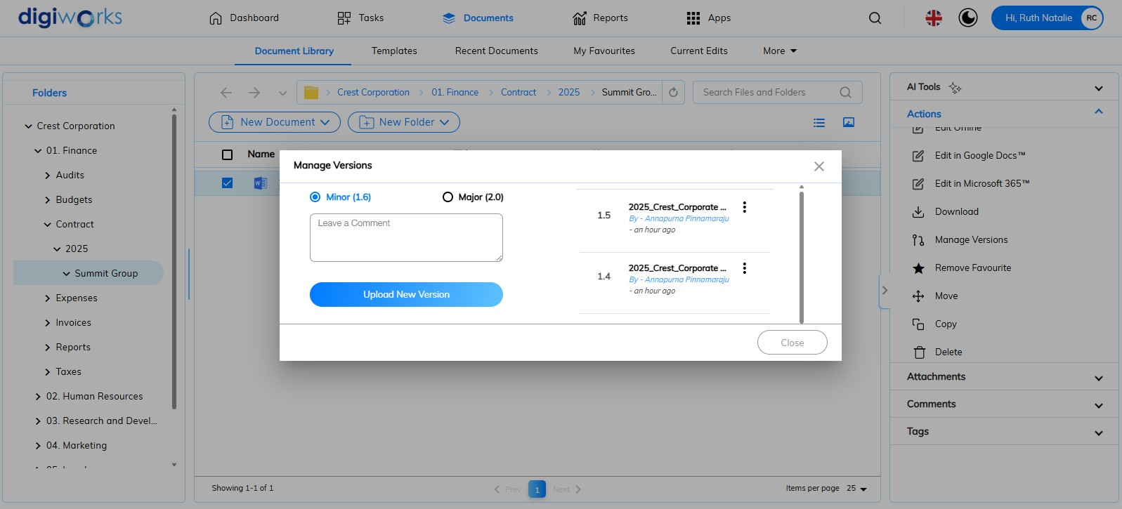

1. For Edit Online, file saved in Minor Version.

##### Editing Files in Microsoft 365

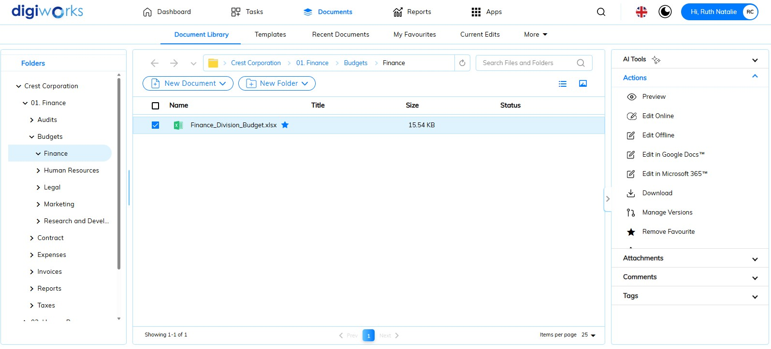

1. Click on the Document Tab.
2. Go to Document Library Tab.
3. Select one of the files for which to edit in Microsoft 365.
4. Click on  button.
5. The page will load to sign in to Microsoft account.

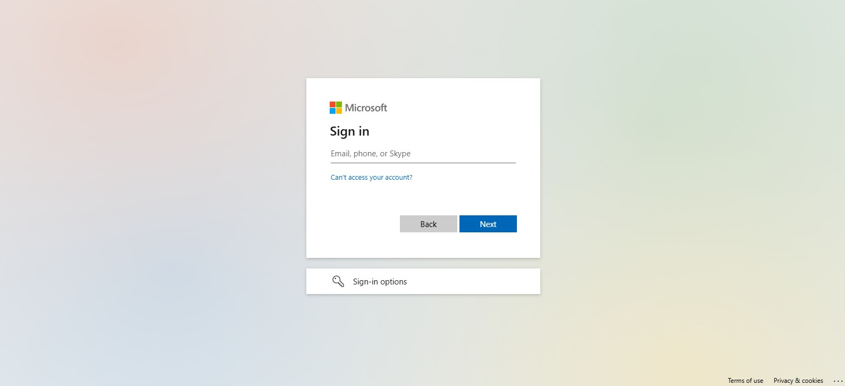

Currently is a bug

##### Editing Files in Google Docs



1. Click on the Document Tab.
2. Go to Document Library Tab.
3. Select one of the files for which to edit in Google Docs.
4. Click on  button.

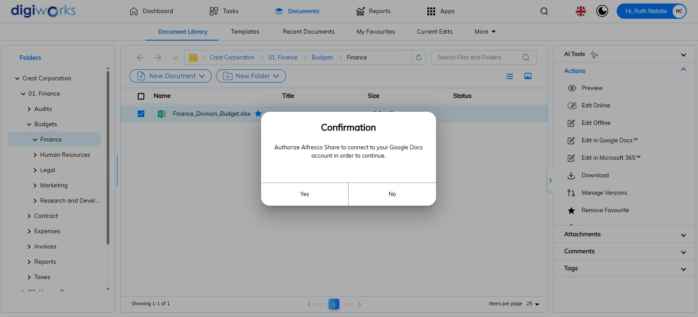

1. Click ‘Yes’ on pop up confirmation to authorize Alfresco Share to connect to Google Docs.
2. A pop-up tab will open, and the file will be ready for editing.

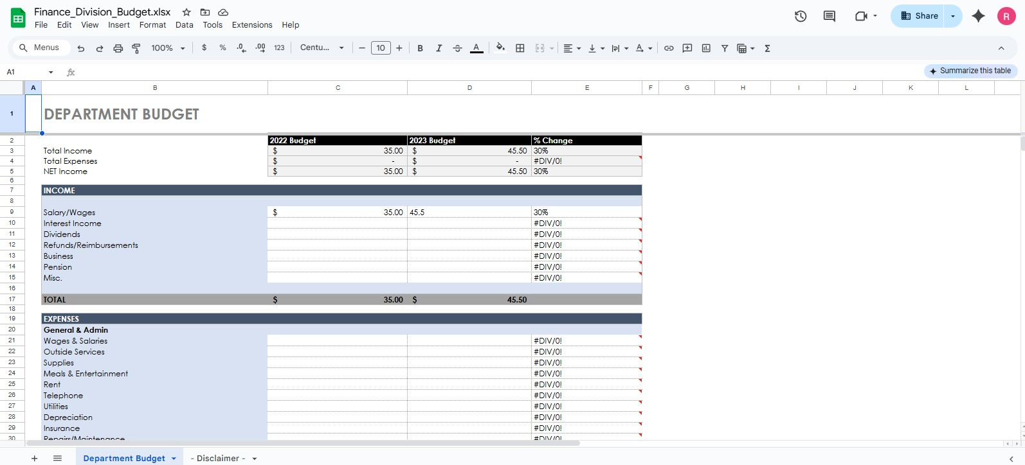

1. After completing edits, close the tab. Return to DigiWorks and select the previously edited file.

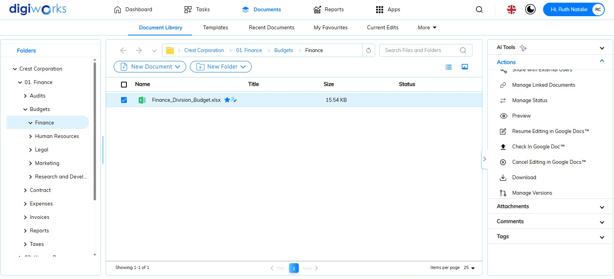

1. There are some actions below after editing the file in Google Docs:

|  |  |
| --- | --- |
|  | To cancel editing in Google Docs |
|  | To resume editing in Google Docs |
|  | * + To save the document as a new version, either minor or major, users can leave an optional comment.   + Click Check In to save the document in new version. |

1. Check Manage Version to see previous and current document versions.

#### Downloading Files

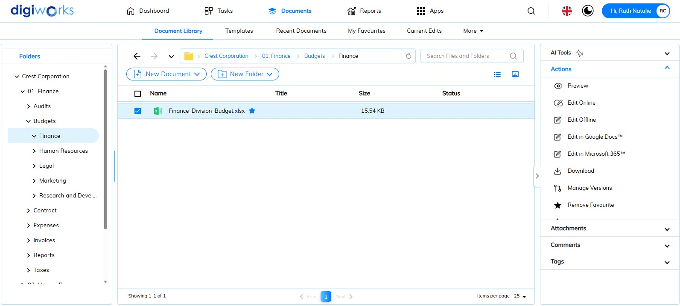

1. Click on the Document Tab.
2. Go to Document Library Tab.
3. Select one of the files for which to download.
4. Click button to download the selected file.
5. The saved files will be saved to the PC.

#### Sharing Files

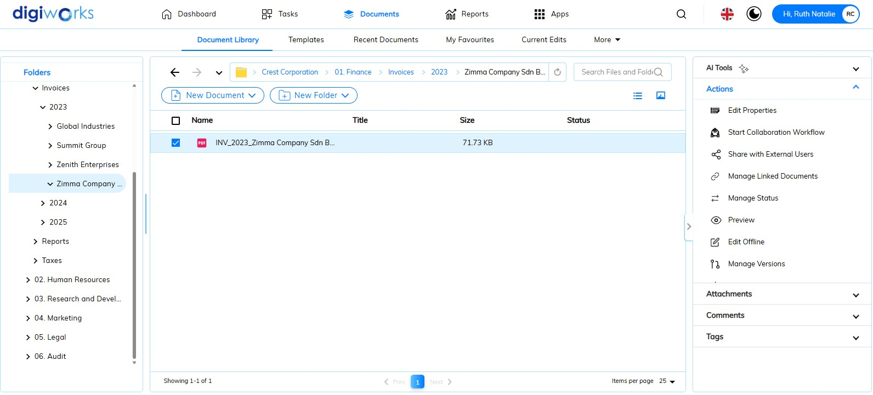

1. Click on the Document Tab.
2. Go to Document Library Tab.
3. Select one of the files for which to share.
4. Click button to share the selected file.

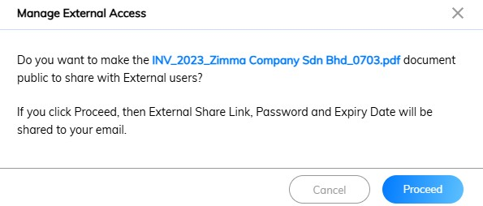

1. The pop-up window will appear, click button then the External Share Link, Password and Expiry Date will be shared to email or click 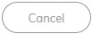button to cancel the action.

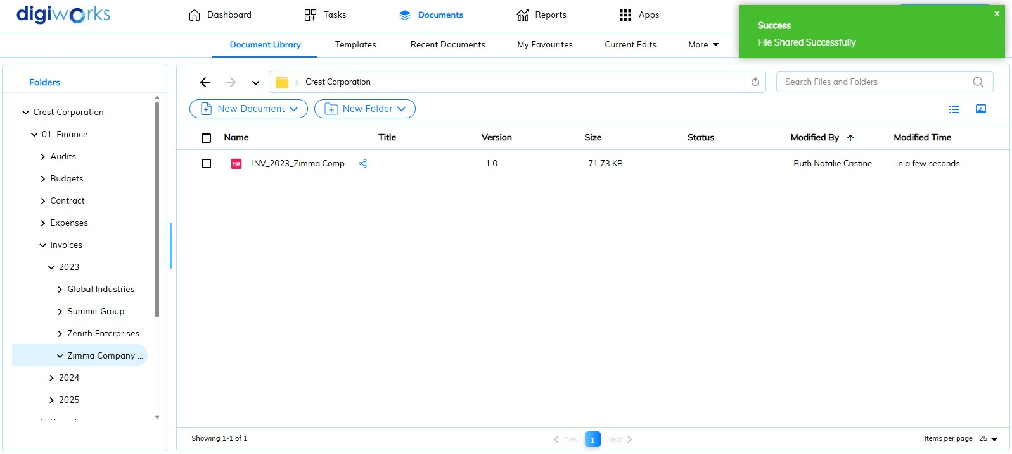

1. After click button, the success message will prompt on the screen. An icon indicates that the file is currently in sharing mode.

To add email screenshot, currently is a bug.

1. The email provides details regarding the shared external link, password, and expiry date. The email message can be forwarded to the external user's email address.
2. Click the external link to open the shared files.

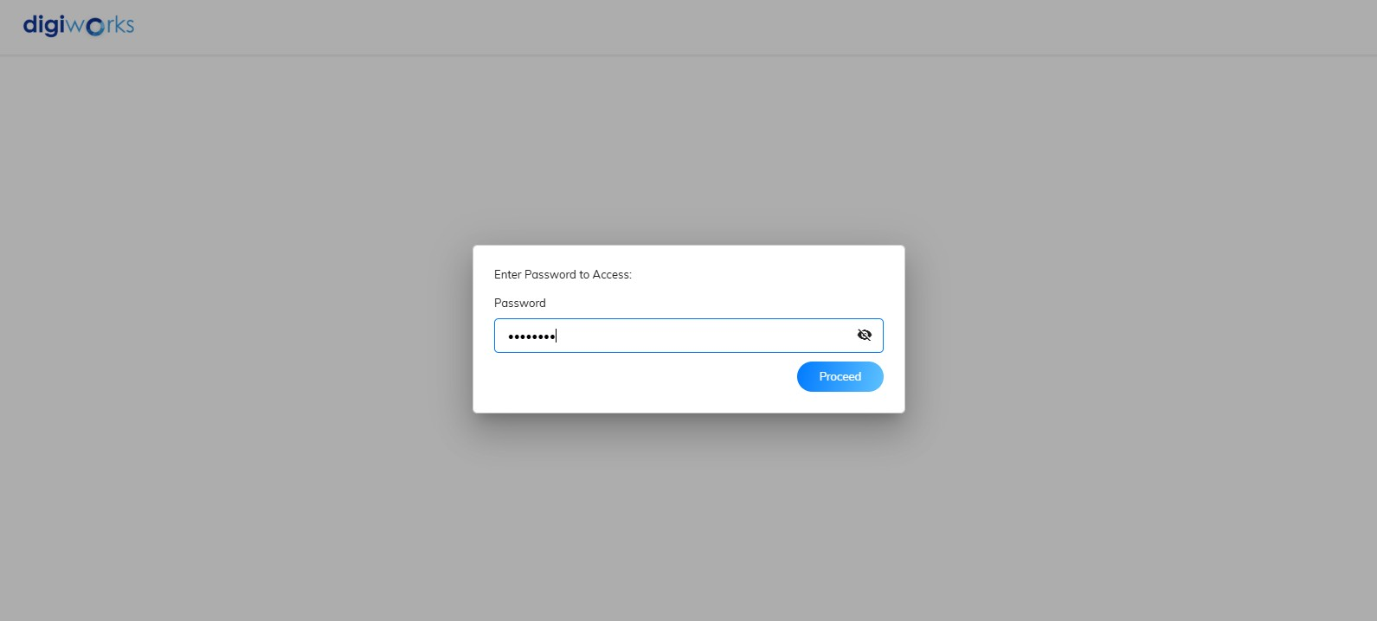

1. Enter the password provided in the email.
2. Click button to open the shared files.

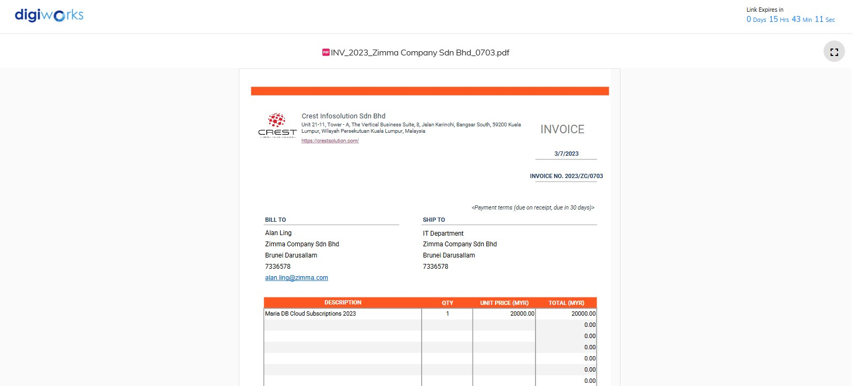

1. The file will open with the expiry countdown details *displayed in the upper right corner*.

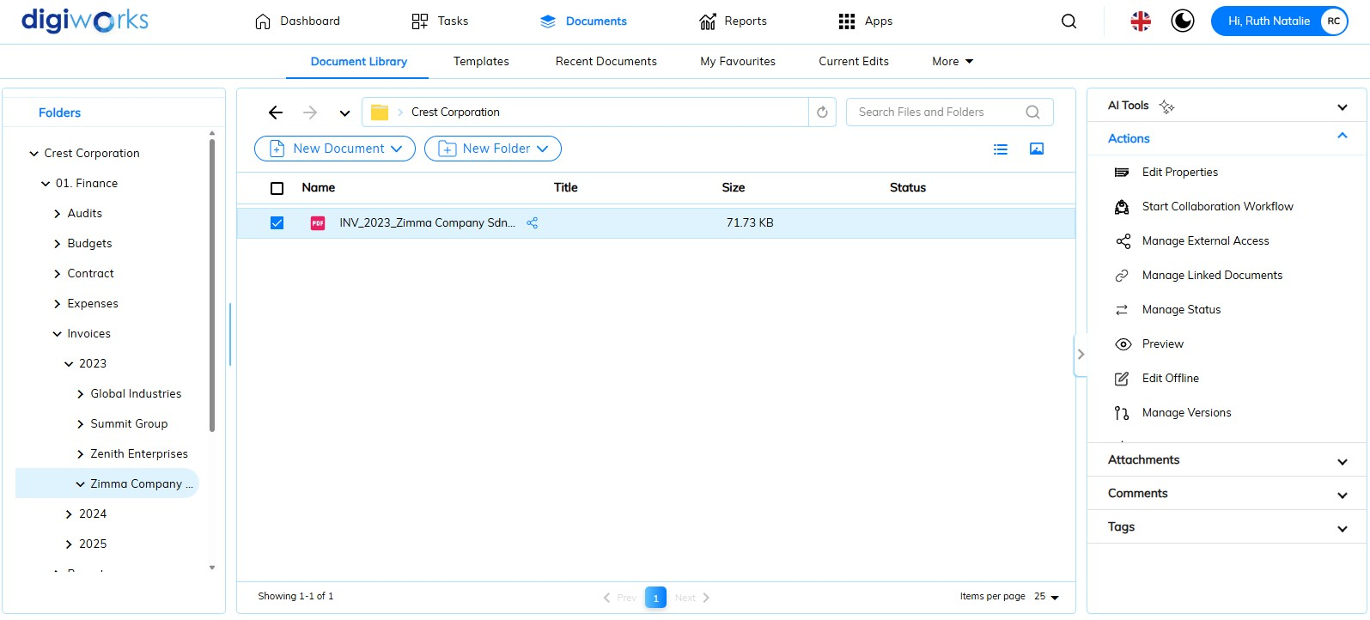

1. Go back to DigiWorks and select the shared file.
2. The Shared with External User button has been changed to the Manage External Access button.

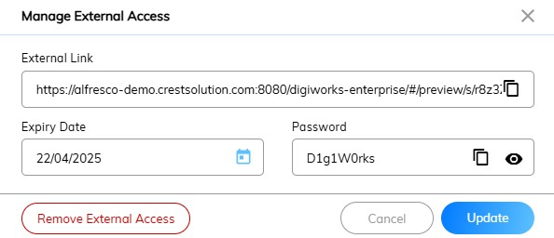

1. Click button to remove the external access or update the expiry date or modify the password.
2. Click 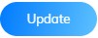button to maintain sharing mode (*repeat* ***step g****. to forward email to external user*) or click button to abort the action.
3. 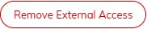 button is used to revoke external access before the expiry date.

#### Managing File and Folder Permissions

Default site permissions for content added to the document library can be overridden. This allows for granular control over site member access and actions. Each site member has an assigned role—Manager, Collaborator, Contributor, or Consumer—and these roles have default permission sets that dictate available actions within the site.

The Manage Permissions feature extends beyond site-wide permissions, enabling the override of a user's site role for specific content items or folders. This allows for granular access control, granting site members varied access levels to individual content compared to their general site permissions. This functionality proves useful for restricting content visibility to designated site member groups.

**Note**: Assigning permissions to non-site members can lead to document library errors.

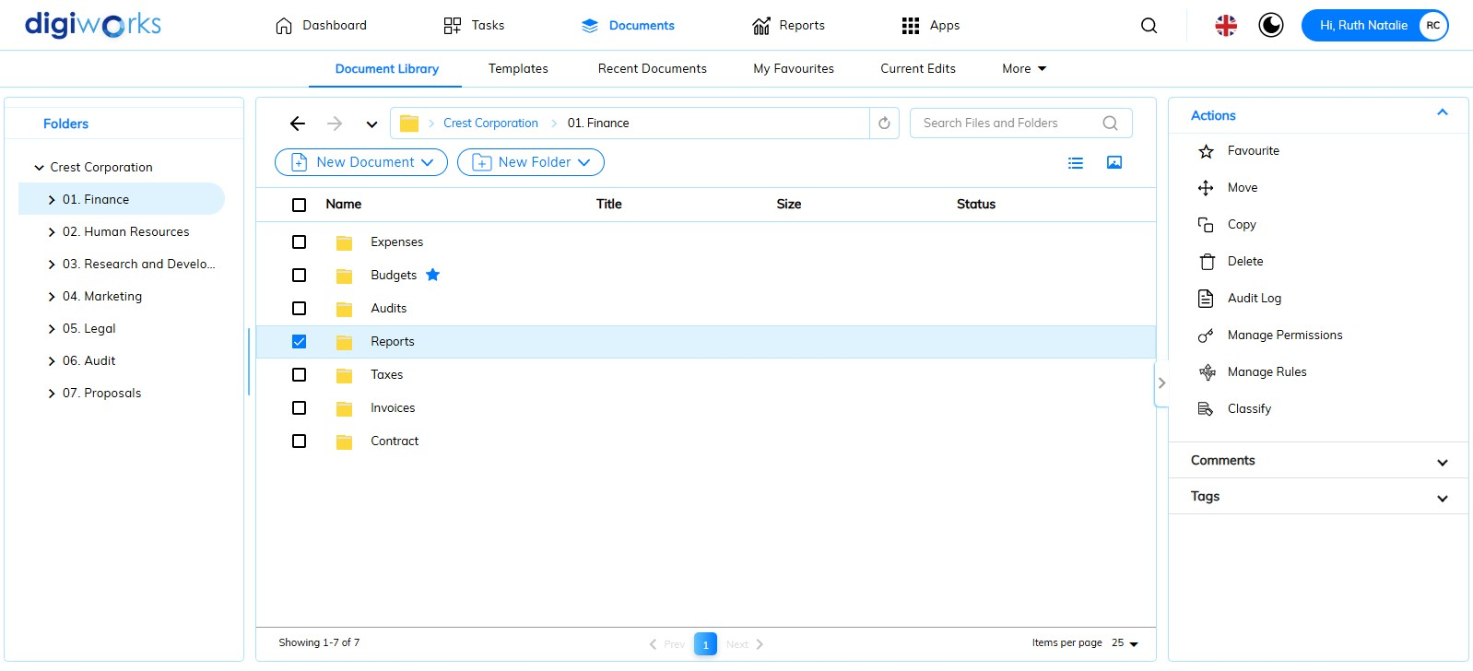

1. Click on the Document Tab.
2. Go to Document Library Tab.
3. Select one of the files/folders for which to manage permission.
4. Click button.

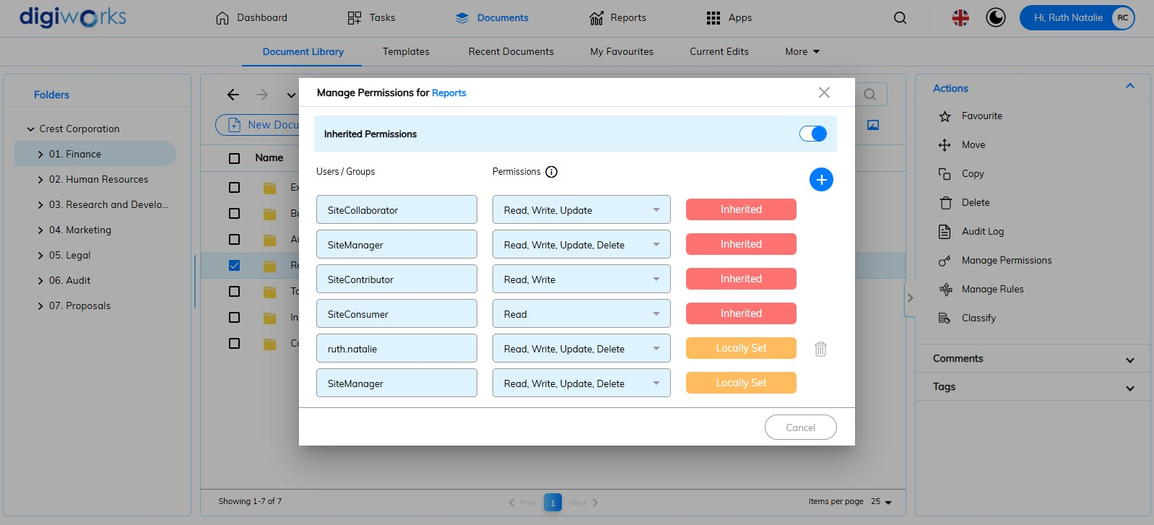

1. The pop-up window will appear.
2. Click button.

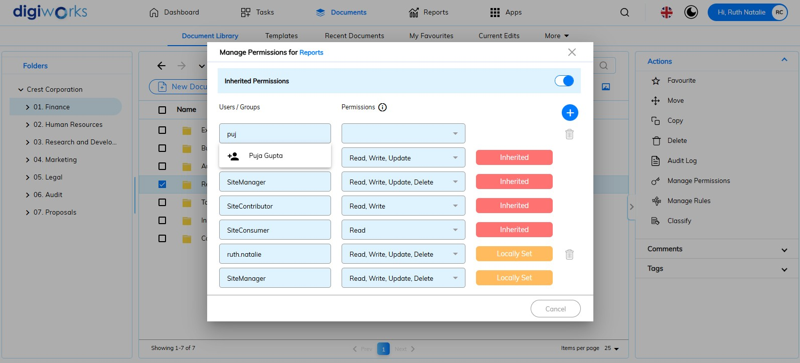

1. Enter the user or group name. A system-generated drop-down list of user and group names will provide suggestions.

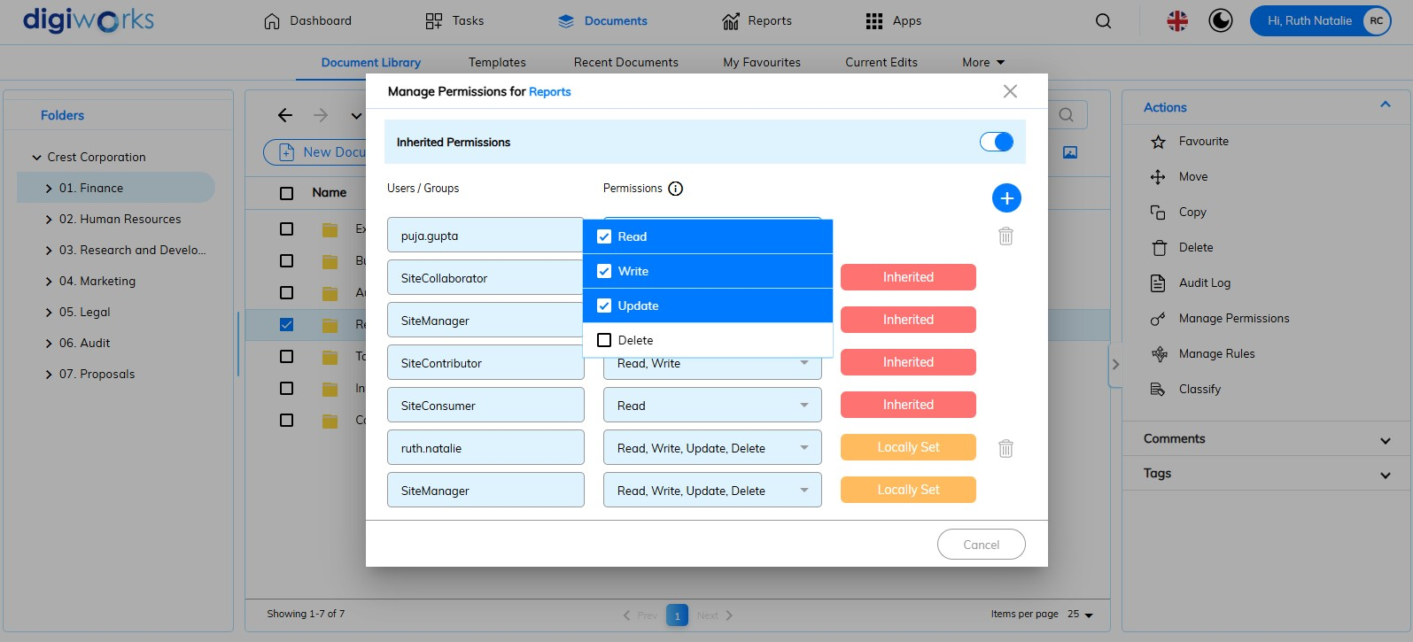

1. Select a permission.

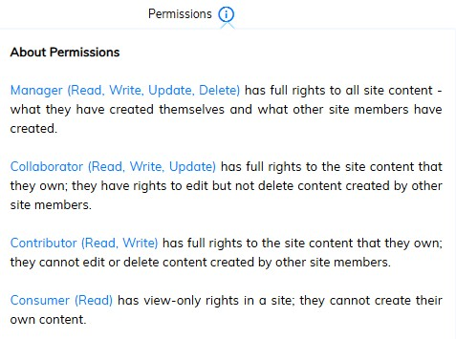

1. The definition of each permission can be viewed by hover the icon.

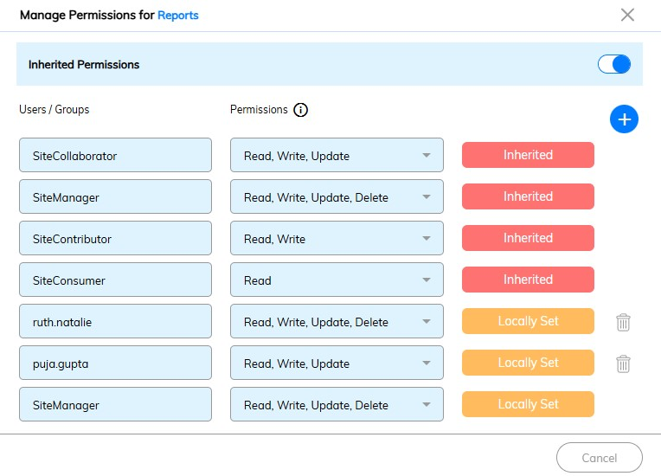

1. Permission is successfully added.

** Note**s:

* To revoke the permissions for a user, click icon.
* Turning off inherited permissions using the button means that only the site manager and any manually added users can access this folder/file.

### Folder rules

Within the library, folder rules enable automated content management. Numerous creative solutions can be devised to automate specific content processes, eliminating manual intervention.

Rules govern the management of content entering, leaving, or currently residing in a folder. A content rule comprises three components:

* the event triggering the rule,
* the conditions the content must meet,
* the action performed on the content.

Triggering events include:

* content item arrival in the folder,
* content item departure (move or delete),
* content item modification within the folder.

Examples of rule-based automation for repetitive tasks include:

* versioning all files placed in the "*Drafts*" folder;
* incorporating all files in the "*Drafts*" folder into a simple workflow;
* moving all files in the "*Completed*" folder tagged "final" to the "Archived" folder;
* transforming all *GIF* files in the "*Images*" folder to PNG files;
* transforming presentation documents in the "*Published*" folder to Flash and copying them to the "*Assets*" folder.

#### Defining Rules for a Folder

##### Creating a Rule

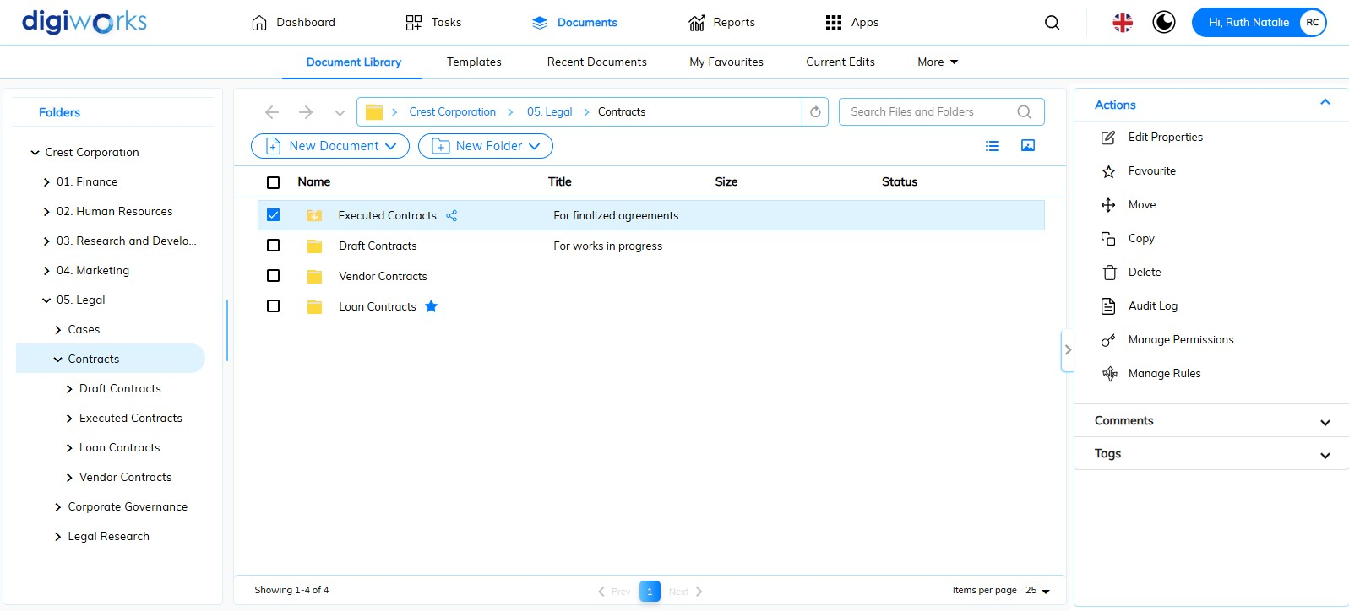

1. Click on the Document Tab.
2. Go to Document Library Tab.
3. Select one of the folders for which to create rules.
4. Click button.
5. Click 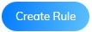button.

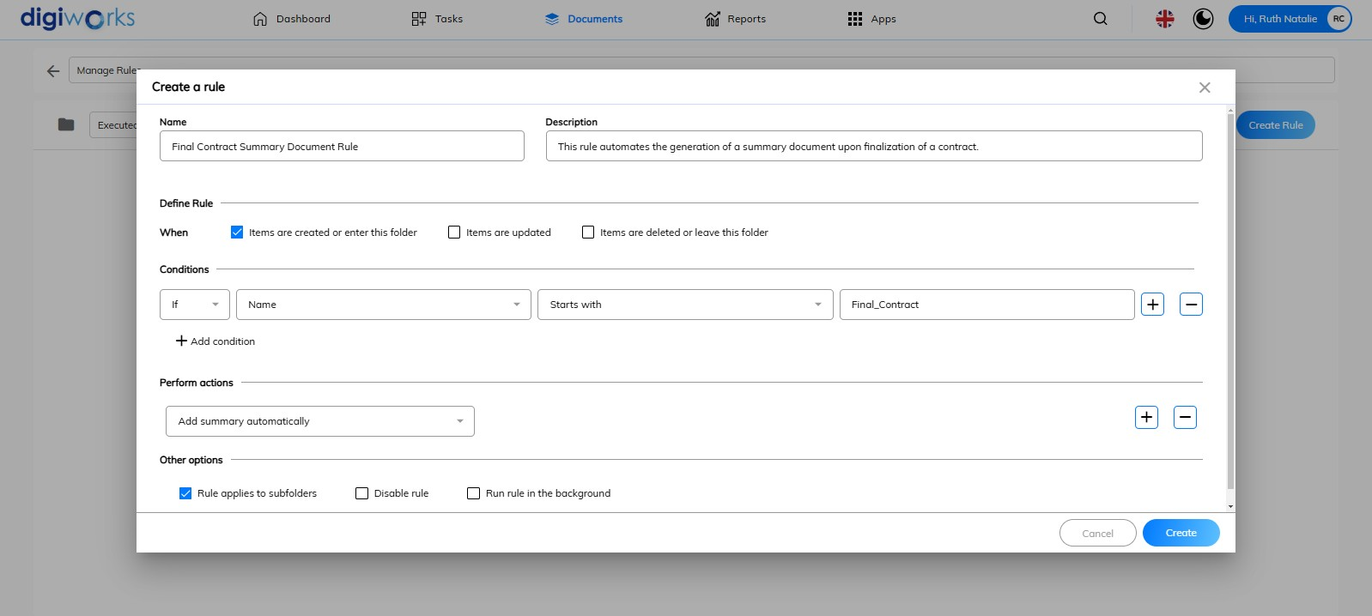

1. All fields should be completed and conditions configured. In this scenario, a rule is created for documents within the 'Executed Contracts' folder. When a document with the condition starts with ‘*Final_Contract*' enters this folder, an automatic action to add a summary will be performed. The rule will apply to its subfolders.
2. Click 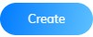button.

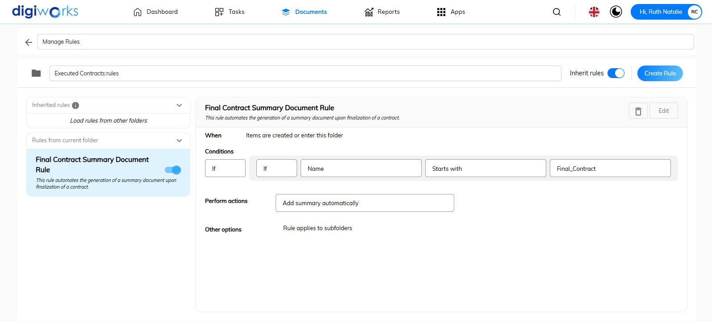

1. Click 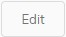button, to edit rule.

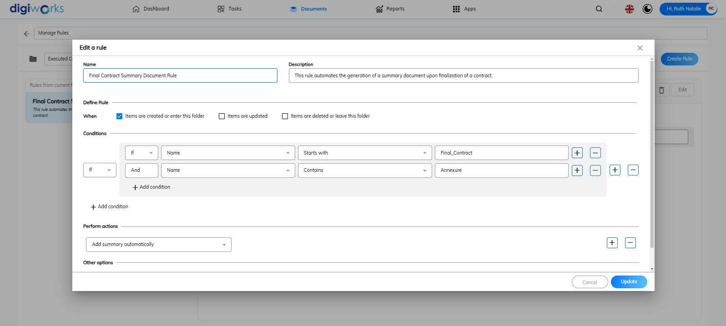

1. The Edit a Rule pop-up allows for the addition or editing of fields. In this scenario, **+ Add Condition** is clicked during rule editing. When a document name contains '*Annexure*', the automatic summary addition will also apply to that document.
2. Click to save modifications.

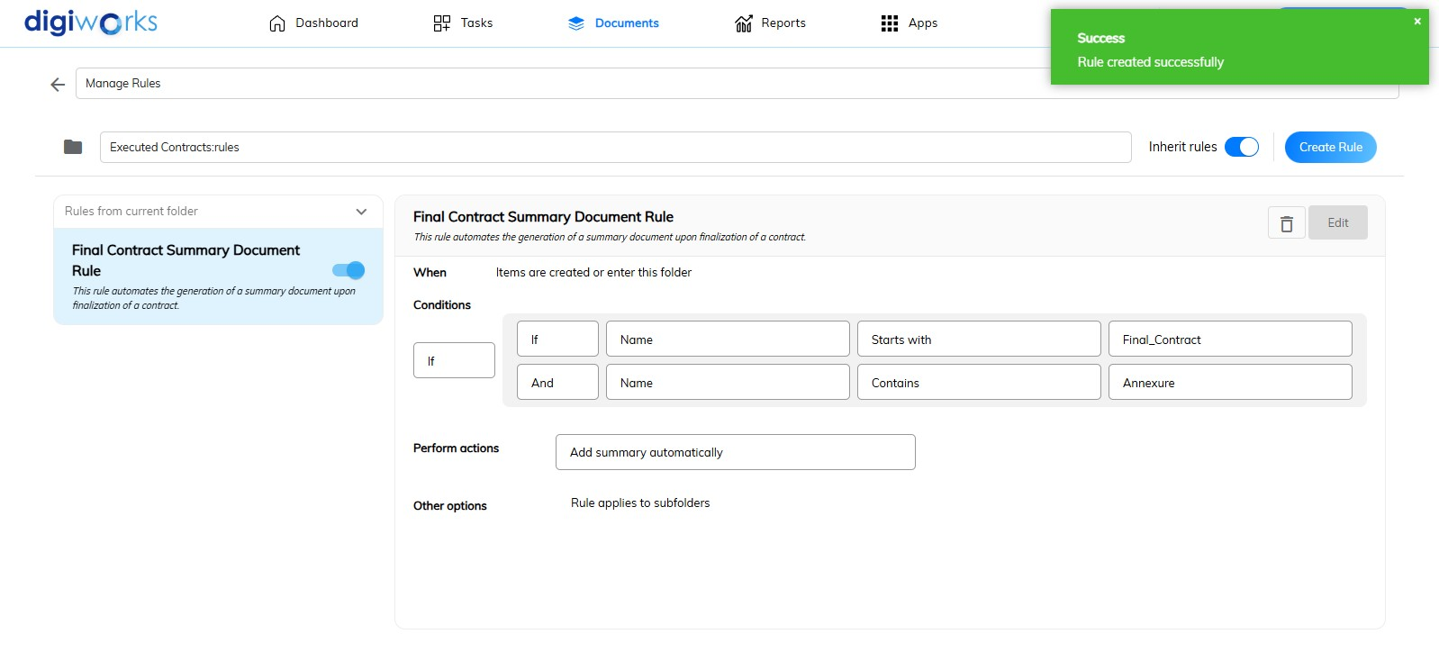

1. A success message will appear.

**Notes**:

* To delete the rule, click button.
* To create another rule, click button. Multiple rules can be created.
* To turn off the inherit rules, click button. When inherited rules are turned off, it stops the automatic application of rules from a parent folder to its child folders.
* To disable the rules, click button. The rules' functionality is stopped within the current folder, either temporarily or indefinitely.

##### Rule Actions



When creating rules, there is a 'Perform Actions' column. The definitions of each action are provided below:

|  |  |
| --- | --- |
| **Actions** | **Descriptions** |
| **action-moveclosedfolder** | This action automatically moves files to a designated "closed" or archived folder. This is used for managing completed or finalized documents. |
| **action-updateemail-cv** | This action automatically updates email communication or content with information from a Curriculum Vitae (CV) or related document. This is often used to extract and update contact or professional information. |
| **Add AI Indexable** | This action prepares files for indexing by artificial intelligence systems. This allows AI to process and understand the content, improving searchability and automated data extraction. |
| **Add aspect** | Adds a property aspect to files, to give it additional behaviours or properties. |
| **Add simple workflow** | Files are added to a workflow. An approval task is included by default, and a reject task can be added. The 'Approve' and 'Reject' steps can be renamed, and locations for copying and moving approved/rejected files can be selected. |
| **Add summary automatically** | This action automatically generates and adds a summary or abstract to the document or file. This is useful for quickly providing an overview of the content without requiring manual input. |
| **Add tags automatically** | This action automatically assigns relevant tags or keywords to the document or file. This helps with categorization, searchability, and organization of content. |
| **Add translation automatically** | This action automatically translates the document or file content into another language. This facilitates multilingual content management and accessibility. |
| **Apply Security Marks** | This action automatically applies security markings or classifications to the document or file. This ensures that sensitive information is properly labelled and protected according to security protocols. |
| **Auto-Declare Options** | This action automates the declaration or classification of documents or records based on predefined options or criteria. This is often used for records management and compliance purposes. |
| **Check in** | Files currently checked out are checked in. For example, this occurs before moving them to another folder. Options are available to select whether files are checked in as minor or major versions. |
| **Check out** | Files are automatically checked out, with a working copy created in a specified location. |
| **Copy** | Copies of files are created in a selected location. The "Deep Copy" option copies sub-folders and their contents. |
| **create-folder-structure** | Automatically generates a predefined folder structure. This helps organize files and maintain consistency. |
| **declare-confidential** | This action automatically marks a document as "confidential" |
| **declare-restricted** | This action automatically marks a document as "restricted" |
| **declare-secret** | This action automatically marks a document as "secret" |
| **declare-topsecret** | This action automatically marks a document as "top secret" |
| **digiworks-archival-reference** | This action automatically creates an archival reference or identifier for a document within the DigiWorks system. |
| **documentShare** | This action automates the sharing of documents with specified users or groups, potentially with defined access permissions. |
| **Execute script** | Runs a custom JavaScript script from the Data Dictionary/Scripts folder. There are a number of sample scripts available. The list can vary depending on how Content Services is configured for your organization. |
| **Extract common metadata fields** | Embedded metadata is extracted from files and added to the file properties. Microsoft Office document properties, LibreOffice, and a number of other formats are supported. |
| **File as Record** | This action designates a file as an official record, applying retention policies and compliance requirements. |
| **File Version as Record** | This action designates a specific version of a file as an official record, useful for version control and compliance. |
| **Hide Record** | This action conceals a record from general view, limiting access to authorized personnel. |
| **Import** | ZIP and ACP files are automatically unpacked. Select a location where the unpacked files will be placed. |
| **Increment Counter** | Automatically increments the value of a number (integer) property. This will generally only be used by Alfresco administrators. |
| **Link to category** | Links files or folders to a category of your choice, such as a region or classification. |
| **Move** | Moves all files and subfolders to the specific location. |
| **Redact PII automatically** | This action automatically removes or obscures Personally Identifiable Information (PII) from a document. This is used for privacy and data protection. |
| **Remove aspect** | Removes a property aspect from files, to remove functionality or properties. |
| **Remove Security Marks** | This action automatically removes previously applied security classifications or markings from a document. |
| **Send email** | Email notifications can be sent when files and subfolders are added. Recipients are selected and a message is added via the "Message" option. |
| **Set property value** | Select a property and then enter a default value. Files with that property will have it changed to the entered value. |
| **Specialise type** | When applicable, changes a file’s content type. For example, changes a standard file into a policy document and adds the appropriate metadata for that content type. |
| **Start Process** | This action creates a folder rule in Share that triggers an Alfresco Process Services process. |
| **Transform and copy content** | Copies of files, in a selected format, are added to another location when applicable. For example, a Word document can be generated as a PDF copy in a different folder. |
| **Transform and copy image** | Copies of image files, in a selected format, are added to another location when applicable. For example, a GIF file can be generated as a PNG copy in a different folder. |

##### Linking to an Existing Rule Set

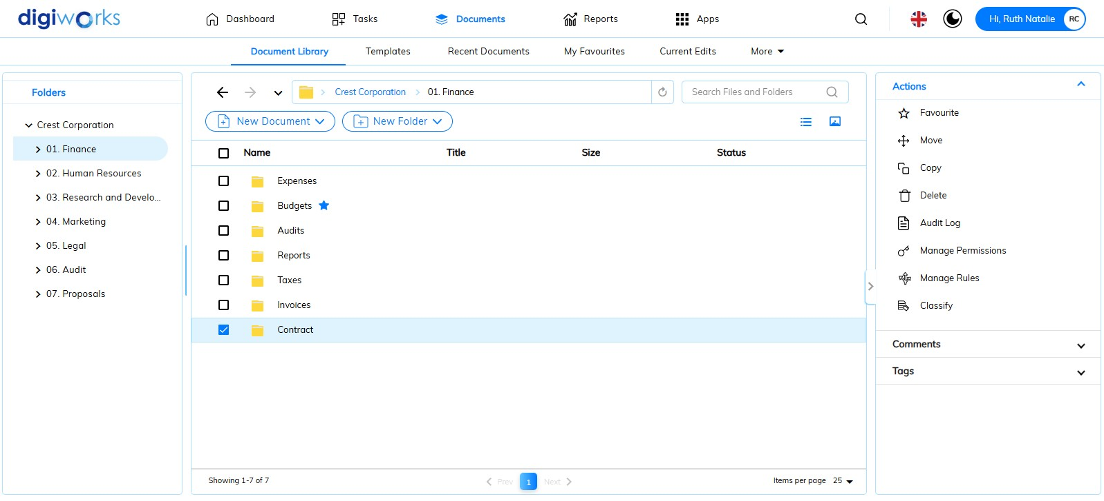

1. Click on the Document Tab.
2. Go to Document Library Tab.
3. Select one of the folders with no rules applied.
4. Click button.

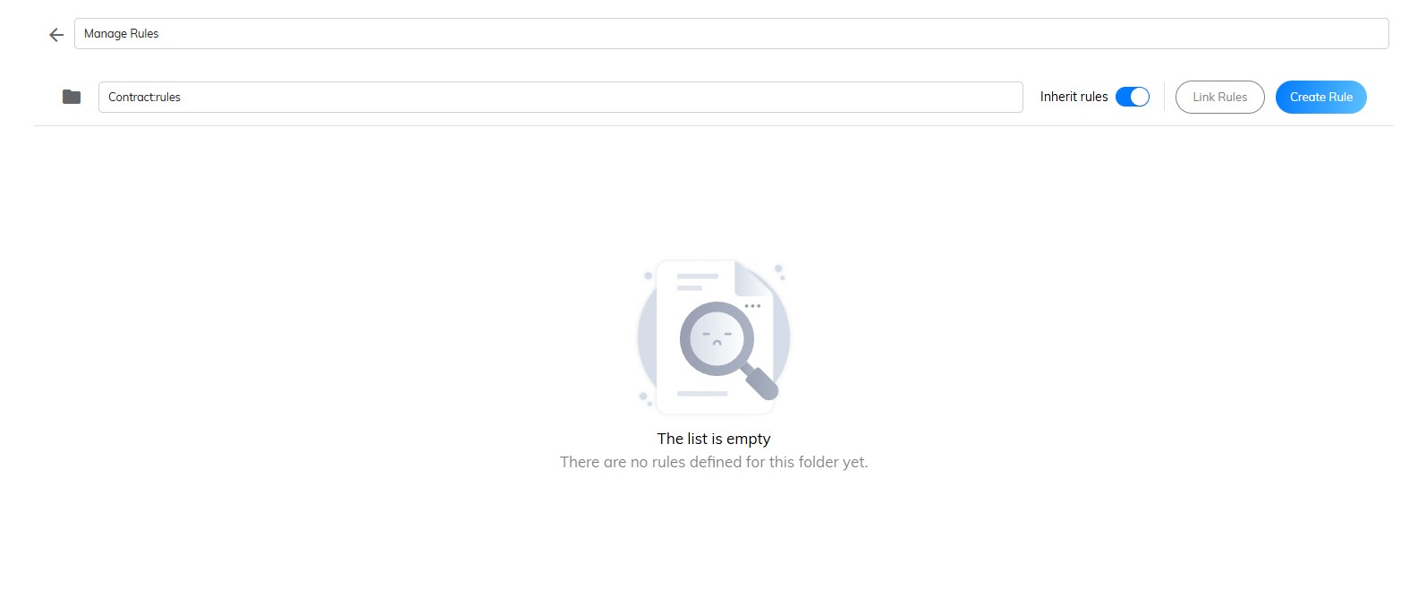

1. Click 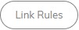button.

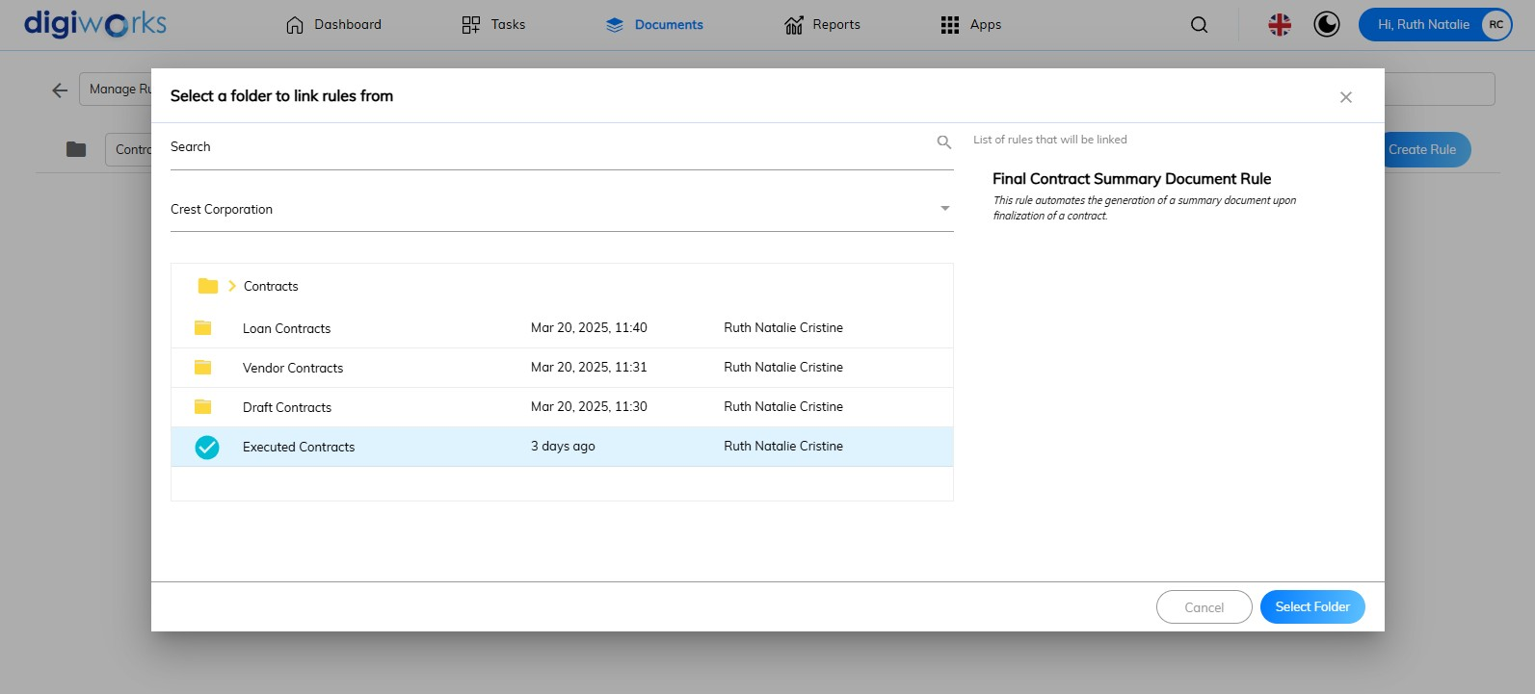

1. Search for the folder name directly in the search box or click the  icon to select from the folder structure.
2. Select the folder which has rules that can be linked to.
3. Click 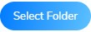button.

 **Note**: Click ‘Cancel’ button to abort the action.

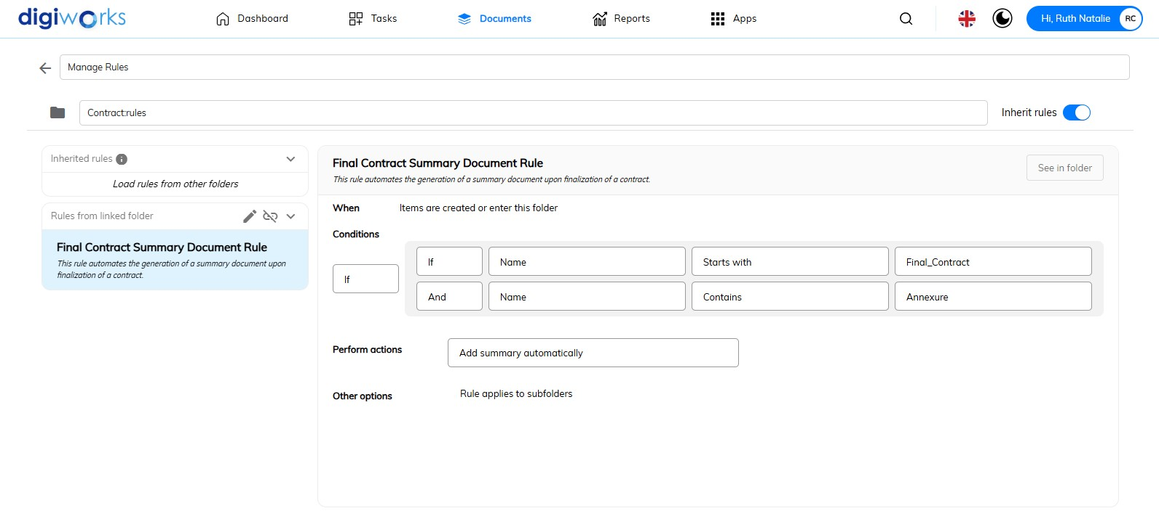

1. Rule has linked.

 **Notes**:

* To delete the folder with linked rules, click thebutton. Then, click the ‘Yes’ button to confirm deletion or the ‘No’ button to cancel deletion.
* When a folder has linked rules, fewer editing options are available compared to when it possesses its own set of rules. The options are to either link to a different rule set or to unlink entirely. Changes to the rule set must be made in the folder where the rules were originally defined. To change the linked rules, a different rule set can be easily linked, click the button. Follow the Step 6 – 9.

#### Working with A Set of Rules

Individual rules that comprise the rule set can be easily viewed and maintained. Rules can be added, edited, and deleted; a rule can be made inactive, and the run order can be changed. Numerous rules can be created to form a complete rule set, and then multiple rules can be applied to folders.

##### Adding to a Set of Rules



1. Click on the Document Tab.
2. Go to Document Library Tab.
3. Select one of the folders for which to create rules.
4. Click button.

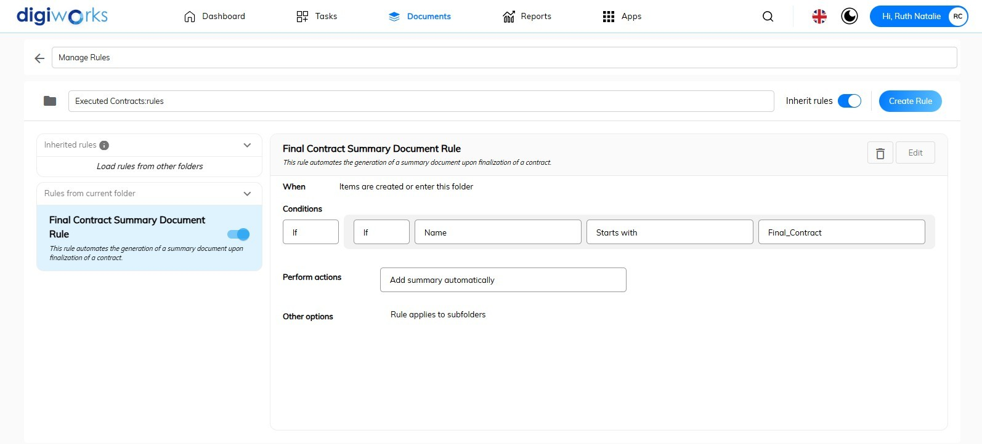

1. Click button.

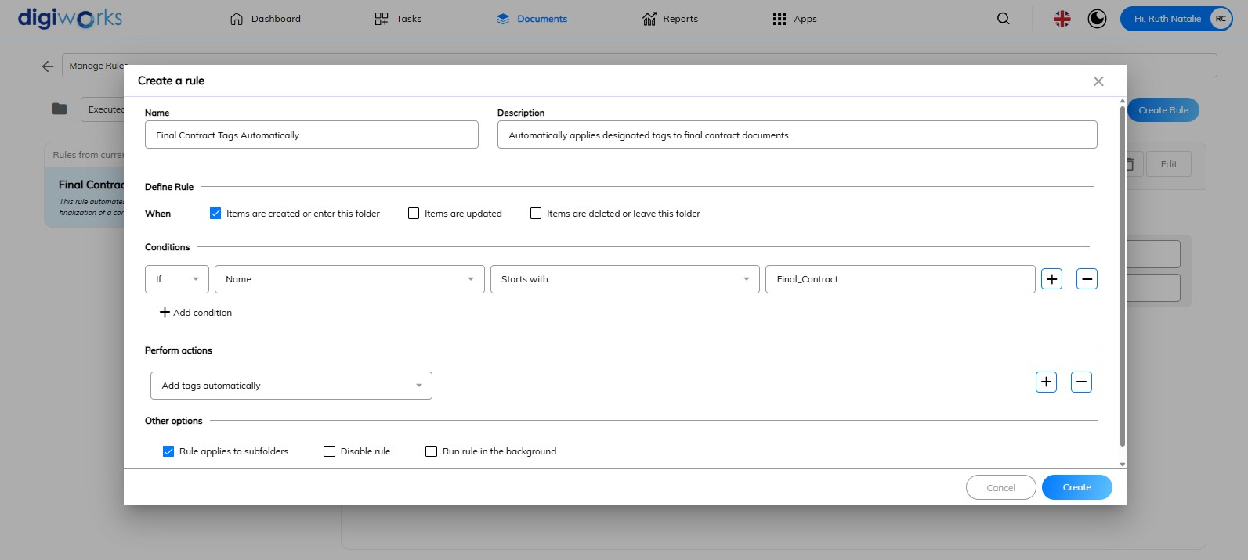

1. All fields should be completed and conditions configured. In this scenario, another rule is created for documents within the 'Executed Contracts' folder. When a document with the condition starts with ‘*Final_Contract*' enters this folder, an automatic action to add tags will be performed. The rule will apply to its subfolders.
2. Click button.

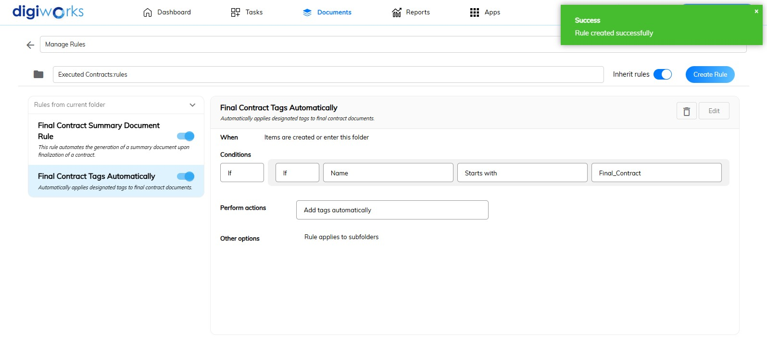

1. Other rules created successfully.

**Notes**:

* To edit the rule, click button. Follow Step 8-11 in 2.4.4.1.1. Creating a Rule.
* To delete the rule, click button.
* To create another rule, click button. Multiple rules can be created.
* To turn off the inherit rules, click button. When inherited rules are turned off, it stops the automatic application of rules from a parent folder to its child folders.
* To disable the rules, click button. The rules' functionality is stopped within the current folder, either temporarily or indefinitely.

## Tasks and workflows

Tasks and workflows facilitate the tracking of actions required by individuals and other users. A standalone task or workflow can be created, or a file can be attached. A workflow is a process that governs a specific task, such as a document review. During workflow creation, each task can be assigned to one or more people. Workflow creators can opt to manually send alert emails to users assigned a task within the workflow, prompting them to begin their work; regardless of email delivery, the task will be visible in the users' My Tasks Tab or Dashboard. Individual users manage their own tasks, and the creator of a workflow manages the workflow.

### Starting a Workflow

There are several ways to initiate the workflow:

1. **Method 1:**

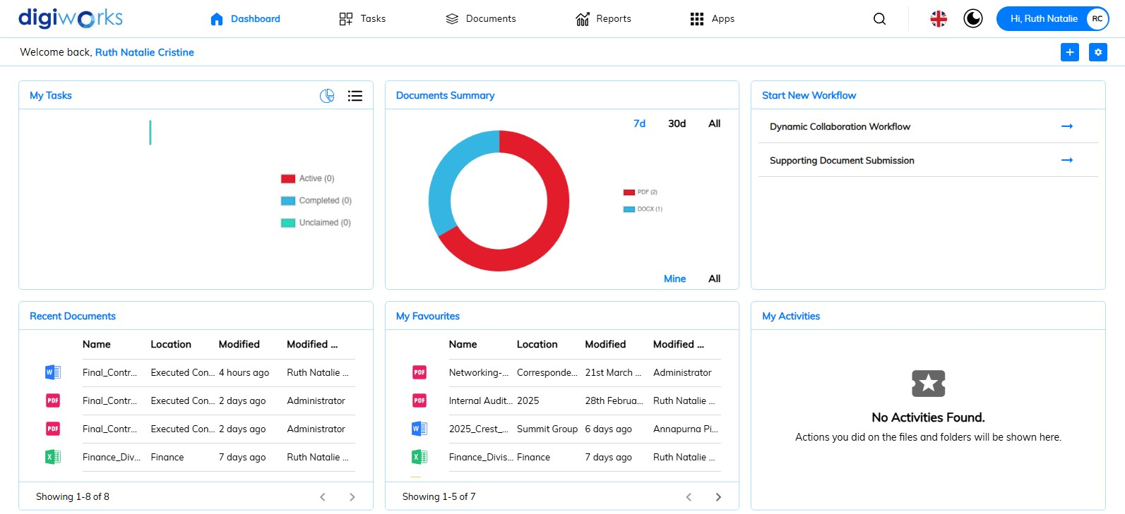

1. Navigate to the Dashboard tab.
2. Within the Start New Workflow widget, click the desired workflow type (e.g., *Dynamic Collaboration Workflow*).

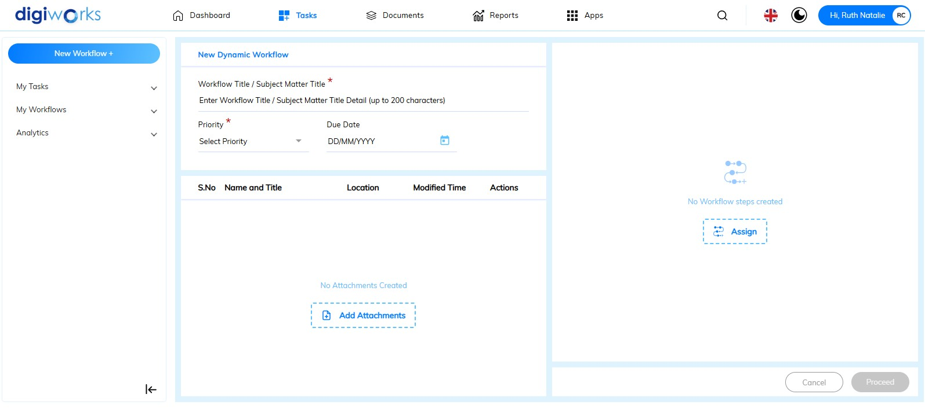

1. The corresponding new workflow form will then open.
2. **Method 2:**

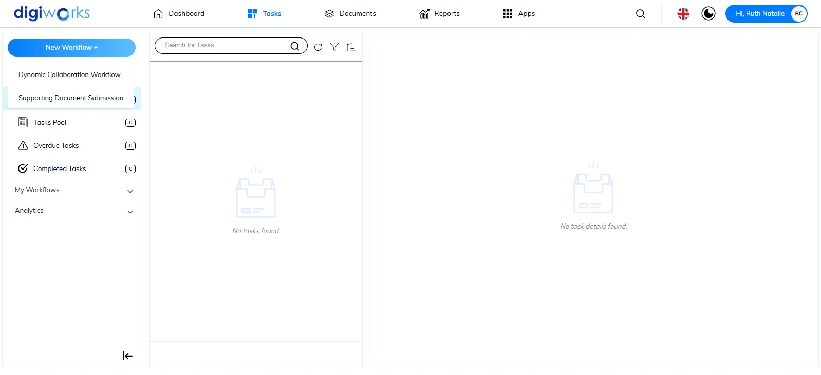

1. Navigate to the Task tab.
2. Click the button.
3. Select the desired workflow type (e.g., *Supporting Document Submission*).

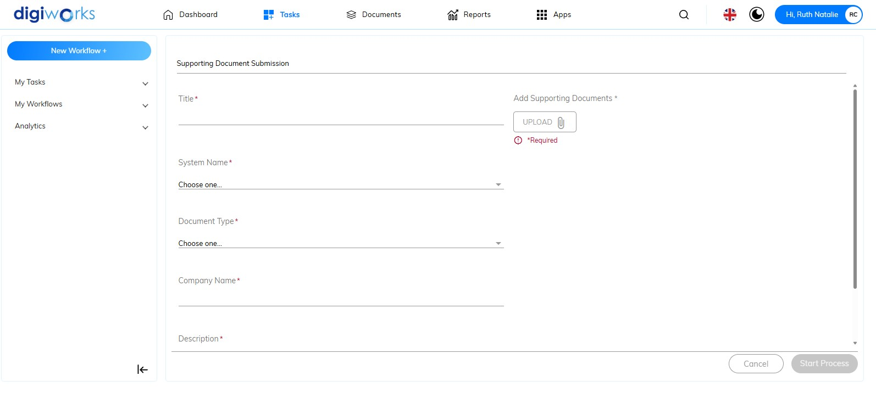

1. The corresponding new workflow form will then open.
2. **Method 3:**

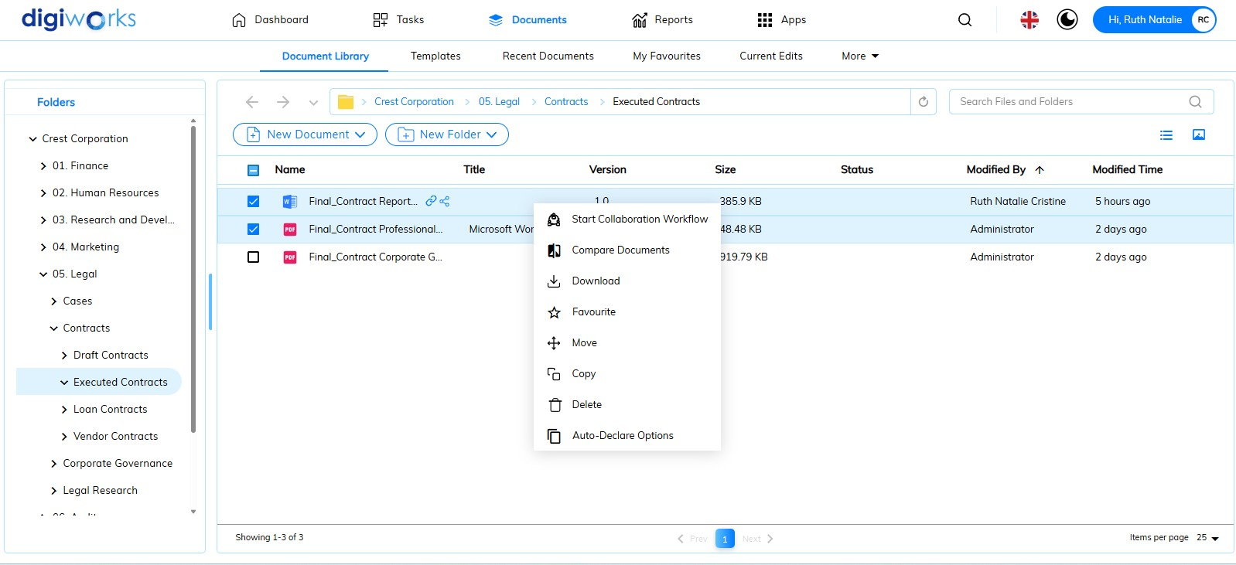

1. Navigate to the Document Tab.
2. Select one or more content items, right-click, and then select *Start Collaboration Workflow*.

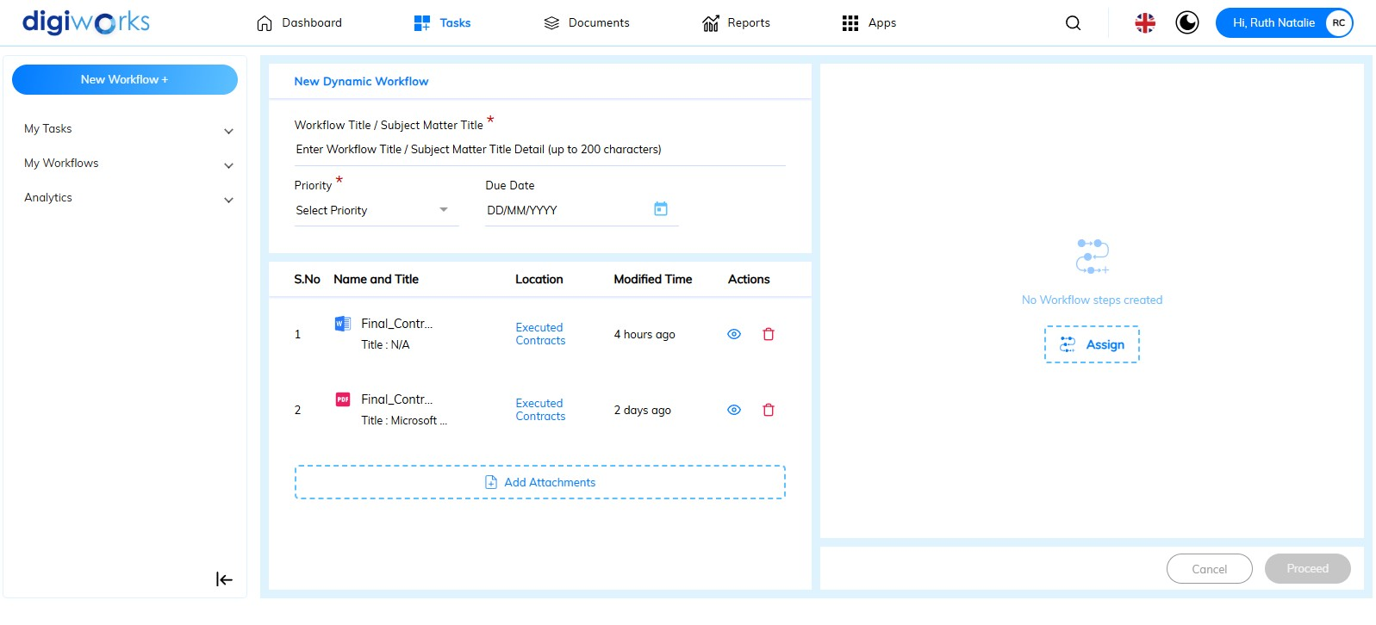

1. The new Dynamic Workflow form will open with the selected content attached.

#### Dynamic Collaboration Workflow

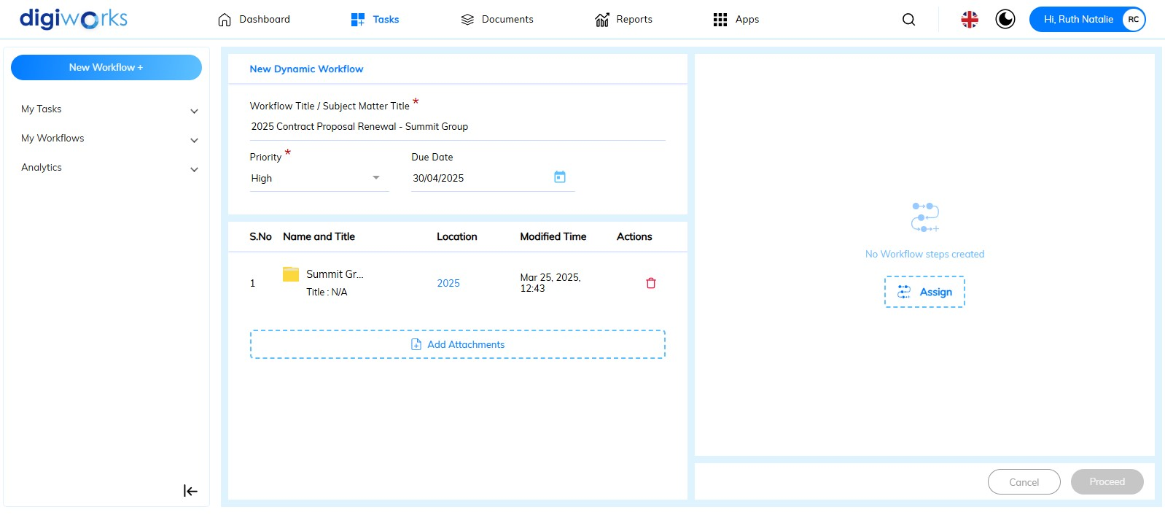

1. Enter all the mandatory metadata, such as Workflow Title and Workflow Priority. The Due Date field is not mandatory to fill.
2. *Optional*: Click the button to add the content from the site.
3. Select the folder or file to be attached to the workflow.
4. Click the button to assign the the workflow to user(s).

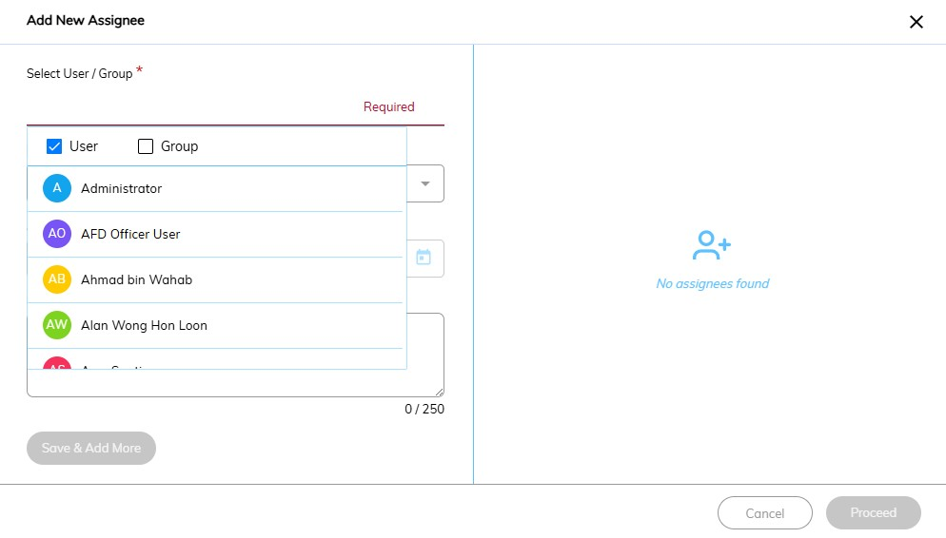

1. Enter the user or group name. A system-generated drop-down list of user and group names will provide suggestions.

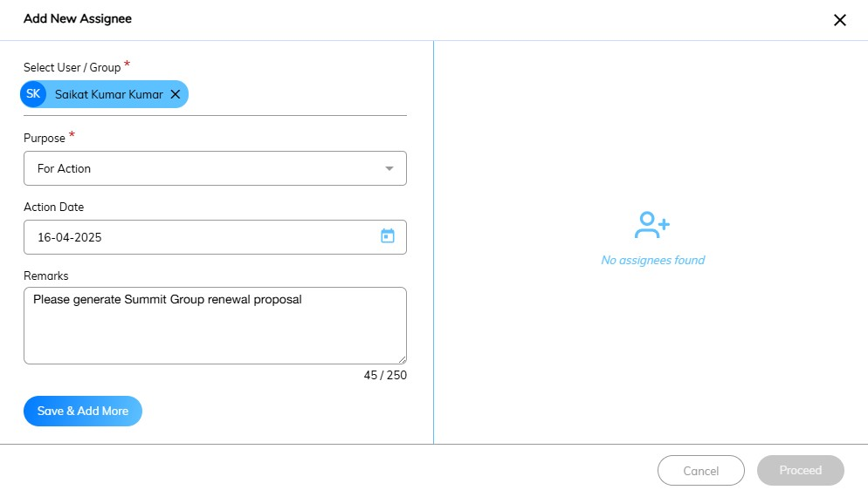

1. Select the purpose: For Information, For Action, or For Signature (this option will appear if a *Word* or *PDF* document is attached to the workflow)
2. *Optional*: Select the Action Date and fill in the Remarks column.
3. Click the  button.

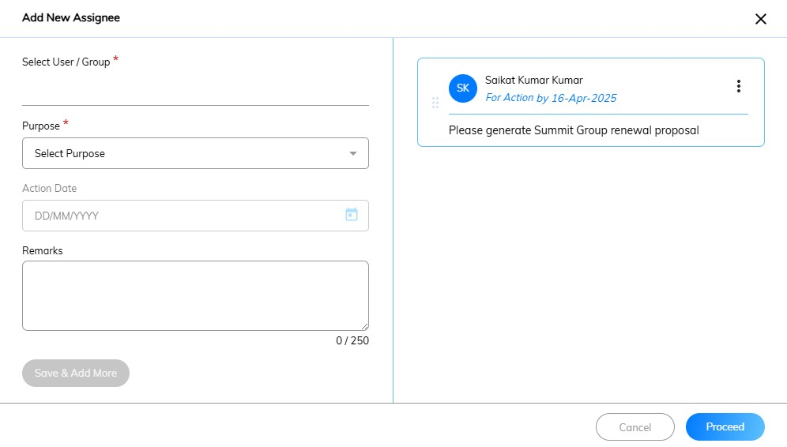

1. For *parallel* workflows, to add another user who can also fill out the form, follow Steps 5-8 again for the new assignee.

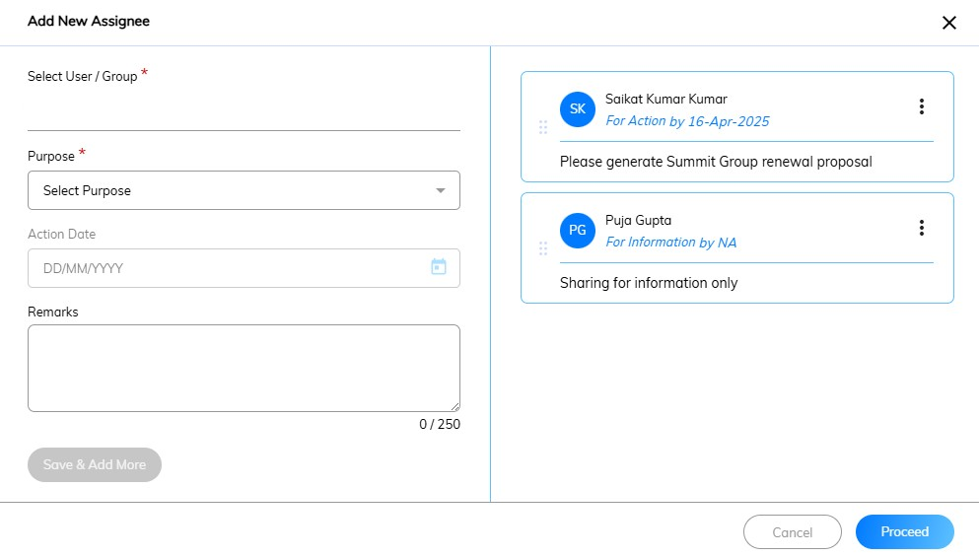

1. Click the button.

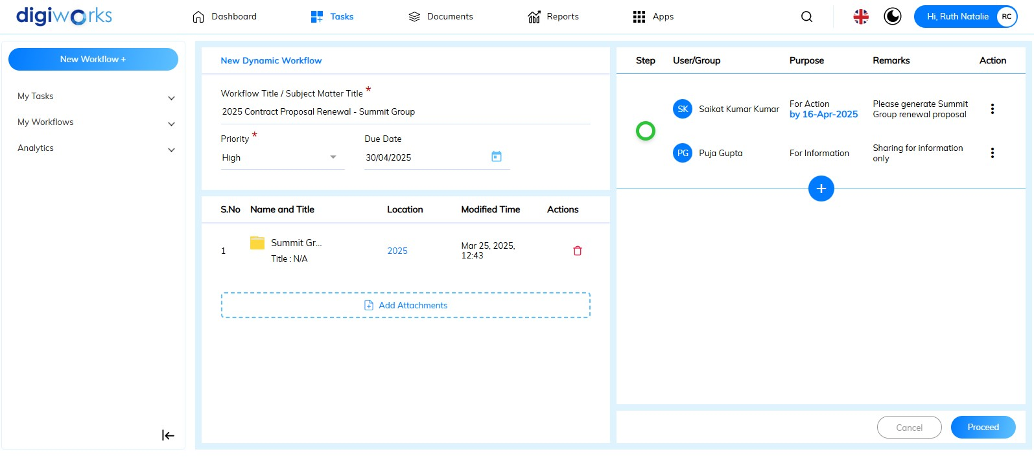

1. For sequential workflow, Click the button and repeat step 5-10.

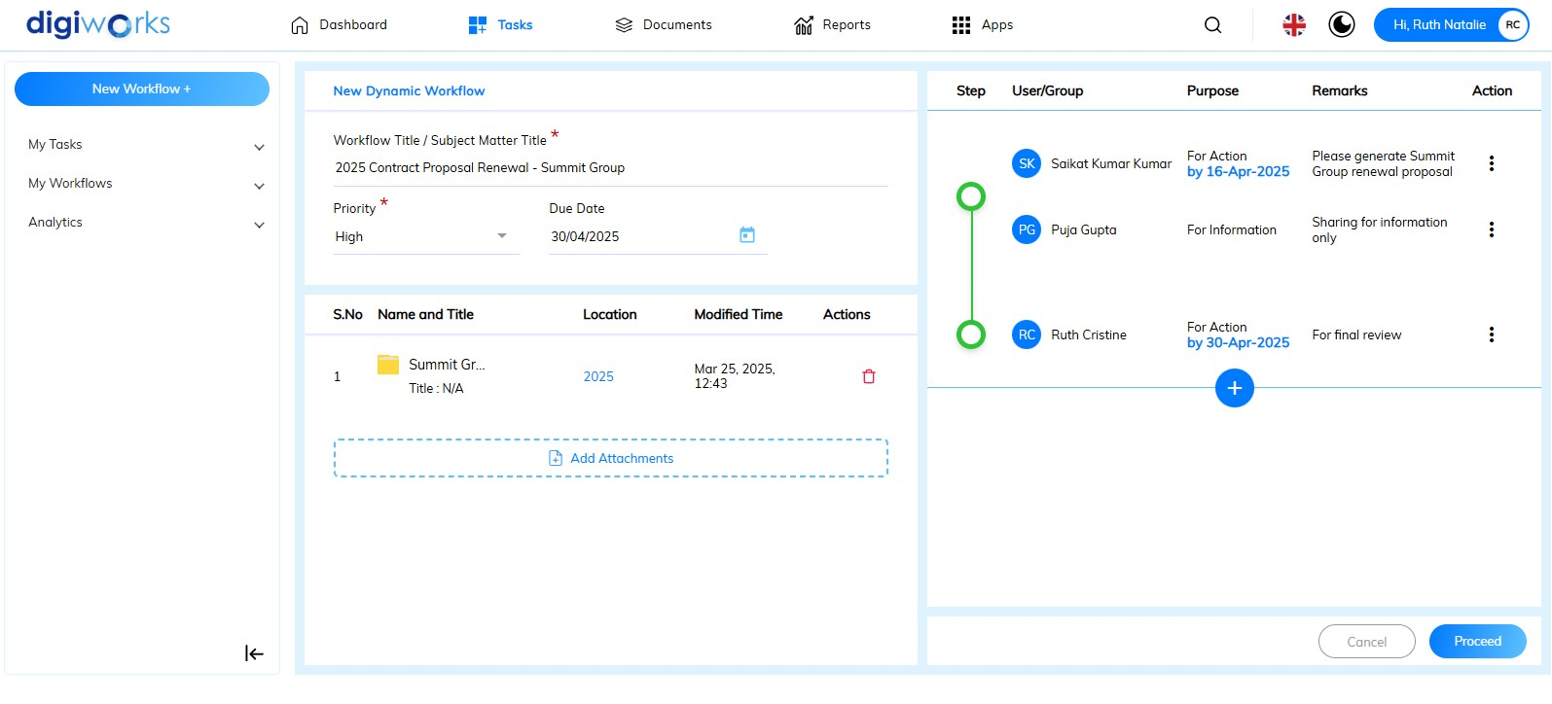

1. Click thebutton to initiate the workflow.

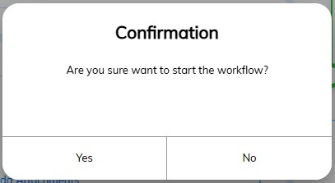

1. Click Yes on the confirmation pop-up to start the workflow, or No to cancel.

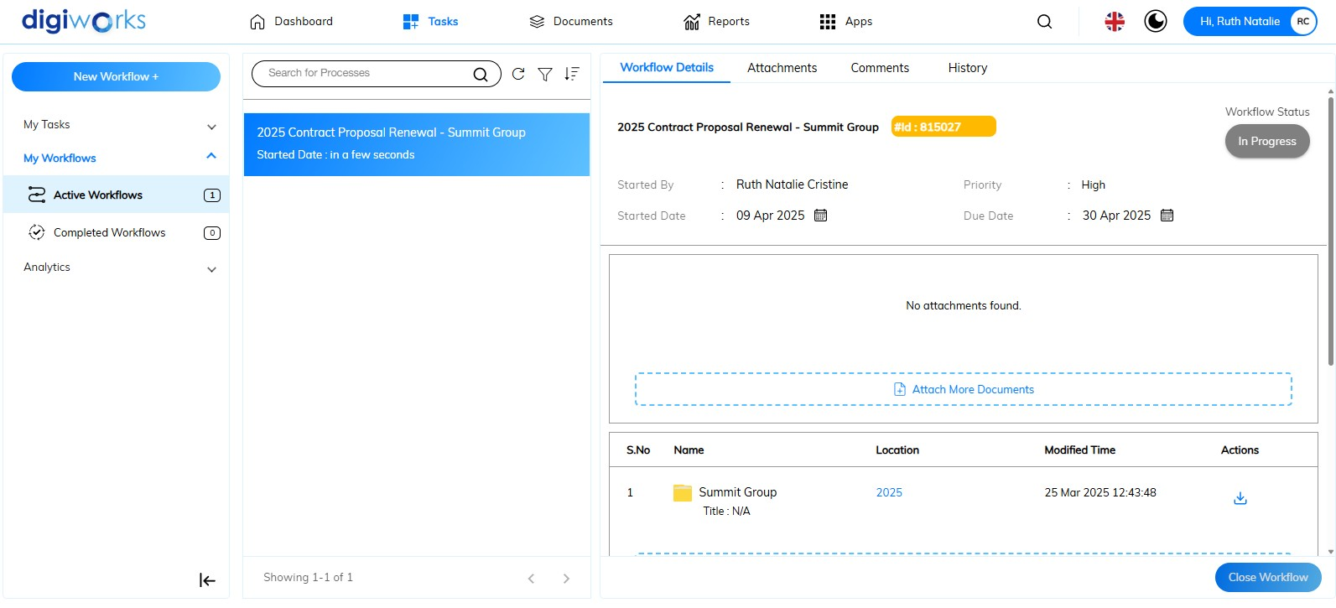

1. The workflow is successfully created.

#### Static Workflow: Supporting Document Submission

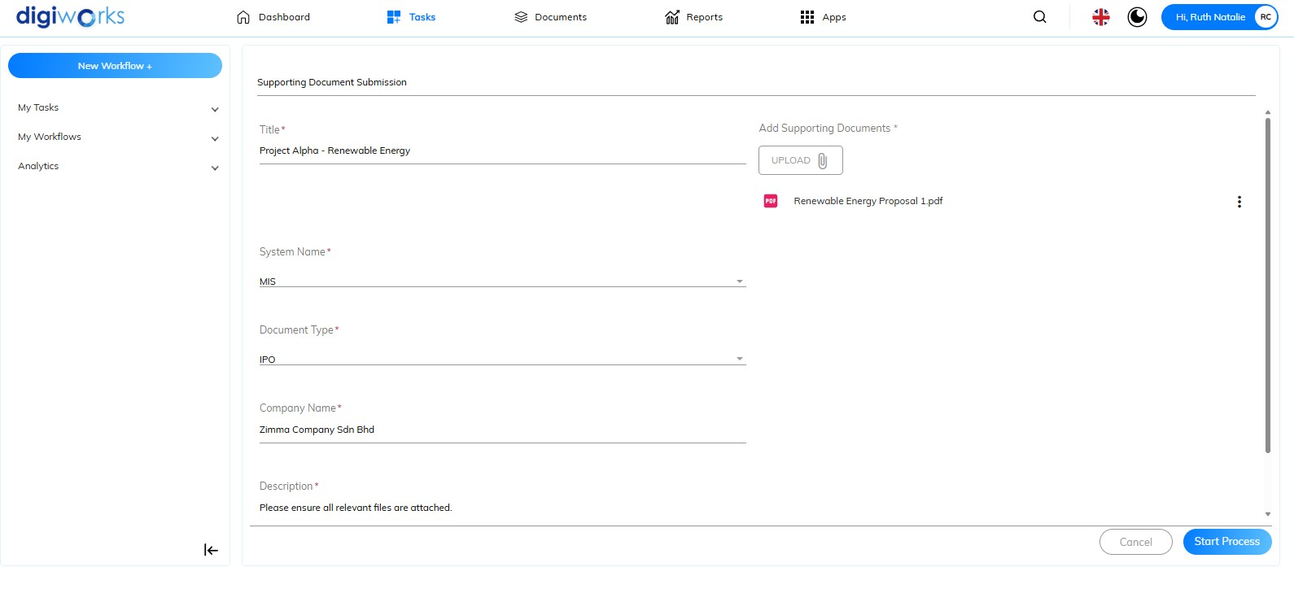

1. Enter all the mandatory metadata, such as *Title, Company Name* and *Description*.
2. Choose Type of *System Name*: *ARAS* or *MIS*
3. Choose *Document Type*: *IPO* or *Prospectus*
4. Click the 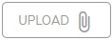button to attach the supporting document(s)

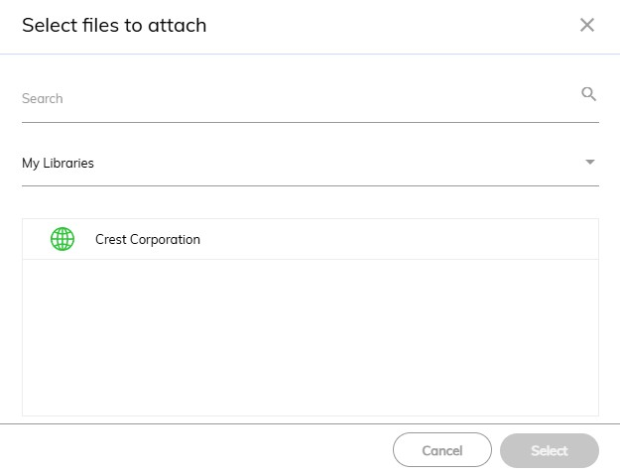

1. Enter the file name or find the file from available site under My Libraries.

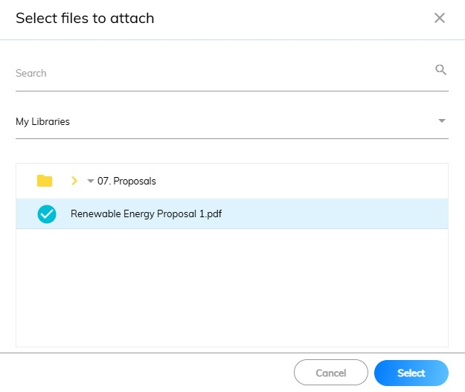

1. Select the file then, click thebutton.
2. Click the button to initiate the workflow.

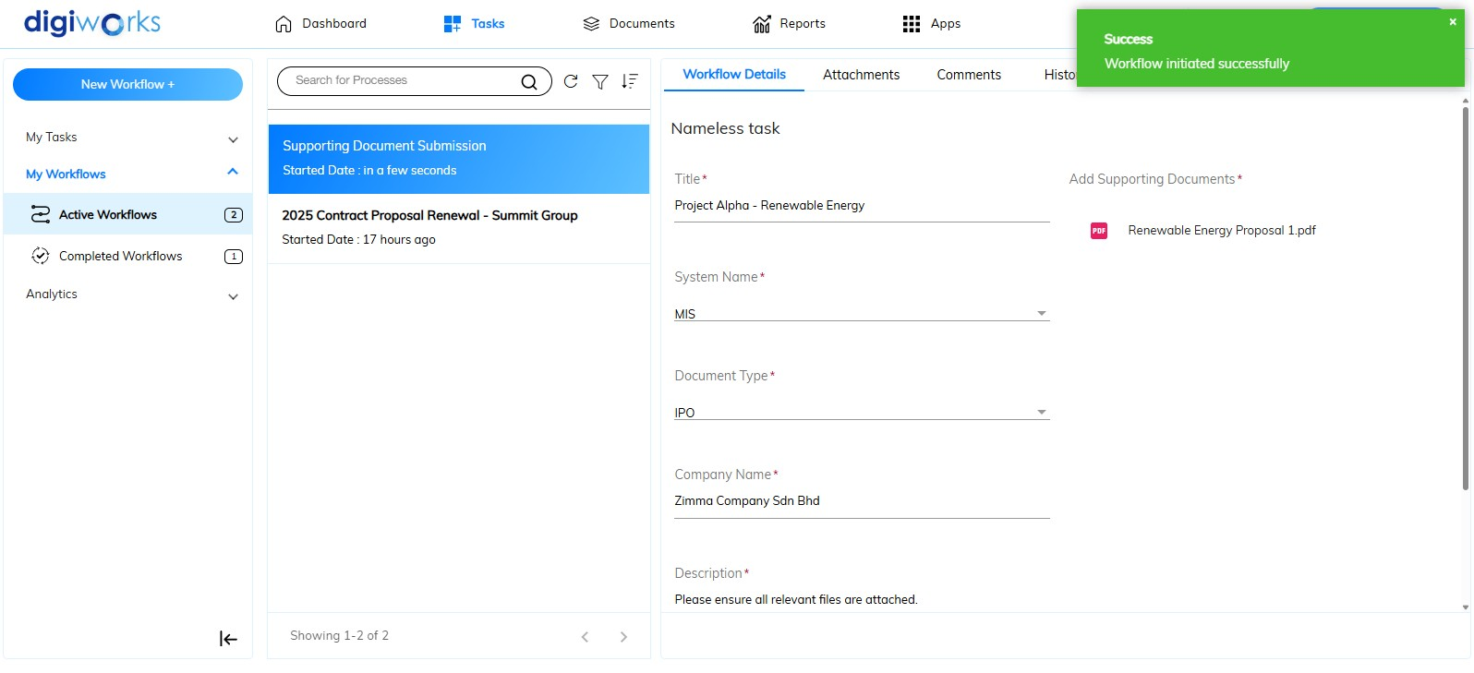

1. The workflow is successfully created

### Viewing Workflows You Started

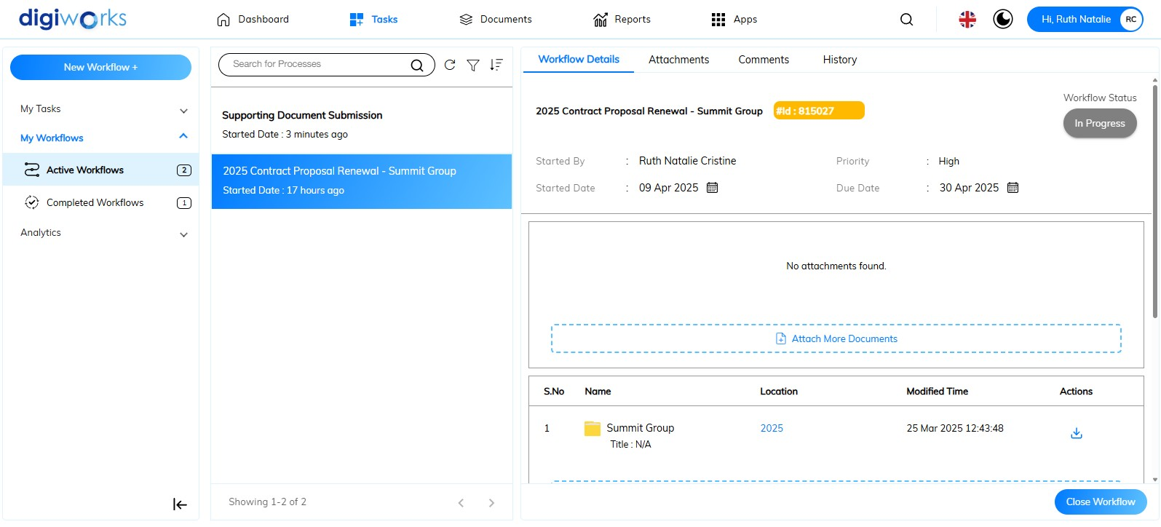

1. Navigate to Tasks Tab.
2. On the left panel, click My Workflows. This section contains the following sub-tabs:

* Active workflows: Shows a summary of all workflows that have been initiated and are currently running, indicating tasks that are pending or in progress.
* Completed workflows: Provides a record of all workflows that have been successfully finished or have been terminated/closed.

 **Note**: The button collapses the left panel, providing more screen space for the main content and the  button expands the left panel to its normal view.

1. The middle panel, under search box "*search for process*," displays all workflows. Active or completed workflows are shown based on the chosen tab (active or completed workflow).

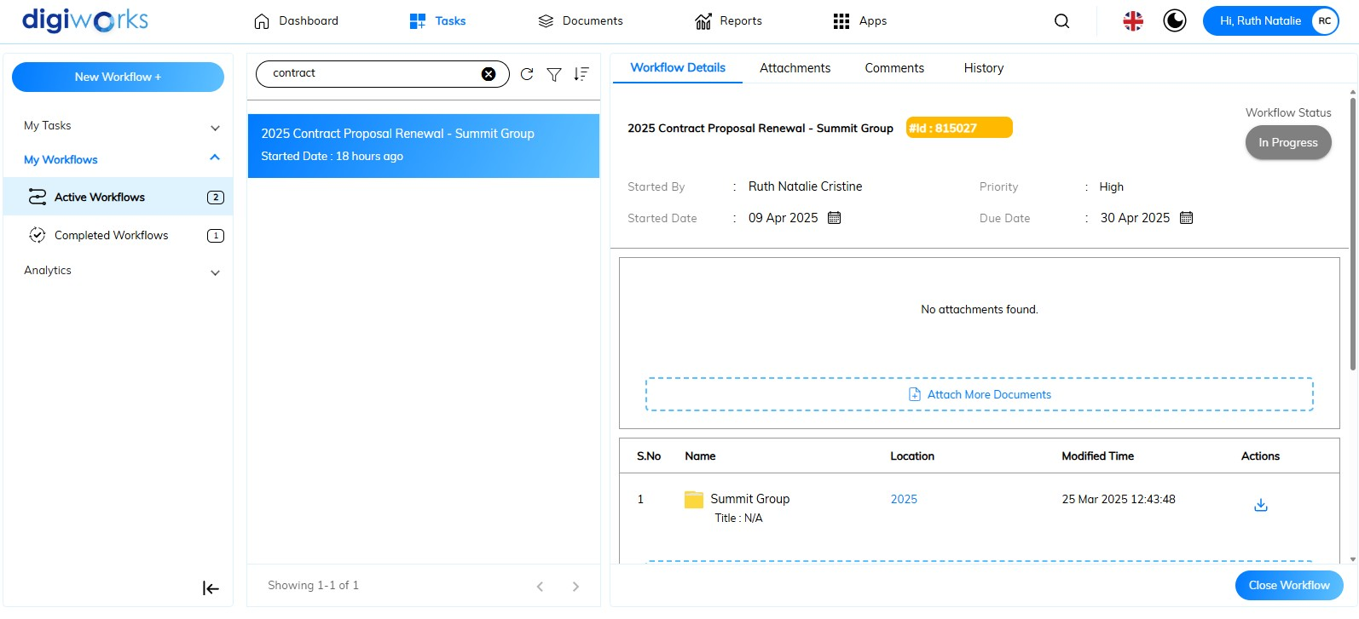

1. To find a particular process, type the workflow title into this 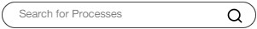 field.
2. Click thebutton to perform a manual refresh of the current workflow list. The manually refresh button provides users with the ability to immediately update the list of displayed workflows to reflect the most current status.
3. Click the button to filter the process.

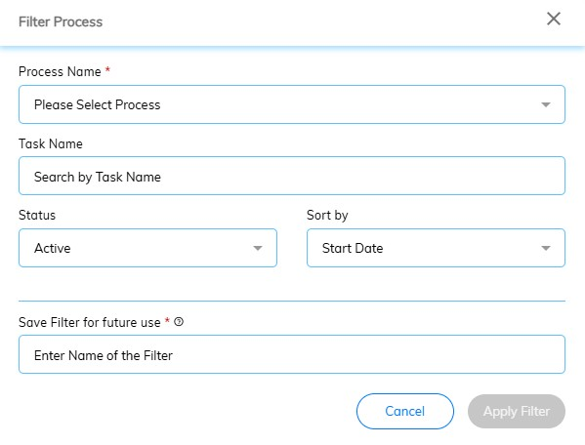

1. Select the process name: *Dynamic Collaboration Workflow* or *Supporting Document Submission.*
2. *Optional*: Enter the keyword for the Workflow Title in the Task Name field.
3. *Optional*: Select the workflow status: *Active* or *Completed.*
4. The ‘Sort By’ field is automatically selected with ‘Start Date’.
5. Enter a name for the filter for future use in ‘Save filter for future use’ field.

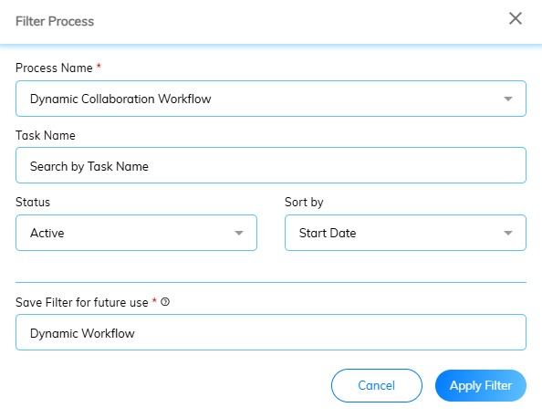

1. Click the  button.

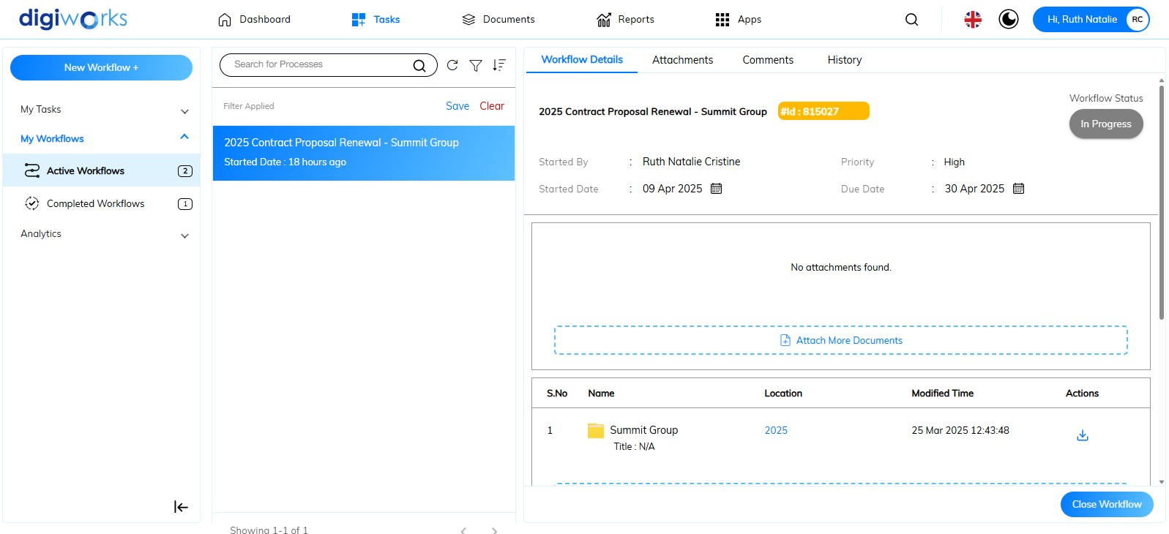

1. Filter successfully applied.
2. Click **the Save button, for the filter for future use.

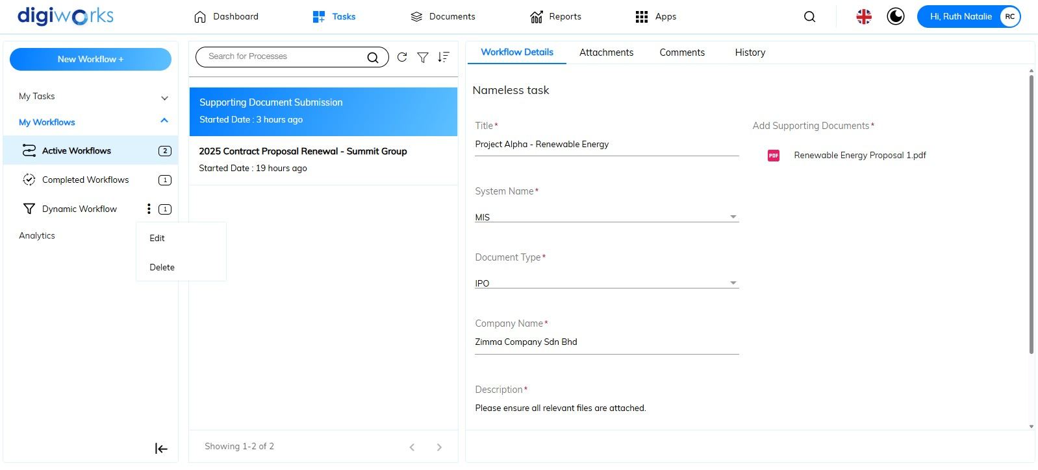

1. The filter saved successfully.
2. To edit or delete the filter click  button.
3. Click on Edit repeat steps 7-12.

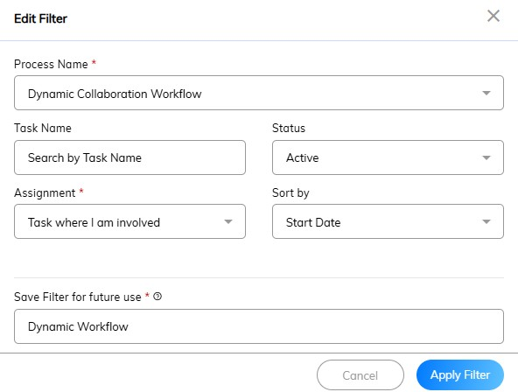

1. Edit filter saved successfully.
2. Click on the **again, to delete the filter. Click Yes on the confirmation message or No to cancel the action.
3. Custom filter deleted successfully.



1. Click on the **button change the sorting order in which the workflows are displayed. For instance, a user might want to see the most recently started workflows at the top (descending order by "Start Date").
2. On the right panel is showing the selected process with the details of *Workflow, Attachment, Comments, History.*

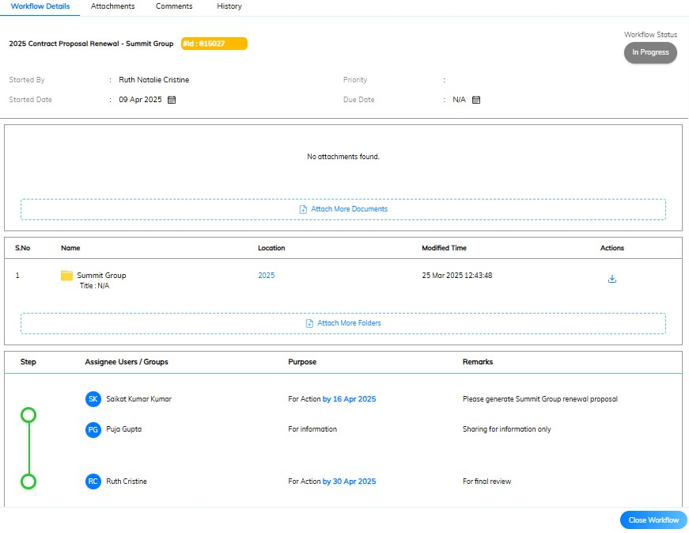

* **Workflow details**: This section provides a comprehensive overview of the selected workflow's core information. It displays key attributes such as:
* *Started By*: The user who initiated the workflow process.
* *Start Date*: The date and time when the workflow was first created and launched.
* *Priority*: The assigned level of importance or urgency for this workflow.
* *Due Date*: The target date by which the workflow or its associated tasks should be completed.
* *File and Folder Attachments*: A summary or link to any files or folders that were attached to the workflow upon initiation.
* *Initial Workflow Steps*: An outline or visual representation of the stages and tasks that were defined when the workflow was first started.
* *Workflow Status*: Indicating whether it is currently In Progress or Completed.

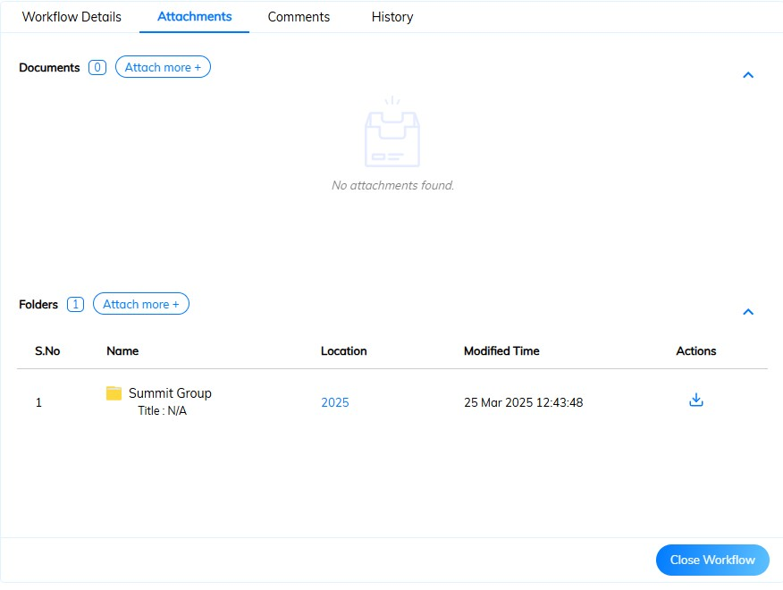

* **Attachments***:* This section lists all files and folders associated with the current workflow, providing a centralized location to view and access relevant documents and directories. Attachments can be added even after the workflow has started.

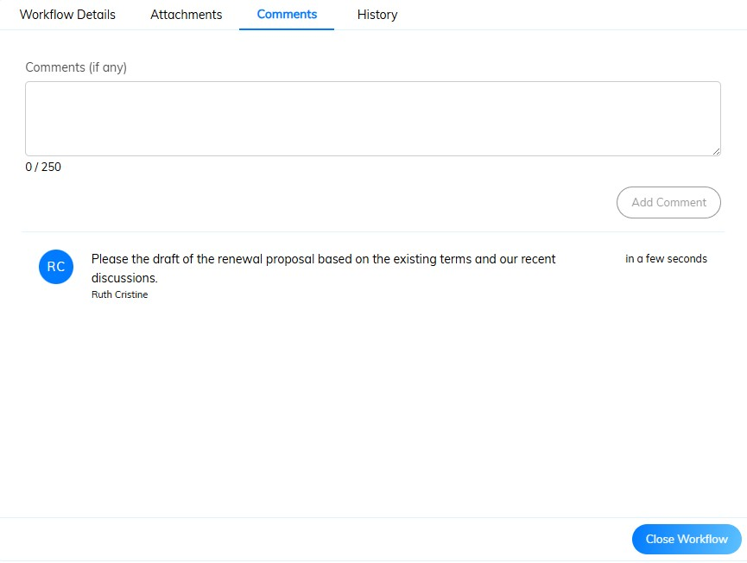

* **Comments***:* This section displays a chronological record of all comments and discussions related to the workflow. It includes contributions from any users involved in the workflow, fostering communication and providing context around specific actions or decisions.

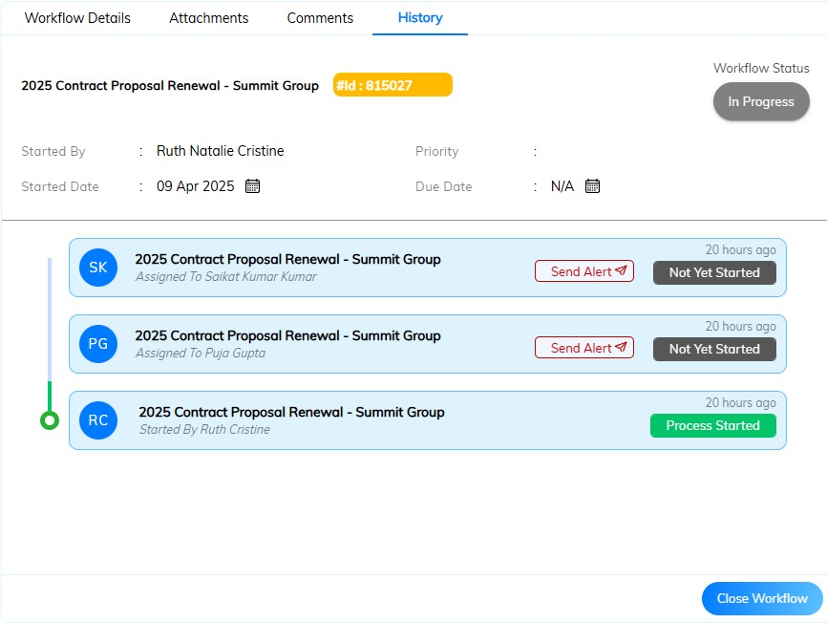

* **History**:This section presents a comprehensive audit trail of the workflow's lifecycle, detailing all significant events from initiation to completion, such as task assignments, reassignments, and other modifications. Notably, in the History tab, the workflow initiator has the ability to send alerts to assignees by clicking the  button, which will result in an email notification to the assignee.

### Canceling an Active Workflow



1. The 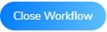button provides the functionality to cancel an active workflow before the assigned user finalizes their task. This feature is intended for scenarios where adjustments are required, an incorrect user has been assigned, or other circumstances necessitate the workflow's termination prior to task completion by the designated assignee.

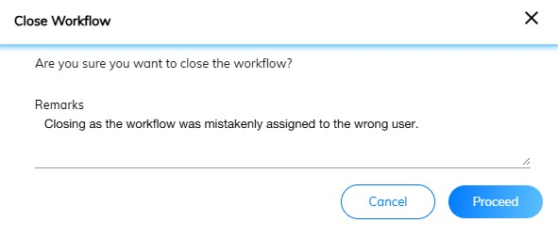

1. Click the**button to confirm cancelling the workflow or click the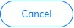button to abort the action.
2. The workflow is successfully cancelled.

### Viewing Tasks Assigned to You

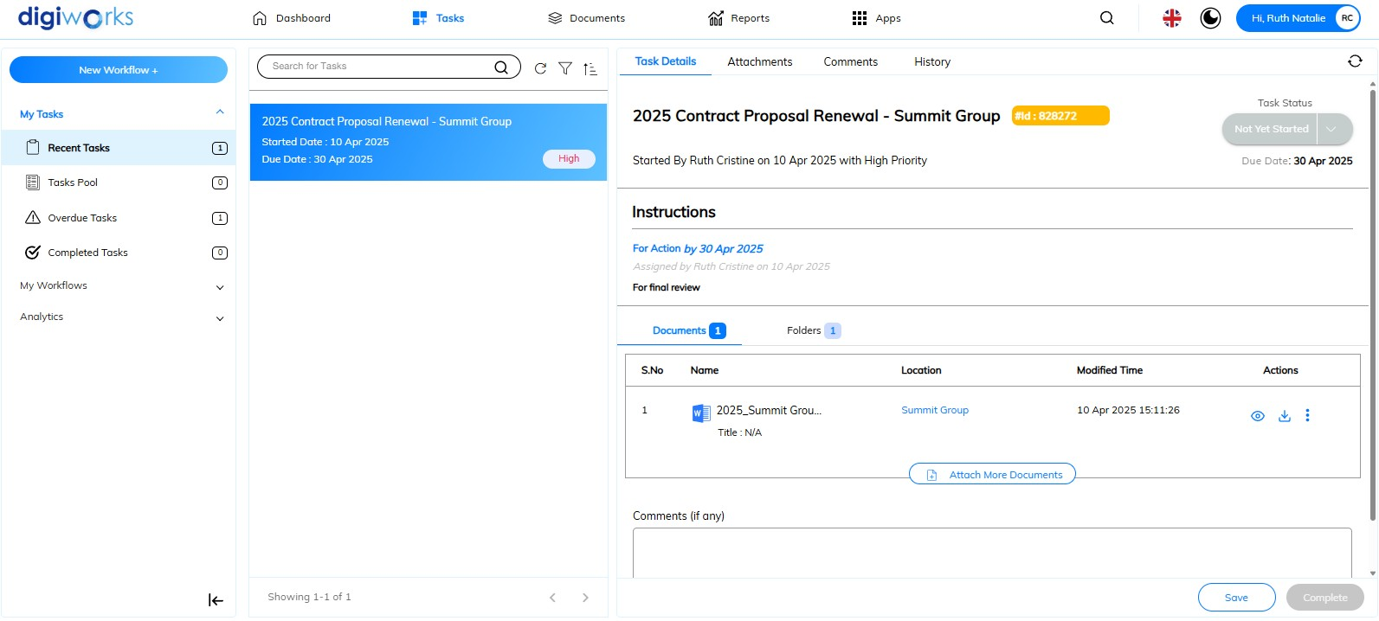

1. Navigate to Tasks Tab.
2. On the left panel, click on My Tasks. This section contains the following sub-tabs:

* Recent Tasks: This section displays a list of tasks that have been recently assigned. It provides a quick overview of the most current activities requiring attention or recently concluded.
* Task Pool: This area lists tasks that are not yet assigned to a specific individual but are available for any member of a designated group or team to claim and work on. These tasks represent shared responsibilities within the workflow.
* Overdue Tasks: This section highlights tasks that have passed their specified due date and are still incomplete. It serves as a reminder of pending actions that require immediate attention to avoid further delays in the workflow.
* Completed Task: This section provides a record of tasks that have been marked as finished or resolved within the system. It allows for tracking progress and reviewing previously completed work.

 **Note**: The button collapses the left panel, providing more screen space for the main content and the  button expands the left panel to its normal view.

1. The middle panel, under search box "*search for process*," displays all tasks. The tasks shown (Recent, Task Pool, Overdue, or Completed) are determined by the selected tab on the left panel.
2. To find a particular task, type the workflow title into this 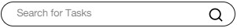 field.
3. Click thebutton to perform a manual refresh of the current task list. The manually refresh button provides users with the ability to immediately update the list of displayed tasks to reflect the most current status.
4. Click the button to filter the process.

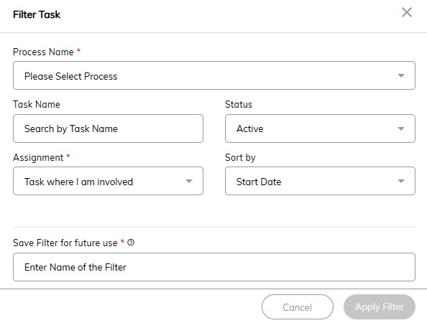

1. Select the process name: *Dynamic Collaboration Workflow* or *Supporting Document Submission.*
2. *Optional*: Enter the keyword for the Workflow Title in the Task Name field.
3. *Optional*: Select the workflow status: *Active* or *Completed.*
4. The ‘Sort By’ field is automatically selected with ‘Start Date’.
5. Enter a name for the filter for future use in ‘Save filter for future use’ field.

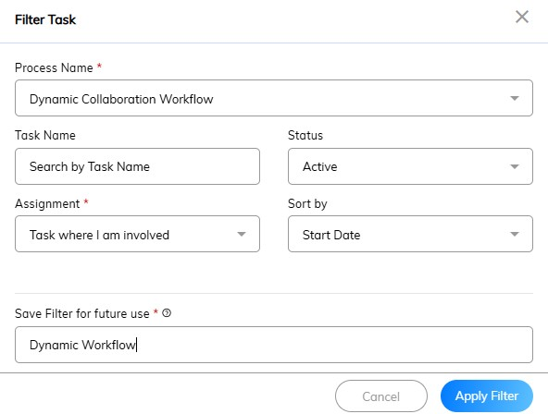

1. Click the  button.

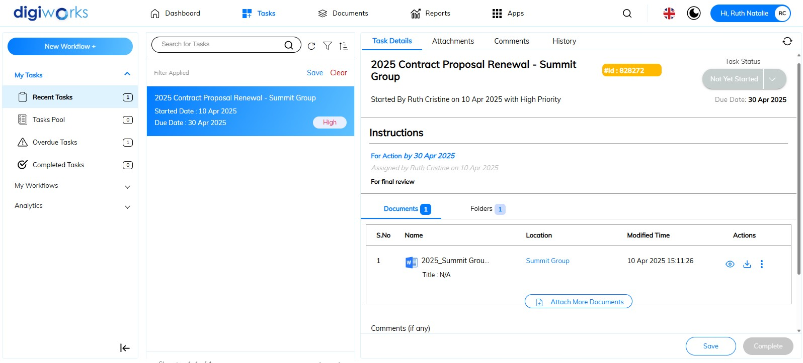

1. Filter successfully applied.
2. Click **the Save button, for the filter for future use.

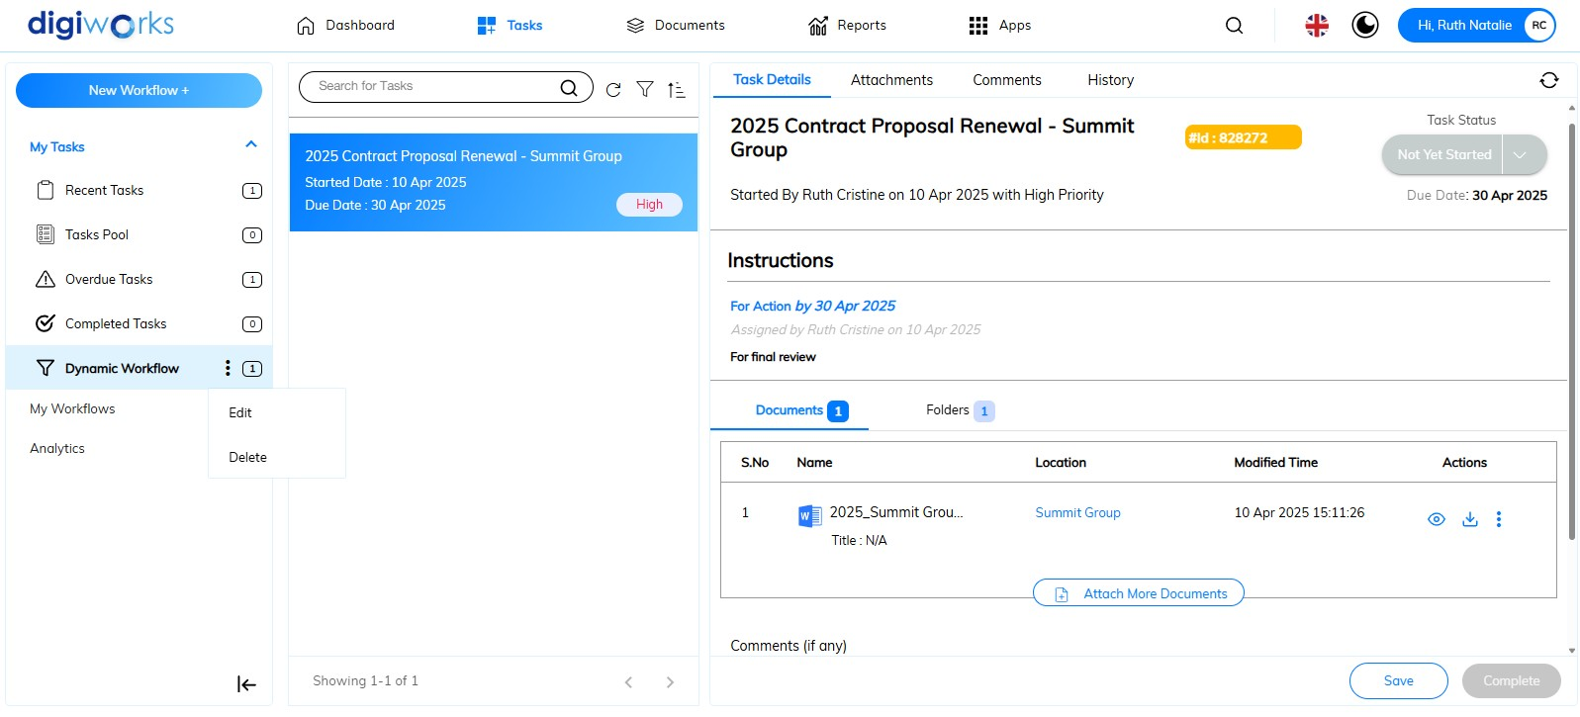

1. The filter saved successfully.
2. To edit or delete the filter click  button.
3. Click on Edit repeat steps 7-12.



1. Edit filter saved successfully.
2. Click on the **again, to delete the filter. Click Yes on the confirmation message or No to cancel the action.
3. Custom filter deleted successfully.



1. Click on the **button change the sorting order in which the tasks are displayed. For instance, a user might want to see the most recently started tasks at the top (descending order by "Start Date").
2. On the right panel is showing the selected process with the details of *Task, Attachment, Comments, History.*

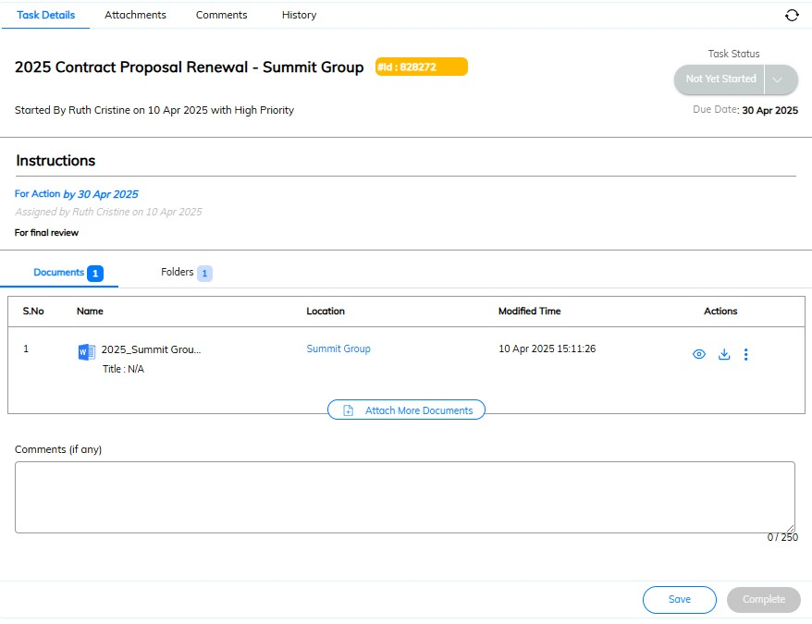

* **Task details**: This section provides a comprehensive view of the selected task. The key information displays include:
* *Workflow title*: Displays the name or title of the overall workflow to which this task belongs, providing context.
* *Started By*: The user who initiated the workflow process.
* *Start Date*: The date when the workflow was first created and launched.
* *Priority*: The assigned level of importance or urgency for this workflow.
* *Instructions***:** Presents the specific actions or guidance required to complete this particular task.
* *Due Date*: The target date by which the workflow or its associated tasks should be completed.
* *File and Folder Attachments*: Lists any documents or directories associated with this task. The system allows for the addition of more files and folders relevant to the task.
* *Task Status*: Show the current stage or state of this individual task
* *(Optional) Comment Box*: Provides a field to enter and save notes or feedback related to the task.

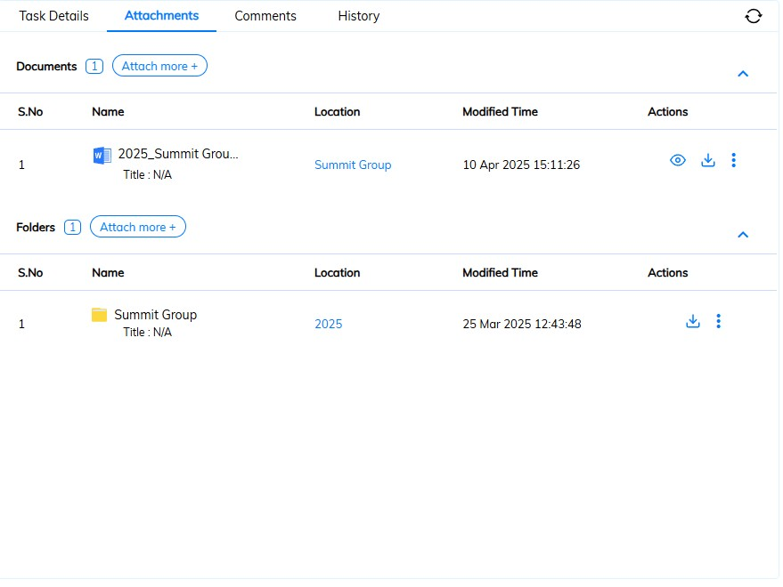

* **Attachments**: This section manages files and folders associated with the workflow. Allows the addition of more files and folders relevant to the overall workflow process and provides a centralized location to access all documents and directories related to the workflow.

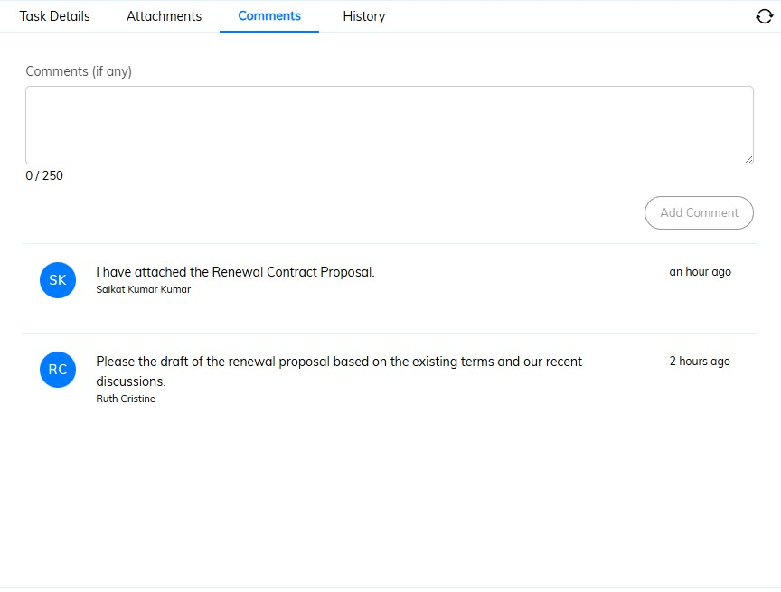

* **Comments**: This section manages files and folders associated with the workflow. Allows the addition of more files and folders relevant to the overall workflow process and provides a centralized location to access all contents and directories related to the workflow.

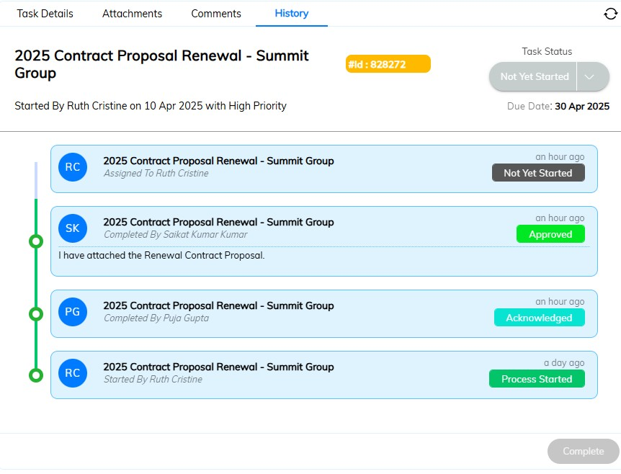

* **History**: This section provides a complete record of the workflow's progression.
  + Details the end-to-end history of the workflow, from its initial creation to its final completion.
  + Logs significant events such as task assignments, reassignments, and any other modifications made throughout the workflow's duration.
  + Even after a task within the workflow has been completed, the entire workflow history remains accessible for monitoring and review in this tab.

### Managing Tasks

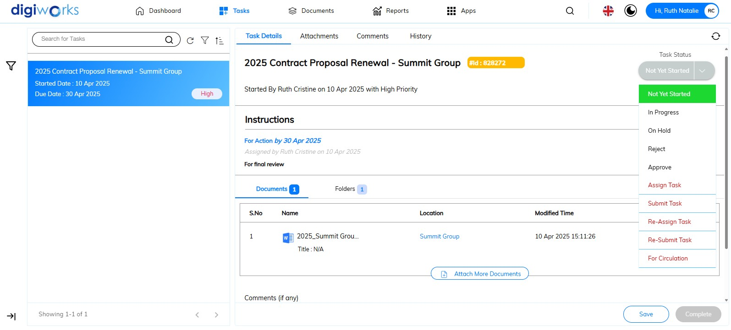

1. To manage the task, click the button under ‘Task Status’ in the ‘Task Details’ tab. Refer to the table below for instructions specific to the task.

| **Instruction** | **Available statuses** |
| --- | --- |
| For Action | Not Yet Started, In Progress, On Hold, Reject, Approve, Assign Task, Submit Task, Re-Assign Task, Re-Submit Task and For Circulation. |
| For Information | Not Yet Started, In Progress, On Hold and Acknowledge. |
| For Signature | Not Yet Started, In Progress, On Hold, Reject and Approve. |

The following descriptions define the status definitions:

* Not Yet Started: Indicates the task is awaiting commencement.
* In Progress: Shows that the task is currently being worked on.
* On Hold: Signifies a temporary suspension of work on the task.
* Reject: Used when the task outcome does not meet the required standards.
* Approve: Confirms that the task outcome has been accepted.
* Acknowledge: Signifies that the assigned user has verified receipt, comprehension, and understanding of the task details.
* Assign Task: Permits the delegation of this task to another user.
* Submit Task: Allows the assigned user to finalize and present their work for review.
* Re-Assign Task: Facilitates the transfer of the task responsibility to a different user.
* Re-Submit Task: The task is being submitted again after revisions or corrections were made.
* For Circulation: Designates the task for distribution among relevant individuals for their awareness or input.

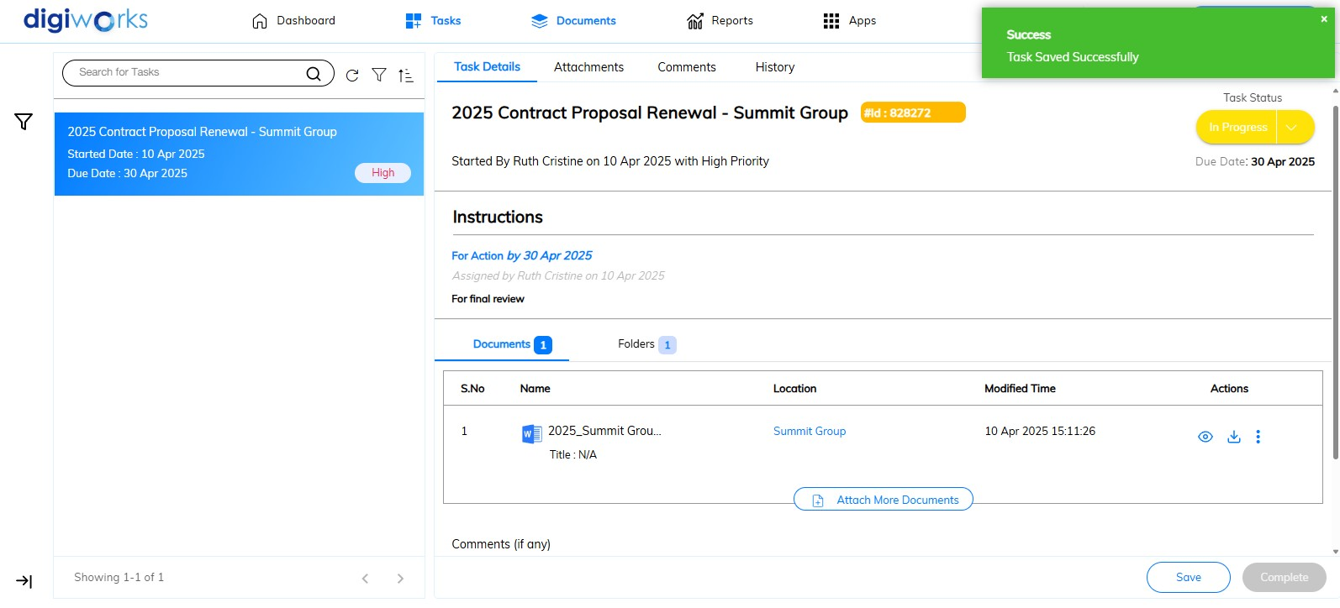

1. For instance, select the ‘In Progress’ status then click the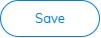button. Selecting the status ‘Not Yet Started,’ ‘In Progress,’ or ‘On Hold’ will keep the task within the user's active tasks.
2. Task saved successfully.

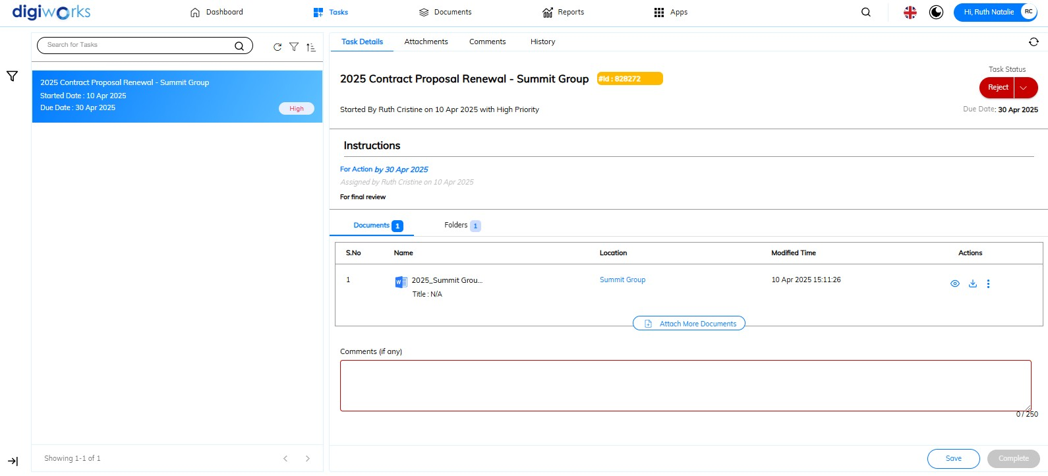

1. When selecting the ‘Reject’ status, the user must enter reasons or remarks in the comment box before completing the task.

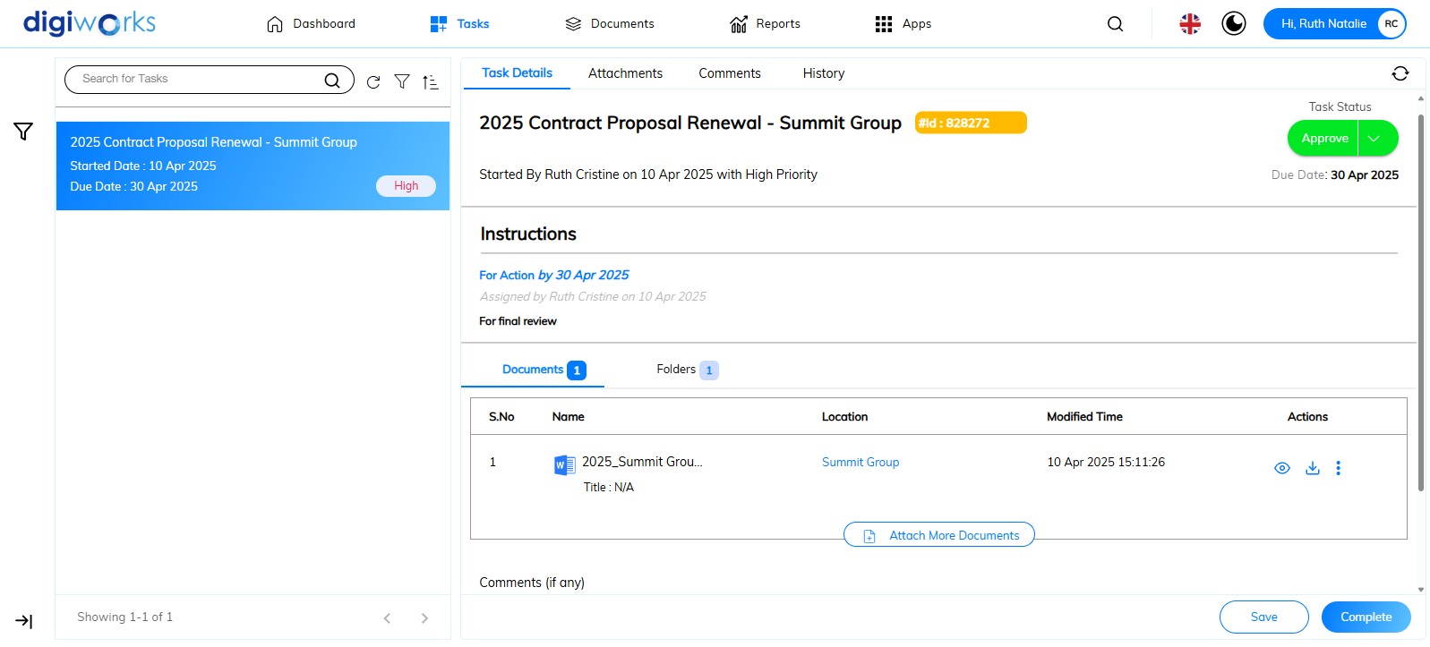

1. When the ‘Approve’ or ‘Acknowledge’ status is selected, the user can directly click the 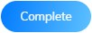button.

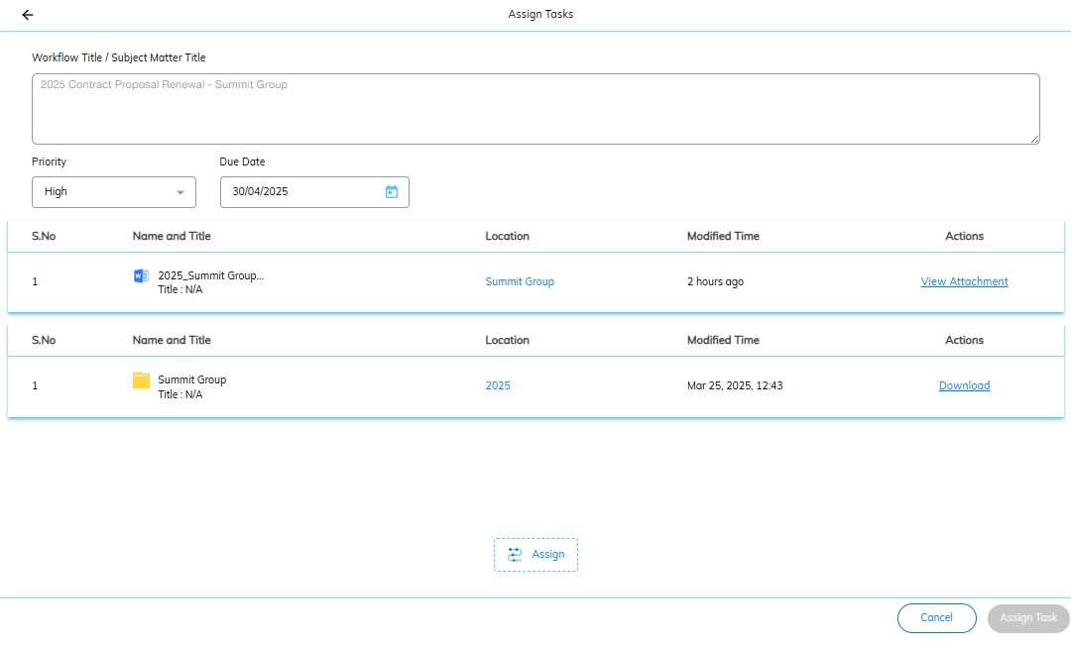

1. Selecting ‘Assign Task’, ‘Submit Task’, ‘Re-Assign Task’, ‘Re-Submit Task’, or ‘For Circulation’ will prompt the user to add a new assignee.
2. Click on the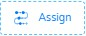button.

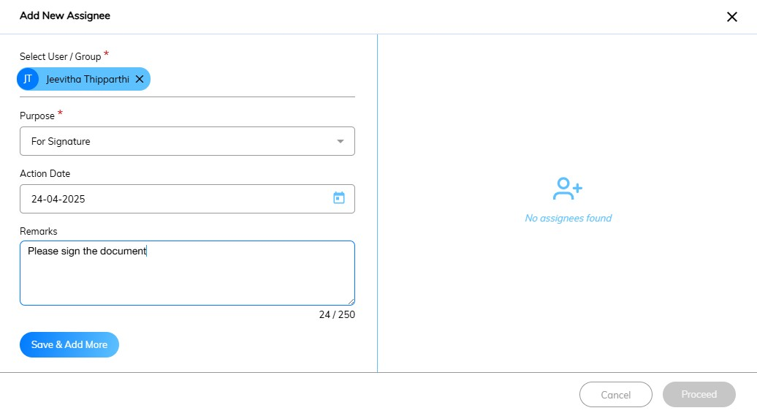

1. Fill in the available metadata. Select a User or Group, choose the purpose of the task, and optionally enter an action date and remarks.
2. Click the button.
3. *Optional*: To add more assignee in parallel task, repeat steps 8-9.

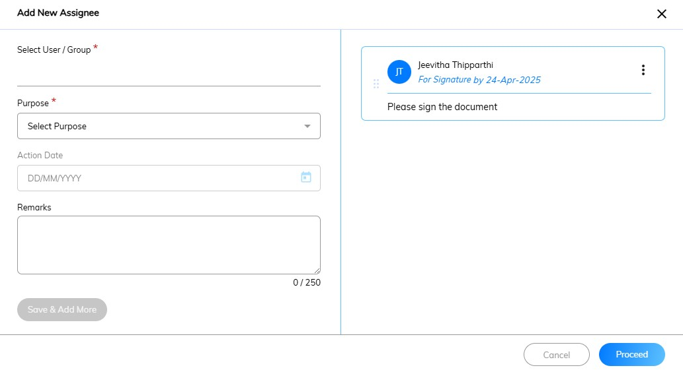

1. Click the 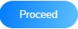button.

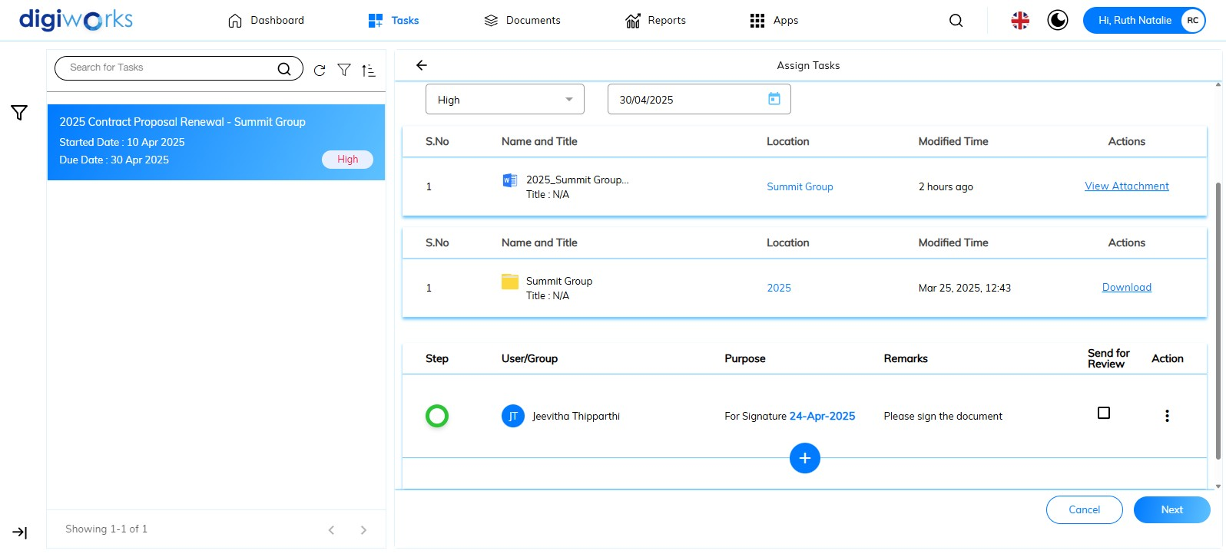

**Note**: *Optionally*, ticking theunder ‘Send for Review’ ensures the task returns upon the assignee's completion.

1. *Optional*: Click the button to add assignee in sequential task, then repeat steps 8-11.
2. Click the button.

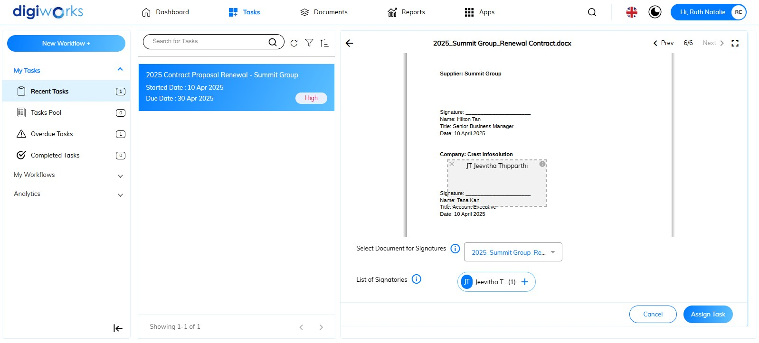

1. Select document for signatures; only one document is allowed per task.
2. The list of signatories is determined by the assignees specified in the preceding step.
3. Click the button to add a signature placement.
4. Position the signature field within the document.
5. Click the 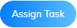 button.
6. Confirm the action by clicking Yes on the confirmation message.
7. The task has been successfully assigned to the designated assignee.

### Signing the Document via the task

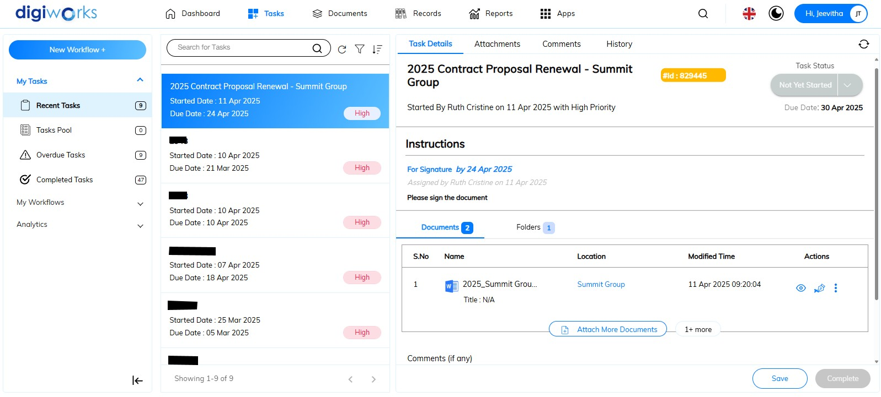

1. Navigate to the Tasks Tab
2. Select My Tasks
3. Click the Recent Taks sub-tab
4. Click the icon to sign the document.

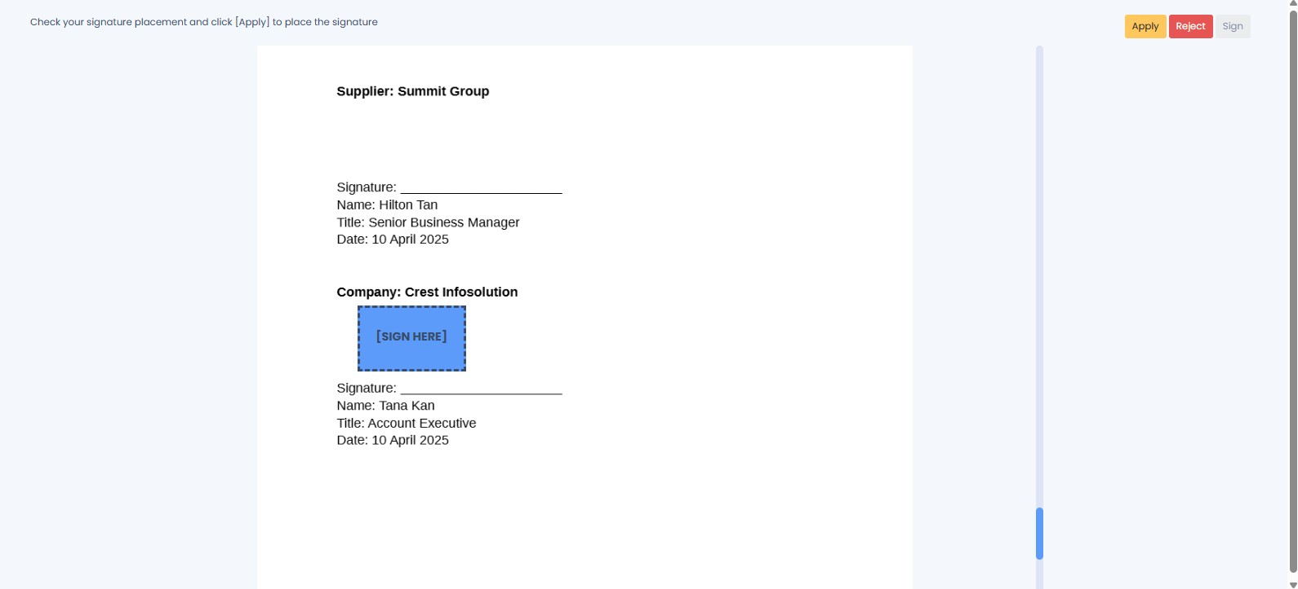

1. The Correspondence tab will open. Click the button to sign the document.

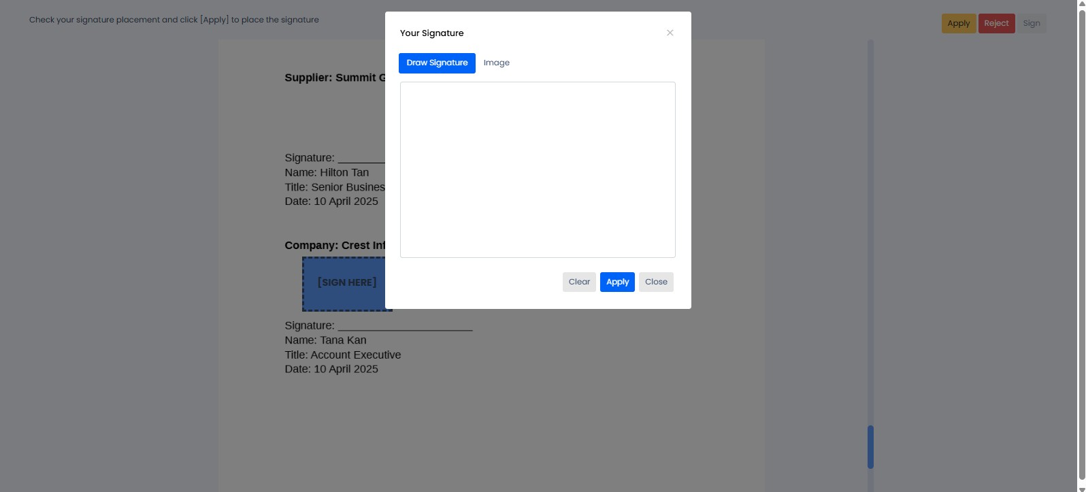

1. There are some options to sign the document:
   1. **Draw signature**: Allows a user to create their signature by drawing it directly using a mouse, stylus, or touch input.
   2. **Image**: Enables a user to upload a pre-existing image of their signature to be applied to the document.
2. One done, click the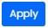button.

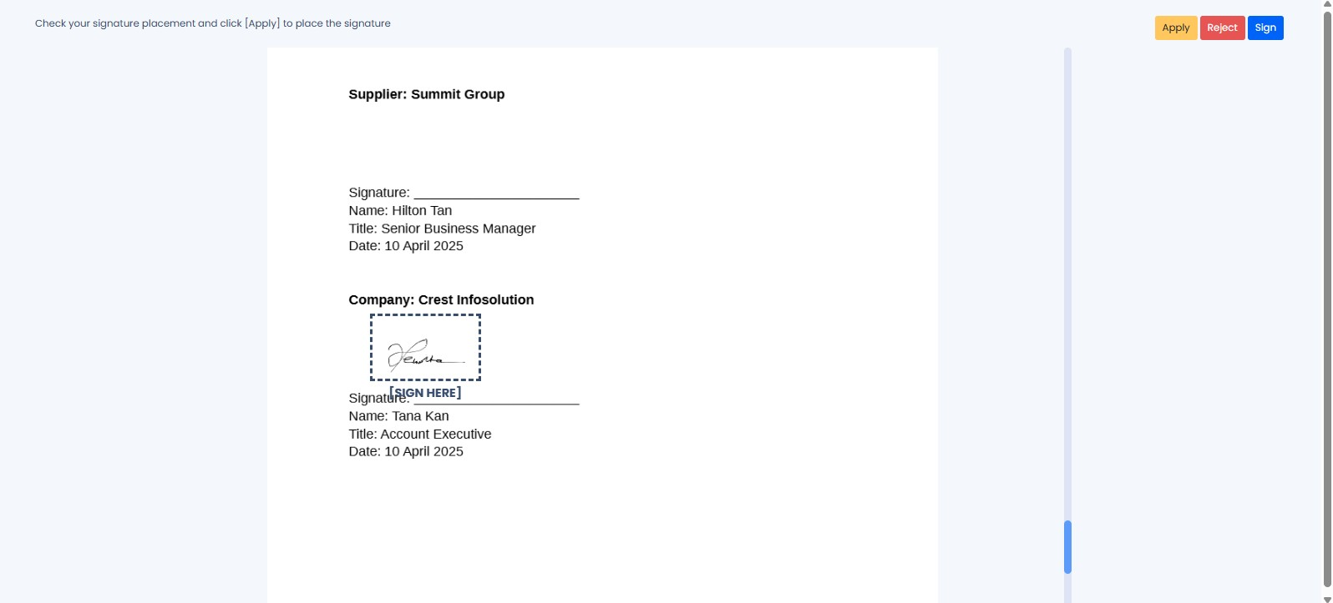

1. Click the button.
2. Click the button to proceed to sign the document.

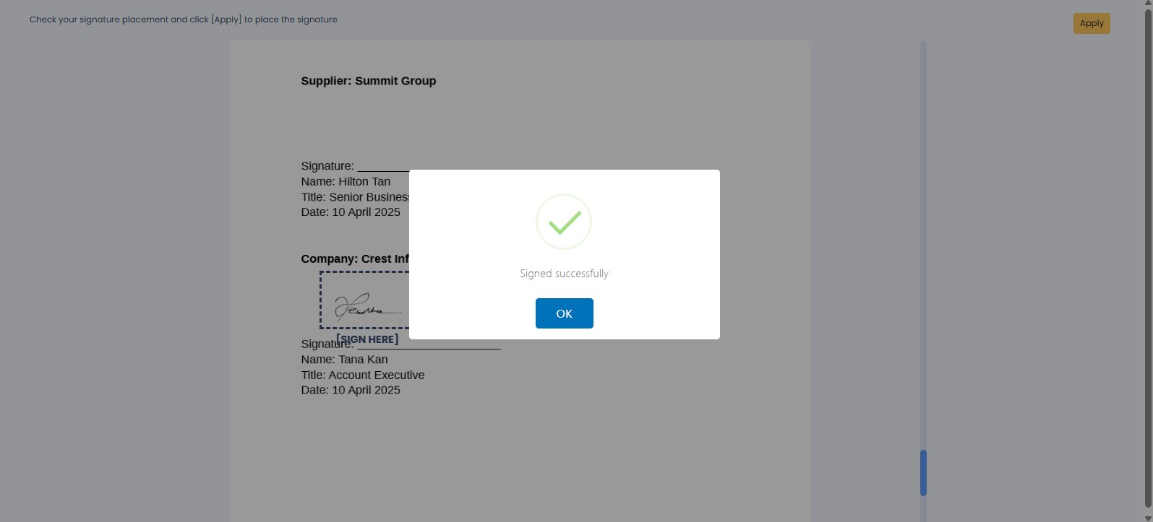

1. The document signed successfully. Click the button.

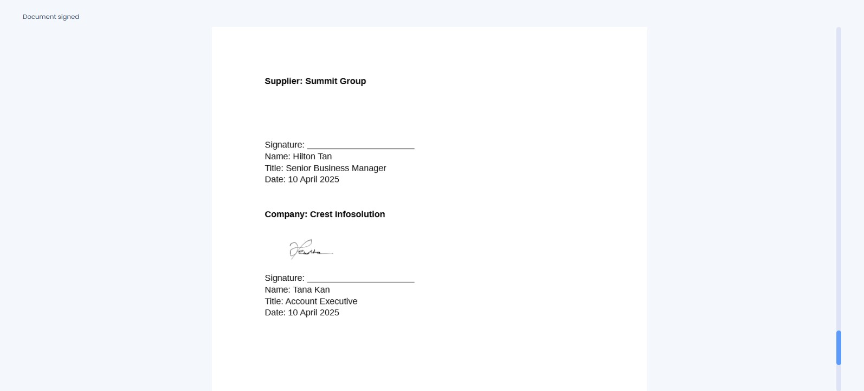

1. The signature is applied to the loaded document.
2. Close the Correspondence tab to return to DigiWorks.

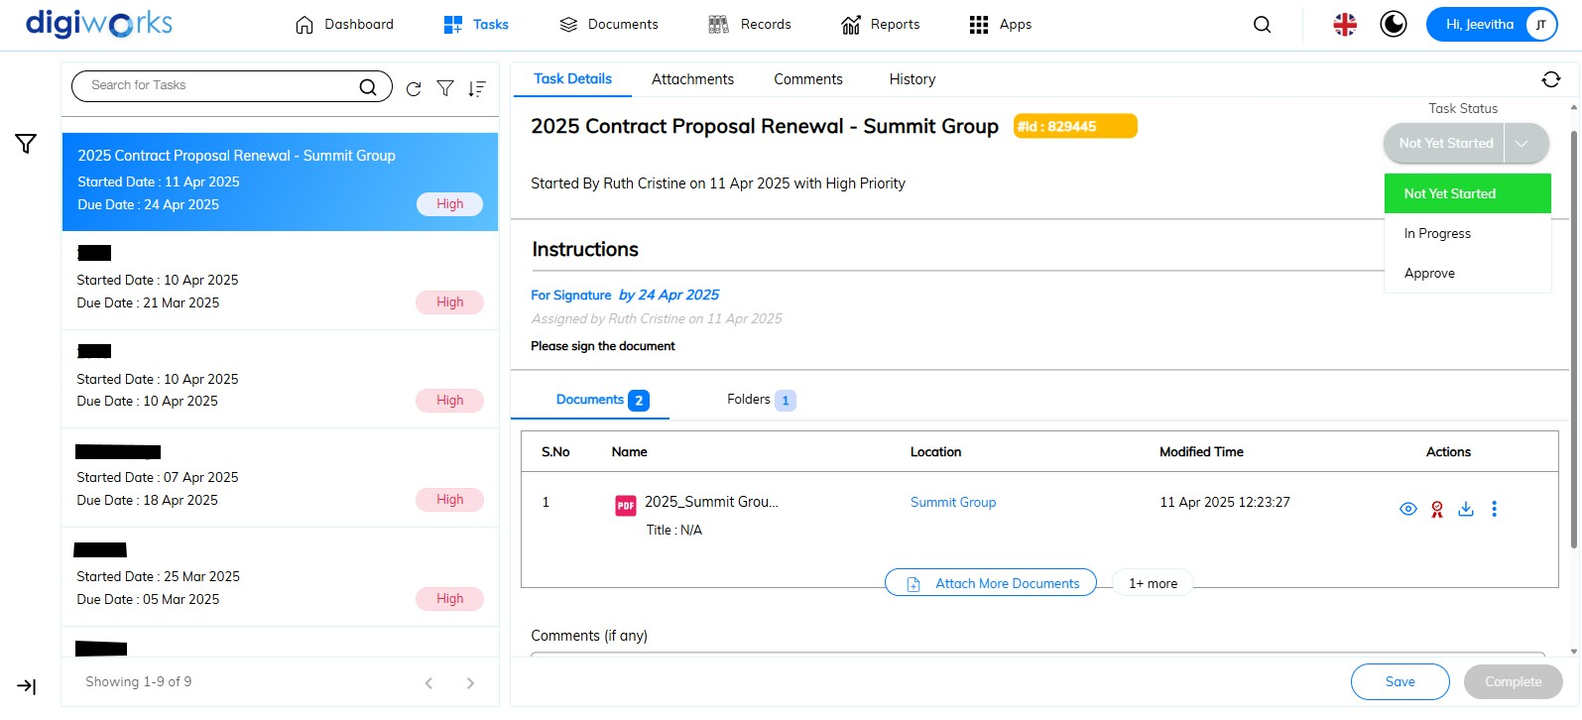

1. Upon successful document signing, the icon will be replaced with the icon.
2. Click the icon to view the certificate details.

This is a bug

1. Select ‘Approve’ on the Task Status and click thebutton.
2. Confirm the action by clicking Yes on the confirmation message.
3. The task has been completed successfully.

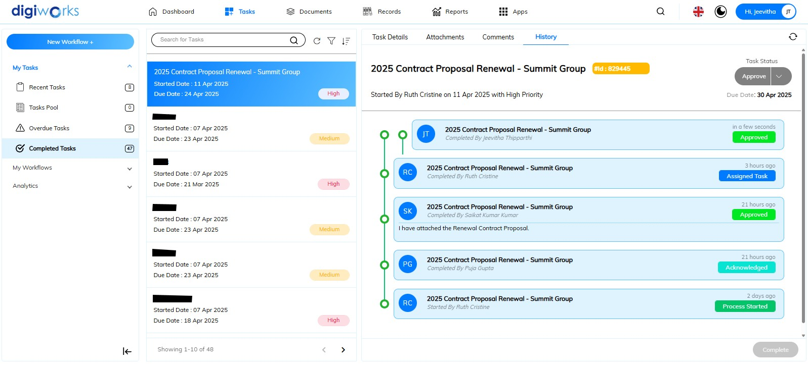

1. Navigate to Completed Tasks in the left panel's sub-task section.
2. Click on the History Tab.
3. The complete end-to-end workflow history is now visible.

### Analytics

#### Workflows Report

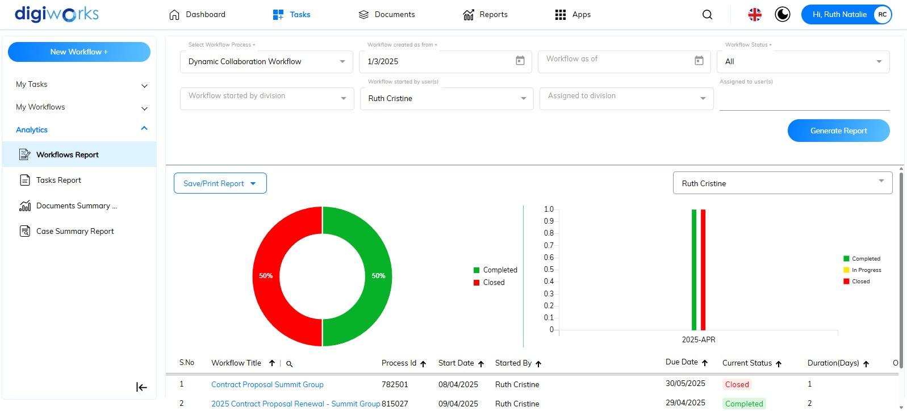

1. Navigate to Tasks tab.
2. Select Analytics.
3. Click the Workflows Report sub-tab.
4. Complete the mandatory fields: ‘*Select Workflow Process’*, ‘*Workflow created as from’*, and ‘*Workflow status’*.
5. The optional fields include *‘Workflow as of’*, ‘*Workflow started by division’*, ‘*Assigned to division’*, and ‘*Assigned to users*’.
6. ‘*Workflow started by user(s)*’ is automatically selected.

**Notes**:

* *Select Workflow Process*: This is a mandatory field used to specify the type of workflow process for the report. Users must choose either Dynamic Collaboration Workflow or Supporting Document Submission to generate the report.
* *Workflow created as from*: This is a mandatory field requiring the selection of the starting date for the workflow creation period to be included in the report.
* *Workflow status*: This is a mandatory field used to filter the report based on the current status of the workflows. Users must select one of the available options: *all*, *in progress*, *completed*, or *closed*.
* *Workflow as of*: This is an optional field to define a date range for the workflow start date in the report. If this field is left empty, the report will include all workflows created up to the current date.
* *Workflow started by division*: This is an optional field to filter the report to show workflows initiated by a specific division. If no division is selected, the report will include workflows started by all divisions.
* *Assigned to division*: This is an optional field to filter the report to show workflows currently assigned to a specific division. If no division is selected, the report will include workflows assigned to all divisions.
* *Assigned to users*: This is an optional field to view tasks assigned to specific individuals within the workflows. If no users are selected, the report will include tasks assigned to all users.
* *Workflow started by user(s)*: This field is automatically populated based on the currently logged-in user's account. By default, the report will only display workflows initiated by this user. However, users with higher hierarchical levels may have access to reports for other users depending on the configuration within *Alfresco Process Services* (APS).

1. Click the button.
2. Report generation is successful.
3. Pie and bar charts show the status graph for the selected user 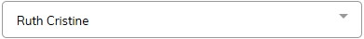 on the right-hand side, above the bar chart. The percentage data for the selected user's workflow statuses is represented in the pie chart. The bar chart displays the count of these statuses on a monthly basis, according to the applied date filter.
4. The table below the charts shows the list of workflows for the user selected in the ‘*Workflow started by user(s)*’ field. The table header includes details such as *Workflow Title, Process Id, Start Date, Started By, Due Date, Current Status, Duration (Days), Overdue, Pending At, Completed By, End Date, and Comments* (latest comment of the workflow).
5. Users can also save or print the report by clicking the 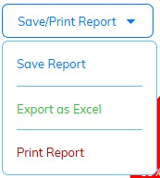button. The available options include saving the report to an accessible site, exporting it as an Excel file to the user's PC, and printing it directly.

#### Tasks Report

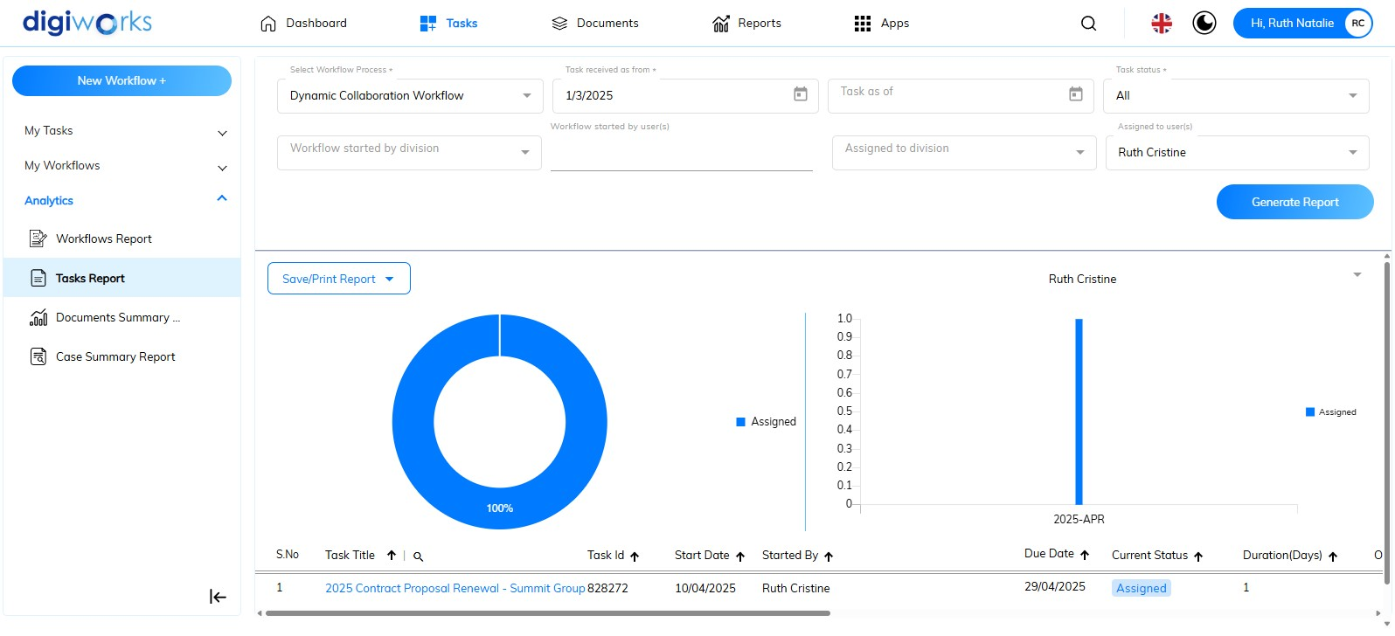

1. Navigate to Tasks tab.
2. Select Analytics.
3. Click the Tasks Report sub-tab.
4. Complete the mandatory fields: ‘*Select Workflow Process’*, ‘*Task received as from’*, and ‘*Task status’*.
5. The optional fields include *‘Task as of’*, ‘*Workflow started by division’*, ‘*Workflow started by user(s)*’, and ‘*Assigned to division’*.
6. ‘*Assigned to users*’ is automatically selected.

**Notes**:

* *Select Workflow Process*: This is a mandatory field used to specify the type of workflow process for the report. Users must choose either Dynamic Collaboration Workflow or Supporting Document Submission to generate the report.
* *Task created as from*: This mandatory field requires selecting the starting date for the assigned task period to be included in the report.
* *Task status*: This is a mandatory field used to filter the report based on the current status of the workflows. Users must select one of the available options: *all*, *acknowledged, approved, assigned,* *in progress*, *on hold, submitted, not yet started, reject, re-submitted, re-assigned,* and *for circulation*.
* *Task as of*: This optional field defines a date range for the assigned task date in the report. If left empty, the report will include all tasks assigned up to the current date.
* *Workflow started by division*: This is an optional field to filter the report to show workflows initiated by a specific division. If no division is selected, the report will include workflows started by all divisions.
* *Workflow started by user(s):* This is an optional field to filter the report to show workflows initiated by a specific user. If no user is selected, the report will include workflows started by all users.
* *Assigned to division*: This is an optional field to filter the report to show workflows currently assigned to a specific division. If no division is selected, the report will include workflows assigned to all divisions.
* *Assigned to user(s)*: This field is automatically populated based on the currently logged-in user's account. By default, the report will only display tasks assigned to this user. However, users with higher hierarchical levels may have access to reports for other users depending on the configuration within *Alfresco Process Services* (APS).

1. Click the button.
2. Report generation is successful.
3. Pie and bar charts show the status graph for the selected user  on the right-hand side, above the bar chart. The percentage data for the selected user's workflow statuses is represented in the pie chart. The bar chart displays the count of these statuses on a monthly basis, according to the applied date filter.
4. The table below the charts shows the list of tasks for the user selected in the ‘*Assigned to user(s)*’ field. The table header includes details such as *Task Title, Task Id, Start Date, Started By, Due Date, Current Status, Duration (Days), Overdue, Pending At, Completed By, End Date, and Comments* (latest comment of the workflow).
5. Users can also save or print the report by clicking the **button. The available options include saving the report to an accessible site, exporting it as an Excel file to the user's PC, and printing it directly.

#### Document Summary Report

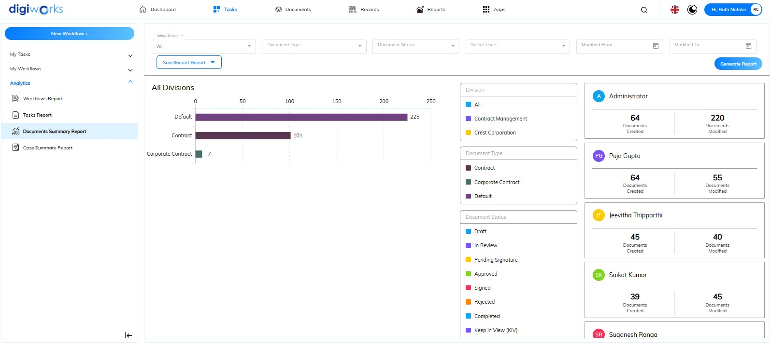

1. Navigate to Tasks Tab.
2. Select Analytics.
3. Click the Document Summary Report sub-tab.
4. Complete the mandatory field: ‘*Select Division’*.
5. The optional fields include ‘*Document Type’*, ‘*Document Status’*, ‘*Select Users*’, ‘*Modified from*’ and ‘*Modified to*’.

**Notes**:

* *Select Division:* This is a mandatory field requiring the user to specify a division for the report. Users can choose to view data for all divisions they have access to or select a particular division from the available options.
* *Document Type*: This is an optional field used to filter the report by specific document types. If no document type is selected, the report will include data for all document types.
* *Document Status*: This is an optional field used to filter the report by specific document statuses. If no status is selected, the report will include data for all document statuses.
* *Select Users*: This is an optional field allowing users to specify particular individuals for the report. If no users are selected, the report will include data for all users who have created or modified documents.
* *Modified from*: This is an optional field used to define the starting date of a date range for when documents were modified. If no date is selected, the report will include data from all modification dates.
* *Modified to*: This is an optional field used to define the ending date of a date range for when documents were modified. If no date is selected, the report will include data up to the latest modification date.

1. Click the button.
2. Report generation is successful.
3. The bar chart displays the count of document types in the selected division, or across all divisions depending on the filter.

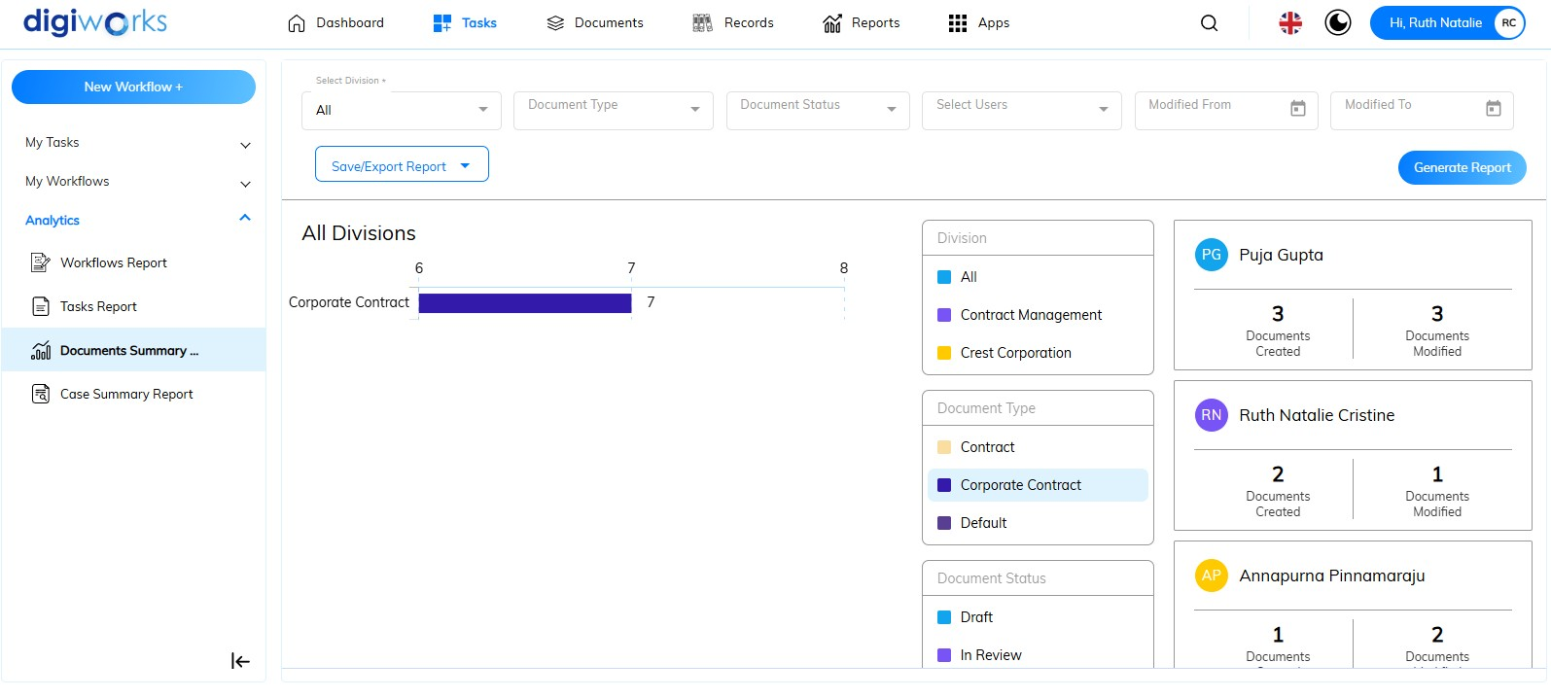

1. The middle panel displays a list of generated reports based on Division, Document Type, and Document Status. Clicking on an item in the list will show the corresponding number on the graph. For instance, clicking "Corporate Contract" under the Document Type header will filter the graph to show the count of corporate contracts only.
2. Users can also save or print the report by clicking the **button. The available options include saving the report to an accessible site, exporting it as an Excel file to the user's PC, and printing it directly.

#### Case Summary Report

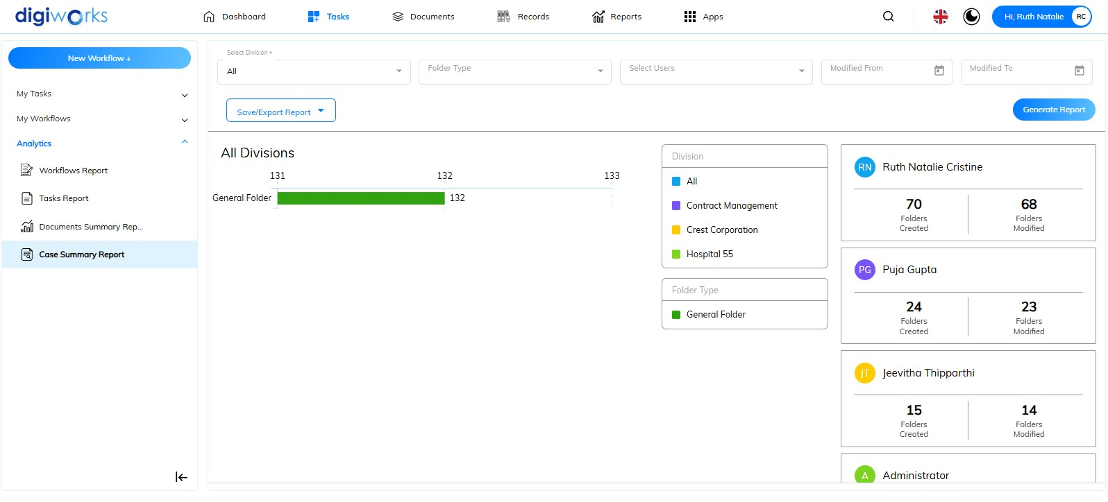

1. Navigate to Tasks Tab.
2. Select Analytics.
3. Click the Case Summary Report sub-tab.
4. Complete the mandatory field: ‘*Select Division’*.
5. The optional fields include ‘*Folder Type’*, ‘*Select Users*’, ‘*Modified from*’ and ‘*Modified to*’.

**Notes**:

* *Select Division:* This is a mandatory field requiring the user to specify a division for the report. Users can choose to view data for all divisions they have access to or select a particular division from the available options.
* *Folder Type*: This is an optional field used to filter the report by specific folder types. If no folder type is selected, the report will include data for all folder types.
* *Select Users*: This is an optional field allowing users to specify particular individuals for the report. If no users are selected, the report will include data for all users who have created or modified documents.
* *Modified from*: This is an optional field used to define the starting date of a date range for when documents were modified. If no date is selected, the report will include data from all modification dates.
* *Modified to*: This is an optional field used to define the ending date of a date range for when documents were modified. If no date is selected, the report will include data up to the latest modification date.

1. Click the button.
2. Report generation is successful.
3. The bar chart displays the count of folder types in the selected division, or across all divisions depending on the filter.

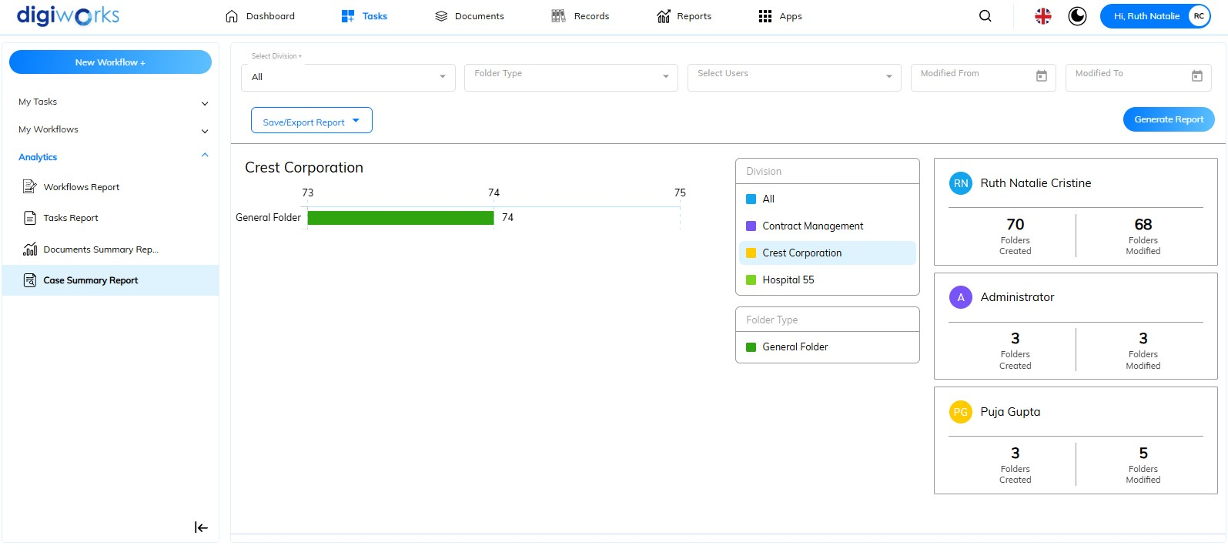

1. The middle panel displays a list of generated reports based on Division and Folder Type. Clicking on an item in the list will show the corresponding number on the graph. For instance, clicking "Crest Corporation" under the Division header will filter the graph to show the count of folder in “Crest Corporation” Site/Division only.
2. Users can also save or print the report by clicking the **button. The available options include saving the report to an accessible site, exporting it as an Excel file to the user's PC, and printing it directly.

## Search

### Global Search

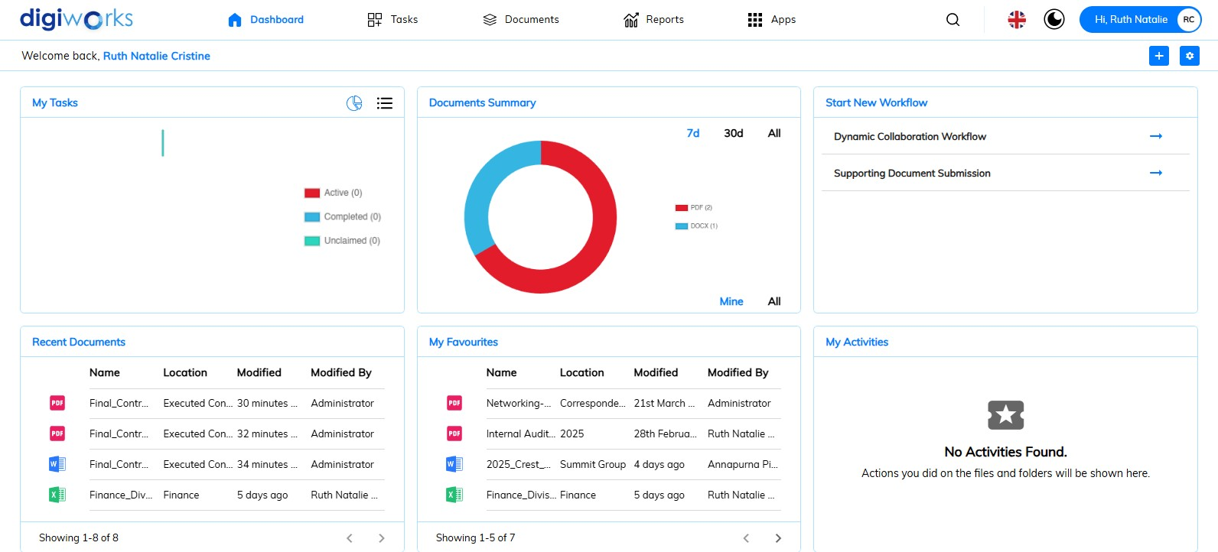

1. Search files and folders by clicking .
2. Enter keywords in the  at least three characters to start searching.
3. Choose type of search 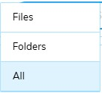.

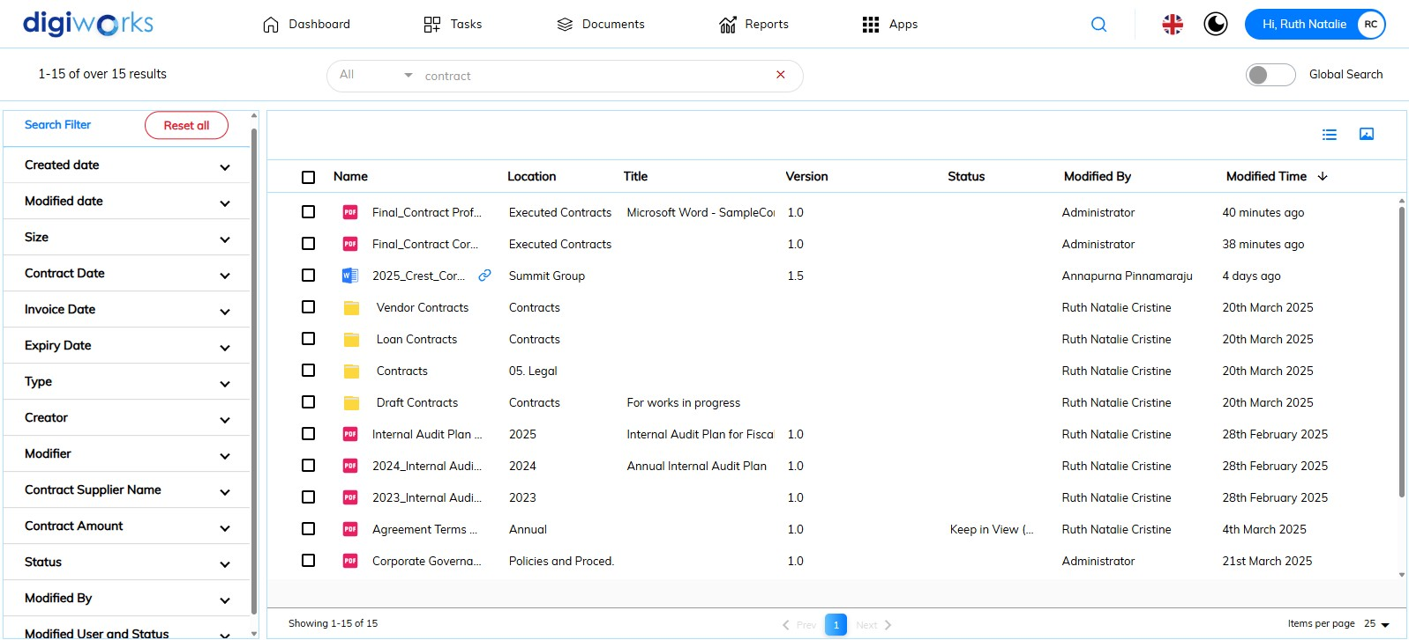

1. The results of files or folders with names, titles, descriptions, or content containing the ‘contract’ keywords from accessible sites are shown.

### Using the Advance Search

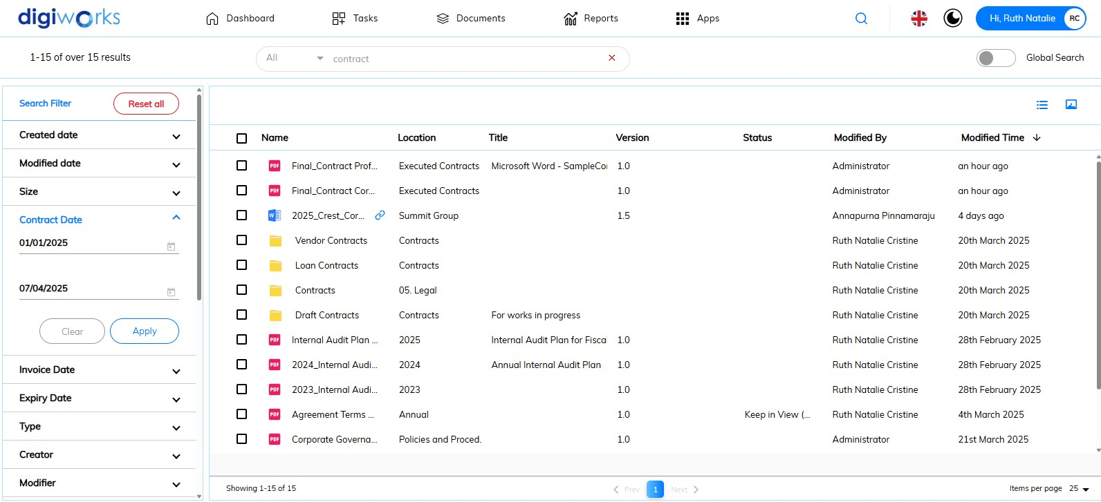

1. For more specific search results, metadata is displayed on the left panel to refine the current search output.
2. For example, the search result can be narrowed down by adding the contract date range and clicking Apply button.

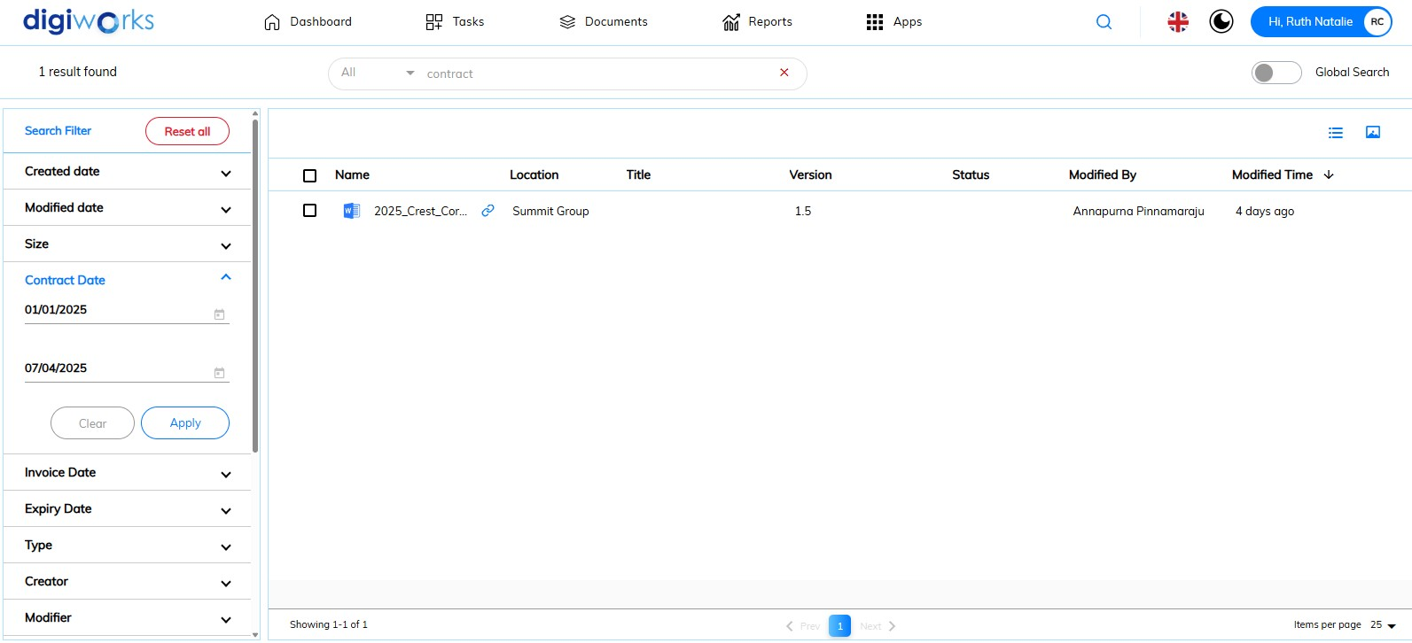

1. So, the search result is more precise, making it easier for users to find the desired files or folders.
2. The search results can currently be refined using filters for: *Created Date, Modified Date, Size, Contract Date, Invoice Date, Expiry Date, Type, Creator, Modifier, Contract Supplier Name, Contract Amount, Status, Modified By,* and *Modified User and Status.*

### AI Search

1. Click on 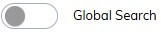to change to .

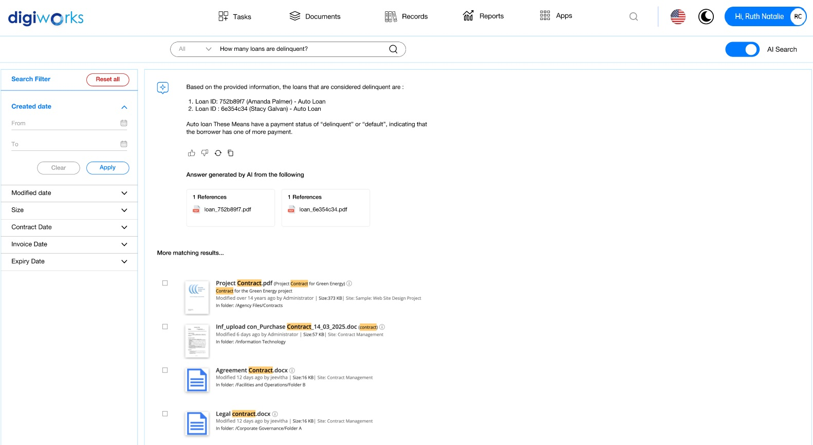

1. Enter a question or keywords to receive a real-time answer from AI search, based on content within accessible documents or folders. A file reference is provided for the user to read the complete document.

## AI Tools

DigiWorks AI Tools provide a suite of intelligent features designed to enhance document management and workflow efficiency. Leveraging artificial intelligence, these tools empower users to:

* **Ask AI:** Directly query the content of documents using natural language, enabling quick access to specific information and insights without manual searching.
* **Detect PII (Personally Identifiable Information):** Automatically identify and flag sensitive data within documents, aiding in compliance with privacy regulations and ensuring data security.
* **Generate Tags:** Intelligently analyze document content to automatically suggest relevant tags, improving organization, searchability, and categorization of files.
* **Summarize:** Condense lengthy documents into concise summaries, allowing users to quickly grasp key information and save valuable time.
* **Translate All Files:** Seamlessly translate the content of entire documents between various languages, facilitating collaboration and understanding across multilingual teams.

These AI-powered capabilities streamline document-related tasks, improve information retrieval, enhance data privacy, and boost overall productivity within DigiWorks.

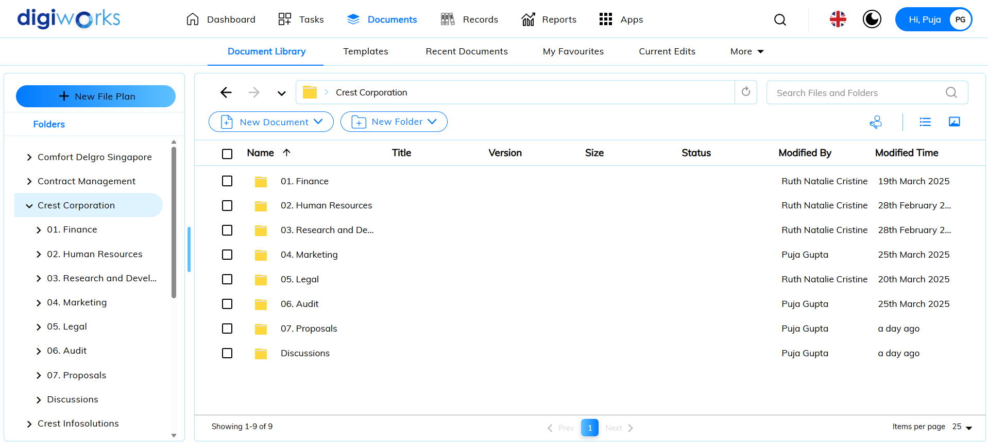

1. Click on Documents tab.
2. Click on Document Library.
3. Navigate to the desired folder and click on a file.
4. There will be five (5) AI Tools available on the right panel:

* Ask AI
* Detect PII
* Generate Tags
* Summarize it
* Translate It

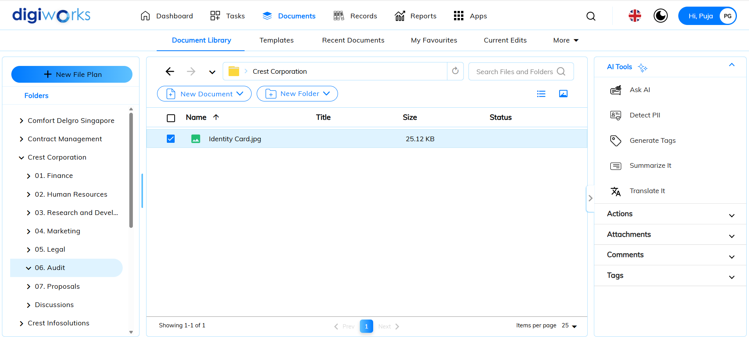

### Ask AI

1. Click on Ask AI.
2. Type and ask any questions.

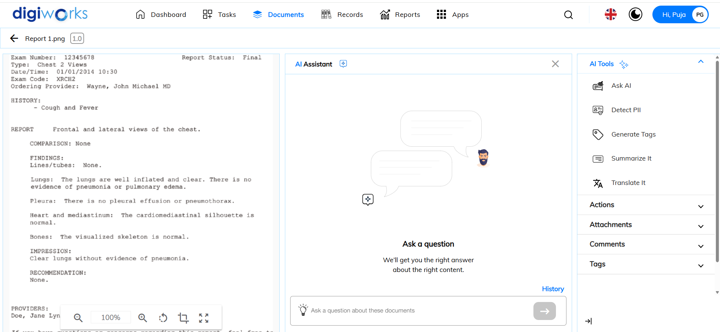

1. Answers will be generated by AI from the document.

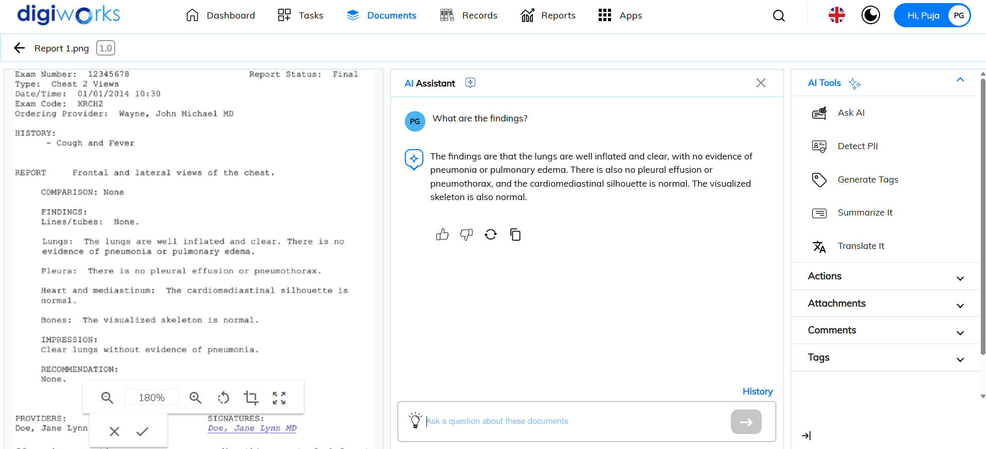

### Detect PII

1. Click on Detect PII.
2. PII (Personally Identifiable Information) results will be displayed.

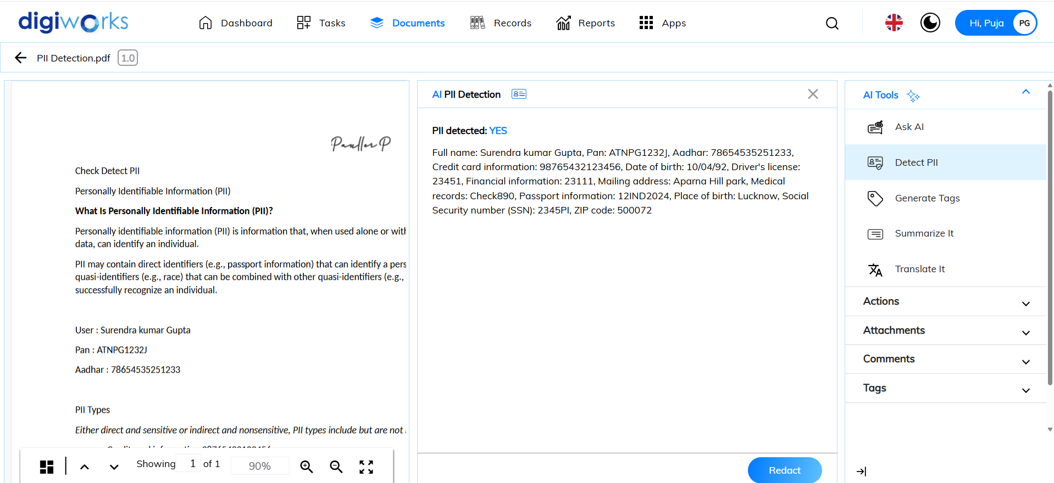

1. User can choose to Redact PII by clicking .
2. The document will be redacted successfully.

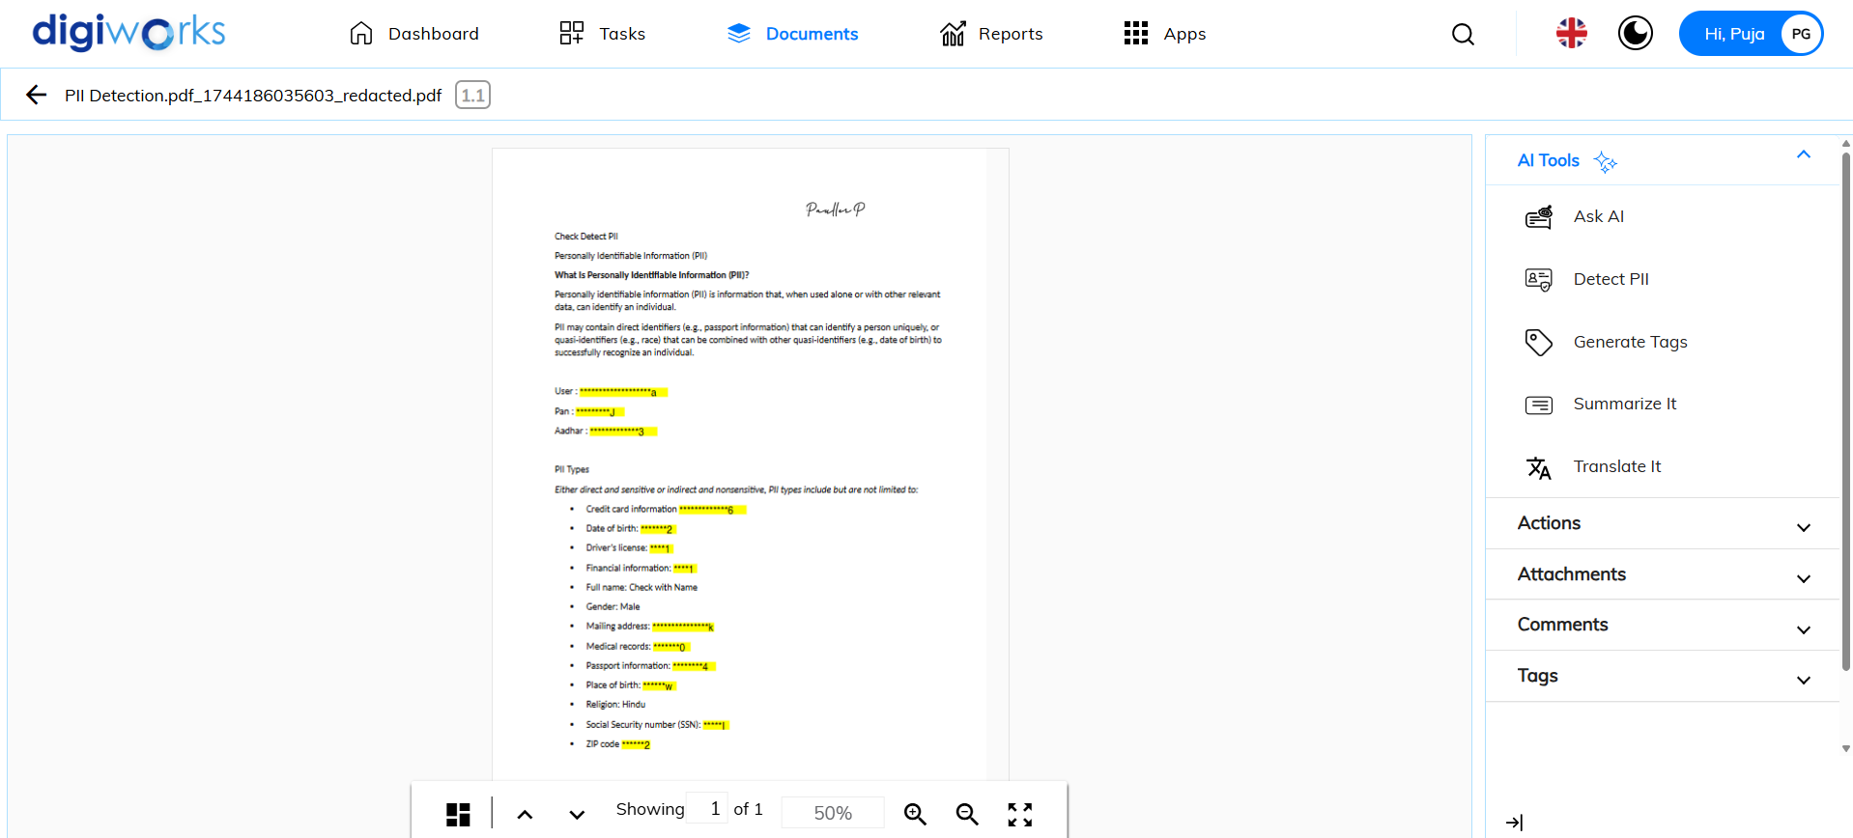

### Generate Tags

1. Click on Generate Tags.
2. Tags will be generated from the document.

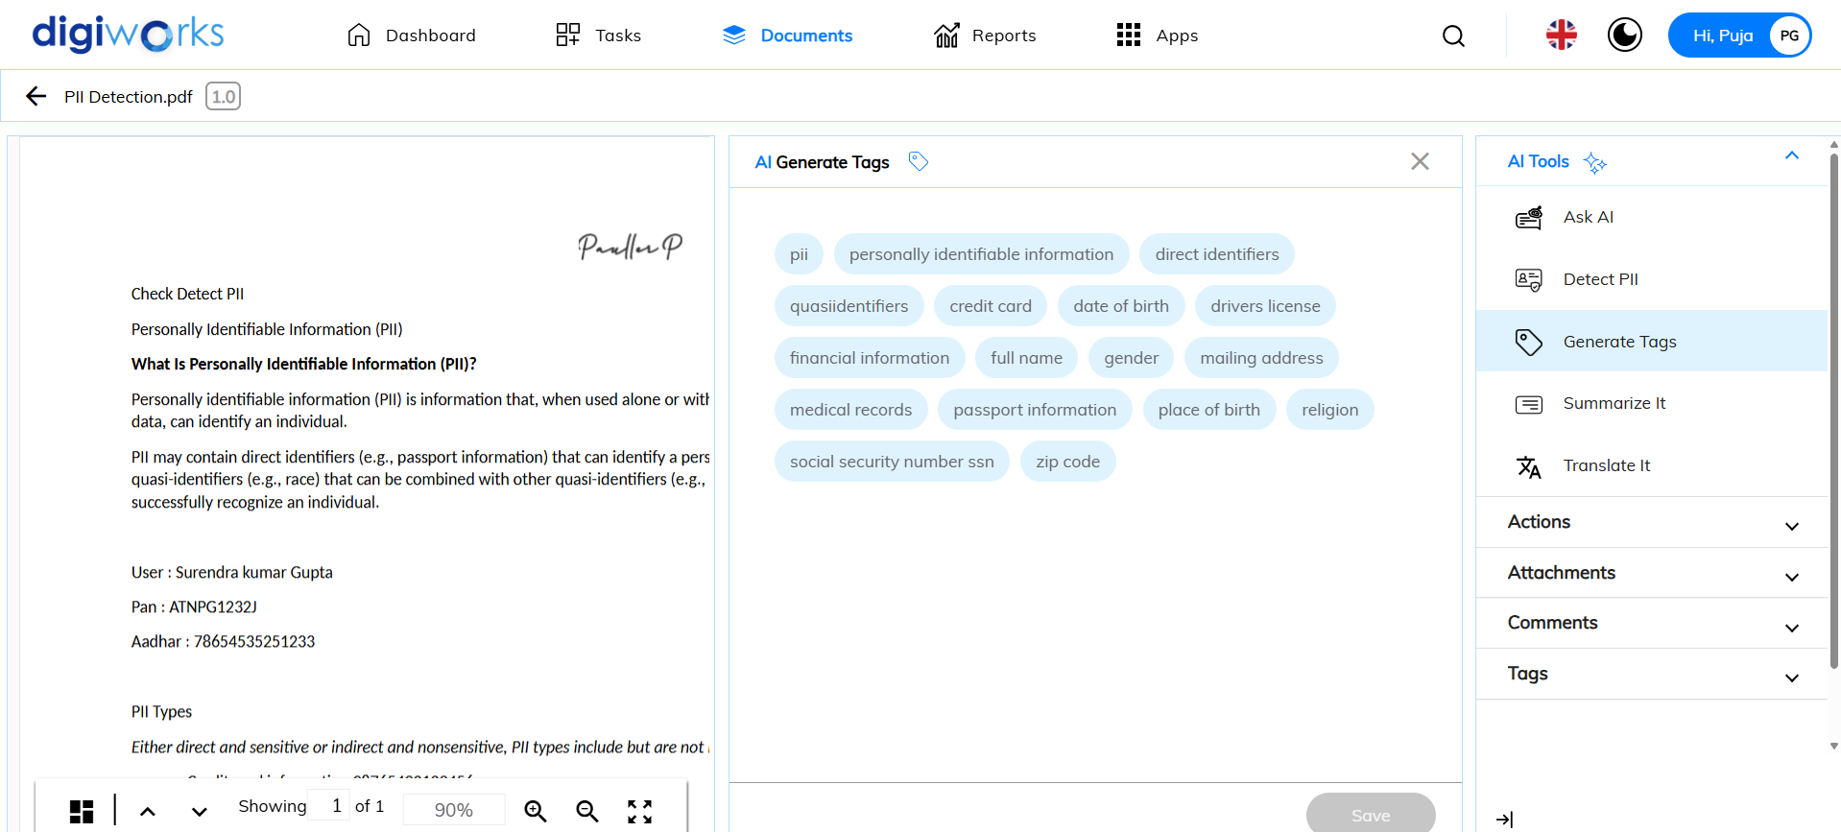

1. Select the desired tags and click Save.

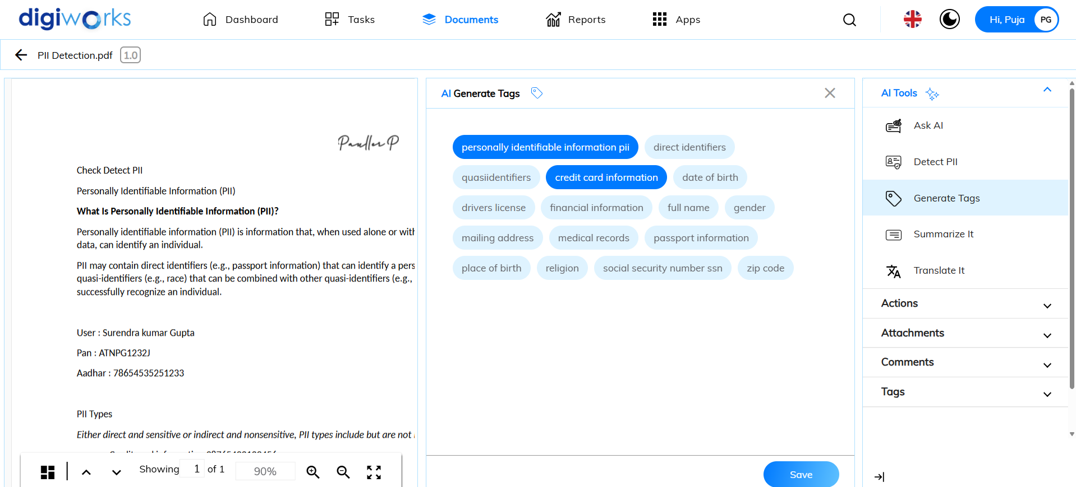

1. Tags will be saved under the Tags section of the document.

### Summarize It

1. Click on Summarize It.

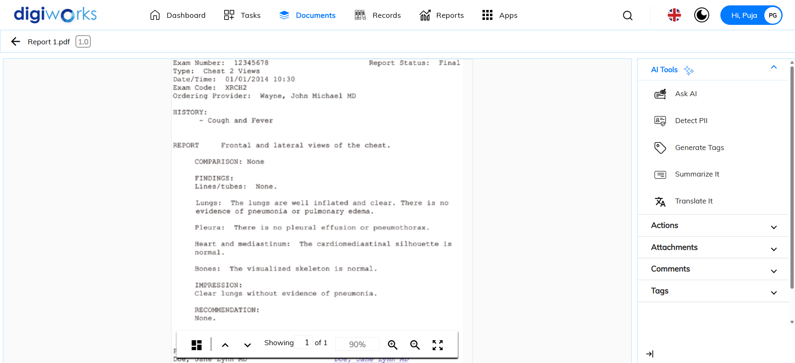

1. A summary of the document will be generated.

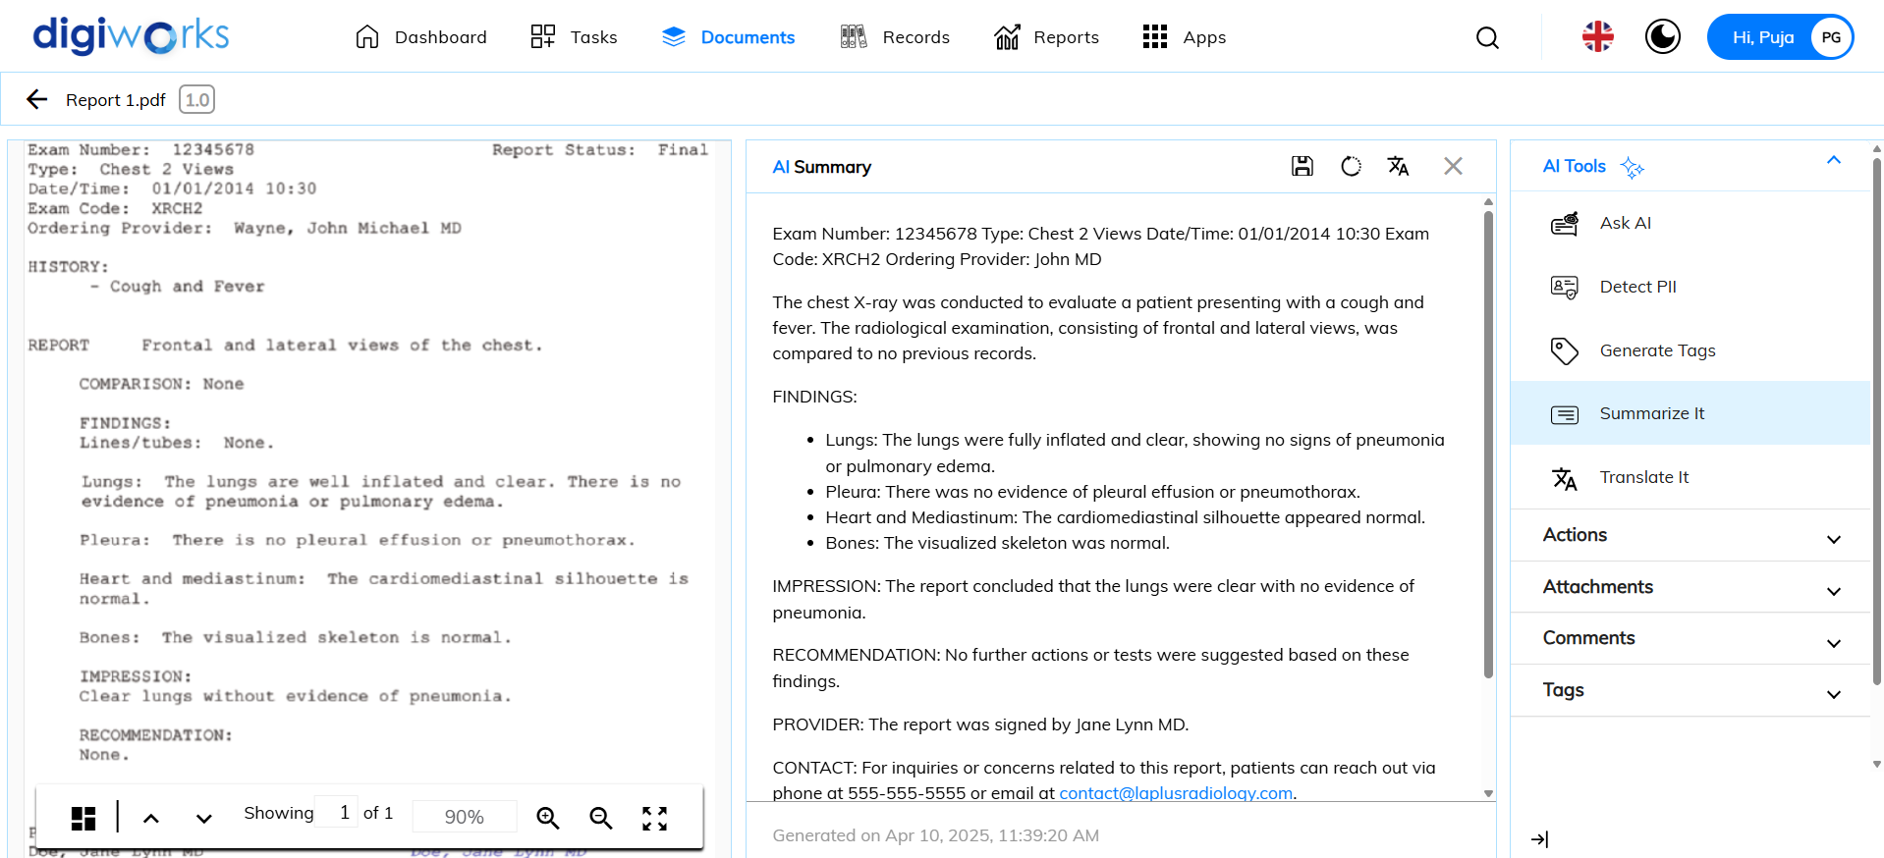

1. There are three (3) actions available:

* Save the summary to the document description by clicking .
* Re-execute the summarization by clicking .
* Copy the summary by clicking .

### Translate It

1. Click on Translate It.



1. AI Translation tab will appear and document language will be detected.

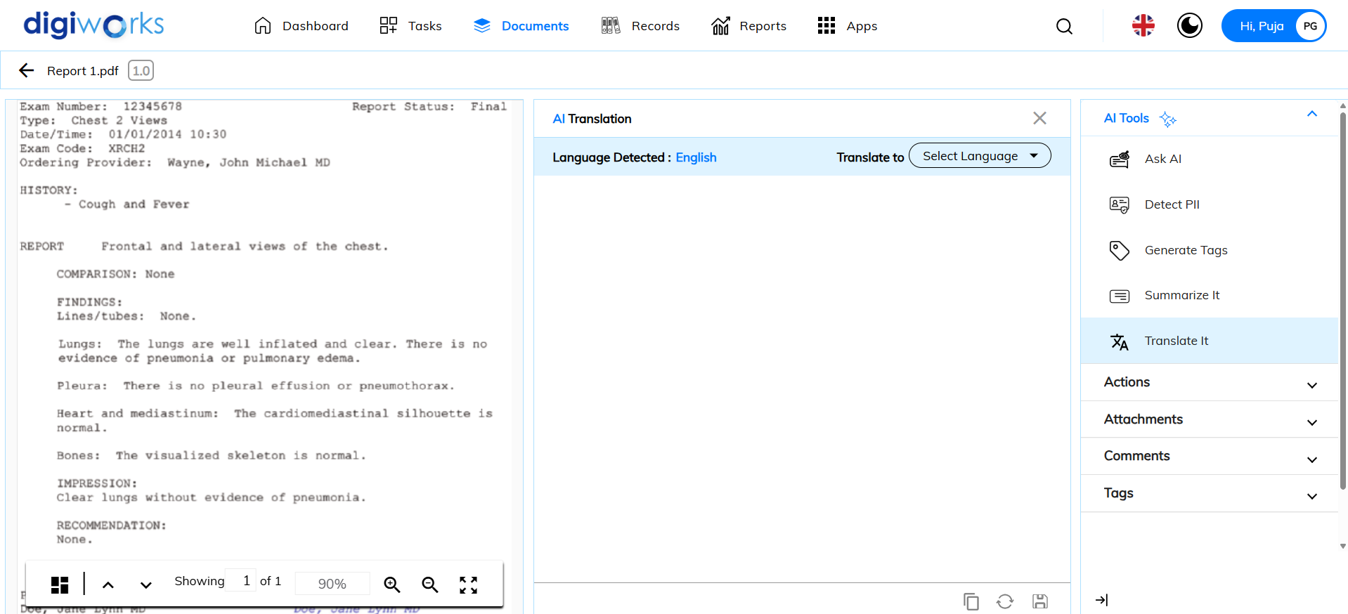

1. Click on 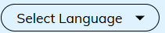and select the desired language.

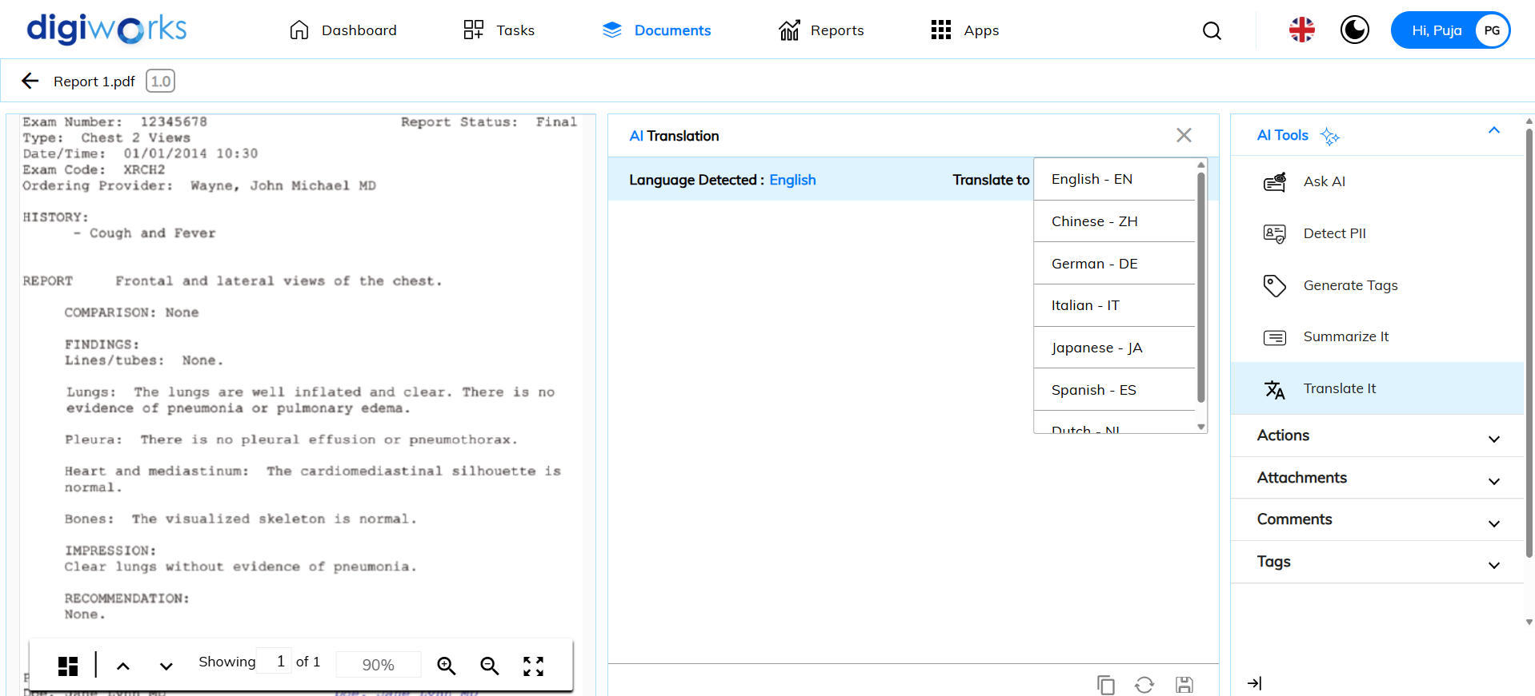

1. Document will be translated to the selected language.

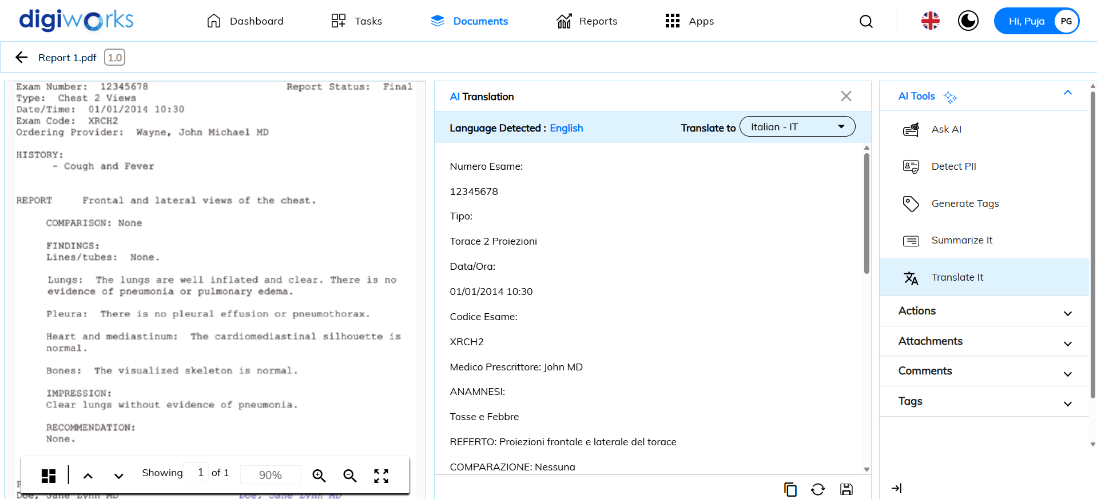

## Roles and permissions

### Dashboards Permissions

The following sections detail the user permissions for dashboards (personal and site). Each user has full access to the toolbar functionality available on the Dashboard Tab.

|  |  |  |  |  |
| --- | --- | --- | --- | --- |
| **Permission** | **Consumer** | **Contributor** | **Collaborator** | **Manager** |
| Add user to site |  |  |  | ✓ |
| Leave site |  |  |  | ✓ |

### Content Permissions

The following sections detail the user permissions for content.

#### Folders and Files

| **Permission** | **Consumer** | **Contributor** | **Collaborator** | **Manager** |
| --- | --- | --- | --- | --- |
| View folder / item details page | ✓ | ✓ | ✓ | ✓ |
| Favorite / unfavorite | ✓ | ✓ | ✓ | ✓ |
| Rename folder / item - *created / added by self* |  | ✓ | ✓ | ✓ |
| Rename folder / item - *created by other user* |  |  | ✓ | ✓ |
| Edit properties - *created by self* |  | ✓ | ✓ | ✓ |
| Edit properties - *created by other user* |  |  | ✓ | ✓ |
| Copy | ✓ | ✓ | ✓ | ✓ |
| Move - *content created by self* |  | ✓ | ✓ | ✓ |
| Move - *content created by other user* |  |  |  | ✓ |
| Delete - *content created by self* |  | ✓ | ✓ | ✓ |
| Delete - *content created by other user* |  |  |  | ✓ |
| Audit log - *content created by self* |  | ✓ | ✓ | ✓ |
| Audit log - *content created by other user* |  |  | ✓ | ✓ |
| Manage permissions - *content created by self* |  | ✓ | ✓ | ✓ |
| Manage permissions - *content created by other user* |  |  |  | ✓ |
| Share with external user - *content created by self* |  | ✓ | ✓ | ✓ |
| Share with external user - *content created by other user* |  |  |  | ✓ |
| Manage external access - *content created by self* |  | ✓ | ✓ | ✓ |
| Manage external access - *content created by other user* |  |  |  | ✓ |
| Remove external access- *content created by self* |  | ✓ | ✓ | ✓ |
| Remove external access- *content created by other user* |  |  |  | ✓ |
| Add comment |  | ✓ | ✓ | ✓ |
| Edit comment - *content created by self* |  | ✓ | ✓ | ✓ |
| Edit comment - *content created by other user* |  |  |  | ✓ |
| Delete comment - *content created by self* |  | ✓ | ✓ | ✓ |
| Delete comment - *content created by other user* |  |  |  | ✓ |

#### Folders only

| **Permission** | **Consumer** | **Contributor** | **Collaborator** | **Manager** |
| --- | --- | --- | --- | --- |
| Create folder |  | ✓ | ✓ | ✓ |
| Locate folder | ✓ | ✓ | ✓ | ✓ |
| Manage rules *in self-created folder* |  | ✓ | ✓ | ✓ |
| Manage rules *in folder created by other user* |  |  |  | ✓ |
| Manage linked folders *in self-created folder* |  | ✓ | ✓ | ✓ |
| Manage linkedfolders *created by other user* |  |  | ✓ | ✓ |
| Edit link type - *created / added by self* |  | ✓ | ✓ | ✓ |
| Edit link type - *created / added by other user* |  |  | ✓ | ✓ |
| Remove link - *created / added by self* |  | ✓ | ✓ | ✓ |
| Remove link - *created / added by other user* |  |  |  | ✓ |
| Preview link | ✓ | ✓ | ✓ | ✓ |
| Locate link | ✓ | ✓ | ✓ | ✓ |

#### Files only

| **Permission** | **Consumer** | **Contributor** | **Collaborator** | **Manager** |
| --- | --- | --- | --- | --- |
| Create content |  | ✓ | ✓ | ✓ |
| Upload content |  | ✓ | ✓ | ✓ |
| Download content | ✓ | ✓ | ✓ | ✓ |
| Upload new version - *created / added by self* |  | ✓ | ✓ | ✓ |
| Upload new version - *created / added by other user* |  |  | ✓ | ✓ |
| Upload new version - *locked / currently editing by other user* |  |  |  |  |
| Edit online - *created / added by self* |  | ✓ | ✓ | ✓ |
| Edit online - *created / added by other user* |  |  | ✓ | ✓ |
| Edit offline - *created / added by self* |  | ✓ | ✓ | ✓ |
| Edit offline - *created / added by other user* |  |  | ✓ | ✓ |
| Edit in Microsoft 365 - *created / added by self* |  | ✓ | ✓ | ✓ |
| Edit in Microsoft 365 - *created / added by self* |  |  | ✓ | ✓ |
| Edit in Google Docs - *created / added by self* |  | ✓ | ✓ | ✓ |
| Edit in Google Docs - *created / added by self* |  |  | ✓ | ✓ |
| Check out to Google Docs -  *created / added by other user* |  | ✓ | ✓ | ✓ |
| Check out to Google Docs - *created / added by other user* |  |  | ✓ | ✓ |
| Check in from Google Docs - *created / added by self* |  | ✓ | ✓ | ✓ |
| Check in from Google Docs - *created / added by other user* |  |  |  |  |
| Cancel editing - *locked / currently editing by self* |  | ✓ | ✓ | ✓ |
| Cancel editing – *locked / currently editing by other user* |  |  |  | ✓ |
| View original version | ✓ | ✓ | ✓ | ✓ |
| View working copy | ✓ | ✓ | ✓ | ✓ |
| View in Google Docs | ✓ | ✓ | ✓ | ✓ |
| Manage status *- content create by self* |  | ✓ | ✓ | ✓ |
| Manage status - *content create by other user* |  |  | ✓ | ✓ |
| Start Collaboration Workflow | ✓ | ✓ | ✓ | ✓ |
| Locate file | ✓ | ✓ | ✓ | ✓ |
| Download previous version | ✓ | ✓ | ✓ | ✓ |
| Revert to previous version |  | ✓ | ✓ | ✓ |
| Manage linked documents- *created by self* |  | ✓ | ✓ | ✓ |
| Manage linkeddocuments- *created by other user* |  |  | ✓ | ✓ |
| Edit link type - *created / added by self* |  | ✓ | ✓ | ✓ |
| Edit link type - *created / added by other user* |  |  | ✓ | ✓ |
| Remove link - *created / added by self* |  | ✓ | ✓ | ✓ |
| Remove link - *created / added by other user* |  |  |  | ✓ |
| Preview link | ✓ | ✓ | ✓ | ✓ |
| Locate link | ✓ | ✓ | ✓ | ✓ |

### Member Permissions

The following section details the member permissions.

| **Permission** | **Consumer** | **Contributor** | **Collaborator** | **Manager** |
| --- | --- | --- | --- | --- |
| Change a user role |  |  |  | ✓ |
| Remove user from site |  |  |  | ✓ |

### Power Users

DigiWorks power users have additional options that aren’t available to standard users. These options become available when an Alfresco administrator grants advanced permissions by assigning the user to a power user group in Alfresco Content Services (ACS) and Alfresco Content Process (APS). The following section details the power users’ permissions.

| **Permission** | **Consumer** | **Contributor** | **Collaborator** | **Manager** | **Power User** |
| --- | --- | --- | --- | --- | --- |
| Admin tools |  |  |  |  | ✓ |
| Create new site |  |  |  |  | ✓ |
| Access to all reports*  *\*This access supports customization to Consumer, Contributor, Collaborator, and Manager roles.* |  |  |  |  | ✓ |
| Access to all sites and contents |  |  |  |  | ✓ |

## Reports

The Reports feature provides insights into document activities, workflow executions, and user tasks. It helps organizations track process status, identify bottlenecks, and improve efficiency.

### Workflow Reports

#### Workflow Instance Report

1. Navigate to Reports tab.
2. Click on Workflow Instances Report.
3. There are three (3) types of report sections displayed:

* Workflow Instances Summary by Status
* Workflow Instances Status by Process Definitions Chart
* Workflow Instances Summary Table

1. User can filter the report. There are four (4) available filters:

* Process Name (Contract Management, Dynamic Collaboration Workflow and Supporting Document Submission)
* Status (Closed, Completed and In Progress)
* User
* Date Range

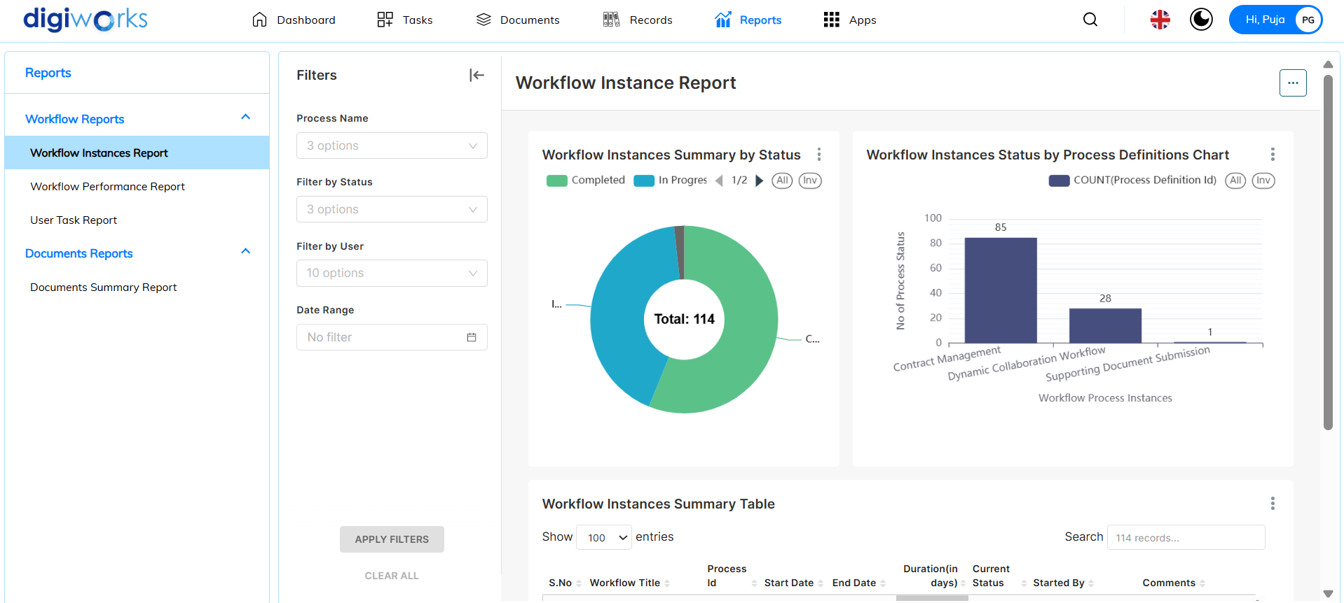

1. Filter accordingly and click Apply Filters.
2. Results will be displayed according to the filter.

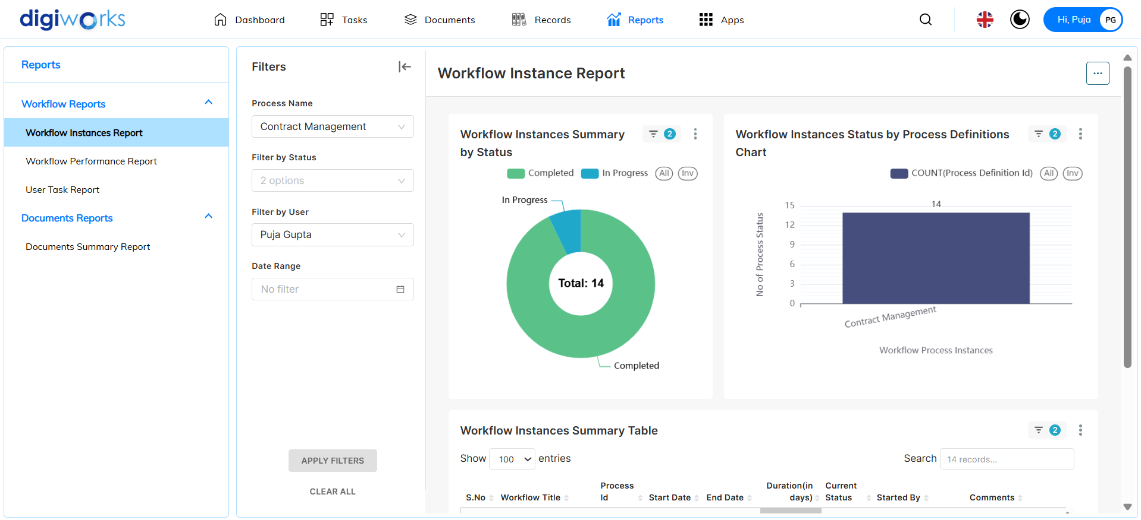

1. Click on 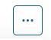to view report actions.
2. There are four (4) available report actions:
   * Refresh Dashboard
   * Download
   * Share
   * Set auto-refresh interval
3. User can choose accordingly.

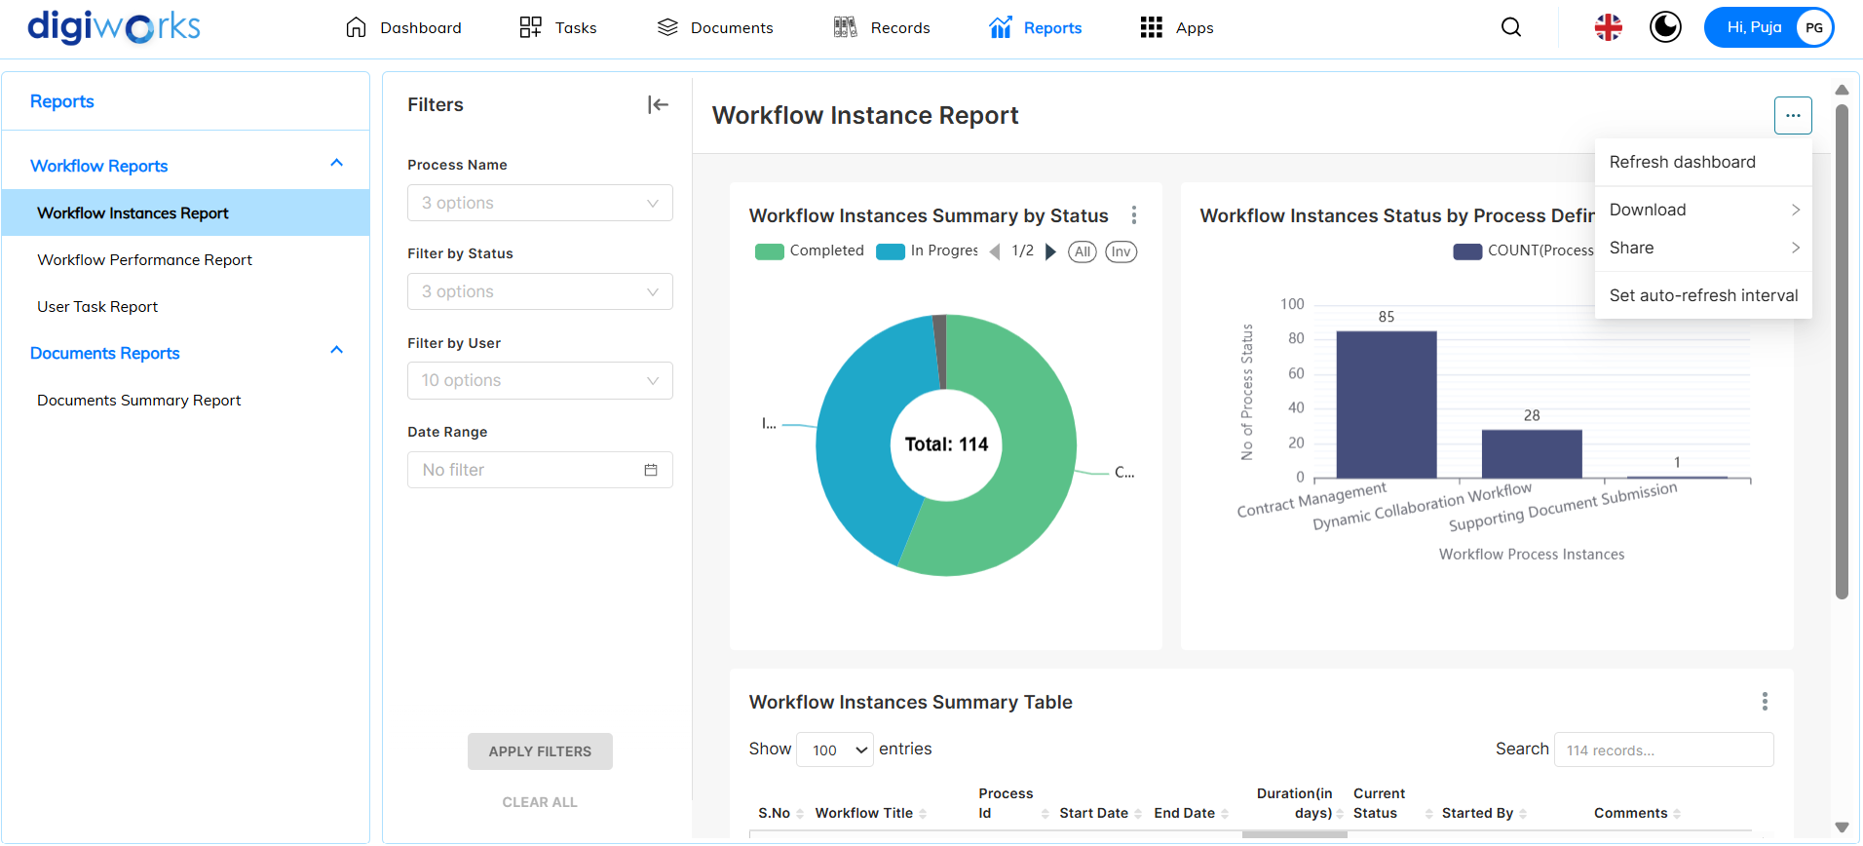

1. For each report section, click on to view available actions.
2. There are seven (7) available actions:

* Force Refresh
* Enter fullscreen
* Edit Chart
* View Query
* View as table
* Share (Copy permalink to clipboard)
* Download (Export to CSV/Excel or Download as Image)

1. User can choose accordingly.

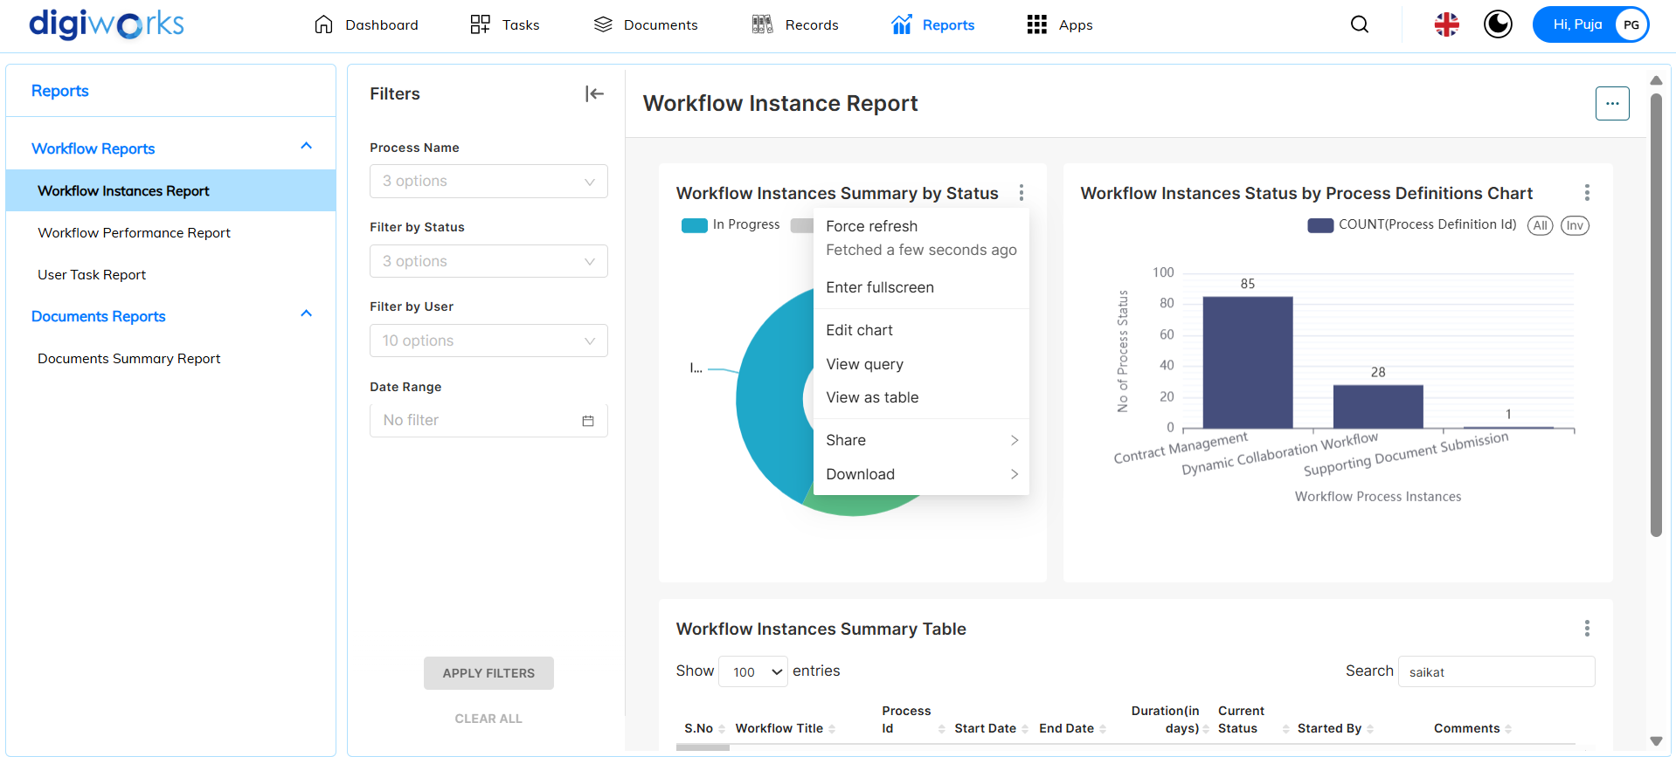

#### Workflow Performance Report

1. Navigate to Reports tab.
2. Click on Workflow Performances Report.
3. There are three (3) reports section available:

* Workflow Task Summary by Status
* Workflow Task Summary by Date
* Workflow Tasks Summary Table

1. There are two (2) available filters:

* Process Name (Contract Management and Dynamic Collaboration Workflow)
* Date Range

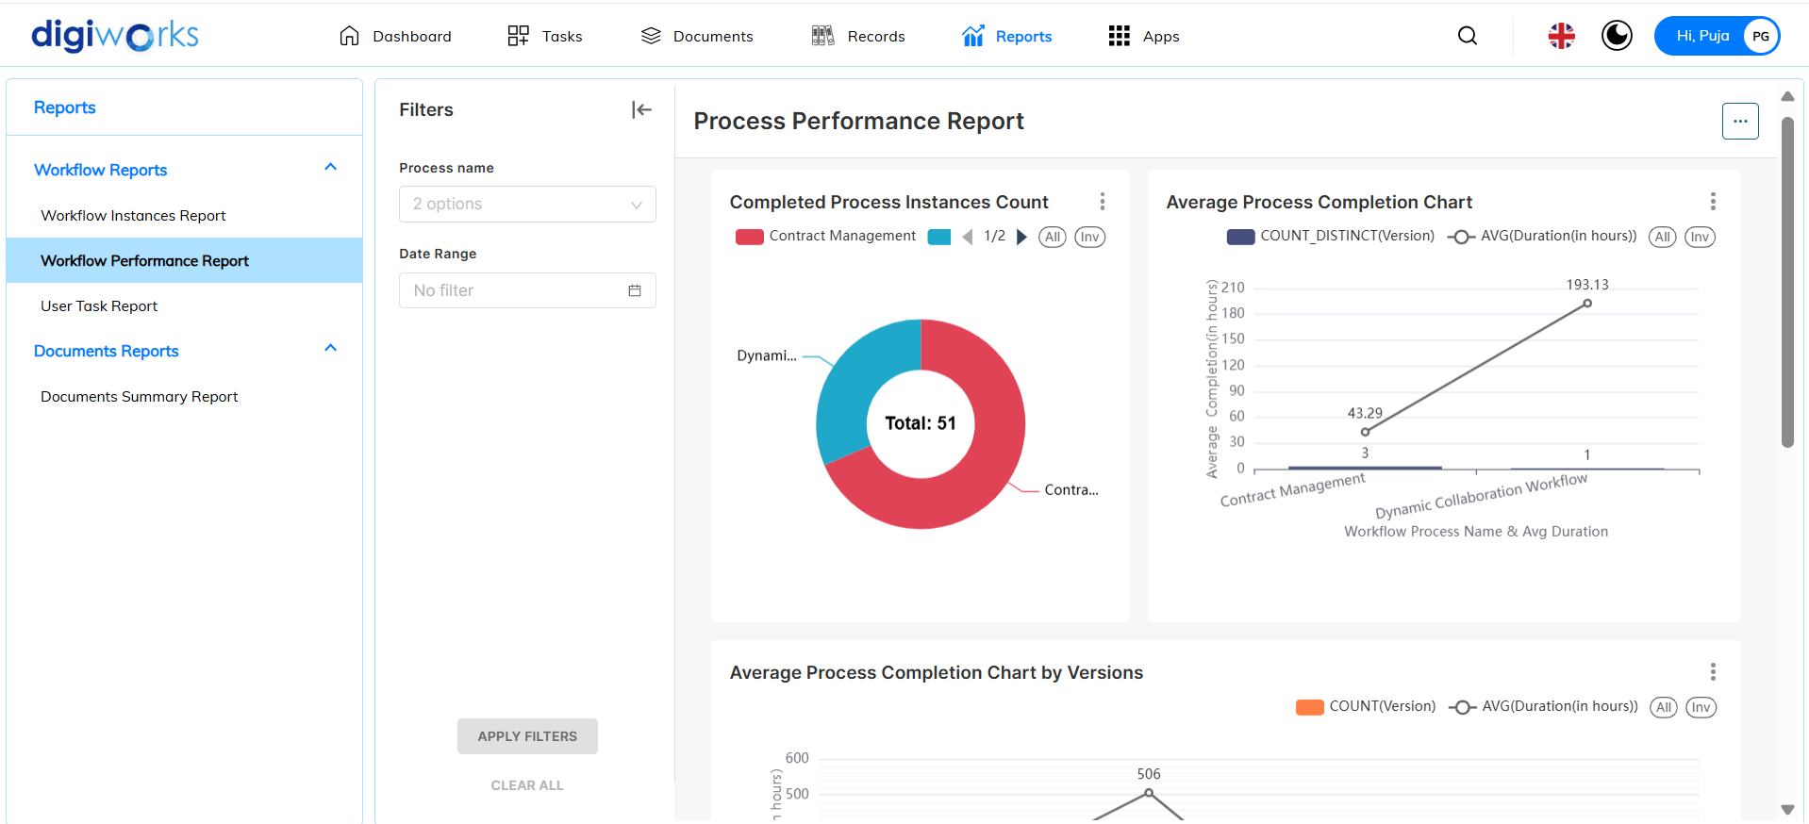

1. Filter accordingly and click Apply Filters.
2. Results will be displayed according to the filter.

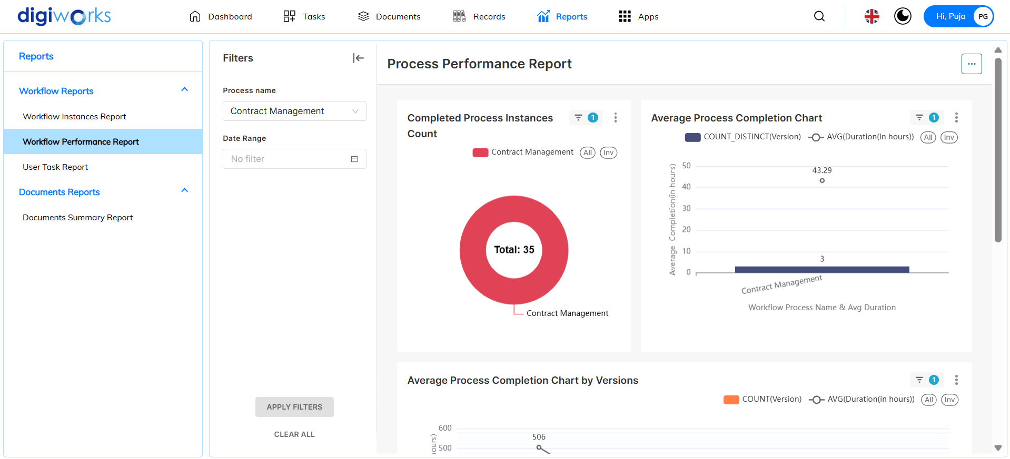

1. Click on  to view report actions.
2. There are four (4) available report actions:

* Refresh Dashboard
* Download
* Share
* Set auto-refresh interval

1. User can choose accordingly.

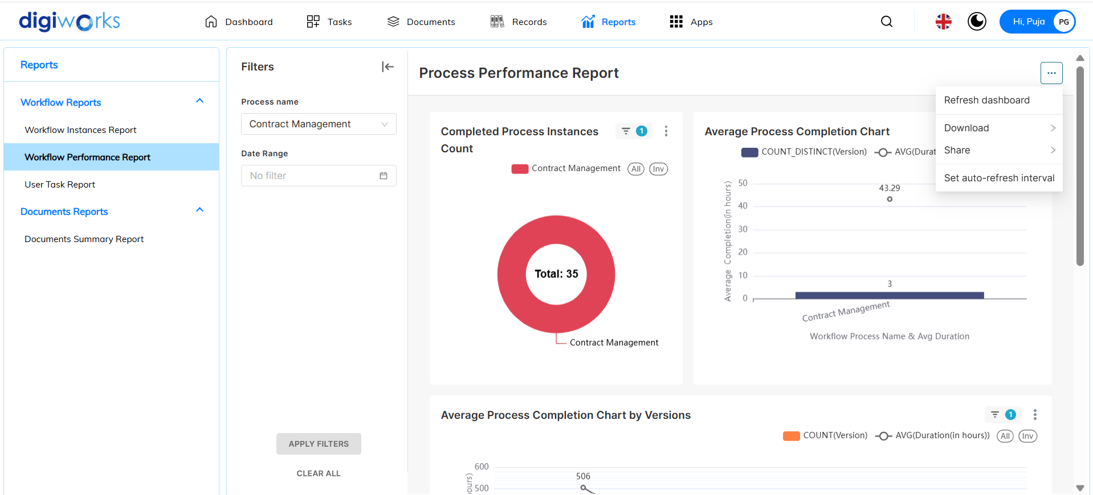

1. For each report section, click on  to view available actions.
2. There are seven (7) available actions:

* Force Refresh
* Enter Fullscreen
* Edit Chart
* View Query
* View as table
* Share (Copy permalink to clipboard)
* Download (Export to CSV/Excel or Download as Image)

1. User can choose accordingly.

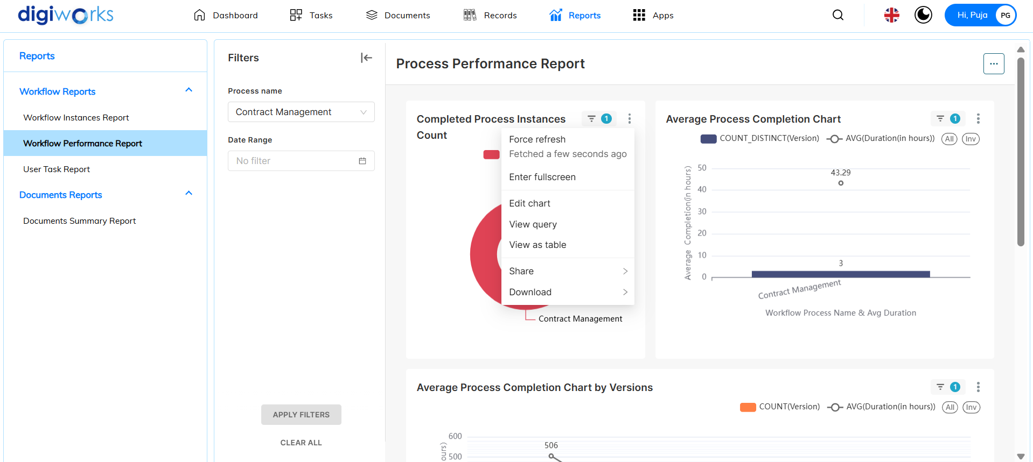

#### User Task Report

1. Navigate to Reports tab.
2. Click on User Task Report.
3. There are three (3) reports section available:

* Completed Process Instances Count
* Average Process Completion Chart
* Average Process Completion Chart by Versions

1. There are three (3) available filters:

* Process Name (Contract Management and Dynamic Collaboration Workflow)
* Username
* Date Range

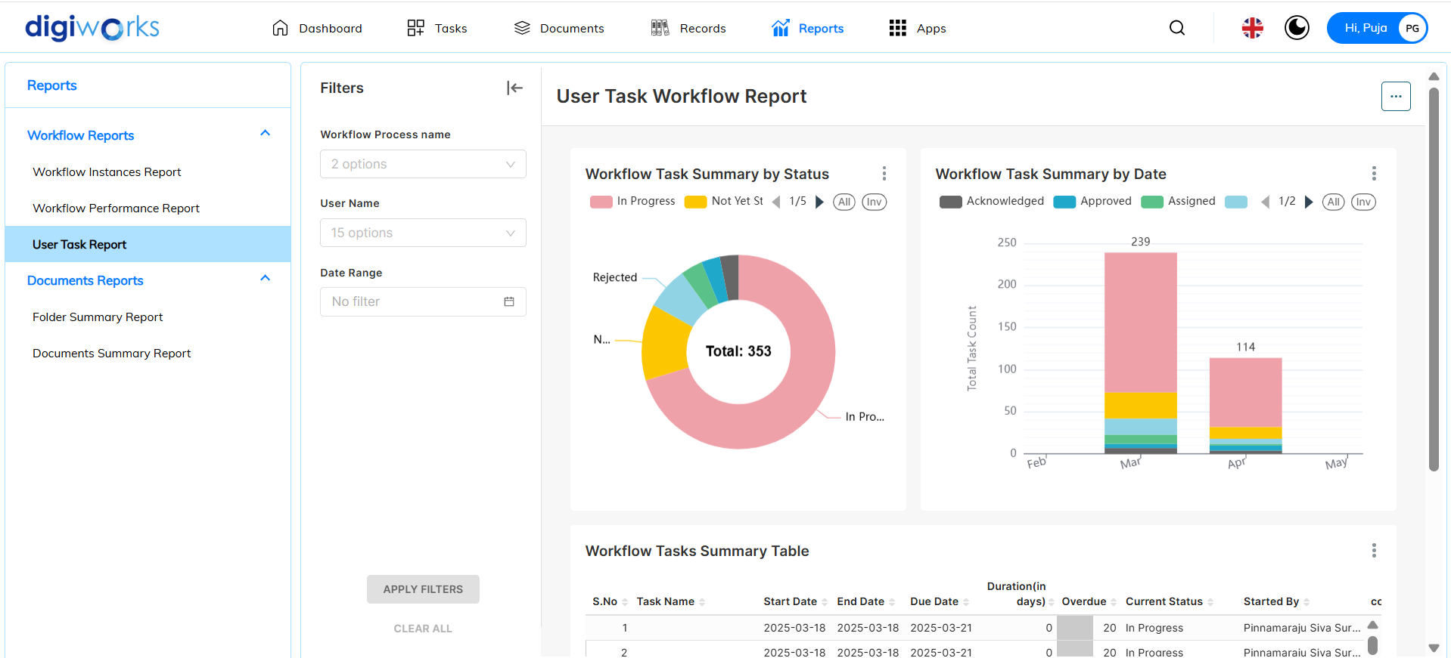

1. Filter accordingly and click Apply Filters.
2. Results will be displayed according to the filter.

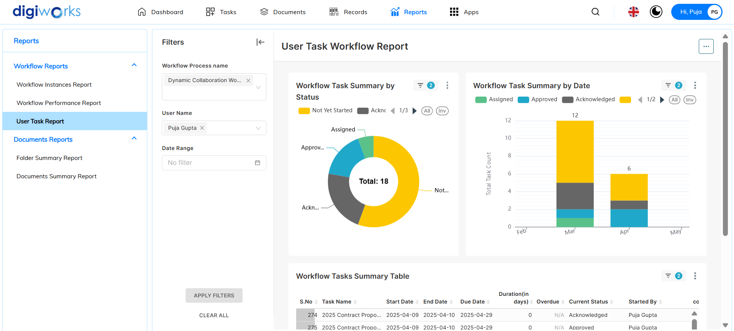

1. Click on  to view report actions.
2. There are four (4) available report actions:

* Refresh Dashboard
* Download
* Share
* Set auto-refresh interval

1. User can choose accordingly.

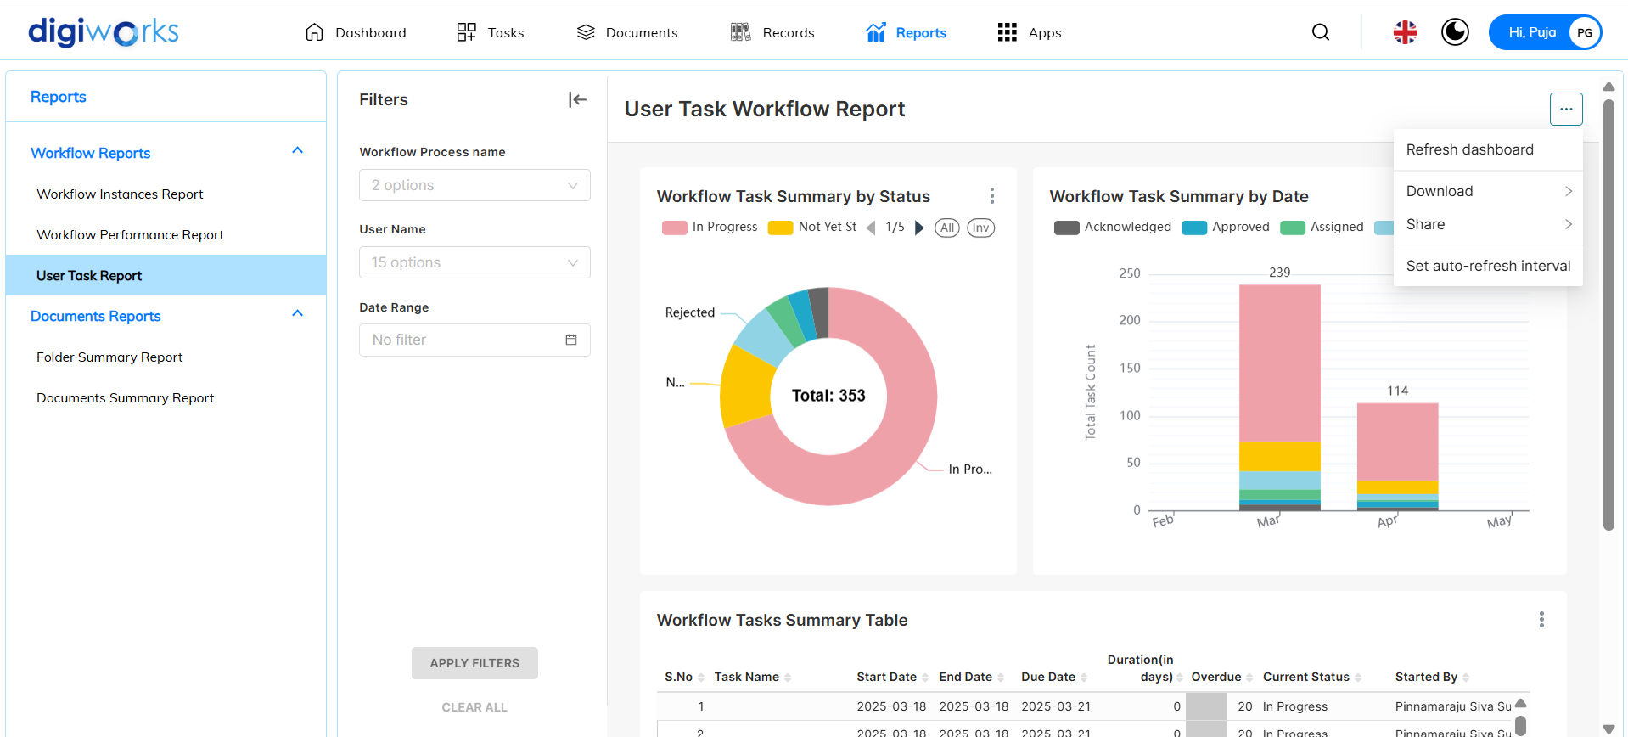

1. For each report section, click on  to view available actions.
2. There are seven (7) available actions:

* Force Refresh
* Enter fullscreen
* Edit Chart
* View Query
* View as table
* Share (Copy permalink to clipboard)
* Download (Export to CSV/Excel or Download as Image)

1. User can choose accordingly.

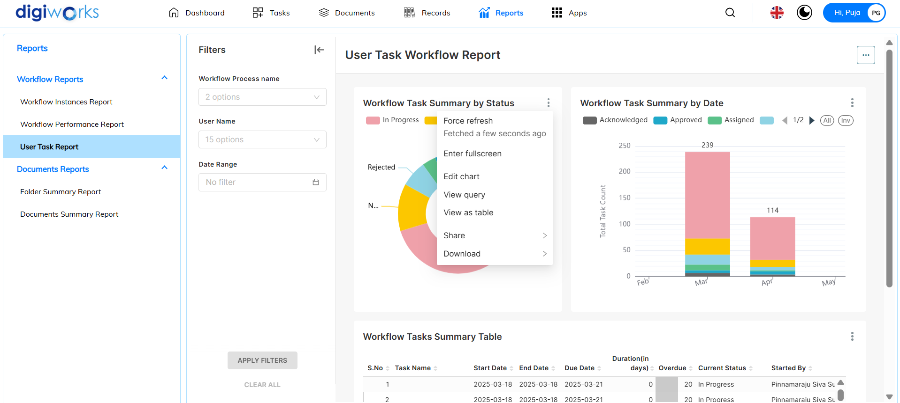

### Document Reports

#### Documents Summary Report

Currently is a bug

1. Navigate to Reports tab.
2. Click on Documents Summary Report.
3. There are three (3) reports section available:

* File Types Summary by Count
* File Types Summary by Total File Size
* Folders and Files Summary

1. There are three (3) available filters:

* User Name
* File Type
* Byte Range

1. Filter accordingly and click Apply Filters.
2. Results will be displayed according to the filter.
3. Click on  to view report actions.
4. There are four (4) available report actions:

* Refresh Dashboard
* Download
* Share
* Set auto-refresh interval

1. User can choose accordingly.
2. For each report section, click on  to view available actions.
3. There are seven (7) available actions:

* Force Refresh
* Enter fullscreen
* Edit Chart
* View Query
* View as table
* Share (Copy permalink to clipboard)
* Download (Export to CSV/Excel or Download as Image)

1. User can choose accordingly.